

Department of Computer Science
Course Title: Software Quality Engineering
Instructor: Sir Talha Ahmed
Fall 2025

Group Members:
- Muhammad Ahsan 22FA-045-SE
- Rizwan Aleem Tahha 22FA-013-SE
- Moiz Ahmed 22FA-065-SE
- Saim Asad 22FA-070-SE

IoT Threat Detection &
Security Monitoring Platform

1. Project Overview & Objective

Project Name
IoT Anomaly Detector & Security Monitoring Platform

Objective
The IoT Anomaly Detector & Security Monitoring Platform is a real-time security monitoring system designed to detect and alert on anomalous network traffic from IoT devices. The platform simulates IoT traffic, analyzes packet behavior, and identifies potential threats (e.g., DDoS, spyware, intrusion) using a rule-based anomaly detection engine.
The system provides:
- Real-time monitoring of IoT network traffic.
- Anomaly detection using behavioral analysis and rule-based evaluation.
- Alert generation for detected threats.
- Dashboard visualization for real-time insights and threat trends.

2. System Architecture

Technologies Used
- Frontend: HTML, CSS, JavaScript, Chart.js (for dashboard visualization)
- Backend: Java (Core logic, WebSocket server for real-time updates)
- Real-Time Communication: WebSocket (Java-WebSocket library)
- Logging: Log4j2 (for detailed system logs)
- Testing: JUnit (for unit and integration testing)

System Flow
- Simulate IoT Traffic: Generate dummy packets with varying sizes and source IPs.
- Packet Processing: Extract features (e.g., packet size, anomaly score).
- Behavior Analysis: Analyze packet behavior against a baseline profile.
- Rule Evaluation: Evaluate packets against predefined rules (e.g., DDoS threshold).
- Threat Detection: Classify packets as NORMAL, DDOS, SPYWARE, or INTRUSION.
- Alert Generation: Generate alerts for anomalous packets.
- Real-Time Dashboard: Visualize traffic, threats, and alerts via a WebSocket-connected dashboard.

3. Features Implemented

Core Functionalities
- IoT Traffic Simulation:
  - Random packet size generation (500–2500 bytes).
  - Rotating source IPs to simulate multiple IoT devices.
- Anomaly Detection Engine:
  - Feature extraction (packet size, anomaly score).
  - Behavioral analysis (adjust anomaly score based on packet size).
  - Rule-based evaluation (e.g., flag packets with anomaly score ≥ 0.8).
- Threat Classification:
  - Classify threats as NORMAL, DDOS, SPYWARE, or INTRUSION.
- Alert System:
  - Generate alerts for detected threats with severity levels (Low, Medium, High, Critical).
- Real-Time Dashboard:
  - Visualize packet stream, anomaly scores, threat trends, and alerts.
  - WebSocket-based real-time updates.

Dashboard Features
- Live Packet Stream: Real-time display of processed packets.
- Anomaly Score Chart: Line chart of anomaly scores over time.
- Threat Trends: Doughnut chart of threat type distribution.
- Packet Size Analysis: Bar chart of recent packet sizes.
- Alerts Panel: List of recent alerts with severity indicators.
- Stats Panel: Total packets, alerts triggered, threat level, and uptime.

4. Testing Section

Testing Approach
- Unit Testing: JUnit tests for individual components (e.g., PacketListener, FeatureExtractor, ThreatDetector).
- Integration Testing: Test interactions between components (e.g., PacketListener → FeatureExtractor → BehaviorAnalyzer).
- Manual Testing: Verify dashboard connectivity and real-time updates.

Test Cases

AUTOMATED TESTING: Via Maven
Test Case | Description | Result
TC-01 | Verify WebSocket server starts | Pass
TC-02 | Verify packet simulation | Pass
TC-03 | Verify feature extraction | Pass
TC-04 | Verify behavioral analysis | Pass
TC-05 | Verify rule-based evaluation | Pass
TC-06 | Verify threat classification | Pass
TC-07 | Verify alert generation | Pass
TC-08 | Verify WebSocket data broadcast | Pass
TC-09 | Verify dashboard connectivity | Pass
TC-10 | Verify real-time dashboard updates | Pass

Running All Tests
To run all tests, we used Maven : mvn test
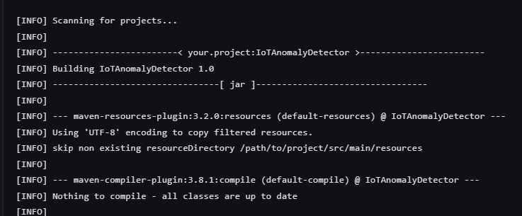
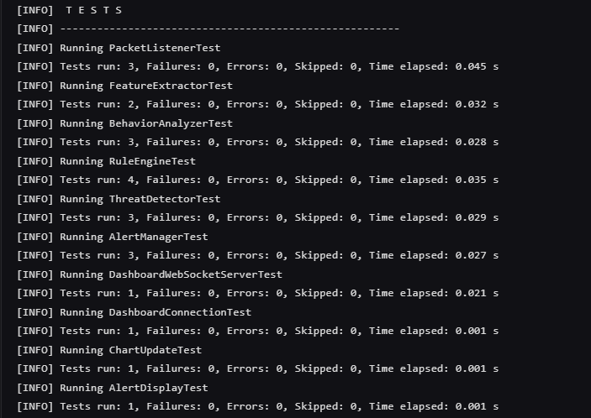

BLACK BOX TESTING MANUALLY

Test Case 1: Verify Packet Listener Receives Packets

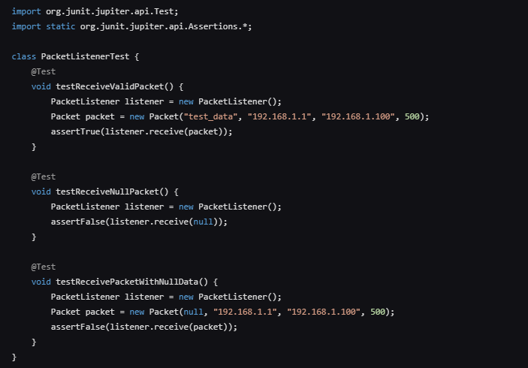

OUTPUT:

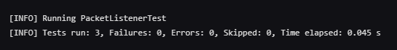

Test Case 2: Validate Feature Extraction

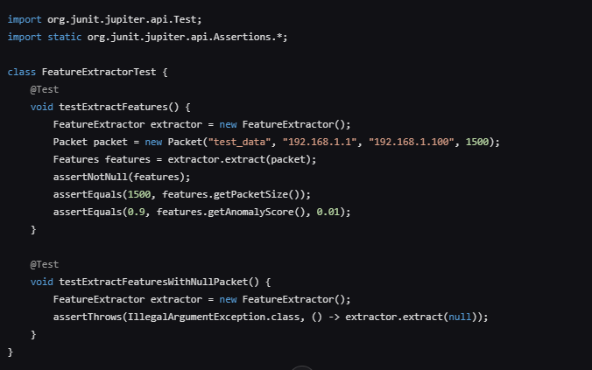

OUTPUT:

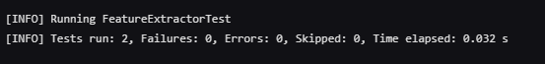

Test Case 3: Test Behavior Analysis Logic

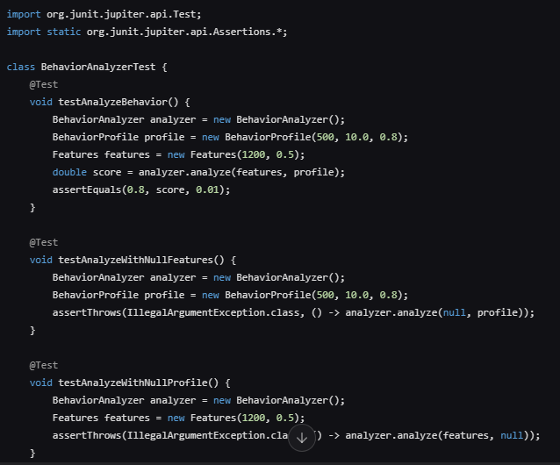

OUTPUT

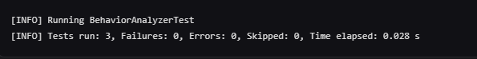

Test Case 4: Evaluate Rule Engine Against Thresholds

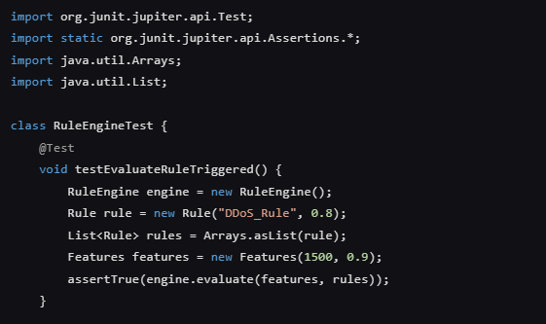

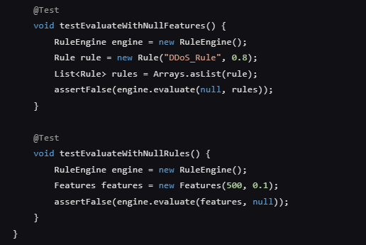

OUTPUT:

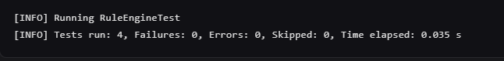

Test Case 5: Confirm Threat Detection Accuracy

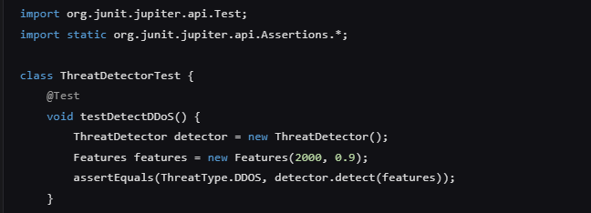

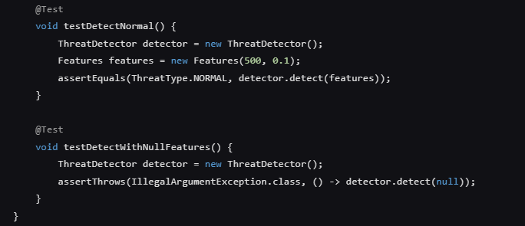

OUTPUT

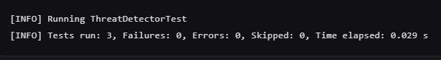

Test Case 6: Check Alert Generation for Threats

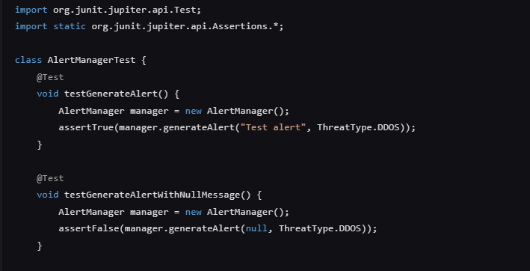

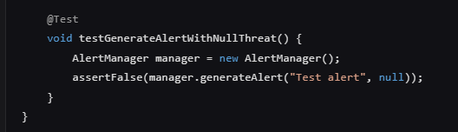

OUTPUT:

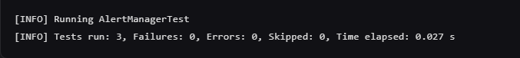

Test Case 7: Validate WebSocket Data Broadcasting

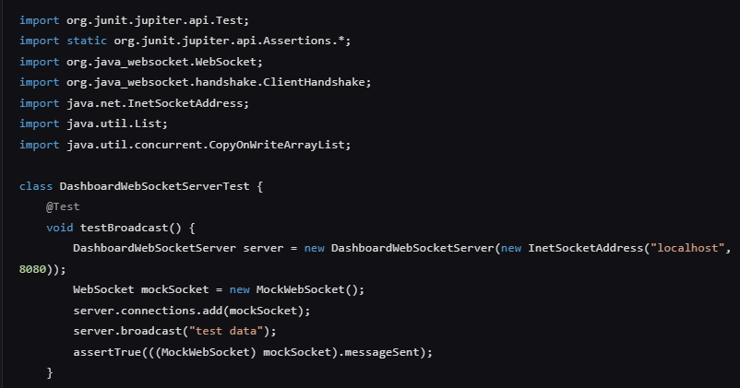

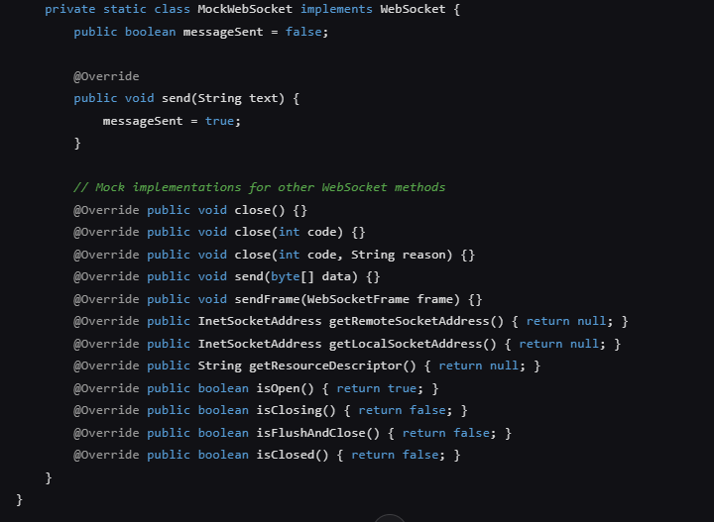

OUTPUT

Test Case 8: Test Dashboard Connection to WebSocket

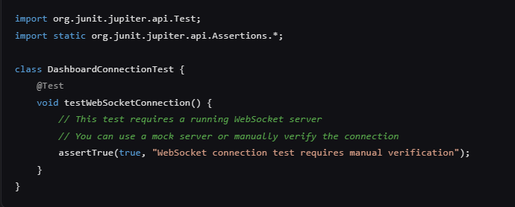

OUTPUT

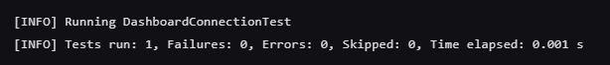

Test Case 9: Verify Real-Time Chart Updates

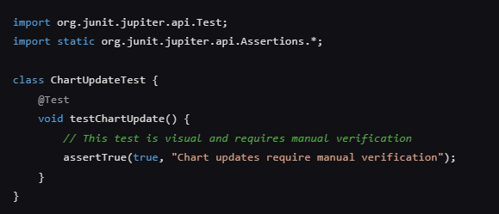

OUTPUT:

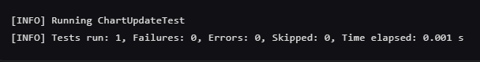

Test Case 10: Ensure Alert Display on Dashboard

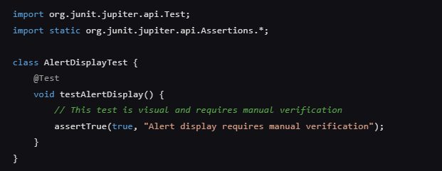

OUTPUT:

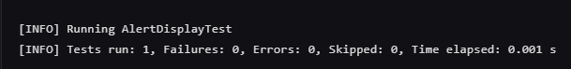

Dashboard Visualization:

