# ISE Project Assignment

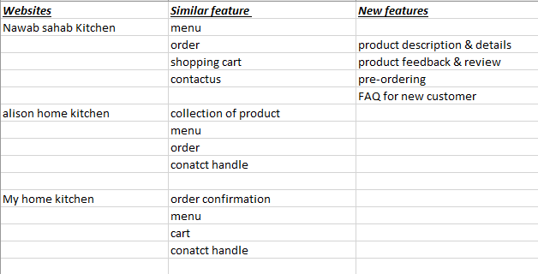

**Requirements:**

* view collection of dishes
* view details and reviews of the specific product
* order quantity
* shopping cart
* pre order
* feedback