The University of Lahore

Department of Computer science & IT

“Course Allocation System”

**Submitted To: Sir Ahsan Nabi**

**Submitted By: Muhammad Husnain Zafar (BSSE-02153010)**

**Umar Shahzad (BSSE-02153065)**

**Haris Waseem (BSSE-02153160)**

**Section: T**

**Subject: Object Oriented Software Engineering**

Table of Contents

Table of Contents 2

1. Introduction 3

1.1 Purpose 3

1.2 Document Conventions 3

1.3 Intended Audience and Reading Suggestions 3

1.4 Product Scope 3

1.5 References 3

2. Overall Description 3,4

2.1 Problem Statement 3

2.2 Functional Requirements 4

2.3 User Classes and Characteristics 4

3. External Interface Requirements 5

3.1 User Interfaces 5

3.2 Hardware Interfaces 5

3.3 Software Interfaces 5

4. Other Nonfunctional Requirements 5

5. System diagrams…………………………………………………………………………......6

5.1 Usecase Diagram………………………………………………………………………………………………………..….6

5.2 Sequence Diagram……………………………………………………………………...…7

5.3 Class Diagram………………………………………………………………………….….8

# Introduction

## Purpose

**CAS (Course Allocation System)** is a system that allows students to enroll their courses from the courses that are allowed to them that they want to study. Purpose of this system is to make registration process of courses online and easily accessible by the students so the students can enroll their courses by their self. And the other purpose is to shift the manual system to online system.

## Document Conventions

In this document we use the font style “Time New Roman” and all the requirement in this document have their own priority and specification. All the diagrams and the requirements are for course allocation system.

## Intended Audience and Reading Suggestions

This document is intended for, developers, project managers, marketing staff, users, testers, documentation writers and all the other system stake holders. This document is in a sequence of first introduction, scope, functional and non-functional requirements, Use case diagram, Sequence diagrams and Class diagram.

## Product Scope

This system will be used in all the educational institutes where they want to allow their students to enroll their own subjects by their self. Our goal to creating this system is to make allocation system online and to provide authority to students to enroll the number of courses that they want to study only from the allocated or allowed courses.

## References

This SRS is according to the HEC SRS template pattern.

# Overall Description

## Problem Statement

Previously everywhere the course allocation system was manual all the courses are allocated by the admin and the students have to study the courses that are allocated to them they not have any rights to choose the courses by their self. There are also many other disadvantages for this manual system especially to maintain the record of all the students that are previously studied in their institute and the students who are studying now. And it also required a lot of man power to do this all. There is a lots of chances to losing the data or record. So to getting rid of it they need an online system which can be able to manage all the course allocation process.

## Functional Requirements

**Components/Modules:**

* User registration
* Course allocation
* Select subjects
* Select section
* Provide Feedback

**During enrolment system should check there:**

* Pre and post ranks
* CGPA
* Course is allowed or not allowed
* Clashes
* Query

## User Classes and Characteristics

User classes may be differentiated on the base of the system functionalities, security or privilege levels or educational level. Certain requirements may pertain only to certain user classes. Only the most important user classes for this system are mentioned in the last of the document.

## Operating Environment

System can be able to run on the Windows and Linux system. The system should have windows 7 or above and any version of Linux. 2GB RAM, 2.0 Processor Core2due or above. Must have internet connection with any connection speed. This can be run on only desktop computers with in an organization with its approved hosted website. There should also be a server in the organization where this system can run to store all the previous and new data for students through which an admin can verify and allow students to allocate courses and enroll them.

## Design and Implementation Constraints

There are some system constraints:

* Not generate time table
* No external integrations with external systems
* System cannot be able to run without internet
* System not provide billing and printing facility
* System should be complete in 4 months
* Budget is 5 lack
* 50% before start work

# External Interface Requirements

## User Interfaces

User can be able to interact with the system through the website and the desktop systems available present in the organization. User can be of any type as there is a different interfaces for the end-user, admin and teachers.

## Hardware Interfaces

There are no any physical interface of our system as it is a software.

## Software Interfaces

There are difference interfaces for different users.

# Nonfunctional Requirements

* Efficient
* Completeness
* Correctness
* Robustness
* Usability
* Acceptability
* Security
* Pre-requisite
* Re-useable

These non-functional requirements are used to make system more efficient, fast and more usable.

# System Diagrams

## Usecase Diagram

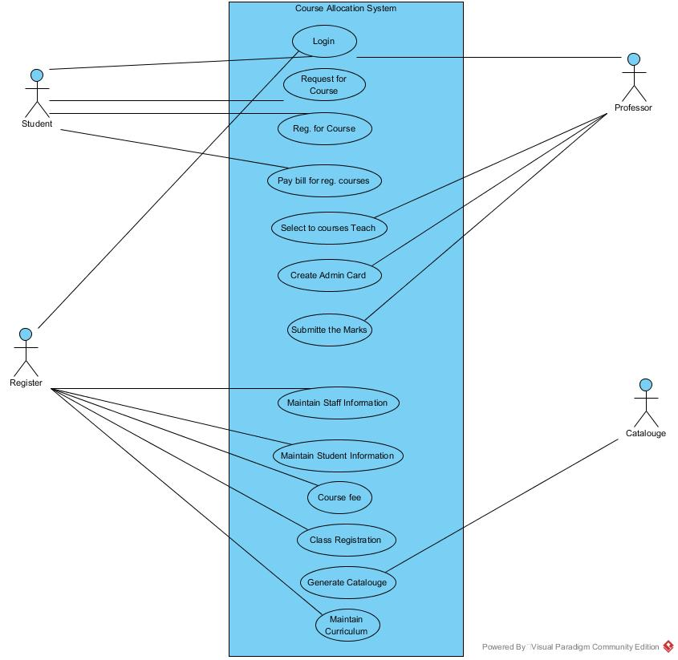

## Sequence Diagram

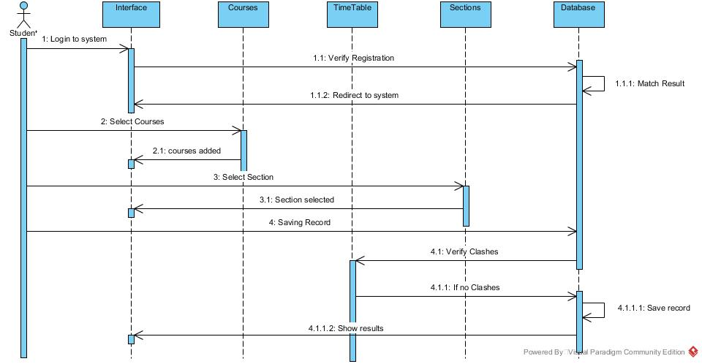

## Class Diagram