Software Requirements Specification

for

myZindagi.com

Version 1.0 approved

Prepared by Hamza Farrukh, Muhammad Sanan, Ansab Majeed, Tanseer Javed, Hafiz Usama Ayub

10th April, 2018

Table of Contents

Table of Contents ii

Revision History ii

1. Introduction 1

1.1 Purpose 1

1.2 Document Conventions 1

1.3 Intended Audience 1

1.4 Product Scope 2

1.5 References 2

2. Overall Description 2

2.1 Product Perspective 2

2.2 Product Functions 3

2.3 Operating Environment 3

2.4 Constraints 3

2.5 User Characteristics 4

2.6 Assumptions and Dependencies 4

3. External Interface Requirements 4

3.1 User Interfaces 4

3.2 Hardware Interfaces 5

3.3 Software Interfaces 6

3.4 Communications Interfaces 6

4. System Features 6

4.1 Use case diagram 7

4.2 Patient appointment 7

4.3 Display patient details 7

4.4 Display all registered doctors 8

4.5 Display individual doctor 8

4.6 Edit doctor information 8

5. Other Nonfunctional Requirements 8

5.1 Performance Requirements 8

5.2 Safety Requirements 9

5.3 Security Requirements 9

5.4 Software Quality Attributes 9

5.5 Business Rules 9

Revision History

|  |  |  |  |
| --- | --- | --- | --- |
| **Name** | **Date** | **Reason For Changes** | **Version** |
|  |  |  |  |
|  |  |  |  |

# Introduction

## Purpose

The purpose of this document is to present a detailed description of a Personal Medical Record application for the iPhone/Android. It explains the purpose and features of the application itself, the web interface through which a user can access a personal account, the server that hosts the user accounts, and the constraints that must be satisfied for security purposes. Requirements statements in this document are both functional and non-functional.

## Document Conventions

SRS: Software Requirements Specification

**Iteration**: One execution of a sequence of operations or instructions

**Actors:** Entities that provide input data or receive the output result

**Wi-Fi:** Wireless networking technology that uses radio waves to provide high speed internet as well as a local area network

**Operating system:** Interface between hardware and applications and is responsible for managing, sharing and coordination of resources

**Secure account:** A web based account in which some form of encryption is in place

**User:** An instance of the User class for someone accessing their own medical records with the web application

**iPhone User:** An instance of the User class for someone accessing their own medical records in the myZindagi.com with an iPhone

**Android User:** An instance of the User class for someone accessing their own medical records in the myZindagi.com with an android phone

**Healthcare Provider:** An instance of the User class, specifically a healthcare professional (e.g., doctor)

**MedRecord:** An instance of one person’s medical record

**Local:** Refers to a MedRecord that is stored on the user’s iPhone/Android

**PHN**: Patient Health Number

**Name used for software:** myZindagi.com, health care system

**DIN**: Doctor Identification Number

## Intended Audience

The intended audience includes all stakeholders in the potential system. These include, but are not necessarily limited to, the following: Administrative Staff,   patients and developers.   
Developers should consult this document and its revisions as the only source of requirements for the project. They should not consider any requirements statements, written or verbal as valid until they appear in this document or its revision.

## Product Scope

This Personal Medical Record application for the iPhone/Android, called myZindagi.com, is used to capture personal medical history. This application will be designed to provide a simple and reliable way to store and convey one’s medical history. Upon the event of an emergency, medical information would have to be acquired from the patient’s current doctor or family for any informed, safe procedure. myZindagi.com would alleviate the need to track down this medical history because it would be readily available. Doctors would be able to add information to the patient’s myZindagi.com account at anytime, including at an appointment, with the patient’s consent.

More specifically, myZindagi.com will contain extensive documentation of the iPhone/Android device owner’s medical records, which can be authored by the owner or the owner’s healthcare provider(s). This includes diagnoses, treatments, medications, allergies, and medical procedures. myZindagi.com would allow for uniform communication of information between the patient and their respective doctor(s). The software would label and organize information authored by health care providers separately from information authored by the patient to maintain authenticity.

## References

No formal documents have been referenced in this document.

# Overall Description

The purpose of this section is to present a detailed description of the product’s perspective giving information about the context and interface constraints. The product functions section outlines major functionality myZindagi.com will perform. The user characteristics section explains the expectations myZindagi.com has about the user. The constraints section contains detailed descriptions of constraints and safety critical properties pertaining to myZindagi.com. The assumptions and dependencies section summarizes any assumptions or dependencies the application has about the hardware, software, environment and user interactions associated with it.

## Product Perspective

myZindagi application for the iPhone is part of a larger system consisting of a Medical Record repository with three actors: iPhone/android User, User, and Healthcare Provider. The iPhone/Android User interacts with the Medical Record Repository through the myZindagi application on the mobile device over the Internet. The User and Healthcare Provider both interact with the Medical Record Repository through a Web-Interface over the Internet.

The iPhone/Android is limited to connecting to the system with a cellular or Wi-Fi connection. The user is limited to interacting with the application by using a multi-touch screen, on screen keyboard, microphone, accelerometer sensor, proximity sensor, or voice commands. The software needs to be compatible with the current iPhone operating system (Current version 11.1). The hardware constraints are an ARM Cortex A9 chip with 64-bit architecture for iPhone and Qualcomm Snapdragon 801 MSM8974-AC Quad-core, 2500 MHz. The application cannot exceed an active memory usage greater than 256MB, or exceed a disk usage larger than 8GB.

No Flash or Java operations can be handled on the iPhone.

## Product Functions

The system functions can be described as follows:

**Registration:** When a patient visit website or uses iPhone/Android, the system checks if the patient is already registered with the myZindagi.com. If he isn’t already registered, then he/she can make a request for new account. For creating new account, the patient enters his/her information name, date of birth, address, telephone, email, national identity card number and previously known diseases. On completing registration Personal Health Number is given to this patient.

**Login:** When a patient visit website or uses iPhone/Android and he/she is already registered with myZindagi.com then he/she can enter their username and password to get access to get an appointment or check their medical history.

**Report Generation**:  The system generates different reports according to user type e.g. doctor can request to generate weekly report of patients, their medical history and patient can check his/her medical history report, medicine prescribed by doctors on each visit.

## Operating Environment

The software is designed to run on a multitude of systems; ranging from:

* iOS devices: iOS v.10.2.x to v.11.4.x, iPhone 6 to 7 Plus, iPad 5G to Pro 12.9
* Android devices: Android Lollipop 5.0 to Android Oreo 8.1, min. screen resolution 1280x720, min. performance specs 2.5 GHz quadcore & 2 GB RAM

The software must run, whenever needed, alongside the testing apps or any other apps that work in conjunction with the myZindagi app.

## Constraints

myZindagi.com website/app requires a connection for full functionality of the application. If a connection is lost during an active session the outcome may result in viewing only the data the application has currently downloaded on the physical device. Full functionality of the application will resume upon reconnection2.5 User Characteristics

The user is expected to be familiar with either the iPhone or iPod touch as well as android devices and be able to perform basic navigational, input and picture taking operations on the device.

The Web Users are expected to be Internet literate, understand how to navigate around a web page and perform conceptual tasks such as logging into a secure account, uploading pictures, and inputting data into specified fields.

## Assumptions and Dependencies

myZindagi.com assumes that there will be a database of medical records hosted by a server. The server assumes it will be installed with a high-speed Internet connection to communicate with myZindagi.com users. The software being developed assumes that the users have an iPhone, iPod touch or android with access to the Internet from either a cellular or Wi-Fi connection to establish a connection between the application and the medical record repository. The web version of myZindagi.com assumes that the user has a computer with an Internet connection and a web browser to access the online version of myZindagi.com.

The mobile application will run on the user’s iPhone, iPod touch and android devices. Full functionality of myZindagi.com will depend on the availability of an Internet connection. The web version of myZindagi.com will run on the user’s computer. The use of this web-based application will completely depend on an Internet connection.

# External Interface Requirements

## User Interfaces

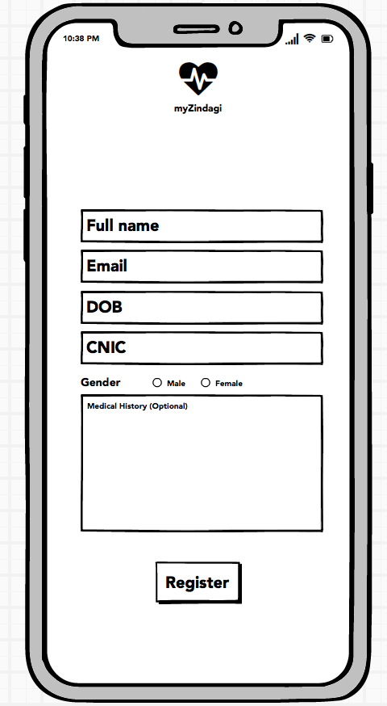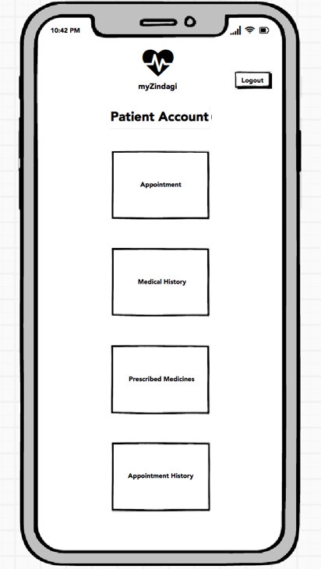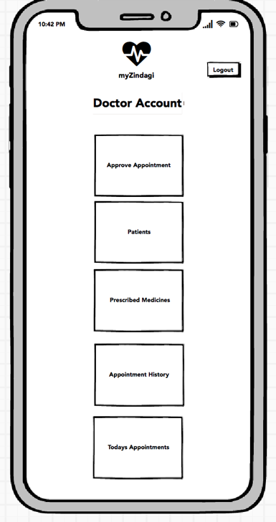

## Hardware Interfaces

* **Laptop/Desktop PC** 
  + core i3 processor
  + minimum 1GB RAM
  + 80GB HDD

Purpose of this pc is to give information when Patients ask information about doctors, appointments etc. To perform such action, it need very efficient computer otherwise due to that reason patients have to wait for a long time to get what they ask for.

* **Display Unit (LED/LCD Monitor/TV)** This unit is for display the channel number when the patients visit site on their computer. It will avoid chaos. And also display Hospital welcome screen, video, information etc.
* **Laser Printer (B/W)** Simply this device is for printing bills and view reports.
* **Wi-Fi router** Wi-Fi router is used to for internetwork operations inside of a hospital and simply data transmission from pc’s to sever.
* **Mobile phone** Either iPhone or Android phone

## Software Interfaces

**Developing end**

* JDK 1.8 - Java is fast, secure, and reliable. From laptops to data centres, game consoles to scientific supercomputers, cell phones to the Internet
* NetBeans 8.1 - IDE for Java developing
* MySQL server - Database connectivity and management
* Adobe Photoshop (cs6) - Logo and other designing such as User interfaces

**Client End**

* OS – Windows 8/8.1/10, OS X -Very user friendly and common OS
* JRE 1.8 -JAVA Runtime Environment for run Java   Application and System
* MySQL server - Database connectivity

## Communications Interfaces

The communication b/w the system and its constituents is vital since they depend on each other. The method of communication is not important for the system and is therefore handled by the underlying OSs for both the mobile application and the website. The product also calls for a database system that stores user information and call history. The HTTP server will use a push protocol to push notifications of updates onto the iOS or Android phones.

* **NIC (Network Interface Card**) - It is a computer hardware component that allows a computer to connect to a network. NICs may be used for both wired and wireless connections.
* **CAT 5 network cable**- for high signal integrity
* **TCP/IP protocol**- Internet service provider to access and share information over the  Internet
* **Ethernet Communications Interface**- Ethernet is a frame-based computer network technology for local area networks (LANs)
* **Ubiquitous**, easy to set up and easy to use. Low cost and high data transmission rates.

# System Features

The functional requirements for the product by system features, the major services provided by the product.

## USE CASE DIAGRAM

## Patient Appointments:

**Input** Patient must be login, then visit its main page

**Action** Enter all details and request for an appointment

**Output** myZindagi screen will display information of appointment including name of Doctor, location, status and Time.

**Notes** System should get information from database.

**Priority** High

## Display Patient Details:

**Input** Doctor must be logged in, and on its main page.

**Action** Search patient by its PHN and then get its details

**Output** All details of particular patient should be displayed on screen

**Notes** System should get information from database

**Priority** High

## Display All registered Doctors:

**Input** Admin logged in, select doctor category from menu

**Action** Search all registered doctors with myZindagi

**Output** Display details of all registered doctors

**Notes** System should get information from database.

**Priority** High

## Display Individual Doctor:

**Input** Patient/admin search for particular doctor by its name or DIN (Doctor Identification Number)

**Action** Individual profile will be displayed

**Output** Doctors profile with all available details should be displayed

**Notes** N/A

**Priority** High

## Edit Doctors Information

**Input** Doctor visit his profile and select edit option.

**Action** A new page displayed to enter new details

**Output** Doctor edit its details and then update

**Notes** N/A

**Priority** High.

# Other Nonfunctional Requirements

## Performance Requirements

* **Response time**-The system will give responses within 1 second after checking the patient information and other information.
* **Capacity**-The system must support 1000 people at a time
* **User interface**- User interface screen will response within 5 seconds.
* **Conformity** –The system must conform to the Microsoft accessibility

## Safety Requirements

If there is extensive damage to a wide portion of the database due to catastrophic failure, such as a disk crash, the recovery method restores a past copy of the database that was backed up to archival storage and reconstructs a more current state by reapplying or redoing the operations of committed transactions from the backed up log, up to the time of failure.

## Security Requirements

This application assumes that only the user or whoever he/she allows will have access to

his/her Android handset. With that being said, after the initial creation of the account with a secure password, the user will be logged in until he/she decides to log out. The user will be asked to login again whenever he/she opens the app again. The data is secured and encrypted locally and can only be accessed by the app itself.

## Software Quality Attributes

* **AVAILABILITY:** The system shall be available all the time.
* **CORRECTNESS:** A bug free software which fulfil the correct need/requirements of the client.
* **MAINTAINABILITY**: The ability to maintain, modify information and update fix  problems of the system
* **USABILITY:** software can be used again and again without distortion.
* **ACCESSIBILITY:** Administrator and many other users can access the system but the  access level is controlled for each user according to their work scope.
* **ACCURACY:** The reliability on the information/output. Can depend/be sure of the outcome.
* **STABILITY:** The system outcome/output won’t change time to time. Same output will be given always for a given input.
* **SECURITY:** The system must be secure at its best from all kind of vulnerabilities.

## Business Rules

* Want take the responsibility of failures due to hardware malfunctioning.
* Warranty period of maintaining the software would be one year.
* Additional payments will be analysed and charged for further maintenance
* If any error occurs due to a user’s improper use. Warranty will not be allocated to it.
* No money back returns for the software.
* Trust bond placement should be done before designing and coding. An advance or an Agreement.