**Object DETECTION**

MODULE Project

Road Detection on YOLO v5 + Custom Dataset.

**AHSAN NADIR**

**Email:** [ahsannadiir@gmail.com](mailto:ahsannadiir@gmail.com)

**GitHub:** <https://github.com/ahsannadir>

**Project Repository Link:** <https://github.com/ahsannadir/roads-detection-yolo>

# Project Documentation

A custom dataset was required for this project so I started collecting data throughout the Gilgit city. I woke up at 5 AM in the morning for 2 days to collect photos of road turns and unexpected road conditions. It was a very difficult task because the data was to be collected early in the morning before the traffic. In two days, I collected 74 images. I classified the images into 4 categories ‘left, right, straight and damaged’.

After data collection I started Data Annotation. I kept 90% of the images for training and the rest for validation. I used Roboflow to Annotate all the images one by one. The images were in 3000x3000 resolution so In Pre-processing I resized the images to standard YOLO resolution which is 640x640. The dataset was very small so I applied data augmentation to increase the dataset. I avoided rotation of the images because rotation at a certain angle can change a left turn image to right turn and vice versa. I applied image crop, brightness adjustment, noise and random exposure as the data augmentation technique. Then I exported the dataset into PyTorch format supported by YOLO v5. After Exporting the size of Dataset increased from 74 to 204.

After data annotation I started the training process on Google Colab. I cloned the YOLO v5 repository in my environment. Then installed all the dependencies. After that I imported the dataset from Roboflow and started the training. There are Nano, Small, Medium, Large and XLarge models of YOLO v5. I trained the dataset on all the models for 120 epochs and analyzed the results. The best results I got was from YOLOv5m which is the Medium version of model. So, I kept the results of YOLOv5m.

# Result Examples from Validation Data

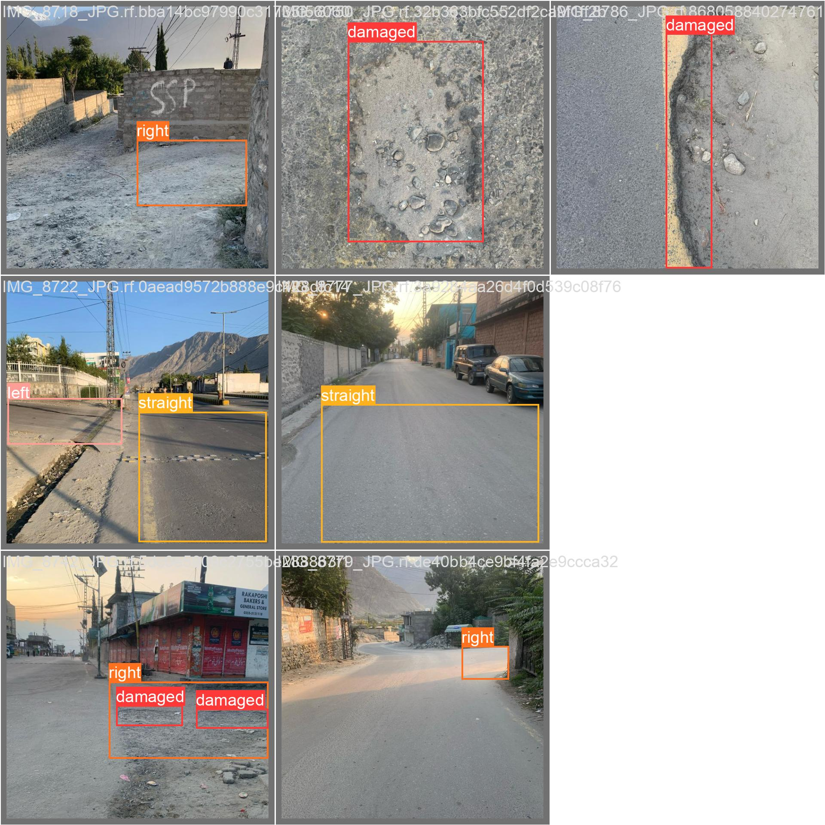

# Improvement Scope

This model can be improved by increasing the dataset furthermore It can be improved by changing the YOLO weights, the number of Epochs and the data augmentation techniques.

**Project Repository Link:** <https://github.com/ahsannadir/roads-detection-yolo>