## ***INTRODUCTION:***

In this report, I will be presenting you the details about the application that I have built that is named ‘QUIZZER’. This application is built on native java and it is designed for basic purposes of Quizzes. The application is provided with features of SIGN IN, SIGN UP , RULE BOOK , STUDY MATERIAL BEFORE QUIZ and TAKE QUIZ.

## ***PREPARATION:***

## *Idea:*

At first, I thought I would make a grade management system and the login screen of it is attached below in the prototype but then the Quizzer application looked more student friendly and educational.

## ***Prototyping:***

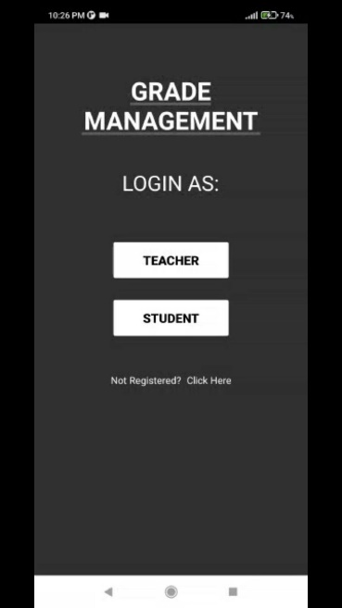

While I was developing the UI and logic of this application, I had no fixed name for this application neither any color theming or anything. So I kept on building whatever I thought was the best.

The screenshot of the initial work Is also attached.

***LOGIC OF THE APPLICATION:***

The below drawn flowchart explains the logical structure of my application and the way it operates. The circles tell you about the screen name and the text tells the functionality of respected screens.

## ***ACTIVITIES:***

My project consists of almost 9 activities to fulfill the necessary conditions of an educational Quiz system. Below are the screenshots of each screen to further elaborate the functionality of it.

## ***SPLASH SCREEN:***

Once you start the application, you will be presented with a beautiful UI of a puzzle and it will remain there for a few seconds and then you will be shown the SIGN IN screen

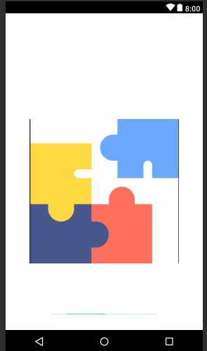

## ***MAIN ACTIVITY/SIGN IN PAGE:***

This screen prompts the student to enter his or her email and password if he has logged in previously in this application or otherwise he/she will have to SIGNUP first in order to play the quiz game.

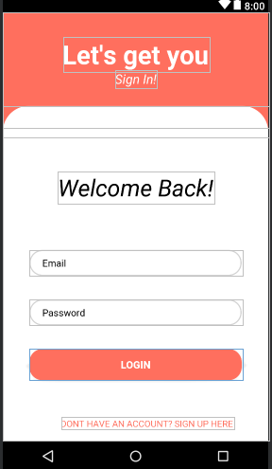

## ***STUDENT SIGNUP SCREEN:***

If the student have not used this application before then he/she will have to register to the application in order to play the quiz game. Proper validation logic is applied at the backend of this screen to validate user email id and password.

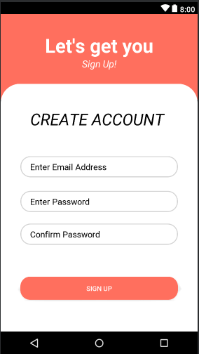

## ***STUDENT HOME SCREEN:***

If the student succeeds to log into the system then he will be presented with the below provided UI and he will have options to :

* Check the rule book
* Play the Quiz
* Access the study material regarding the exam
* LOGOUT.

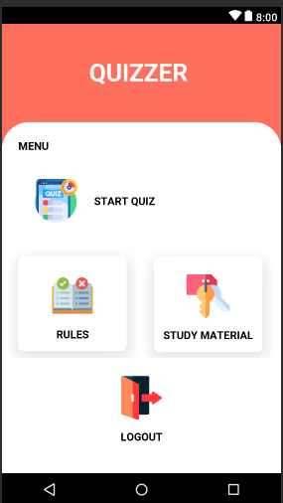

## ***QUIZ START SCREEN:***

If the student opts for the ‘START QUIZ’ tab , then the quiz will be started and in the quiz there will be 3 randomized questions , after these 3 questions , the results will be shown to the student.

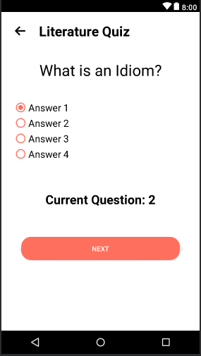

Like these , there will be 2 more screens after which the result will be updated and shown.

## ***RESULT ACTIVITY:***

Once the Student completes the quiz(3 questions) , he will be presented with the total score , the marks he achieved and with the option to play again.

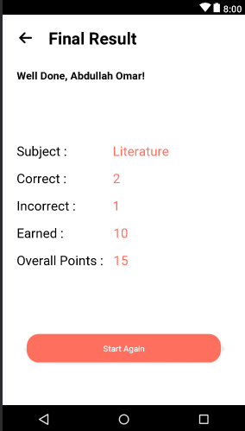

## ***RULEBOOK ACTIVITY:***

This screen will provide the user the details that are very important for the quiz before attempting it like how many questions will be there etc.

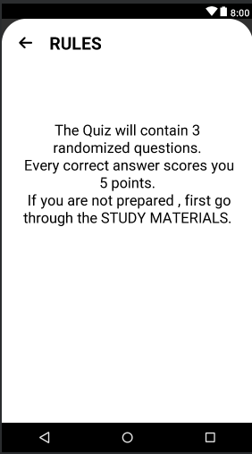

## ***STUDY MATERIALS ACTIVITY:***

This activity will allow the student to study before the exam so that he/she can score good marks and also provides knowledge about grammer.

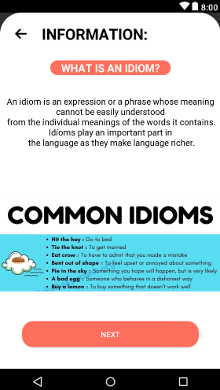 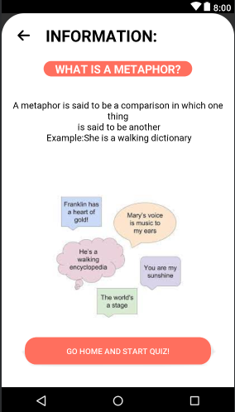

## ***TOOLS AND TECHNQUES USED:***

* Constraint Layouts
* Conditional coding
* Object Oriented Approach
* Validation for sign up and login screens.
* JAVA

## ***FILE STRUCTURE:***

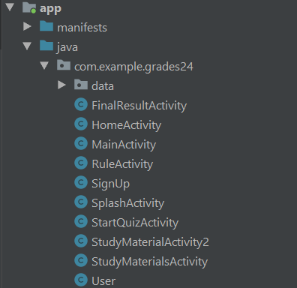 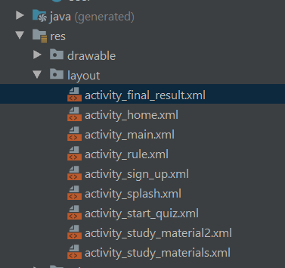

## ***CONCLUSION:***

I, hereby, conclude my course with the ‘QUIZZER APPLICATION. It was really a tremendous opportunity for students to polish their coding and designing skills. It provided me a way to think about how to design mobile applications. Also, in the near future, I will work on this project further by adding a database in it.