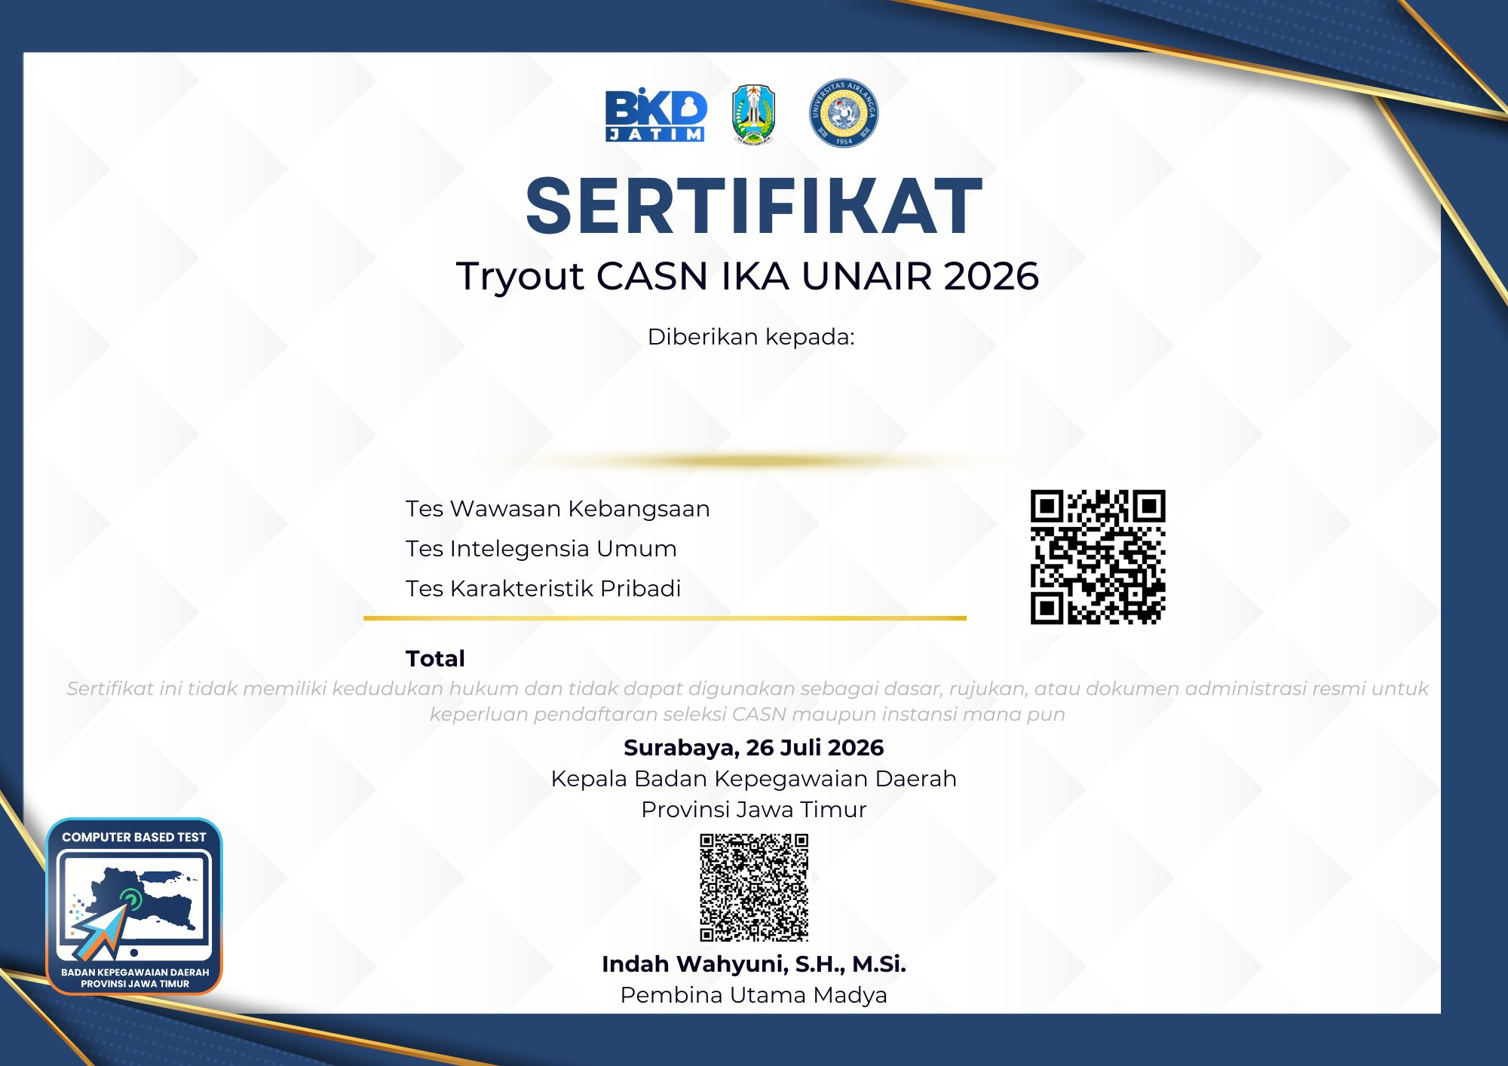
{nama_peserta}
{nilai_total}
{nilai_tkp}
{nilai_tiu}
{nilai_twk}

