**A Report On**

Microprocessors and Microcontrollers Laboratory

**Project Name**

Measuring the tilt of two points of a movable object and calculating the height difference

# Introduction

Our project is to make a tilt meter that can show the tilt angle and can calculate the height difference of two points of any movable object.

# Objective

* To measure the tilt of a movable object
* To find the height difference of two different points on object

# **Apparatus and Tools**

* Microcontroller
* Burner
* DC battery
* Connecting wire
* Accelerometer
* Liquid Crystal Display
* Keypad
* Glue gun

N.B: Apparatus and tools are changeable.

**Progression Stages**

1. At first we’ll design the complete circuit with necessary elements on a computer simulation software. 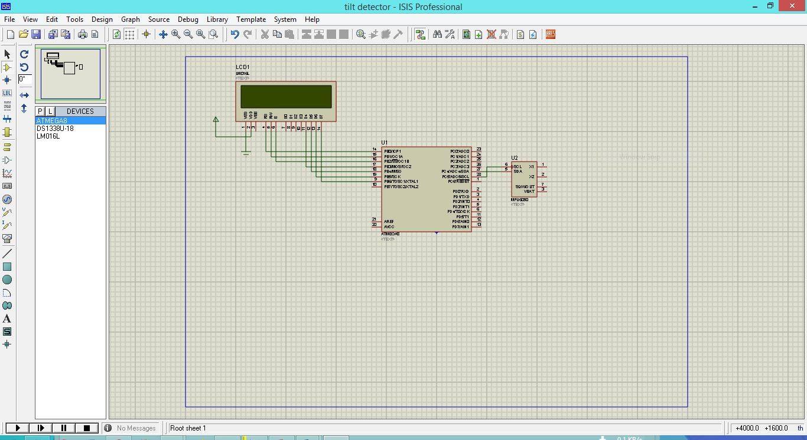
2. At first we will connect the Accelerometer with the Microcontroller on a bread board and interface it with necessary steps. An accelerometer uses gravitational acceleration equations of general theory of relativity to generate the tilting angle.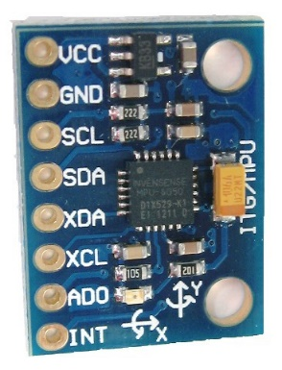
3. Then we’ll interface a LCD with the microcontroller and will test if it can read and display the reading from the accelerometer. A 16*2 LCD has two rows and 16 columns. So it can display two rows with every one of them can display 16 characters. On the first line we’ll display the angle of tilt and on the second line we’ll display the height difference of the two points.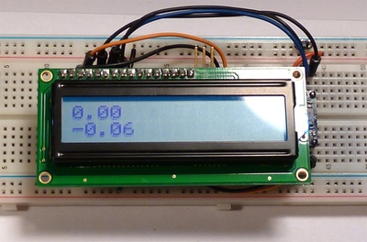
4. Then we’ll interface a keypad with the system and check if it can input the length that is provided. A keypad may be 4*3 or 4*4. If a button is pressed, a unique digital is produced and sent to the microcontroller. Microcontroller analyzes the signal, detects which button is pressed and obeys the command.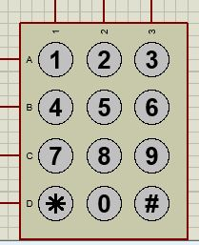
5. Then we’ll test the system several times to examine if it actually works decent.

Conclusion

When we’ll complete the project, it’ll be a very useful device for various purposes.

We’ll try our best to make a decent enough device to extract accurate output.

Submitted By:

* 130203
* 130212
* 130220

3rd Year, Term I

Computer Science and Engineering Discipline  
Khulna University

Khulna - 9208