**A LAB REPORT**

**ON**

**MICROPROCESSORS AND MICROCONTROLLERS LABORATORY**

**COURSE NAME: Microprocessors and Microcontrollers Laboratory**

**COURSE NO: CSE-3112**

**PROJECT NAME: Measuring the Tilt of Two Points of a Movable Object and Calculating the Height Difference**.

**Group Members:**

130203

130212

130220

**DATE OF SUBMISSION:**

# **16-03-2016**

Table of Contents Page

1. Introduction…………………………………………………………………………………………………………..3

2. Objective…………………………………………………………………………………………………..............3

3. Description…………………………………………………………………………………………………………..3

3.1. Circuit diagram……………………………………………………………………………………………4

4. Required Equipment…………………………………………………………………………………………..5

5. System Architecture…………………………………………………………………………………………..5-7

6. Cost ……………………………………………………………………………………………………………………..7-8

7. Weekly plan …………………………………………………………………………………………….…9

8. Conclusion ..................………………………………………………………………………………….……9

**1.Introduction:**

The Microcontroller based Tilt Measurement project aims to design a device that can calculate the tilt of a movable object and determine the height difference between two given points. Measuring tilt is needed in various purposes in practical life and engineering works. Tilt monitoring is an important exercise in many industrial applications as well as in our daily lives. An accelerometer is a device which measures the acceleration in terms of m/s². There are many MEMS-based (Micro-electro-mechanical systems) Accelerometers available in the market. MEMS-based Accelerometers convert the tilt signal to an electrical signal which can be used for measurement. The output electrical signal generated is a digital signal in most cases. The MEMS Accelerometer contains on-board signal processing units which convert the mechanical signal to a digital format. This digital signal will further require processing so that we can extract the measurement information from the signal.

**2.Objective:**

* Using accelerometer measured degree which is shown on an electronic display.
* Can be find many applications where we have to maintain stability.
* Coupling the application with our device will provide the application user with the tilt information on the display.
* User can manually work towards achieving stability.
* The user can confirm that the control system is functioning correctly by monitoring the visual readout provided by our device.

**3.Description:**

Tilt measurement is needed is various purposes in our daily life and engineering purposes. The objective of this project is to use this signal from the accelerometer to present the measured degree of tilt on an electronic display. The tilt measurement device can find many applications where we have to maintain stability. Coupling the application with our device will provide the application user with the tilt information on the display. Hence, he can manually work towards achieving stability, or design a separate control system with the same purpose. The user can confirm that the control system is functioning correctly by monitoring the visual readout provided by our device.

**3.1.Circuit diagram:**

ATmega8

mpu6505

LCD

Matrix Keypad

**Circuit Diagram**

**4.Required Equipment:**

* Microcontroller ( ATmega8a )
* Accelerometer (MPU – 6050 )
* 4 * 20 Liquid Crystal Display
* 4 * 3 Matrix Keypad
* Breadboard
* 9V DC Rechargeable Battery
* 7805 IC
* 10µF, 50V Capacitor
* DIOD
* Necessary Connecting wears
* Soldering Tools
* Microcontroller Burner
* Necessary Software’s
* Battery Charger

**5.System Architecture:**

1. At first we’ll design the complete circuit with necessary elements on a computer simulation software.
2. Then we will connect the Accelerometer with the Microcontroller on a bread board and interface it with necessary steps. An accelerometer uses gravitational acceleration equations of general theory of relativity to generate the tilt angle.

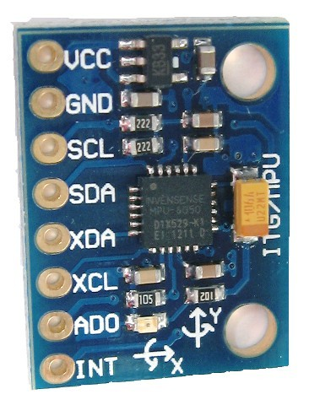

1. Then we’ll interface a LCD with the microcontroller and will test if it can read and display the reading from the accelerometer. A 4*20 LCD has 4 rows and 20 columns. So it can display four rows with every one of them can display 20 characters. On the

first line we’ll display the angle of tilt and on the second line we’ll display the height difference of the two points.

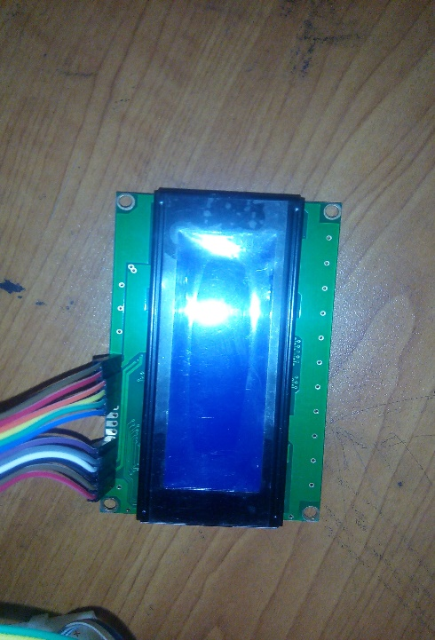

1. Then we’ll interface a keypad with the system and check if it can input the length that is provided. A keypad may be 4*3. If a button is pressed, a unique digital signal is produced and sent to the microcontroller. Microcontroller analyzes the signal, detects which button is pressed and obeys the command.

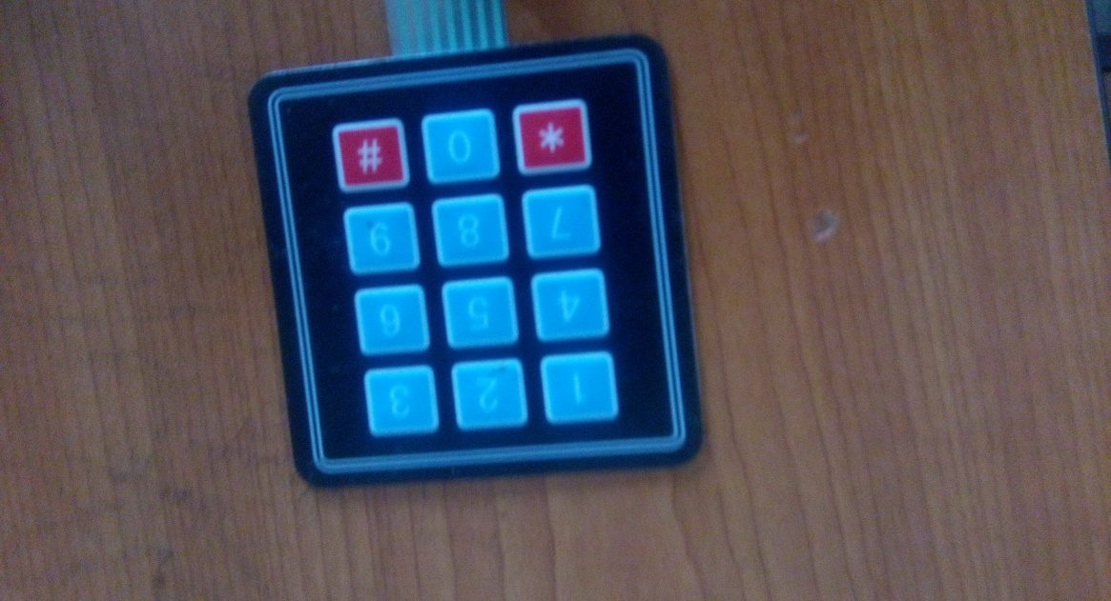

1. At last we’ll test the system several times to examine if it actually works.

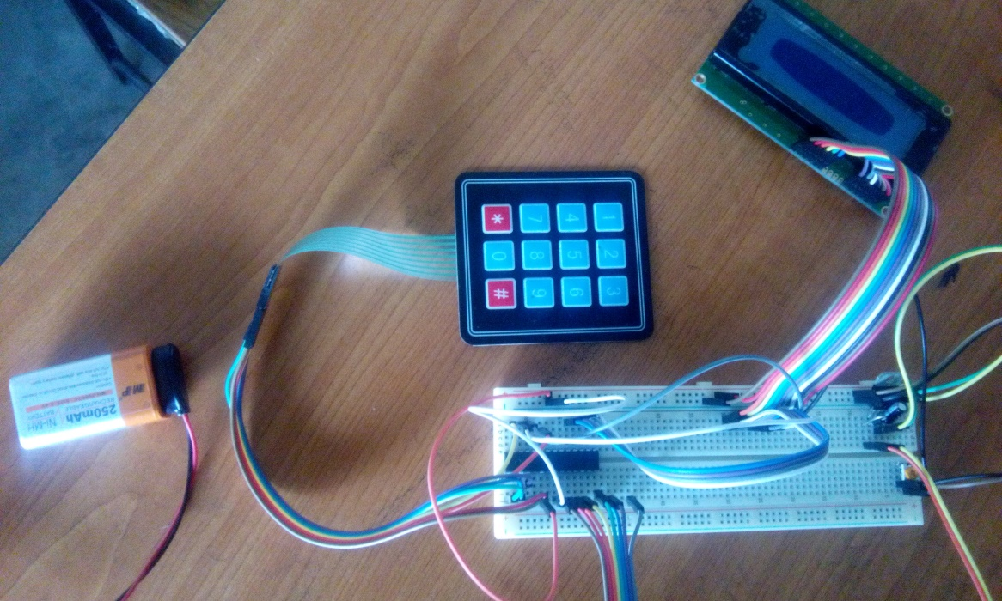

**6. Cost:**

|  |  |  |
| --- | --- | --- |
| Component Name | Quantity | Cost |
| Microcontroller (ATmega8a) | 1 | 90 /= |
| Accelerometer(MPU – 6050) | 1 | 485 /= |
| 4 * 20 Liquid Crystal Display | 1 | 450 /= |
| 4 * 3 Matrix Keypad | 1 | 140 /= |
| Breadboard | 1 | 250 /= |
| 9V DC Rechargeable Battery | 1 | 350 /= |
| 7805 IC | 1 | 20 /= |
| 10µF, 50V Capacitor | 1 | 10 /= |
| DIOD | 2 | 4 /= |
| Necessary Connecting wears | 54 | 145 /= |
| Soldering Tools | - | 158 /= |
| Battery Charger | 1 | 120 /= |
| Others | - | 278 /= |
|  |  | Total: 2500 /= |

**7.Weekly Planning:**

|  |  |  |  |  |  |  |  |
| --- | --- | --- | --- | --- | --- | --- | --- |
| **Activities** | **Weeks** | | | | | | |
| **6** | **7** | **8** | **9** | **10** | **11** |  |
| Coding and Simulation. |  |  |  |  |  |  |  |
| Debugging and Simulation. |  |  |  |  |  |  |  |
| Hardware Implementation. |  |  |  |  |  |  |  |
| Over view project. |  |  |  |  |  |  |  |
| . Final Checking |  |  |  |  |  |  |  |
| Final submission |  |  |  |  |  |  |  |

**Week 3:** Display Interfacing.

**Week 4:** Keypad Interfacing.

**Week 5:** Accelerometer Interfacing.

**Week 6:** Coding and Simulation.

**Week 7:** Debugging and Simulation.

**Week 8:** Hardware Implementation.

**Week 9:** Over view the project.

**Week 10:** Final Checking and debugging (if required)

**Week 11:** Final submission.

**8.Conclusion:**

This Project will help maintain stability where needed. Coupling the application with our device will provide the application user with the tilt information on the display. At last it is said that, it would be a useful and effective device for many purpose in our daily life.