Home Page :

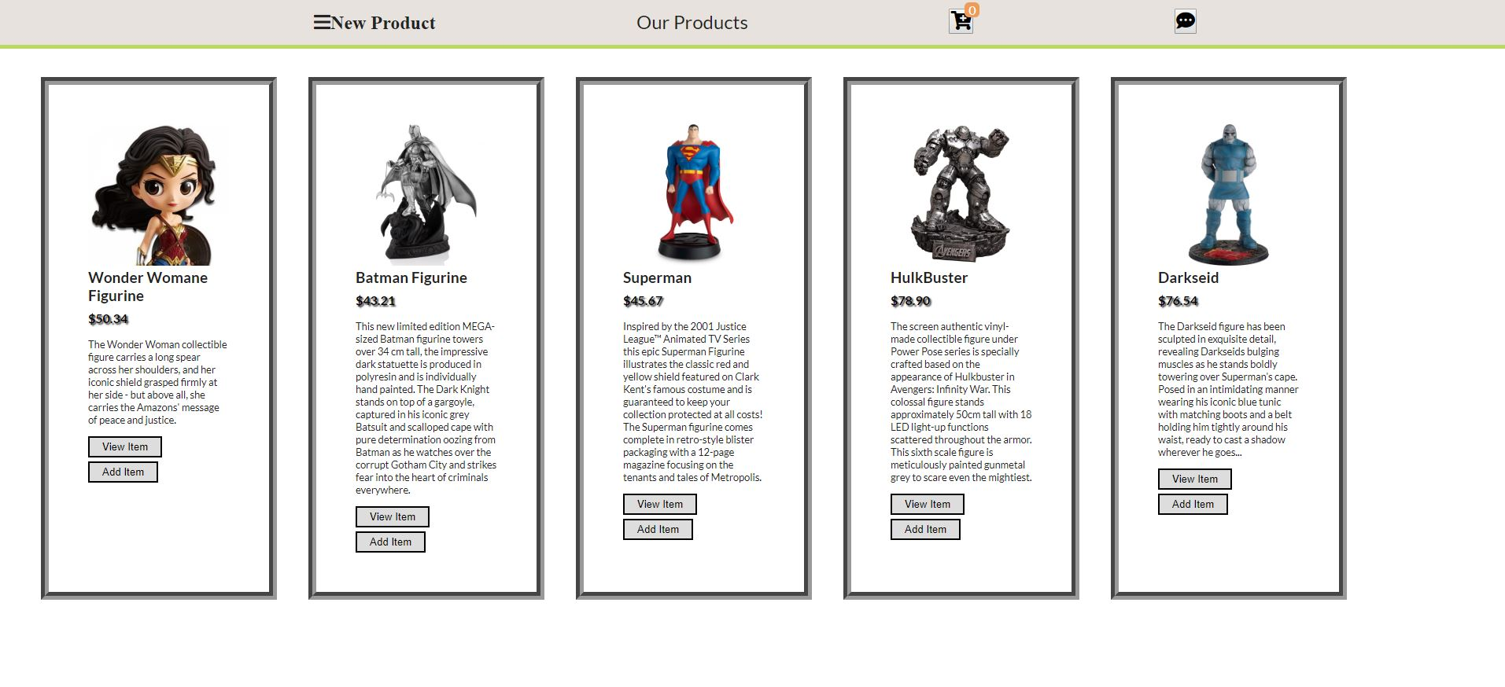

New Product Form Page:

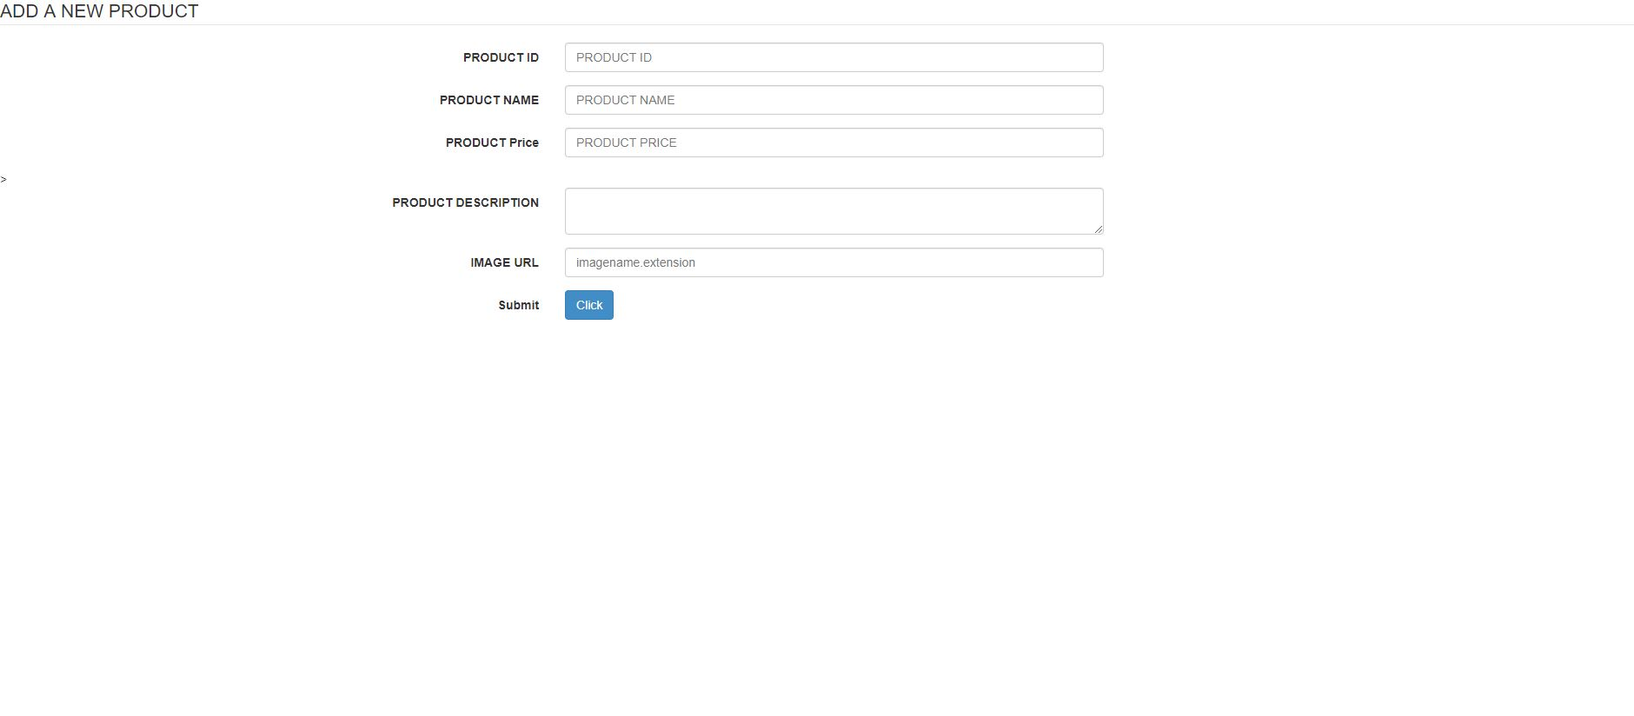

Add information as described

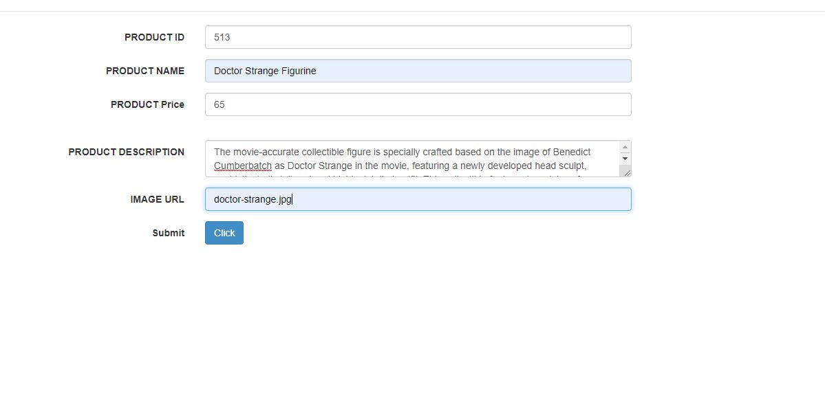

Note: The photo must be saved in the images folder and the image name must match with the IMAGE URL or the photo won’t show .

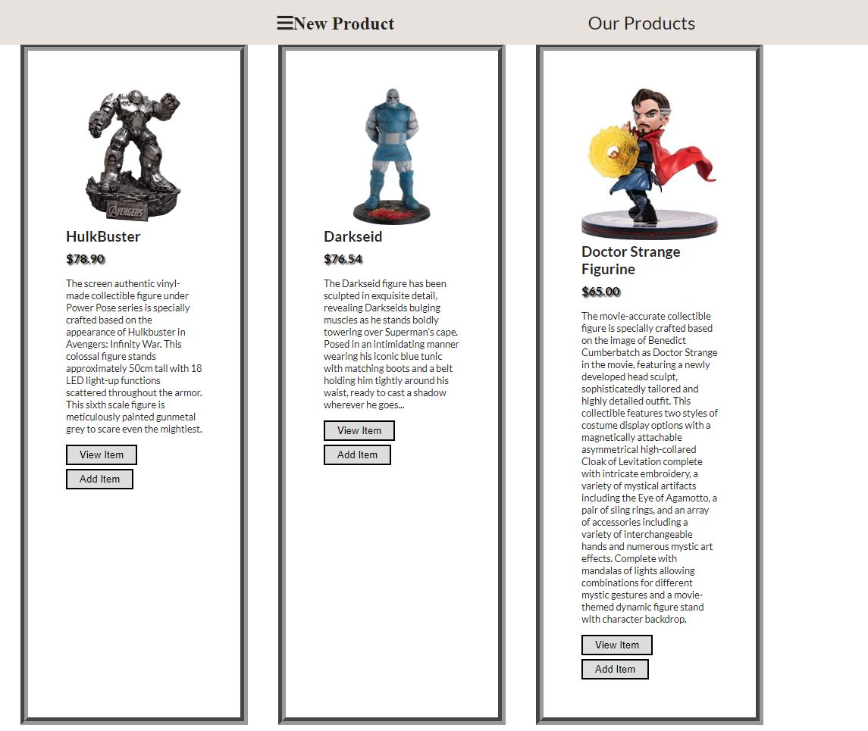

The product is added successfully to our product list.

Single Product View:

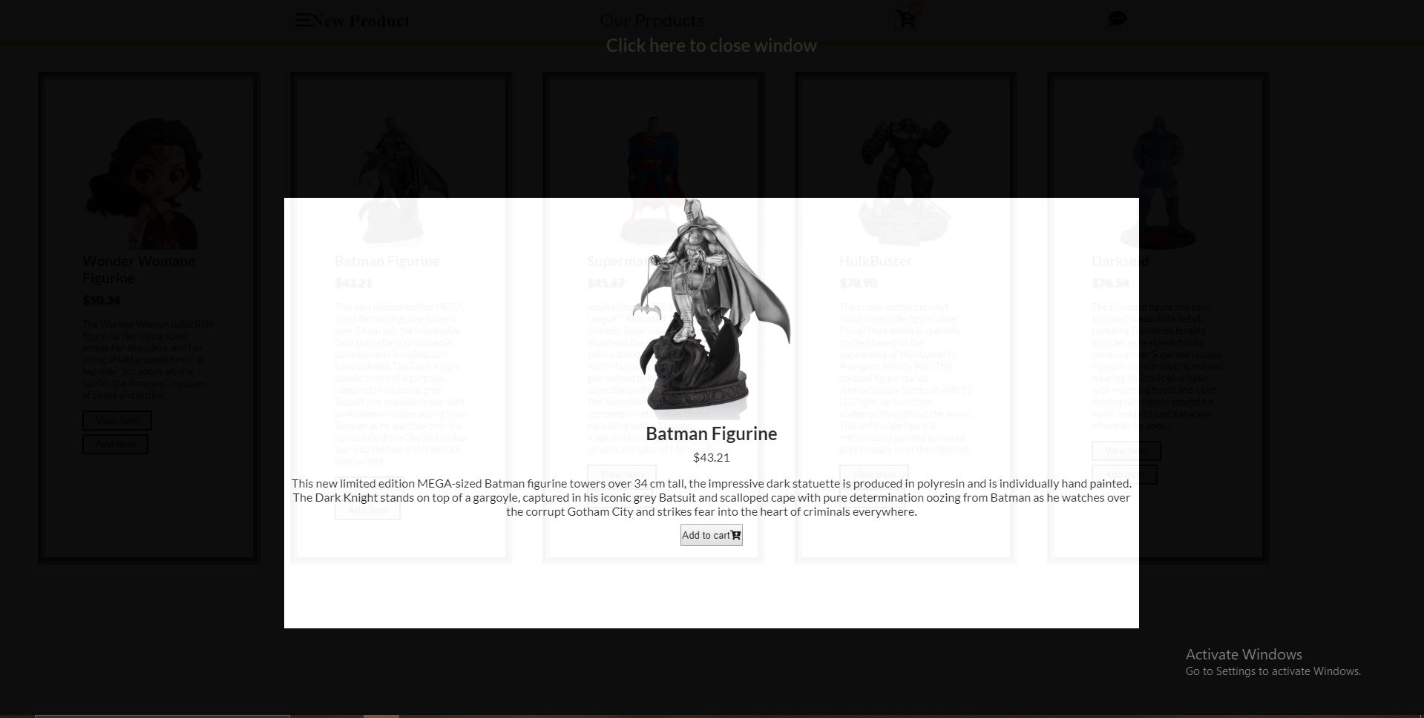

This is single product view page which is popup that shows full details of each product.

The Add to cart button adds the product to out cart.

To close the window press anywhere on the black portion/overlay of the page.

Shopping Cart View:

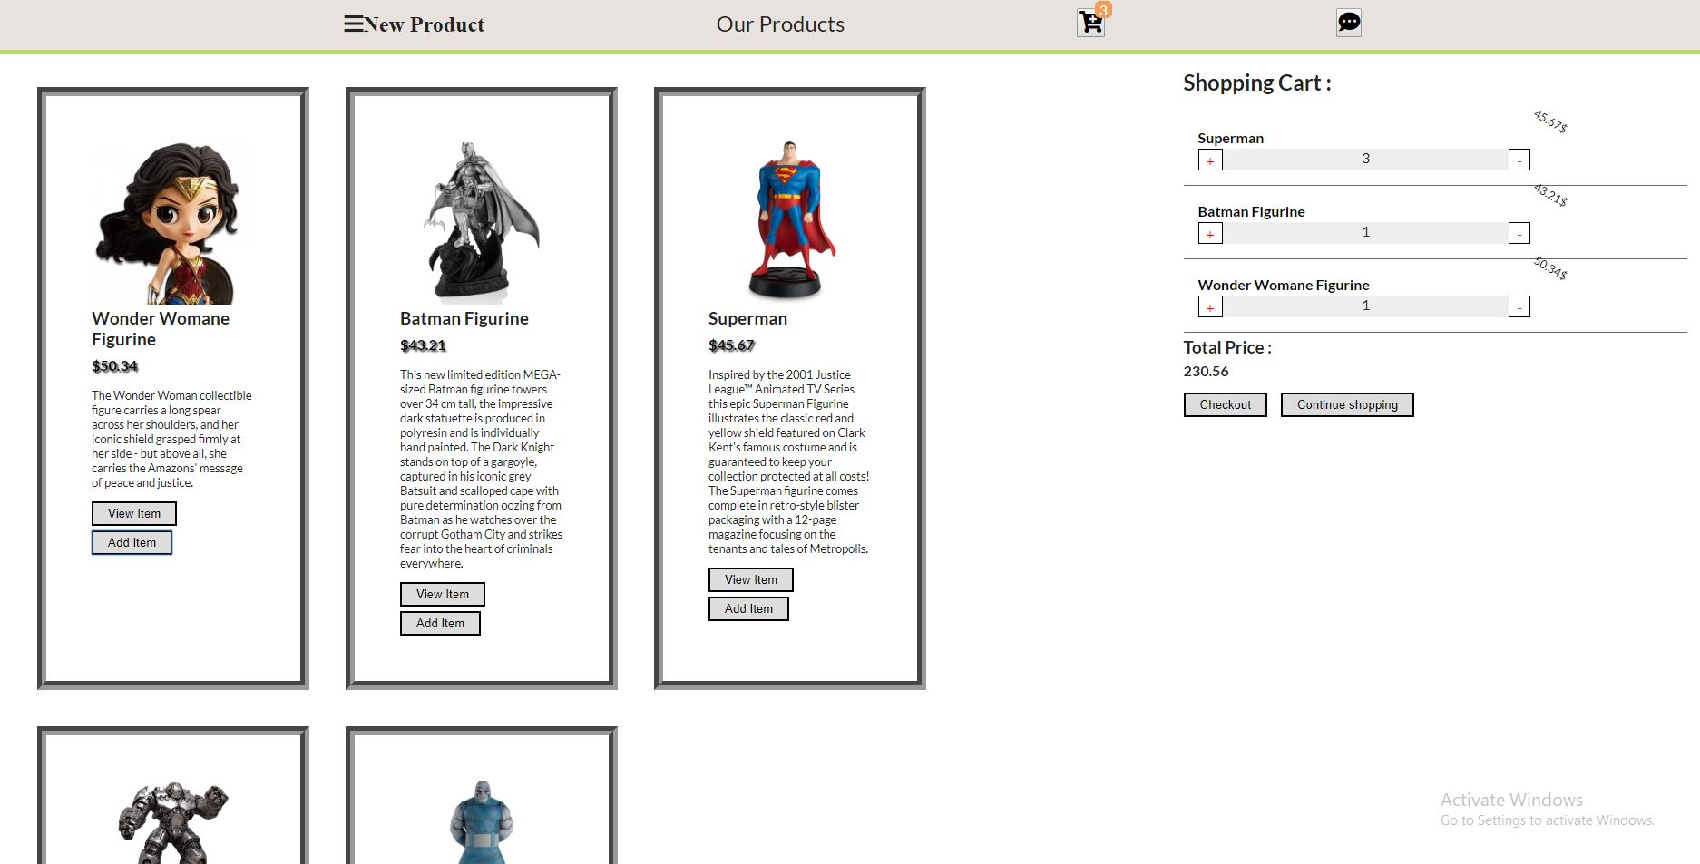

Clicking on the CART icon shows the shopping window. The icon also shows the number of added products in the shopping on the top of the icon.The cart show number of products currently present in the cart with their quantity and the total price. If we decrease the quantity of a product to less then 1 then the item will be removed from the cart. If the cart is empty then this view will show.

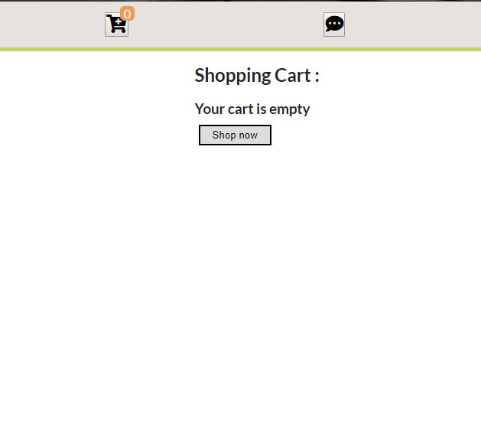

Online Marketplace chat app:

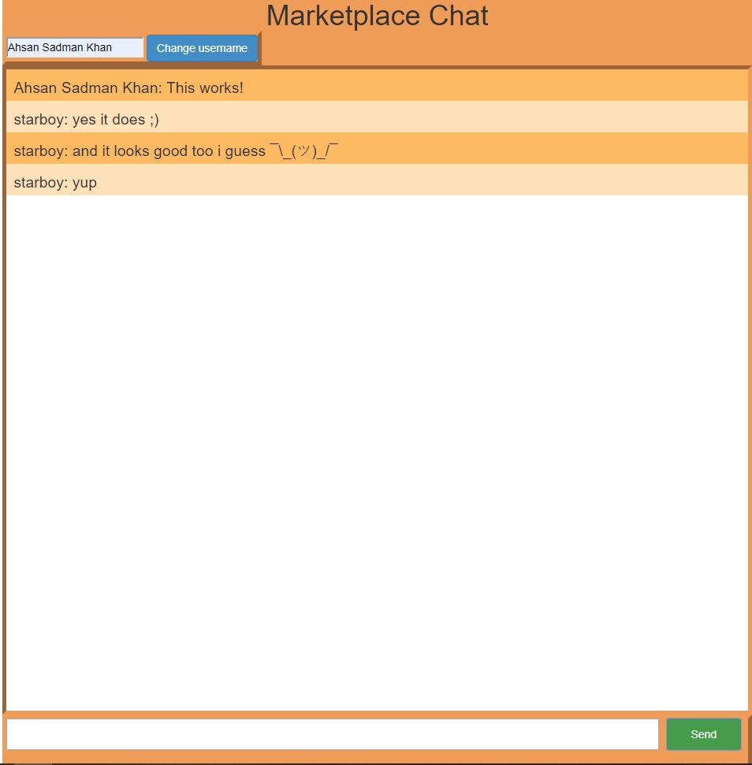

After turning on the server (app.js), clicking on the chat icon will open this chat page where we can chat by changing our username or by opening multiple windows.