1. Which type of sorting you want to apply? Create a menu having the following options:

* Bubble Sort Method
* Selection Sort Method
* Insertion Sort Method

Implement using methods.

**SOLUTION:**

class Program

　{

public static void print(int[] print)

{

for (int i = 0; i < print.Length; i++)

{

Console.WriteLine("{0}", print[i]);

}

}

public static void BubleSort(int[] bubble)

{

int temp;

for (int i = 0; i < bubble.Length; i++)

{

for (int j = (i + 1); j < bubble.Length; j++)

{

if (bubble[i] > bubble[j])

{

temp = bubble[i];

bubble[i] = bubble[j];

bubble[j] = temp;

}

}

}

}

public static void SelectionSort(int[] selection)

{

int smallest, temp;

for (int i = 0; i < selection.Length; i++)

{

smallest = i;

for (int j = (i + 1); j < selection.Length; j++)

{

if (selection[smallest] > selection[j])

{

smallest = j;

}

}

temp = selection[smallest];

selection[smallest] = selection[i];

selection[i] = temp;

}

}

public static void InsertionSort(int[] insetion)

{

int temp;

for (int i = 0; i < insetion.Length - 1; i++)

{

for (int j = (i + 1); j > 0; j--)

{

if (insetion[j - 1] > insetion[j])

{

temp = insetion[j - 1];

insetion[j - 1] = insetion[j];

insetion[j] = temp;

}

}}}

static void Main(string[] args)

{

Console.Write("Enter The Size Of Array : ");

int size = int.Parse(Console.ReadLine());

int[] array = new int[size];

for (int i = 0; i < array.Length; i++)

{

Console.Write("Enter Element At {0} Index : ", (i + 1));

array[i] = int.Parse(Console.ReadLine());

}

Console.Clear();

Console.WriteLine("Before Sorting");

print(array);

Console.WriteLine("Please Choose A Option Below : ");

Console.WriteLine(" 1 ) Bubble Sort Method");

Console.WriteLine(" 2 ) Selection Sort Method");

Console.WriteLine(" 3 ) Insertion Sort Method");

Console.Write("Enter : ");

int res = int.Parse(Console.ReadLine());

switch (res)

{

case 1:

BubleSort(array);

Console.WriteLine("After Sorting");

print(array);

break;

case 2:

SelectionSort(array);

Console.WriteLine("After Sorting");

print(array);

break;

case 3:

InsertionSort(array);

Console.WriteLine("After Sorting");

print(array);

break;

default:

Console.WriteLine("Please Choose Correct Options");

break;

}

Console.ReadLine();

}

}

}

**OUTPUT:**

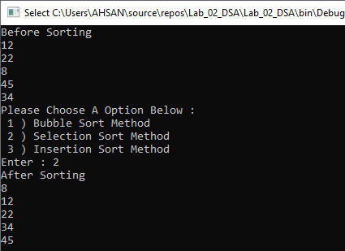

1. Implement Selection sort and print string array data in descending order.

**SOLUTION:**class Program

{

public static void SelectionSort(string[] array)

{

int smallest;

string temp;

for (int i = 0; i < array.Length; i++)

{

smallest = i;

for (int j = (i + 1); j < array.Length; j++)

{

if (array[smallest][0] > array[j][0])

{

smallest = j;

}

}

temp = array[smallest];

array[smallest] = array[i];

array[i] = temp;

}

}

static void Main(string[] args)

{

Console.Write("Enter The Sixe Of Array : ");

int size = int.Parse(Console.ReadLine());

string[] array = new string[size];

for (int i = 0; i < array.Length; i++)

{

Console.Write("Enter Value At {0} Index : ", (i + 1));

array[i] = Console.ReadLine().ToLower();

}

Console.Clear();

for (int i = 0; i < array.Length; i++)

{

Console.WriteLine(" {0}", array[i]);

}

Console.WriteLine("After Sorting In Decending Order \n");

SelectionSort(array);

Console.WriteLine();

for (int i = array.Length - 1; i >= 0; i--)

{

Console.Write(" {0} \t", array[i]);

}

Console.ReadLine();

**OUTPUT:**

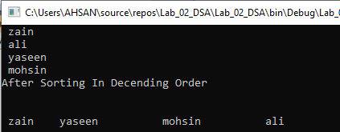

1. A Detox chemical Industry has a list of chemicals along with their concentration and Volume. Your task is to list down the name of chemicals in descending order based on their Volume. In order to fulfil the task you have to select any of the sorting method taught in todays lab with proper reasoning of usage of that algorithm.

**SOLUTION:** public static void BubbleSort(string[,] array, int size)

{

string name;

string concentration;

string volume;

for (int i = 0; i < size; i++)

{ for (int j = (i + 1); j < size; j++) {

if (Convert.ToDouble(array[i, 2]) > Convert.ToDouble(array[j, 2]))

{ name = array[i, 0];

concentration = array[i, 1];

volume = array[i, 2];

array[i, 0] = array[j, 0];

array[i, 1] = array[j, 1];

array[i, 2] = array[j, 2];

array[j, 0] = name;

array[j, 1] = concentration;

array[j, 2] = volume;

}}}}

static void Main(string[] args)

{

Console.Write("Enter The Total Chemical : ");

int size = int.Parse(Console.ReadLine());

string[,] array = new string[size, 3];

for (int i = 0; i < (size); i++)

{ Console.Write("Enter Element Name : ");

array[i, 0] = Console.ReadLine();

Console.Write("Enter Element Concentration : ");

array[i, 1] = Console.ReadLine();

Console.Write("Enter Element Volume : ");

array[i, 2] = Console.ReadLine();

}

Console.Clear();

Console.WriteLine("\t Element Are Before Sorting ");

Console.WriteLine("NAME \t\tCONCENTRATION \t\tVOLUME\n");

for (int i = 0; i < size; i++)

{

Console.WriteLine("{0} \t{1}\t\t{2}", array[i, 0], array[i, 1], array[i, 2]);

}

Console.WriteLine("\n After Sorting In Decending Order According To The Volume\n");

BubbleSort(array, size);

Console.WriteLine("NAME \t\tCONCENTRATION \t\tVOLUME\n");

for (int i = size - 1; i >= 0; i--)

{

Console.WriteLine("{0} \t{1}\t\t{2}", array[i, 0], array[i, 1], array[i, 2]);

}

**OUTPUT:**

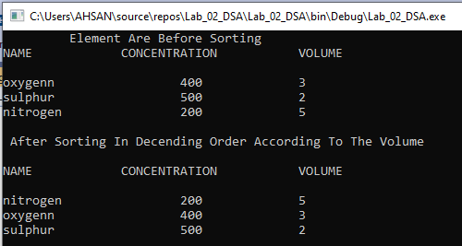

1. You have to write a program which take input from the user and place the value on correct location in ascending order.

**SOLUTION:** int temp;

Console.Write("Enter The Size Of Array : ");

int size = int.Parse(Console.ReadLine());

int[] array = new int[size];

for (int i = 0; i < array.Length; i++)

{

Console.Write("Enter Value At {0} Index : ", (i + 1));

array[i] = int.Parse(Console.ReadLine());

}

Console.Clear();

Console.WriteLine(" Element Are\n");

for (int i = 0; i < array.Length; i++)

{

Console.WriteLine(" {0}", array[i]);

}

Console.Write("\nPlease Enter A Value To Insert In The Array : ");

int value = int.Parse(Console.ReadLine());

int[] newarray = new int[size + 1];

for (int i = 0; i < array.Length; i++)

{ newarray[i] = array[i]; }

newarray[newarray.Length - 1] = value;

for (int i = 0; i < newarray.Length; i++)

{

for (int j = (i + 1); j < newarray.Length; j++)

{ if (newarray[i] > newarray[j])

{

temp = newarray[i];

newarray[i] = newarray[j];

newarray[j] = temp;

}} }

Console.WriteLine(" Element Are\n");

for (int i = 0; i < newarray.Length; i++)

{

Console.WriteLine(" {0}", newarray[i]);

}

**OUTPUT:**

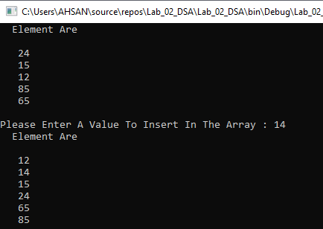

5. Write a program which take N numbers of grocery items from user along with their price. Your main task is to display the items in sorted format. Then allow user to search for any of the item from that list by using name of the item.

**SOLUTION:** public static void Print(string[,] array, int size)

{

Console.WriteLine(" NAME\t\tPRICE\n");

for (int i = 0; i < size; i++)

{

Console.WriteLine($" {array[i, 0] } \t {array[i, 1]}");

}

}

public static void bubbleSort(string[,] array, int size)

{

string tempName;

String tempPrice;

for (int i = 0; i < size; i++)

{

for (int j = (i + 1); j < size; j++)

{ if (array[i, 0][0] > array[j, 0][0])

{

tempName = array[i, 0];

tempPrice = array[i, 1];

array[i, 0] = array[j, 0];

array[i, 1] = array[j, 1];

array[j, 0] = tempName;

array[j, 1] = tempPrice;

}}}}

public static string LinearSearch(string[,] array, int size, string searchitem)

{

string index = "-1";

for (int i = 0; i < size; i++)

{

if (searchitem == array[i, 0]) {

index = Convert.ToString(i);

break;

}}

return index;

}

static void Main(string[] args)

{

Console.Write("Enter total Item : ");

int size = int.Parse(Console.ReadLine());

string[,] array = new string[size, 2];

for (int i = 0; i < size; i++)

{

Console.Write("Enter Name Of Item At [{0},{1}] Index : ", i, 0);

array[i, 0] = Console.ReadLine().ToLower();

Console.Write("Enter Price Of Item At [{0},{1}] Index : ", i, 1);

array[i, 1] = Console.ReadLine();

}

Console.Clear();

Print(array, size);

Console.WriteLine("\n After Sorting Alphabatically \n");

bubbleSort(array, size);

Print(array, size);

Console.Write("\nEnter Item Name You Want To Search : ");

string searchitem = Console.ReadLine();

string found = LinearSearch(array, size, searchitem);

if (found != "-1")

{

Console.WriteLine("Element Is Fount AT Index [{0},{1}]", LinearSearch(array, size, searchitem), 0);

}

int size1 = Convert.ToInt32(LinearSearch(array, size, searchitem));

for (int i = size1; i <= size1; i++)

{

Console.WriteLine($" {array[i, 0] } \t {array[i, 1]}");

}

Console.ReadLine();

**OUTPUT:**

