To open product.html form main page we need to click on 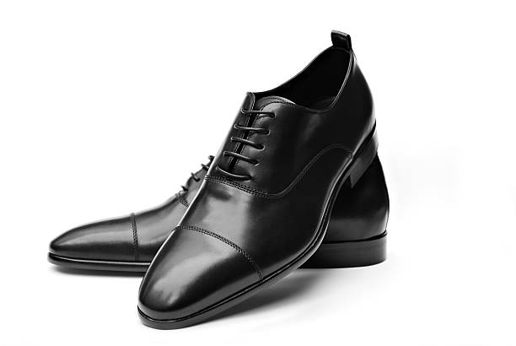 this picture from top brand shoes section

* It will work on all shoes when we will attach backend