OPERATING SYSTEMS LAB-4 WEEK-5

Author: Muhammad Ahsan 1912310 BSCS 5F

1. TASK 1: TO SEE WHICH PROCESS IS RUNNING FIRST (PARENT OR CHILD)

--nano task1.c

#include<stdio.h>

#include<unistd.h>

void main(){

int output=fork();

if(output==0){

for(int i=0;i<5;i++){

printf("\n Printed from child %d",getpid());

}

}

else{

for(int i=0;i<5;i++){

printf("\n Printed from parent %d",getpid());

}

}

}

-- CTRL+X [save quit to terminal and save file in nano]

-- gcc task1.c -o task1 [Compile C file with Output executable using this command]

-- ./task1 [Execute the file using this command]

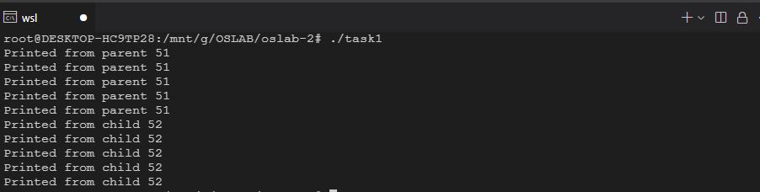

2. TASK 2: TO ADD AN INPUT STATEMENT IN THE PARENT PROCESS

-- nano task2.c

#include<stdio.h>

#include<unistd.h>

void main(){

int outputTwo;

int output=fork();

if(output==0){

for(int i=0;i<5;i++){

printf("\n Printed from child %d",getpid());

}

}

else{

printf("Enter a number:");

scanf("%d",&outputTwo);

for(int i=0;i<5;i++){

printf("\n Printed from parent %d",getpid());

}

}

}

-- CTRL+X [save quit to terminal and save file in nano]

-- gcc task2.c -o task2 [Compile C file with Output executable using this command]

-- ./task2 [Execute the file using this command]

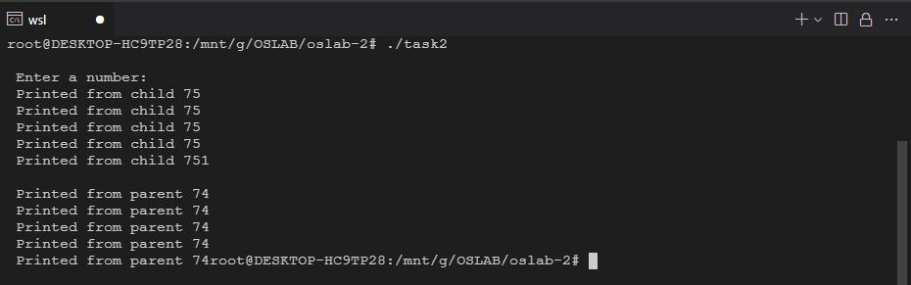

3a. TASK 3A: PARENT PROCESS SHOULD PRINT NUMBERS FROM 6-10 WHILE CHILD SHOULD PRINT 1-5 NUMBERS

-- nano task3a.c

#include<stdio.h>

#include<unistd.h>

void main(){

int output=fork();

if(output==0){

for(int i=1;i<=10;i++){

printf("\n %d",i);

}

}

else{

wait();

for(int i=6;i<=10;i++){

printf("\n %d",i);

}

}

}

-- CTRL+X [save quit to terminal and save file in nano]

-- gcc task3a.c -o task3a [Compile C file with Output executable using this command]

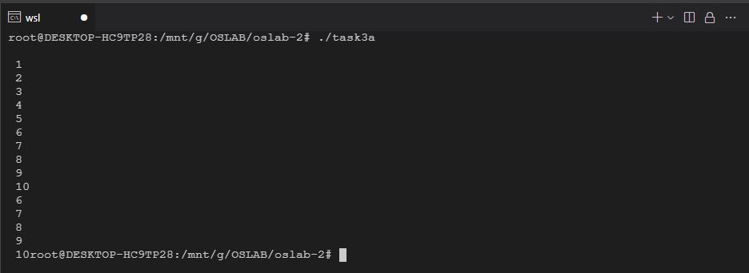 -- ./task3a [Execute the file using this command]

3b. TASK 3B: PARENT PROCESS SHOULD PRINT NUMBERS FROM 6-10 WHILE CHILD SHOULD PRINT 1-5 NUMBERS (Using Single loop)

-- nano task3b.c

#include<stdio.h>

#include<unistd.h>

void main(){

int output=fork();

int j;

if(output==0){

j=1;

}

else{

wait();

j=6;

}

for(int i=j;i<5+j;i++){

printf("Printed from %d , %d \n",getpid(),i);

}

}

-- CTRL+X [save quit to terminal and save file in nano]

-- gcc task3b.c -o task3b [Compile C file with Output executable using this command]

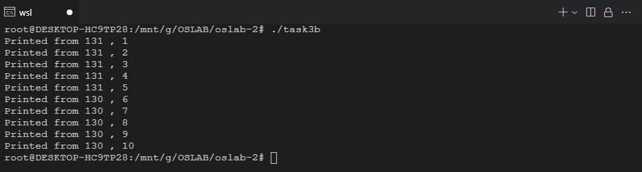 -- ./task3b [Execute the file using this command]

4. TASK 4: WRITE A PROGRAM WHICH TAKES AGE INPUT IN CHILD AND DETERMINES IF THE AGE IS ABOVE 18 OR NOT AND IN THE PARENT TAKE TWO NUMBERS AND CALCULATE THEIR SUM

-- nano task4.c

#include<stdio.h>

#include<unistd.h>

void main(){

int output=fork();

int age;

int num1;

int num2;

if(output==0){

printf("\n Enter Age:");

scanf("%d",&age);

if(age>18){

printf("\n Age is above 18");

}

else{

printf("\n Age is below 18");

}

}

else{

wait();

printf("\n Enter Number 1:");

scanf("%d",&num1);

printf("\n Enter Number 2:");

scanf("%d",&num2);

printf("\n Sum=%d",num1+num2);

}

}

-- CTRL+X [save quit to terminal and save file in nano]

-- gcc task4.c -o task4 [Compile C file with Output executable using this command]

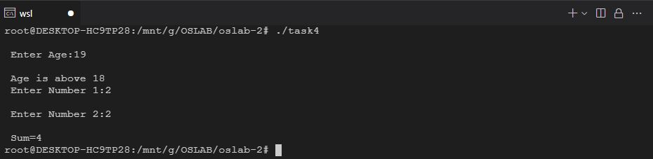 -- ./task4 [Execute the file using this command]