OPERATING SYSTEMS LAB-5 WEEK-6

Author: Muhammad Ahsan 1912310 BSCS 5F

1. TASK 1: **Dynamic sizing of array and finding the highest element in the array**

--nano task1.c

#include<stdio.h>

void main(){

int arr[]={2,5,79,96};

int highest=arr[0];

int size=sizeof(arr)/sizeof(arr[0]);

for(int i=0;i<size;i++){

if(highest<arr[i]){

highest=arr[i];

}

}

printf("%d",highest);

}

-- CTRL+X [save quit to terminal and save file in nano]

-- gcc task1.c -o task1 [Compile C file with Output executable using this command]

-- ./task1 [Execute the file using this command]

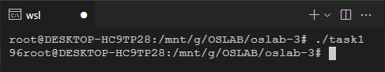

2. TASK 2: **Using pipe to transfer a single variable from child to parent process**

--nano task2.c

#include<stdio.h>

#include<unistd.h>

void main(){

int id;

int fd[2];

pipe(fd);

id=fork();

if(id==0){

int value=5;

printf("CHILD PROCESS\n");

close(fd[0]);

write(fd[1],&value,sizeof(value));

close(fd[1]);

}

else{

int valuefromChild=0;

printf("PARENT PROCESS\n");

read(fd[0],&valuefromChild,sizeof(valuefromChild));

printf("%d",valuefromChild);

}

}

-- CTRL+X [save quit to terminal and save file in nano]

-- gcc task2.c -o task2 [Compile C file with Output executable using this command]

-- ./task2 [Execute the file using this command]

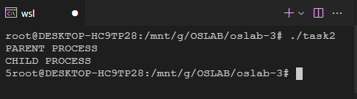

3. TASK 3: **Enter value from child and pass it through the pipe**

--nano task3.c

#include<stdio.h>

#include<unistd.h>

void main(){

int id;

int fd[2];

pipe(fd);

id=fork();

if(id==0){

int value;

printf("ENTER VALUE:");scanf("%d",&value);

printf("CHILD PROCESS\n");

close(fd[0]);

write(fd[1],&value,sizeof(value));

close(fd[1]);

}

else{

int valuefromChild=0;

printf("PARENT PROCESS\n");

read(fd[0],&valuefromChild,sizeof(valuefromChild));

printf("%d",valuefromChild);

}

}

-- CTRL+X [save quit to terminal and save file in nano]

-- gcc task3.c -o task3 [Compile C file with Output executable using this command]

-- ./task3 [Execute the file using this command]

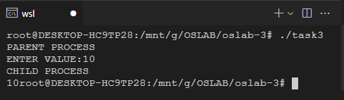

4. TASK 4: **Dividing an array and calculating the sum in different processes and merging the sum using fork and pipe**

--nano task4.c

#include <stdio.h>

#include <unistd.h>

void main(){

int id;

int fd[2];

int arr[]={2,5,7,80,90,104};

pipe(fd);

int len=sizeof(arr)/sizeof(arr[0]);

int half=len/2;

id=fork();

if(id==0){

int sum=0;

for(int i=0;i<=half-1;i++){

sum=sum+arr[i];

}

close(fd[0]);

write(fd[1],&sum,sizeof(sum));

close(fd[1]);

}

else{

int valuefromChild=0;

read(fd[0],&valuefromChild,sizeof(valuefromChild));

int sum=valuefromChild;

for(int i=half;i<=len-1;i++){

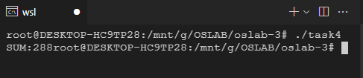sum=sum+arr[i];

}

printf("SUM:%d",sum);

}

}

-- CTRL+X [save quit to terminal and save file in nano]

-- gcc task4.c -o task4 [Compile C file with Output executable using this command]

-- ./task4 [Execute the file using this command]