The Islamia University of Bahawalpur

**U**niversity **C**ollege of **E**ngineering **&T**echnology **D**epartment of **C**omputer **S**ystem **E**ngineering

|  |  |  |
| --- | --- | --- |
| **LAB MANUAL** | **SIGNALS AND SYSTEMS EE-311** | **5thSemester** |

**LAB EXPERIMENT # 09**

**Implementation of Laplace Transform in MATLAB**

|  |  |
| --- | --- |
| **Student Name: Laiba Saleem** | **Roll No: 20-CSE-09** |
| **Lab Instructor Signatures:** | **Date:** |

## OBJECTIVE:

* Familiarization with Laplace transforms.

# Laplace Transform:

Laplace transform ( is a linear operator on a function with real argument , which transforms it to a function with a complex argument In signals and

systems, the real argument usually represents time domain , and complex argument represents frequency domain.

↔

MATLAB uses the command ***“laplace”*** to find the Laplace transform of a function, and

***“ilaplace”*** for the inverse Laplace.

**Example:** Let f(t)= -1.25+3.5te-2t+1.25e-2t

## Code:

>>syms t s

>> f=-1.25+3.5*t*exp(-2*t)+1.25*exp(-2*t);

>> F=laplace(f,t,s)

**Output:**

F = -5/4/s+7/2/(s+2)^2+5/4/(s+2)

>>simplify(F)

ans = (s-5)/s/(s+2)^2

>>pretty(ans)

s - 5

s (s + 2)2

**** Alternatively, we can also write the function f(t) directly as part of the laplace command:

>>F2=laplace(-1.25+3.5*t*exp(-2*t)+1.25*exp(-2*t))

This corresponds to F(s),

# Inverse Laplace Transform:

The command will be *ilaplace*. Also needs to define the symbols t and s.

**Example:** Lets calculate the inverse of the previous function F(s),

## Code:

>>syms t s

>> F=(s-5)/(s*(s+2)^2);

>>ilaplace(F) ans=

-5/4+(7/2*t+5/4)*exp(-2*t)

>>simplify(ans)

>>pretty(ans)

**Output:**

- 5/4 + 7/2 t exp(-2 t) + 5/4 exp(-2 t)

Which corresponds to f(t)

f(t)= -1.25+3.5te-2t+1.25e-2t

**** Alternatively,

**>>ilaplace((s-5)/(s*(s+2)^2))**

**Example:** Using the MATLAB *residue* command, determine the inverse Laplace transform of following

**(a)**

>>num = [2 0 5]; den = [1 3 2];

>> [r, p, k] = residue(num,den);

>>disp([ '(a) r = [ ',num2str(r. ', ' %0.5g '), '] ']);...

>>disp([ ' p = [ ',num2str(p. ', ' %0.5g '), '] ']);...

>>disp([ ' k = [ ',num2str(k. ', ' %0.5g '), '] ']);...

## Output:

(a) r = [-13 7]

p [-2 -1]

k = [2]

Therefore, *Xa*(*s*) = −13/(*s* + 2) + 7/(*s* + 1)+2 and *xa*(*t*) = (−13*e*−2*t*+7*e*−t)*u*(*t*)+2δ(*t*).

**(b)**

>>num = [2 7 4]; den = [conv([1 1],conv([1 2], [1 2]))]);

>> [r, p, k] = residue(num,den);

>>disp([ '(b) r = [ ',num2str(r. ', ' %0.5g '), '] ']);...

>>disp([ ' p = [ ',num2str(p. ', ' %0.5g '), '] ']);...

>>disp([ ' k = [ ',num2str(k. ', ' %0.5g '), '] ']);...

## Output:

(b) r = [3 2 -1]

p [-2 -2 -1] k = [ ]

Therefore, *Xb*(*s*) = 3/(*s* + 2) + 2/(*s* + 2)2− 1/(*s* + 1) and *xb*(*t*) = (3*e*−2*t*+ 2*te*−2*t*−*e*−*t*)*u*(*t*).

**Tasks:**

1. Find the Inverse Laplace of

F(s)=10(s+2)/s(s2+4s+5)

Ans:

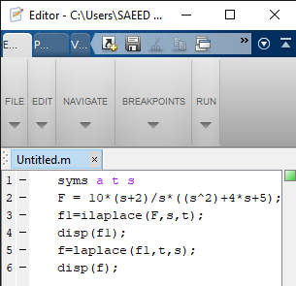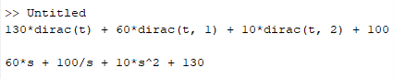

1. Find the Laplace transform of following functions

* U(t)

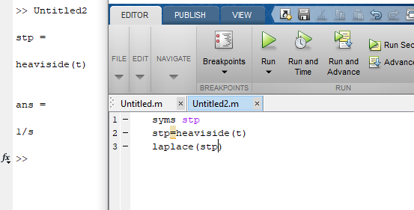

$δ(t)$

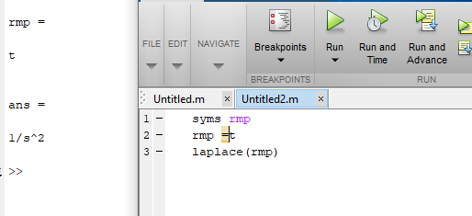

* e-at u(t)

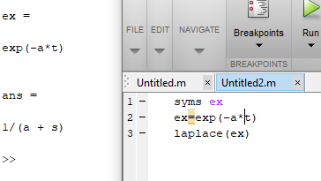

* cos(2t)u(t)

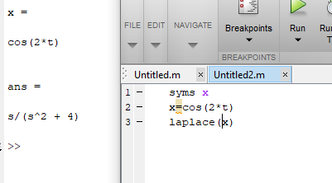

* sin(2t)u(t)

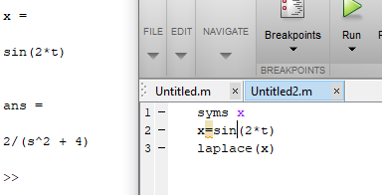

* (t3 +3t2+4t+3)u(t)

