The Islamia University of Bahawalpur

**U**niversity **C**ollege of **E**ngineering **&T**echnology **D**epartment of **C**omputer **S**ystem **E**ngineering

|  |  |  |
| --- | --- | --- |
| **LAB MANUAL** | **SIGNALS AND SYSTEMS EE-311** | **5thSemester** |

**LAB EXPERIMENT # 12**

**Implementation of Analog Filter Design in MATLAB**

|  |  |
| --- | --- |
| **Student Name:** | **Roll No:** |
| **Lab Instructor Signatures:** | **Date:** |

**OBJECTIVE:**

* **Designing of Analog Filter in Matlab**

## Introduction:

Analogue [filters](https://en.wikipedia.org/wiki/Filter_(signal_processing)) are a basic building block of [signal processing](https://en.wikipedia.org/wiki/Signal_processing) much used in [electronics](https://en.wikipedia.org/wiki/Electronics). Filters may be further categorized according to the specific design method and the way they are implemented. Specific design methods that have been developed include Butterworth, Chebyshev Type I, Chebyshev Type II, and Cauer (or elliptic),.

## Butterworth filter design:

**Syntax:**

* 1. [b,a] = butter(n,Wn) ->> returns the transfer function coefficients of an nth-order lowpass digital Butterworth filter with normalized cutoff frequency Wn
  2. [b,a] = butter(n,Wn,ftype) ->> butter([n](https://www.mathworks.com/help/signal/ref/butter.html#inputarg_n),[Wn](https://www.mathworks.com/help/signal/ref/butter.html#inputarg_Wn),[ftype](https://www.mathworks.com/help/signal/ref/butter.html#inputarg_ftype)) designs a lowpass, highpass, bandpass, or bandstop Butterworth filter, depending on the value of ftype and the number of elements of Wn.

The resulting bandpass and bandstop designs are of order 2n.

c) [z,p,k] = butter( ) ->> butter( ) designs a lowpass, highpass, bandpass, or bandstop digital Butterworth filter and returns its zeros, poles, and gain. This syntax can include any of the input arguments in previous syntaxes.

d) [A,B,C,D] = butter( ) ->> butter( ) designs a lowpass, highpass, bandpass, or bandstop digital Butterworth filter and returns the matrices that specify its state-space representation

## Lowpass Butterworth Transfer Function:

**Example**: Design a 2nd-order low pass Butterworth filter with a cutoff frequency of 300 Hz, which, for data sampled at 1000 Hz, corresponds to rad/sample. Plot its magnitude and phase responses. Use it to filter a 1000-sample random signal.

**Code**

[z,p,k] = butter(2,10,'low', 's'); [b,a]=zp2tf(z,p,k); freqs(b,a,4096)

Output:

# Bandstop Butterworth Filter:

**Example**: Design a 2nd-order Butterworth bandstop filter with normalized edge frequencies of and rad/sample. Plot its magnitude and phase responses. Use it to filter random data.

**Code:**

[z,p,k] = butter(2,[2,10],'stop', 's'); [b,a]=zp2tf(z,p,k);

freqs(b,a,4096)

**Output**:

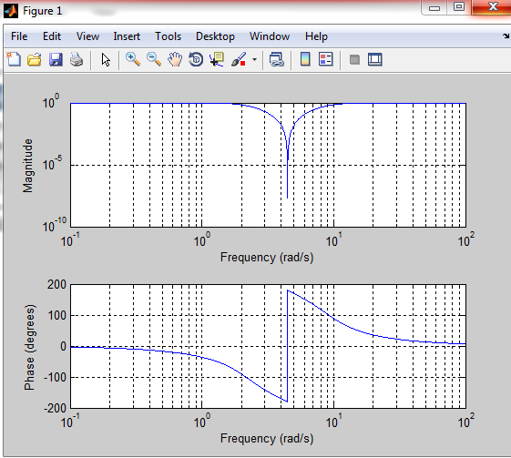

## Highpass Butterworth Filter:

**Example**: Design a 9th-order highpass Butterworth filter. Specify a cutoff frequency of 300 Hz, which, for data sampled at 1000 Hz, corresponds to rad/sample. Plot the magnitude and phase responses. Convert the zeros, poles, and gain to second-order sections for use by fvtool.

**Code:**

[z,p,k] = butter(2,10,'high', 's'); [b,a]=zp2tf(z,p,k);

freqs(b,a,4096)

Output:

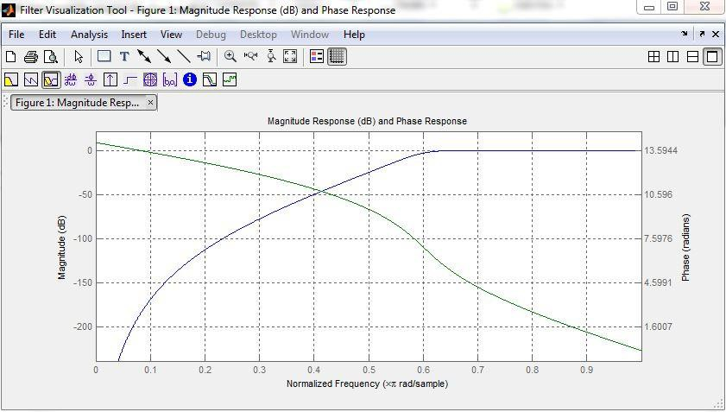

# Bandpass Butterworth Filter:

**Example**: Design a 20th-order Butterworth bandpass filter with a lower cutoff frequency of 500 Hz and a higher cutoff frequency of 560 Hz. Specify a sample rate of 1500 Hz. Use the state- space representation. Design an identical filter using designfilt.

**Code:**

[z,p,k] = butter(2,10,'bandpass', 's'); [b,a]=zp2tf(z,p,k);

freqs(b,a,4096)

Output:

# Low pass Butterworth filters:

**Code:**

D=fdesign.lowpass('Fp,Fst,Ap,Ast',0.2,0.25,0.5,40); H=design(D,'butter');

fvtool(H)

Output:

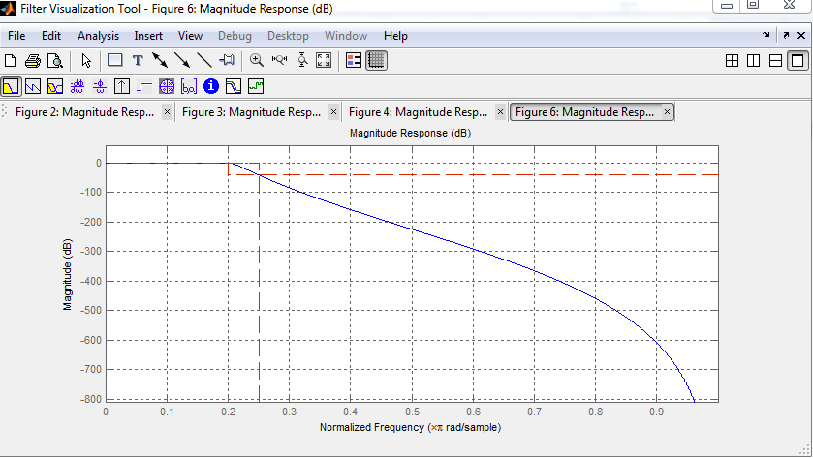

# Some Helpful Commands:

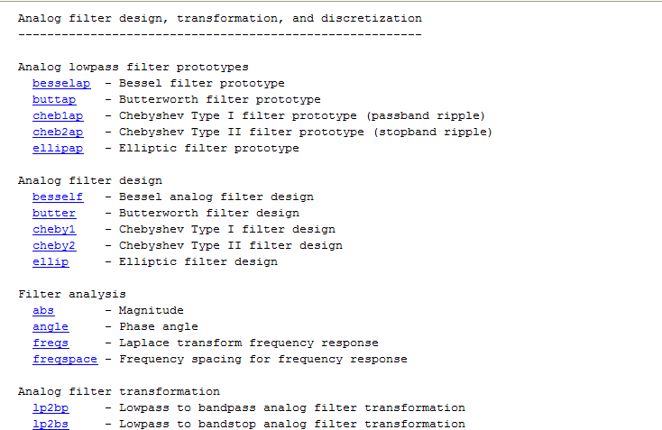

**B. Chebyshev Type I filter design:**

**Syntax**:

[b,a] = cheby1(n,Rp,Wp) ->> returns the transfer function coefficients of an nth-order lowpass digital Chebyshev Type I filter with normalized passband edge frequency Wp and Rp decibels of peak

to-peak passband ripple.

[b,a] = cheby1(n,Rp,Wp,ftype) ->> cheby1([n](https://www.mathworks.com/help/signal/ref/cheby1.html#inputarg_n),[Rp](https://www.mathworks.com/help/signal/ref/cheby1.html#inputarg_Rp),[Wp](https://www.mathworks.com/help/signal/ref/cheby1.html#inputarg_Wp),[ftype](https://www.mathworks.com/help/signal/ref/cheby1.html#inputarg_ftype)) designs a lowpass, highpass, bandpass, or bandstop Chebyshev Type I filter, depending on the value of ftype and the number of elements of Wp. The resulting bandpass and bandstop designs are of order 2n.

[z,p,k] = cheby1( ) ->> designs a lowpass, highpass, bandpass, or bandstop digital Chebyshev Type I filter and returns its zeros, poles, and gain. This syntax can include any of the input arguments in previous syntaxes.

[A,B,C,D] = cheby1( ) ->> designs a lowpass, highpass, bandpass, or bandstop digital Chebyshev Type I filter and returns the matrices that specify its state-space representation.

[ ] = cheby1( ,'s') ->> designs a lowpass, highpass, bandpass, or bandstop analog Chebyshev Type I filter with passband edge angular frequency [Wp](https://www.mathworks.com/help/signal/ref/cheby1.html#inputarg_Wp) and [Rp](https://www.mathworks.com/help/signal/ref/cheby1.html#inputarg_Rp)decibels of passband ripple.

1. **Lowpass Chebyshev Type I Transfer Function:**

Design a 6th-order lowpass Chebyshev Type I filter with 10 dB of passband ripple and a passband edge frequency of 300 Hz, which, for data sampled at 1000 Hz, corresponds to rad/sample. Plot its magnitude and phase responses. Use it to filter a 1000-sample random signal.

**Code:**

1. **Bandstop Chebyshev Type I Filter:**

Design a 6th-order Chebyshev Type I bandstop filter with normalized edge frequencies of and

rad/sample and 5 dB of passband ripple. Plot its magnitude and phase responses. Use it to filter random data.

**Code:**

1. **Highpass Chebyshev Type I Filter:**

Design a 9th-order highpass Chebyshev Type I filter with 0.5 dB of passband ripple and a passband edge frequency of 300 Hz, which, for data sampled at 1000 Hz, corresponds to rad/sample. Plot the magnitude and phase responses. Convert the zeros, poles, and gain to second-order sections for use

by fvtool.

**Code:**

1. **Bandpass Chebyshev Type I Filter:**

Design a 20th-order Chebyshev Type I bandpass filter with a lower passband frequency of 500 Hz and a higher passband frequency of 560 Hz. Specify a passband ripple of 3 dB and a sample rate of 1500 Hz. Use the state-space representation. Design an identical filter using designfilt.

**Code:**

* + **Its Code writing are tasks.**