The Islamia University of Bahawalpur

**U**niversity **C**ollege of **E**ngineering **&T**echnology **D**epartment of **C**omputer **S**ystem **E**ngineering

|  |  |  |
| --- | --- | --- |
| **LAB MANUAL** | **SIGNAL AND SYSTEMS EE-311** | **5thSemester** |

**LAB EXPERIMENT # 14**

**Sampling (A to D conversion) in MATLAB**

|  |  |
| --- | --- |
| **Student Name:** | **Roll No:** |
| **Lab Instructor Signatures:** | **Date:** |

## OBJECTIVE:

* Familiarization with Sampling in Matlab

# Signal Construction:

**Code:**

N = 100;

t = 1 : N;

sig = 2*sin(2*pi*400*t/8000); figure

plot(sig); fs=16;

title ('The Signal in Time Domain'); grid on;

p_max = 2;

p_min = -2;

**Output:**

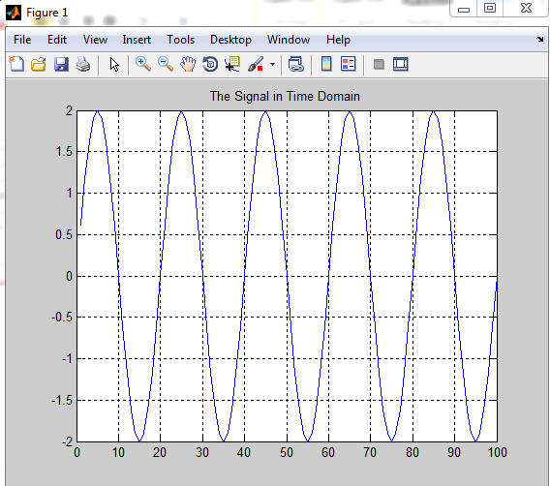

# Sampling the Signal:

**Code:**

b = 32/fs;

% sampling interval

samp = zeros(1,N); % constructing a zero array for (p = 1 : b : N)

samp(p) = sig(p); end

figure stem(samp);

title ('The Sampled Signal') grid on;

**Output:**

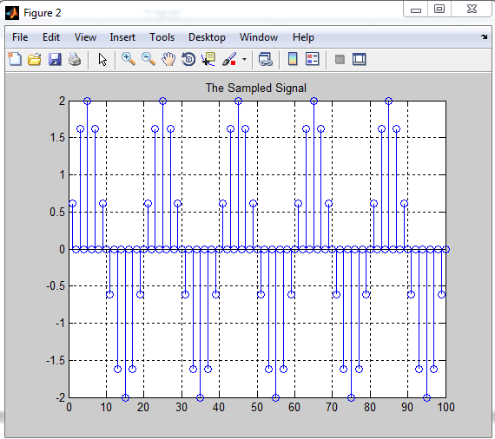

# Quantizing the Sampled Signal:

**Code:**

no = N/b;

% no. of samples

z = ceil(5*(no)); % no. of bits required quan = zeros(1,z); % constructing a zero array

c = (abs(p_max) + abs(p_min))/32 % size of quantized level u = p_min;

w = 1;

quant = zeros(1,N); for (q = 1 : b : N)

for (r = 1 : 32) y = r;

if (samp(q)>=u & samp(q)<=(u+c))

for (v = (w+4) : -1 : w) % this loop is for converting decimal into binary

quan(v) = mod(y,2);

y = (y/2)- (mod(y,2)/2);

end

quant(q) = r;

end

u = u + c;

end

u = p_min; w = w + 5;

end quan

Writing the Quantized Signal fid = fopen ('quant.bin','w');

count = fwrite (fid,quant,'int8');

Reading the Quantized Signal fid = fopen ('quant.bin','r');

[quant_r,count] = fread (fid,inf,'int8');

**Output:**

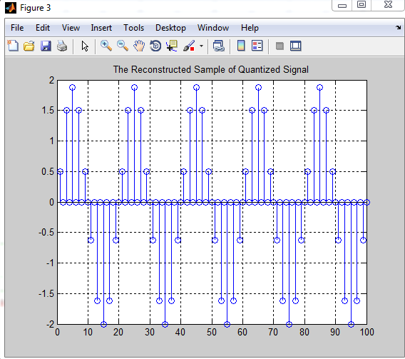

# Reconstructing the Sample of the Quantized Signal:

**Code:**

for (n = 1 : N)

u = p_min;

for (ab = 1 : 32)

if (quant_r(n)==ab) quant_r(n) = u;

end

u = u + c;

end end figure

stem (quant_r);

title ('The Reconstructed Sample of Quantized Signal') grid on;

# Reconstructing the Original Signal:

**Code:**

for (c1 = 1 : b : (N-b)) if (b~=1)

xyz = (quant_r(c1+b)-quant_r(c1))/b; for (c2 = (c1+1) : (c1+b-1))

quant_r(c2) = quant_r(c2-1) + xyz;

end

end end figure

quant_r = smooth (quant_r); plot (quant_r);

title ('The Reconstructed Signal') grid on;

**Output:**

