

CATALOG INTEGRATION GUIDE

Version: 3.8.2

Published date: July 2023

Copyright © 2023 by ESW. All rights reserved. Information contained herein is subject to change without notice.



**SFCC - ESW Cartridge**

+

Contents

**1** **Catalog Integration** 2

1.1 Initial Full Catalog Upload 3

1.2 Delta Catalog Upload 4

**2** **Catalog Integration Configuration** 5

2.1 ESW Catalog Integration Configuration site preferences 5

2.2 eswRetailerCatalogFeed job 6

2.3 ESWSFTP service 6

# **Catalog Integration**

ESW requires a product catalog from retailers as a part of the onboarding process.

A product catalog includes data about the products that you want to sell internationally through the ESW Checkout and ship using the ESW logistics services. The data typically includes Product Code, Product Description, Country of Origin, Weight, HS Code, and so on. Sending the product catalog information is crucial as it allows ESW to accurately calculate the duties & taxes and ensure export compliance and customs clearance. Each time the product catalog is updated, for example, new products are added, the delta changes are required by ESW.

The ESW cartridge omits the need for manually transferring the catalog data to ESW. The eswRetailerCatalogFeed job configured within the cartridge runs at predefined intervals and performs the following operations automatically:

* **Initial full catalog upload**: Uploads the initial full catalog to the ESW catalog service.
* **Delta catalog upload**: Monitors the catalog in SFCC and auto-syncs the delta updates as soon as new products are added or existing products are modified.

For more information on the eswRetailerCatalogFeedjob, see Operations > Job Schedules > eswRetailerCatalogFeed job.

Initial Full Catalog Upload

When the eswRetailerCatalogFeedjob executes for the first time, a CSV file is generated. The file includes details of all products from the catalog:

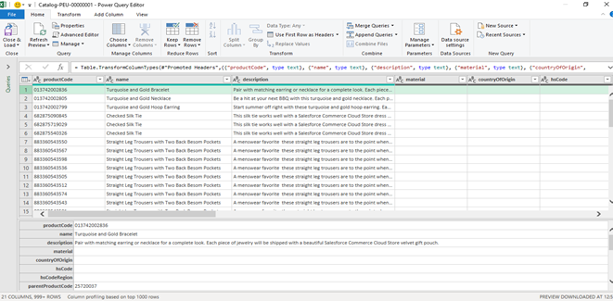

Full catalog upload

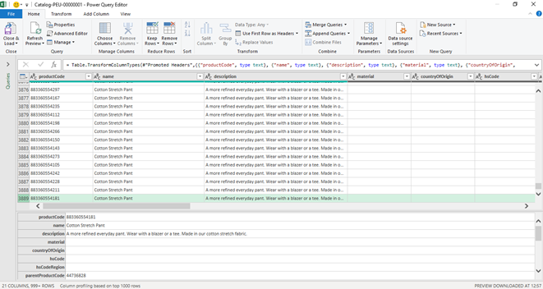

Full catalog upload continued

Delta Catalog Upload

When the eswRetailerCatalogFeedjob executes after the initial full catalog upload, it searches for new products as well as products that are updated since the job was last executed. Once located, the delta product details are sent to the ESW Catalog service.

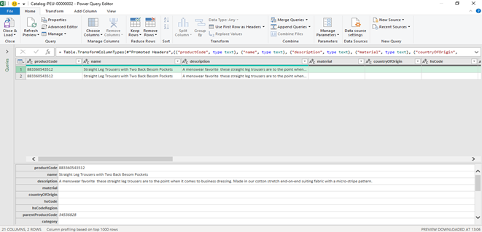

Delta catalog upload

The job uses custom preferences and the ESW SFTP service to transfer the file to the SFTP server. For information on the custom preferences and the ESW SFTP Service, see  
ESW Catalog Integration Configurationand ESWSFTP service respectively.

For information on the Catalog File Specification, including the file format, naming conventions, and data, click [here](https://know.eshopworld.com/space/DT/176980155/Catalog+File).

* The Catalog Feed covers these product types - Simple Product, Variation Product, Product part of Set, Product part of a Bundle, and Orderable Variation Master.
* Along with the ESW naming conventions, the cartridge allows you to store the Instance ID in the **ESW Catalog Feed Instance ID** site preference under ESW Catalog Integration Configuration. You can use the Instance ID in the file name to identify the catalog feed files of specific SFCC instances.
  + If the Instance ID exists in the site preference, the filename is generated as Catalog-nnn-[SFCCInstanceID]xxxxxxxx.
  + If the Instance ID is empty, the filename is generated as Catalog-nnn-xxxxxxxx.

# **Catalog Integration Configuration**

ESW Catalog Integration Configuration site preferences

You can use **Custom Preferences** to manage ESW-specific configurations of the cartridge. You can access Custom Preferences by navigating to **Merchant Tools** > **Site Preferences** > **Custom Preferences.**

The following **ESW Catalog Integration Configuration** options are present:

* **ESW Catalog Feed Local Path**: This preference indicates the local path of the ESW Catalog Feed CSV file.
* **ESW Catalog Feed Remote Path**: This preference indicates the remote path of the ESW Catalog Feed CSV file in the SFTP location.
* **ESW Catalog Feed SFTP Service Name**: The preference indicates the SFTP service name that will be called when establishing the connection with SFTP.
* **ESW Catalog Feed Instance ID**: This preference indicates the SFCC instance from which the catalog feed is generated. The Instance ID is appended in the catalog feed filename, for example, Catalog-nnn-[instanceID]xxxxxxxx.csv. Note that the Instance ID should only contain an alphanumeric value.
* **ESW Catalog Feed Product Custom Fields Mapping**: This preference maps the product custom attributes IDs to the ESW Catalog Feed keys in the following pattern:

{

"EswKeyField1": "ProductCustomAttributeID1",

"EswKeyField2": "ProductCustomAttributeID2"

}

Based on this mapping, the script fetches the value of the mapped product custom attribute and sends it to the assigned ESW catalog feed key. For example, in the CSV file, the **EswKeyField** called hscode will be sent as a header column and the value of the productHSCode (Product level custom attribute) will be sent as a record in each product detail row, as shown in the following example:

{

"material":"productMaterialDescription",

"countryOfOrigin": "productManufacturerCountry",

"hsCode": "productHSCode",

"hsCodeRegion":"productHSCodeRegion",

"category": "",

"gender": "",

"ageGroup": "",

"weight": "",

"weightUnit":"",

"dangerousGoods": ""

}

* **ESW Catalog Feed PriceBook ID**: This preference indicates the pricebook ID from which the prices will be sent against the products in the catalog feed.
* **ESW Catalog Feed Last Executed On**: This preference indicates the last executed timestamp of the catalog feed job. You can trigger 'Full Catalog Upload' by clearing the 'ESW Catalog Feed Last executed on' preference value.
* **ESW Catalog Feed Delimiter**: This preference is to select the delimiter as a separator for catalog feed generated in response of catalog feed job execution. Default value for this preference would be pipe sign **‘|’** and comma **‘,’** can also be selected as delimiter value.

eswRetailerCatalogFeed job

The **eswRetailerCatalogFeed** job syncs the retailer catalog to the ESW Catalog Service by generating the required file in the specific file format. The file is generated in the IMPEX folder. The job also transfers the generated file to the ESW SFTP location using the SFTPClient service framework.

ESWSFTP service

This service is used to make a call to the SFTP client and establish the connection to the remote ESW SFTP server. The service has its credentials that you can find under the **Credentials**tab.

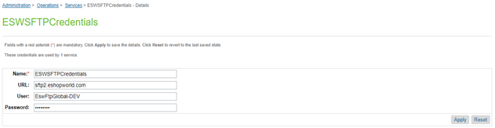

For multiple sites using the common Sandbox, you can configure multiple services for sites that use the different ESW SFTP server. You can also add the service name to the **ESW Catalog Feed SFTP Service Name** custom preference. The examples of the service names are ESWSFTP.SG and ESWSFPT.SFRA.