jnm


Version: 3.8.2

Published date: July 2023

Copyright © 2023 by ESW. All rights reserved. Information contained herein is subject to change without notice.

# **ESW- Share Marketing Opt-In**

INTEGRATION GUIDE



**SFCC - ESW Cartridge**

+

Contents

**1** **ESW Marketing Opt In** 2

* 1. Benefits 3
  2. ESW Marketing opt-in Configuration custom preferences 3
  3. First-time Experience- New shoppers without Marketing opt-in selection to ESW checkout 4
  4. 1.4 Repeat Opt-in selected Shoppers Experience- Returning Shoppers are presented with the Marketing opt-in selected on ESW checkout 5
  5. Testing Sandbox/Staging Environment 7

# **ESW Marketing Opt-In**

* 1. Benefits

Following are some benefits of using the ESW marketing opt-in feature.

* This ESW opt-in allows retailers to create separate newsletters or intimidation emails for ESW opted-in shoppers.
* Registered Shoppers stored opt-in preference value can be passed to the pre-order payload, which will turn on opt-in preference on ESW checkout for already opted-in shoppers.
* The registered shoppers will be able to opt-out by unchecking opt-in preference on ESW checkout.

In addition to checkout shoppers’ registration, Retailers can store opt-in shoppers’ lists on the marketing cloud, i.e. (SFMC, Bronto).

How does this work?

The following flow depicts how marketing opt-in works. Flow is divided into two steps according to customers.

1. The shopper adds an item to the cart and clicks Checkout.
   1. If the user is logged in and has checked the opt-in custom profile preference, add meta in the pre-order request to enable email opt-in on ESW checkout.
   2. If the user is a guest or has unchecked opt-in custom profile preference add meta in the pre-order request to disable email opt-in on ESW checkout.
2. ESW loads the checkout, places an order with successful payment, and calls SFCC to update the order configuration on the SFCC side.
   1. On order payload, if the customer checked opt-in preference on ESW checkout, we are getting the customer from SFCC if it exists ted and then updating profile preference eswMaretingOptIn to check.
   2. If the customer unchecked the opt-in preference on ESW checkout, we update the customer profile preference accordingly.
   3. ESW Marketing opt-in Configuration in the Customer profile

You can use a **customer profile** to manage ESW opt-in to create separate newsletters for opted-in shoppers. You can access it by navigating **Merchant Tools > Customers > Customer Profile**. The following preference will be available in each customer’s profile **eswMaretingOptIn**.

* **ESW Marketing Optin:** To configure if the customer’s ESW opt-in is enabled or not.
  1. First-time Experience- New shoppers without Marketing opt-in selection to ESW checkout

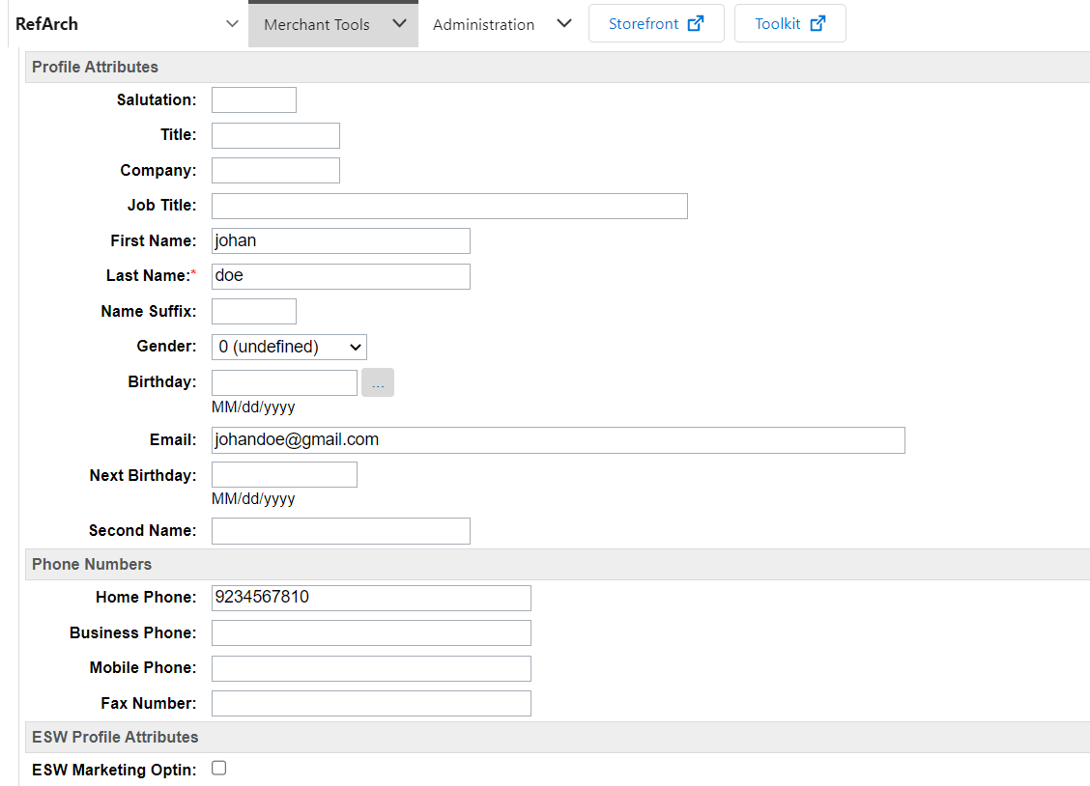

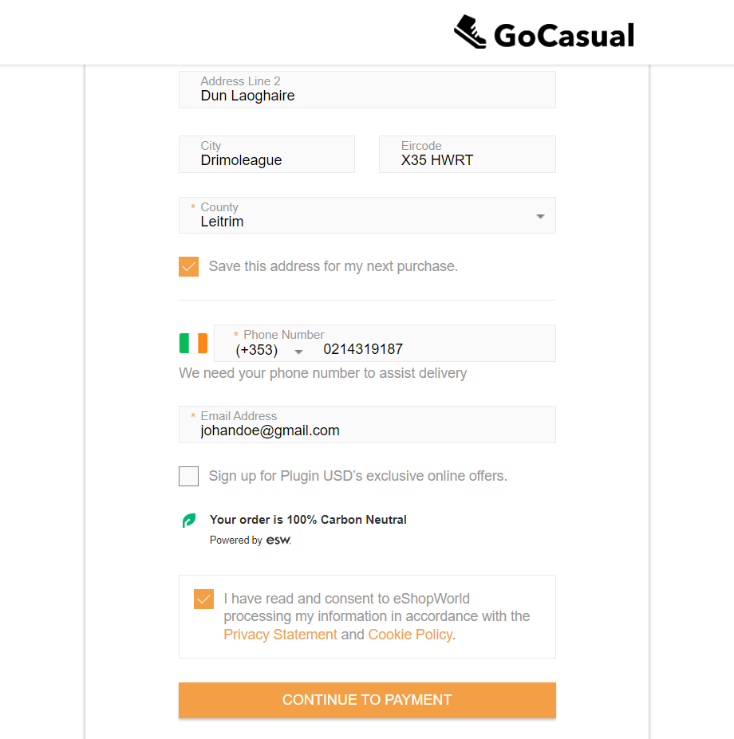

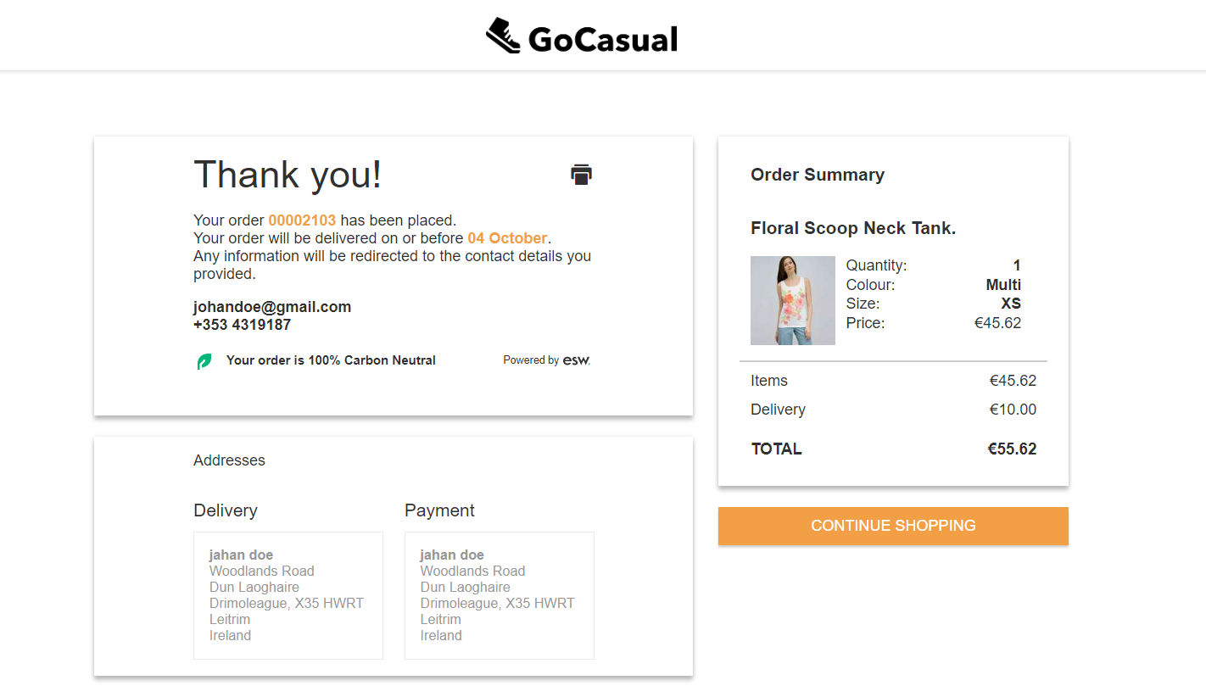

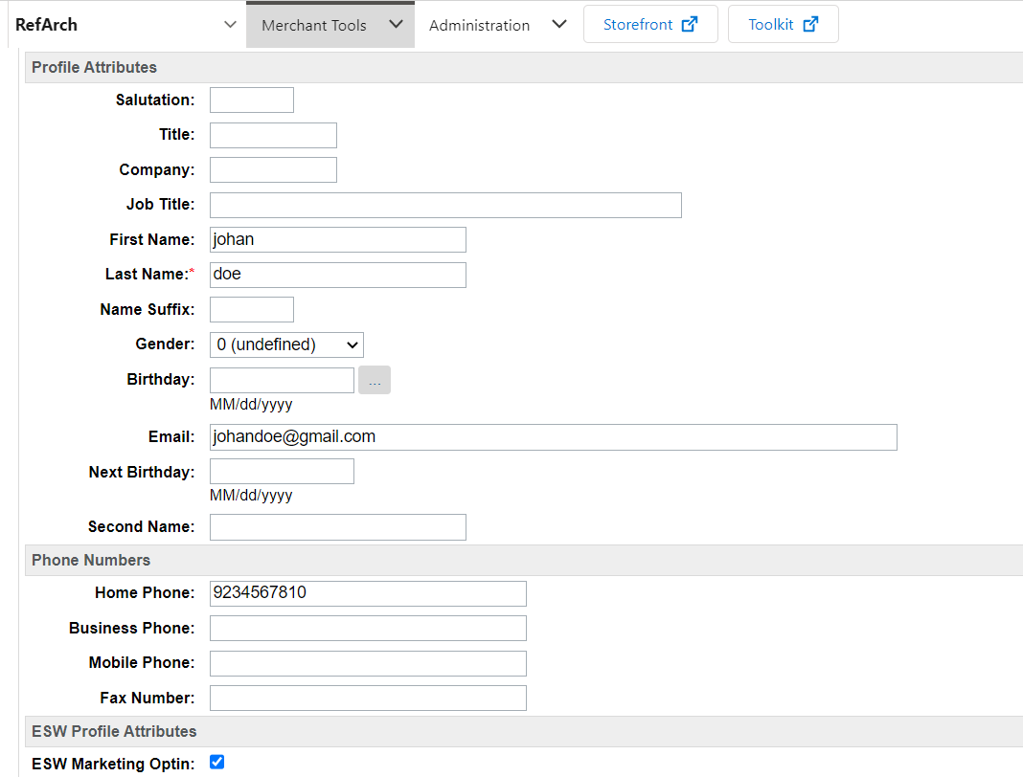

* 1. Repeat Opt-in selected Shoppers Experience- Returning Shoppers are presented with the Marketing opt-in selected on ESW checkout



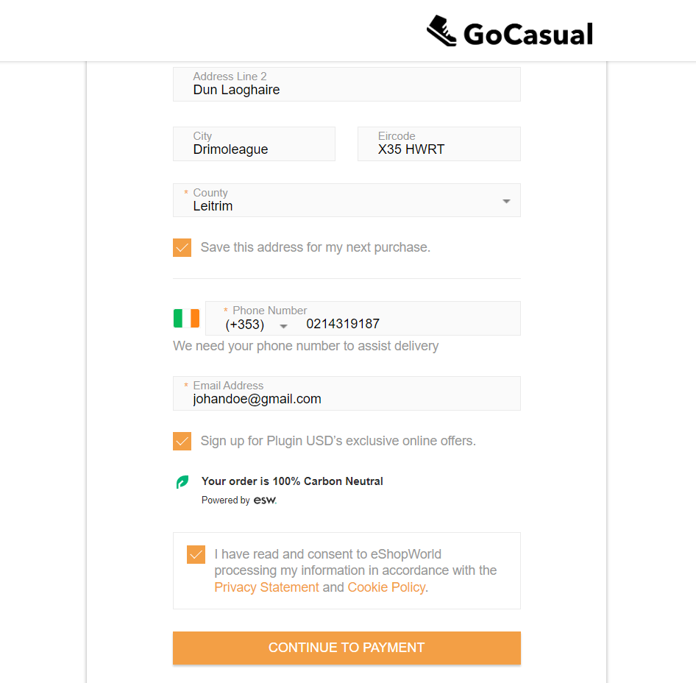



* 1. Testing Sandbox/Staging Environment

There are two options to test this feature in a sandbox/staging environment.

1. Create an order with a newly registered customer following the ESW checkout flow.
2. Review that the registered customer profile custom preference is set to false.



1. On ESW checkout, select the marketing opt-in checkbox to be true and place the order.



1. Check customer’s profile custom preference is set to true.



1. Place an order with the existing account and opted-in for customer preference.
2. Review that the registered customer profile custom preference is set to true  
   
3. On ESW checkout, confirm and deselect the marketing opt-in checkbox to true and place the order.



1. Preview the customer’s profile to confirm if the marketing opt-in reverted to false.

