

Version: 3.8.2

Published date: July 2023

Copyright © 2023 by ESW. All rights reserved. Information contained herein is subject to change without notice.

Share service/webhooks logs on retailer platform



**SFCC - ESW Cartridge**

+

Contents

1. Share service/webhooks logs on retailer platform 3

1.1. Use Case 3

1.2. Feature Scope 3

1.3. How this feature works? 3

2. Configuration for Share service/webhooks logs on retailer platform 4

2.1. Import meta data and Job 4

2.2. Update diagnostic meta data custom object 5

## Share service/webhooks logs on retailer platform

## Use Case

ESW plugin allows retailers to share ESW service and webhooks related logs with ESW teams. Before this feature, if there is a technical issue related to SFCC plugin integration on the retailer side, ESW do not have any source of the retailer's system with initial analysis for integration endpoints. This causes delays to find out the integration endpoint where the issue happens and need a fix.

## Feature Scope

The following services are in scope to log the information on the retailer’s system in case of an error/exception.

* Checkout API V3 PreOrder
* Pricing adviser service
* Catalog API service
* Order confirmation webhook
* Package API service
* Order API
* Order cancellation webhook
* Order returns webhook
* ESW authentication service

## How this feature works?

To generate the log file, user must go to the Jobs section and need to run `ESWHealthCheck` job. This job will generate a JSON file having name format `ESWHealthLog-{Date}.json` under specified folder which can be configured in the job step under parameter `impexDirPath`.

This file is JSON like string and JSON in this file can be fixed using any JSON fixer tool like <https://codebeautify.org/json-fixer>. The file will be generated once in a day and all jobs result will append in the file on each run. The generated output sample will be:

{

"serviceName": "name_of_the_service",

"isOk": true,

"errorCode": "error_code_from_service",

"errorMessage": "error_message_from_service",

"isServiceInUse": "boolean",

"systemInfo": {

"timeStamp": "Wed, 22 Feb 2023 13:12:06 GMT",

"instanceType": "instance_type_of_sfcc",

"compatibilityMode": "Code_compatibility_mode",

"instanceTimeZone": "US/Eastern",

"checkoutVersion": "EswCheckoutV2Service.SFRA",

"sfccArchitectureVersion": "SFRA || SF",

"eswCartridgeVersion": "version_number_of_esw_cartridge"

}

}

## Configuration for Share service/webhooks logs on retailer platform

## Import meta data and Job

We are getting SFCC architect version and ESW cartridge version from custom object `ESW_DIAGNOSTIC_DATA`. Please follow these steps to import meta data to use this feature:

**Upload meta data file**

1. Go to `Administration > Site Development > Import & Export > Manage Import Files`
2. Press `Upload`
3. Choose xml file from `pathToYourProject/link_eshopworld/sitesdata/meta/esw_diagnostic_customobjects.xml`

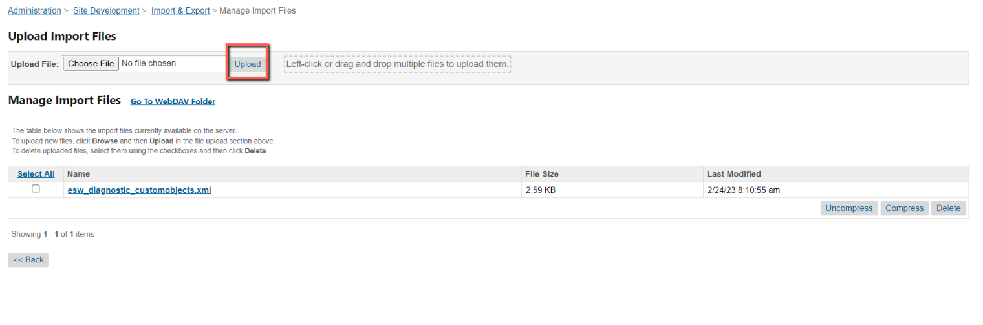

**Import meta data file**

1. Go to ` Administration > Site Development > Import & Export > Step 1 - Select Import File`
2. Choose uploaded file `esw_diagnostic_customobjects.xml
3. Press `Next` and complete the wizard

**Upload Job file**

1. Go to ` Administration > Operations > Import & Export > Manage Import Files`
2. Choose `Upload`
3. Select file from `pathToYourProject/link_eshopworld/sitesdata/jobs.xml`  
   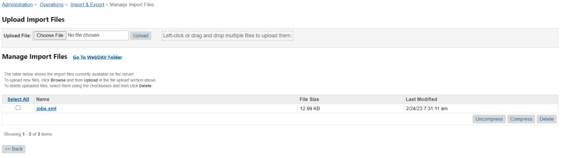

**Import Job file**

1. Go to ` Administration > Operations > Import & Export > Jobs Import Step 1 - Select Import File`
2. Choose ` jobs.xml`
3. Complete the wizard  
   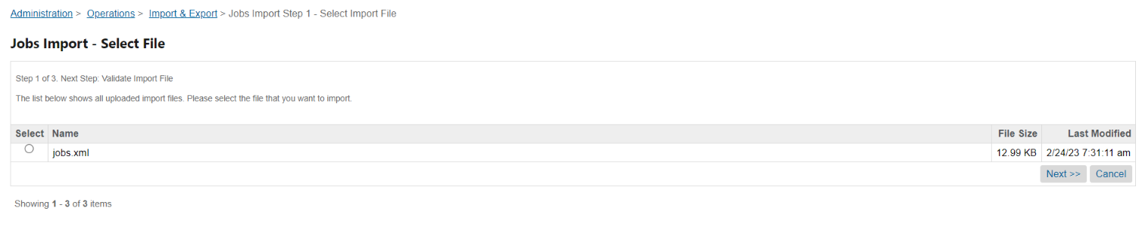

## Update diagnostic meta data custom object

After completing the import for meta data and jobs we need to add values to the custom attribute. A job ` eswRetailerAutoConfigurator` will done this work. Just go to the jobs and run the `eswRetailerAutoConfigurator` job. After running this job you can edit the custom object **ESW_DIAGNOSTIC_DATA** from custom object editor.

The following **ESW_DIAGNOSTIC_DATA** custom attributegroup will be present in Custom Objects Editor.

* **SFCC Cartridge Version**: This custom attribute which will hold the information regarding SFRA or SG version.
* **ESW Cartridge Version**: This will hold the ESW cartridge version

