Table

Table 1

|  |  |  |  |  |  |  |  |  |
| --- | --- | --- | --- | --- | --- | --- | --- | --- |
|  |  | | | | |  |  |  |
|  |  |  |  |  |  | Table |  |  |
|  |  |  |  |
|  |  |  |  |
|  |  | | | | |  |  |  |
|  |  | | | | |  |  |  |

Style 2

|  |  |  |  |  |
| --- | --- | --- | --- | --- |
|  |  |  |  |  |

|  |  |  |  |  |
| --- | --- | --- | --- | --- |
|  |  |  |  |  |
|  |  |  |  |  |
|  |  |  |  |  |
|  |  |  |  |  |

Style 3

|  |  |  |
| --- | --- | --- |
|  |  |  |

|  |  |  |  |
| --- | --- | --- | --- |
|  |  |  |  |
|  |  |  |  |

Picture

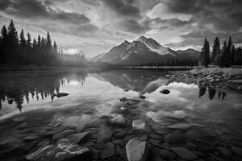

Figure i

Shapes

Kabir

Shapes Group

Flow Chart

F

A

B

C

D

E

**Smart ART**

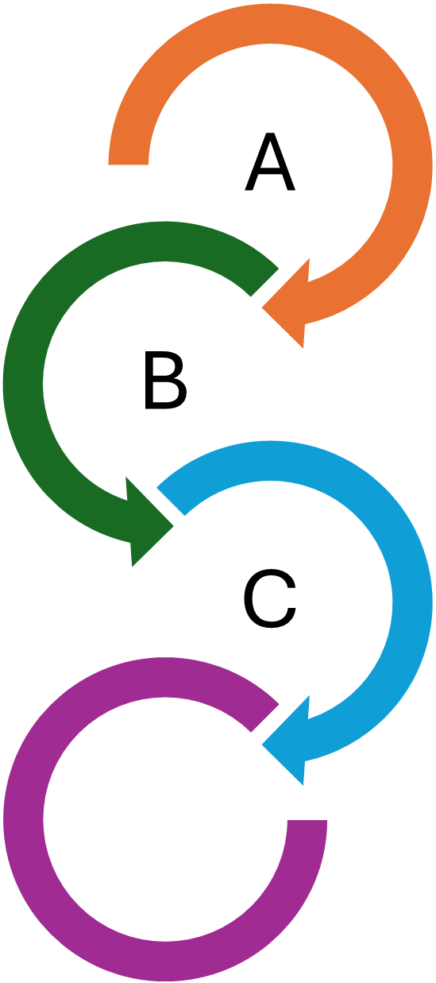

D