1.

安装Git

https://git-scm.com/downloads

2.

安装TortoiseGit (GUI for Git On Windows)

https://tortoisegit.org/

kobe

3.

Repository on GitHub:

SSH:

git@github.com:ahsclhl/EShop.git

HTTPS:

https://github.com/ahsclhl/EShop.git

*在公司使用HTTPS

4.

For Env in SAP Labs:

在Git Bash 中设置代理:

git config --global http.proxy http://proxy.sin.sap.corp:8080

git config --global https.proxy <https://proxy.sin.sap.corp:8080>

为Maven 设置代理

1. Copy **settings.xml** from **apache-maven-3.3.9\conf**  to **C:\Users\YourID \.m2**
2. Modify settings.xml

  <proxies>

    <!-- proxy

     | Specification for one proxy, to be used in connecting to the network.

     |

    <proxy>

      <id>optional</id>

      <active>true</active>

      <protocol>http</protocol>

      <username>proxyuser</username>

      <password>proxypass</password>

      <host>proxy.host.net</host>

      <port>80</port>

      <nonProxyHosts>local.net|some.host.com</nonProxyHosts>

    </proxy>

    -->

                <proxy>

      <id>optional</id>

      <active>true</active>

      <protocol>http</protocol>

      <host>proxy.sin.sap.corp</host>

      <port>8080</port>

    </proxy>

  </proxies>

  <mirrors>

    <!-- mirror

     | Specifies a repository mirror site to use instead of a given repository. The repository that

     | this mirror serves has an ID that matches the mirrorOf element of this mirror. IDs are used

     | for inheritance and direct lookup purposes, and must be unique across the set of mirrors.

     |

    <mirror>

      <id>mirrorId</id>

      <mirrorOf>repositoryId</mirrorOf>

      <name>Human Readable Name for this Mirror.</name>

      <url>[http://my.repository.com/repo/path</url](http://my.repository.com/repo/path%3c/url)>

    </mirror>

     -->

    <mirror>

      <id>repo1</id>

      <mirrorOf>central</mirrorOf>

      <name>repo1</name>

      <url>[http://repo1.maven.org/maven2</url](http://repo1.maven.org/maven2%3c/url)>

    </mirror>

  </mirrors>

5.

在Git Bash 中生产私钥，公钥(For SSH)，把公钥发送给我

ssh-keygen -t rsa -C “XXX@gmail.com”

6.

在Git Bash 中设置账户密码，这样向github 提交代码时不用输入账户密码：

$ git config --global user.name "XXX"

$ git config --global user.email "XXX@gmail.com"

7.

Pull code：

在本地文件夹下，右键 -> Git Sync 打开 TortoiseGit，在”Remote URL” 中输入repository 地址。

点击“Pull”即可

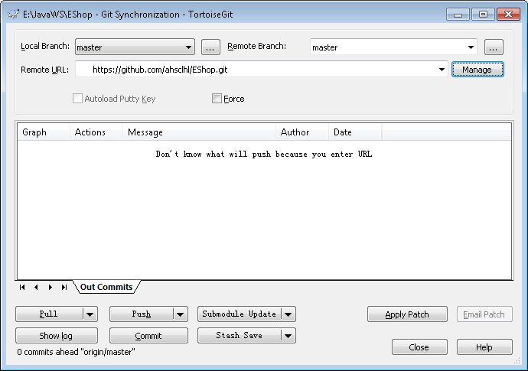

8.

Push Code：

右键选中Git Commit -> “master”，然后填写CL 的description，点击“Push”即可

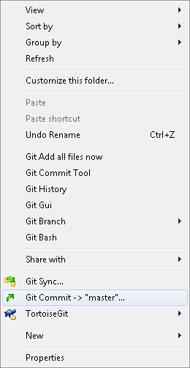

9.

Maven：

<https://maven.apache.org/download.cgi>

设置环境变量 Path，指向Maven 安装目录下的 \bin

10.

MySQL:

安装版or 绿色版，自选

GUI for MySQL ： NaviCat

11.

任何其他maven dependency可以在<http://search.maven.org/>里搜索找到相应的dependency写法

比如hibernate: 搜索spring hibernate找到2.0.8版本，点击”2.0.8”进去拷贝出以下内容到pom.xml

<dependency>

    <groupId>org.springframework</groupId>

    <artifactId>spring-hibernate3</artifactId>

    <version>2.0.8</version>

</dependency>