

Team cAlco-holics

Roll no-f18MS31 Assigned by Sir Abdul Hanan Sheikh

f18MS16

f18MS49

f18MS56

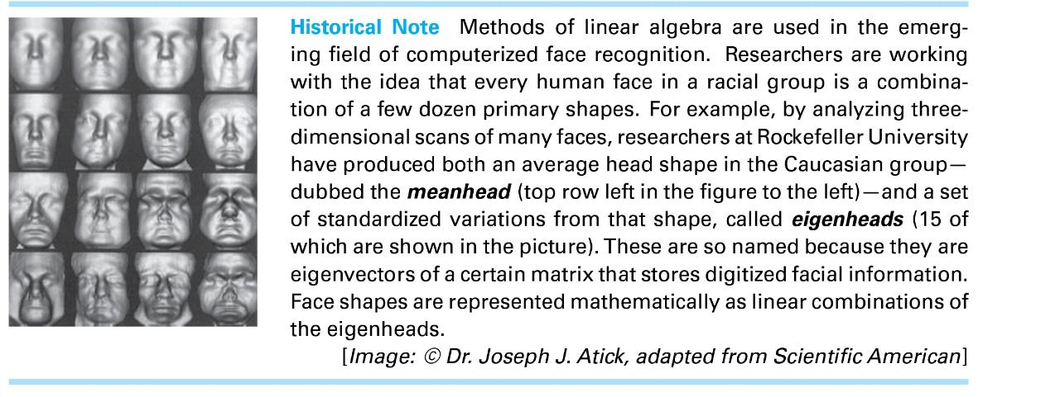

Q NO.1: find eigenvalues and eigenvectors of 3by3 identity matrix?

Solution: eigenvalue is (λ-1)3 then λ=1

For every λ we find its own vector(s):

1. λ1=1

A−λ1*I=

(A−λ1)v=0

So we have a homogenous system of linear equations, we solve it by Gaussian Elimination:

Answer:

* x1=x1
* x2=x2
* x3=x3

general solution: X=

The solution set:

Let x1=1, x2=0, x3=0,

v1=;

Let x1=0, x2=1, x3=0,

v2=;

Let x1=0, x2=0, x3=1,

v3=;

Q No. 2 By virtue of the theorems [Theorem1: The sum of eigenvalues of matrix is equal to trace of matrix and Theorem2: The determinant of matrix is equal to product of eigenvalues], if two matrices have same eigenvalues then trace and determinant of matrices are same. Show that having same determinant and trace, two matrices does not necessarily have same eigenvalues

Answer:

I am proving this by giving first an example then I will define it,

A= and B=

Trace of A=3, trace of B=3

Det (A) =1 and Det (B) =1

The Eigen value of A= (λ-1)3 = λ=1

And the Eigen value of B

• λ1=1/2

• λ2=−ⅈ×7+5/4

• λ3==ⅈ×7+5/4

If we want to get the Eigen values same so we have to take all the Eigen’s or main diagonal greater than zero. So it’s proved by an example that is not necessary for two matrices which have same determinant and trace it must have same Eigen values.

Q No. 3 Find eigenvalues of matrix 𝐴= ∑ni,j=1 𝑎𝑖𝑗 where 𝑎𝑖𝑗=0 for 𝑖<𝑗.

Solution: the given matrix is lower triangular matrix which is squared

So we are taking 3 by 3 matrix

The Eigen values are

• λ1=1

• λ2=−1.

Q No. 4 Find eigenvalues of matrix 𝐴= ∑ni,j=1 𝑎𝑖𝑗 where 𝑎𝑖𝑗=0 for 𝑖>𝑗

Solution: the given matrix is upper triangular matrix which is squared

So we are taking 3 by 3 matrix

**Same comment as in Q No. 3**

The Eigen values are

• λ1=1

• λ2=−1

Special thanks to Sir Abdul Hanan Sheikh.