Question:02
Code:
#include <stdio.h>
#include <GL/gl.h>
#include <GL/glut.h>
#include <math.h>

float X1, Y1, X2, Y2, m;
float dx, dy;

void display(void)
{
glClear(GL_COLOR_BUFFER_BIT);
glColor3f(1.0, 1.0, 1.0);
glPointSize(8.0f);
glBegin(GL_POINTS);

dx = X2 - X1;
dy = Y2 - Y1;

// Handle Vertical Line (Infinite Slope)
if (dx == 0) {
printf("--- Vertical Line ---\n");
int steps = abs((int)dy);
float yStep = (Y1 < Y2) ? 1 : -1;
float currentY = Y1;
for(int i = 0; i <= steps; i++) {
float rX = roundf(X1);
float rY = roundf(currentY);
glVertex2f(rX / 100.0, rY / 100.0);
printf("(%.2f, %.2f) ------> Rounded -----> (%.0f, %.0f)\n", X1, currentY, rX, rY);
currentY += yStep;
}
}
else {
m = dy / dx;
printf("--- Slope (m) = %.2f ---\n", m);

float xInc = X1, yInc = Y1;
int steps;
float xStep, yStep;

// Logic for different slope conditions
if (m < -1) {
// Case: m < -1 (Steep Negative)
steps = abs((int)dy);
yStep = (Y1 < Y2) ? 1 : -1;
xStep = dx / (float)steps;
}
else if (m == -1) {
// Case: m = -1 (Perfect Negative Diagonal)
steps = abs((int)dx);
xStep = (X1 < X2) ? 1 : -1;
yStep = (Y1 < Y2) ? 1 : -1;
}
else if (m > -1 && m < 0) {
// Case: m > -1 (Shallow Negative)
steps = abs((int)dx);
xStep = (X1 < X2) ? 1 : -1;
yStep = dy / (float)steps;
}
else if (m >= 0 && m <= 1) {
// Case: Positive Shallow
steps = abs((int)dx);
xStep = (X1 < X2) ? 1 : -1;
yStep = dy / (float)steps;
}
else {
// Case: m > 1 (Positive Steep)
steps = abs((int)dy);
yStep = (Y1 < Y2) ? 1 : -1;
xStep = dx / (float)steps;
}

// Execution and Printing
for(int i = 0; i <= steps; i++) {
float rX = roundf(xInc);
float rY = roundf(yInc);

// Plotting scaled values
glVertex2f(rX / 100.0, rY / 100.0);

// Outputting the float coordinates and their roundf result
printf("(%.2f, %.2f) ------> Rounded -----> (%.0f, %.0f)\n", xInc, yInc, rX, rY);

xInc += xStep;
yInc += yStep;
}
}

glEnd();
glFlush();
}

void init(void)
{
glClearColor(0.0, 0.0, 0.0, 1.0);
glMatrixMode(GL_PROJECTION);
glLoadIdentity();
// Ortho is set to 5.0 to handle coordinates up to 500 comfortably
glOrtho(0.0, 5.0, 0.0, 5.0, -1.0, 1.0);
}

int main(int argc, char** argv)
{
printf("Enter (X1, Y1): ");
scanf("%f %f", &X1, &Y1);
printf("Enter (X2, Y2): ");
scanf("%f %f", &X2, &Y2);
printf("\nProcessing DDA Steps:\n");
printf("--------------------------------------------------\n");

glutInit(&argc, argv);
glutInitDisplayMode(GLUT_SINGLE | GLUT_RGB);
glutInitWindowSize(600, 600);
glutInitWindowPosition(100, 100);
glutCreateWindow("DDA Line Drawing - Rounded Output");
init();
glutDisplayFunc(display);
glutMainLoop();
return 0;
}
#include <stdio.h>
#include <GL/gl.h>
#include <GL/glut.h>
#include <math.h>

float X1, Y1, X2, Y2, m;
float dx, dy;

void display(void)
{
glClear(GL_COLOR_BUFFER_BIT);
glColor3f(1.0, 1.0, 1.0);
glPointSize(8.0f);
glBegin(GL_POINTS);

dx = X2 - X1;
dy = Y2 - Y1;

// Handle Vertical Line (Infinite Slope)
if (dx == 0) {
printf("--- Vertical Line ---\n");
int steps = abs((int)dy);
float yStep = (Y1 < Y2) ? 1 : -1;
float currentY = Y1;
for(int i = 0; i <= steps; i++) {
float rX = roundf(X1);
float rY = roundf(currentY);
glVertex2f(rX / 100.0, rY / 100.0);
printf("(%.2f, %.2f) ------> Rounded -----> (%.0f, %.0f)\n", X1, currentY, rX, rY);
currentY += yStep;
}
}
else {
m = dy / dx;
printf("--- Slope (m) = %.2f ---\n", m);

float xInc = X1, yInc = Y1;
int steps;
float xStep, yStep;

// Logic for different slope conditions
if (m < -1) {
// Case: m < -1 (Steep Negative)
steps = abs((int)dy);
yStep = (Y1 < Y2) ? 1 : -1;
xStep = dx / (float)steps;
}
else if (m == -1) {
// Case: m = -1 (Perfect Negative Diagonal)
steps = abs((int)dx);
xStep = (X1 < X2) ? 1 : -1;
yStep = (Y1 < Y2) ? 1 : -1;
}
else if (m > -1 && m < 0) {
// Case: m > -1 (Shallow Negative)
steps = abs((int)dx);
xStep = (X1 < X2) ? 1 : -1;
yStep = dy / (float)steps;
}
else if (m >= 0 && m <= 1) {
// Case: Positive Shallow
steps = abs((int)dx);
xStep = (X1 < X2) ? 1 : -1;
yStep = dy / (float)steps;
}
else {
// Case: m > 1 (Positive Steep)
steps = abs((int)dy);
yStep = (Y1 < Y2) ? 1 : -1;
xStep = dx / (float)steps;
}

// Execution and Printing
for(int i = 0; i <= steps; i++) {
float rX = roundf(xInc);
float rY = roundf(yInc);

// Plotting scaled values
glVertex2f(rX / 100.0, rY / 100.0);

// Outputting the float coordinates and their roundf result
printf("(%.2f, %.2f) ------> Rounded -----> (%.0f, %.0f)\n", xInc, yInc, rX, rY);

xInc += xStep;
yInc += yStep;
}
}

glEnd();
glFlush();
}

void init(void)
{
glClearColor(0.0, 0.0, 0.0, 1.0);
glMatrixMode(GL_PROJECTION);
glLoadIdentity();
// Ortho is set to 5.0 to handle coordinates up to 500 comfortably
glOrtho(0.0, 5.0, 0.0, 5.0, -1.0, 1.0);
}

int main(int argc, char** argv)
{
printf("Enter (X1, Y1): ");
scanf("%f %f", &X1, &Y1);
printf("Enter (X2, Y2): ");
scanf("%f %f", &X2, &Y2);
printf("\nProcessing DDA Steps:\n");
printf("--------------------------------------------------\n");

glutInit(&argc, argv);
glutInitDisplayMode(GLUT_SINGLE | GLUT_RGB);
glutInitWindowSize(600, 600);
glutInitWindowPosition(100, 100);
glutCreateWindow("DDA Line Drawing - Rounded Output");
init();
glutDisplayFunc(display);
glutMainLoop();
return 0;
}

Ouput:
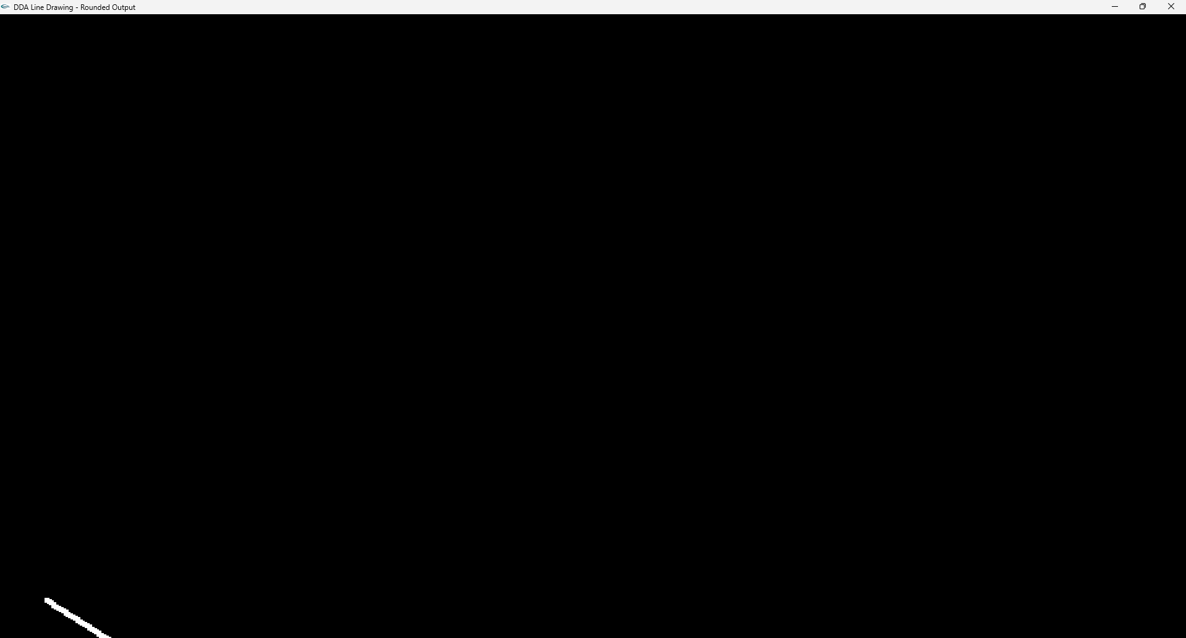

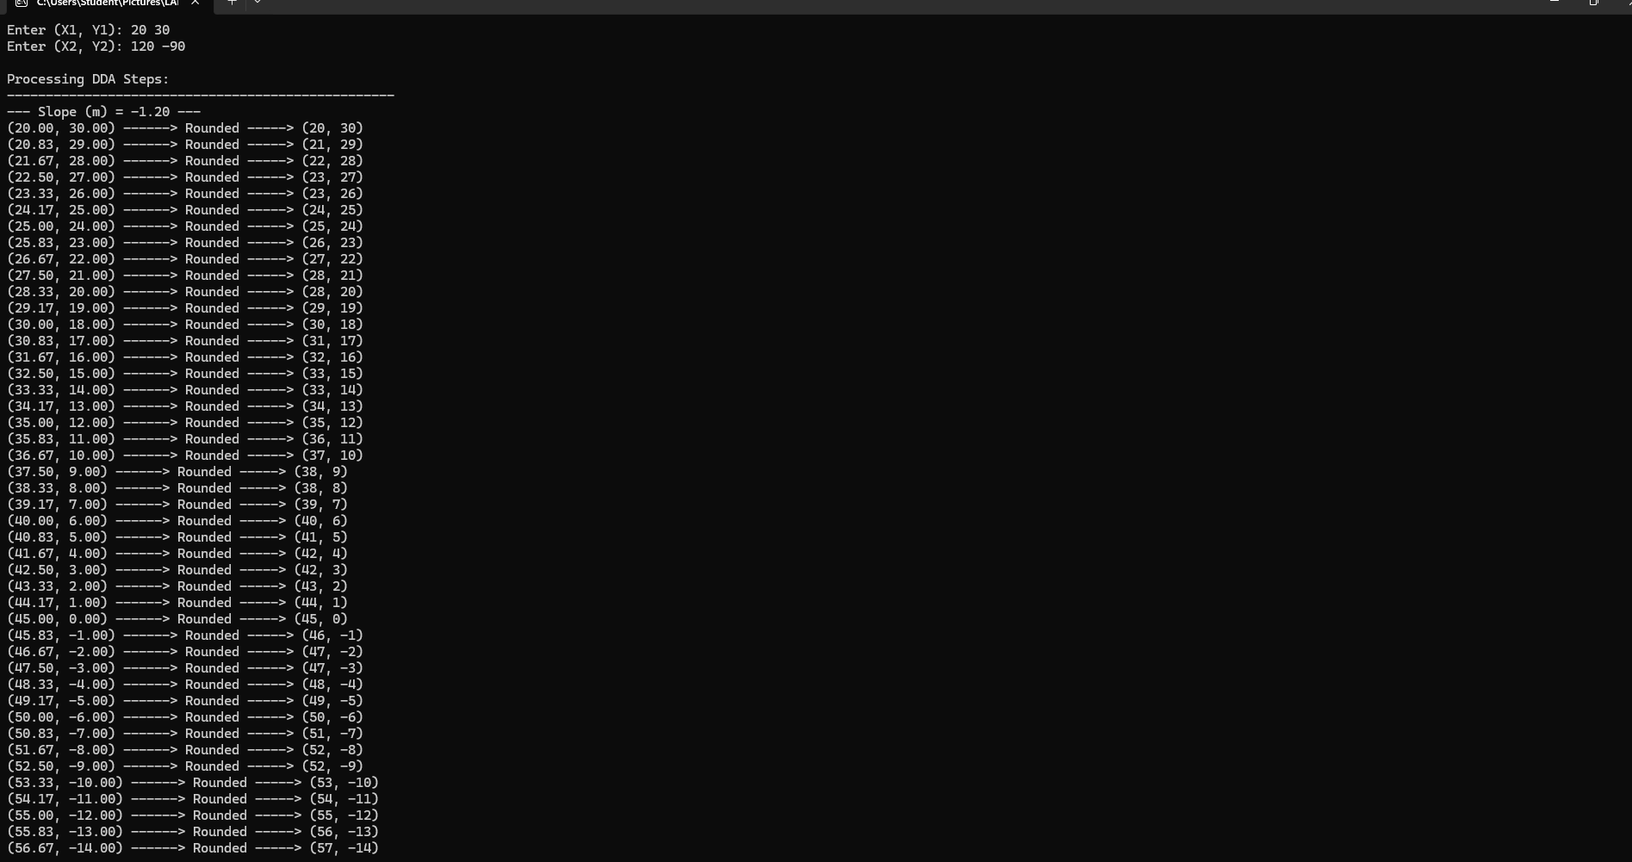

Question 1:
Code:
#include <windows.h>
#include <GL/gl.h>
#include <GL/glut.h>
#include <string.h>
#include <math.h>
// Function to draw text on screen
void drawText(float x, float y, const char* text) {
glRasterPos2f(x, y);
for (int i = 0; i < strlen(text); i++) {
glutBitmapCharacter(GLUT_BITMAP_HELVETICA_12, text[i]);
}
}

//Draw Heading
void drawHext(float x, float y, const char* text) {
glRasterPos2f(x, y);
for (int i = 0; i < strlen(text); i++) {
glutBitmapCharacter(GLUT_BITMAP_HELVETICA_18, text[i]);
}
}

// Function to draw a circle
void drawCircle(float cx, float cy, float radius)
{
glBegin(GL_POLYGON);
for (int i = 0; i < 360; i++)
{
float theta = i * (M_PI / 180.0f);
float x = radius * cos(theta) + cx;
float y = radius * sin(theta) + cy;
glVertex2f(x, y);
}
glEnd();
}

// Display callback function to render the shapes
void display(void)
{
glClear(GL_COLOR_BUFFER_BIT);

//glBegin(GL_LINES); //Draw single line
//glBegin(GL_LINE_LOOP); //Draw borders of any shapes
/*
//Heading
glColor3f(0.0f, 0.0f, 0.0f); // Red
drawHext(40, 92, "ALL GEOMARTRIC SHAPES");

// Triangle
glColor3f(0.9f, 0.1f, 0.1f); // Red
glBegin(GL_TRIANGLES);
glVertex2f(5, 70);
glVertex2f(25, 70);
glVertex2f(15, 87);
glEnd();
drawText(13, 65, "3 edges");

// Parallelogram
glColor3f(0.0f, 0.8f, 0.4f); // Teal
glBegin(GL_QUADS);
glVertex2f(30, 70);
glVertex2f(45, 70);
glVertex2f(50, 87);
glVertex2f(35, 87);
glEnd();
drawText(35, 65, "4 edges");

// Square
glColor3f(0.0f, 0.4f, 0.9f); // Blue
glBegin(GL_QUADS);
glVertex2f(55, 70);
glVertex2f(70, 70);
glVertex2f(70, 87);
glVertex2f(55, 87);
glEnd();
drawText(60, 65, "4 edges");

glEnd();

// Circle
glColor3f(0.9f, 0.2f, 1.0f);
drawCircle(85, 78, 8);
glEnd();
drawText(83, 6, "Circle");
*/

//sky
glColor3f(0.68f, 0.82f, 0.95f);
glBegin(GL_QUADS);
glVertex2f(0,32);
glVertex2f(0,100);
glVertex2f(100,100);
glVertex2f(100,32);
glEnd();
//grass
glColor3f(0.35f, 0.65f, 0.2f);
glBegin(GL_QUADS);
glVertex2f(0,0);
glVertex2f(0,20);
glVertex2f(100,20);
glVertex2f(100,0);
glEnd();

//road
glColor3f(0.50f, 0.50f, 0.52f);
glBegin(GL_QUADS);
glVertex2f(0,0);
glVertex2f(0,30);
glVertex2f(100,30);
glVertex2f(100,20);
glEnd();

// Circle
glColor3f(0.9f, 0.2f, 1.0f);
drawCircle(48,45 ,8);
glEnd();

//stepslower
glColor3f(0.80f, 0.08f, 0.08f);
glBegin(GL_QUADS);
glVertex2f(20,20);
glVertex2f(20,22);
glVertex2f(80,22);
glVertex2f(80,20);
glEnd();

//stepsupper
glColor3f(0.095f, 0.65f, 0.65f);
glBegin(GL_QUADS);
glVertex2f(22,22);
glVertex2f(21,23);
glVertex2f(79,24);
glVertex2f(80,22);
glEnd();

//stepslower
glColor3f(0.80f, 0.08f, 0.08f);
glBegin(GL_QUADS);
glVertex2f(22,23);
glVertex2f(22,25);
glVertex2f(78,25);
glVertex2f(78,23);
glEnd();

//stepsupper
glColor3f(0.095f, 0.65f, 0.65f);
glBegin(GL_QUADS);
glVertex2f(22,25);
glVertex2f(23,26);
glVertex2f(77,26);
glVertex2f(78,25);
glEnd();

//stepslower
glColor3f(0.80f, 0.08f, 0.08f);
glBegin(GL_QUADS);
glVertex2f(26,29);
glVertex2f(26,33);
glVertex2f(75,33);
glVertex2f(75,29);
glEnd();

//moments Pillar
glColor3f(1.0f, 1.0f, 1.0f);
glLineWidth(7.0f);
glBegin(GL_LINE_STRIP);
glVertex2f(30,33);
glVertex2f(30,43);
glVertex2f(35,43);
glVertex2f(34,33);
glEnd();

glColor3f(1.0f, 1.0f, 1.0f);
glLineWidth(7.0f);
glBegin(GL_LINE_STRIP);
glVertex2f(36,33);
glVertex2f(36,55);
glVertex2f(40,55);
glVertex2f(40,33);
glEnd();

glColor3f(1.0f, 1.0f, 1.0f);
glLineWidth(7.0f);
glBegin(GL_LINE_STRIP);
glVertex2f(44 , 33);
glVertex2f(44 , 60);
glVertex2f(52 , 60);
glVertex2f(52 ,33);
glEnd();
//Middlepiller
glColor3f(1.0f, 1.0f, 1.0f);
glLineWidth(4.0f);
glBegin(GL_LINE_STRIP);
glVertex2f(46,33);
glVertex2f(46, 60);
glEnd();

glColor3f(1.0f, 1.0f, 1.0f);
glLineWidth(5.0f);
glBegin(GL_LINE_STRIP);
glVertex2f(56,33);
glVertex2f(56,60);
glVertex2f(60,55);
glVertex2f(60,33);
glEnd();

glColor3f(1.0f, 1.0f, 1.0f);
glLineWidth(5.0f);
glBegin(GL_LINE_STRIP);
glVertex2f(62,33);
glVertex2f(62 , 43);
glVertex2f(66 , 43);
glVertex2f(66 ,33);
glEnd();

//trees

glColor3f(1.0f, 1.0f, 1.0f);
glLineWidth(5.0f);
glBegin(GL_LINE_STRIP);
glVertex2f(76,33);
glVertex2f(76 , 40);
glVertex2f(74 , 45);
glEnd();

glColor3f(1.0f, 1.0f, 1.0f);
glLineWidth(8.0f);
glBegin(GL_LINE_STRIP);
glVertex2f(76,33);
glVertex2f(76,40);
glEnd();

glColor3f(1.0f, 1.0f, 1.0f);
glLineWidth(8.0f);
glBegin(GL_LINE_STRIP);
glVertex2f(76,33);
glVertex2f(76,40);
glVertex2f(78,45);
glEnd();

//trees leves
glColor3f(0.25f, 0.55f, 0.18f);
drawCircle(70, 45, 3);
glEnd();

glColor3f(0.25f, 0.55f, 0.18f);
drawCircle(70, 44, 3);
glEnd();

glColor3f(0.25f, 0.55f, 0.18f);
drawCircle(74, 44, 3);
glEnd();

glColor3f(0.25f, 0.55f, 0.18f);
drawCircle(78, 44, 3);
glEnd();

glColor3f(0.25f, 0.55f, 0.18f);
drawCircle(82, 44, 3);
glEnd();

glColor3f(0.25f, 0.55f, 0.18f);
drawCircle(68, 46, 8);
glEnd();

glColor3f(0.25f, 0.55f, 0.18f);
drawCircle(72, 46, 3);
glEnd();

glColor3f(0.25f, 0.55f, 0.18f);
drawCircle(76, 46, 8);
glEnd();

glColor3f(0.25f, 0.55f, 0.18f);
drawCircle(80,46 ,3);
glEnd();

}

// Initialization
void init(void)
{
glClearColor(1.0, 1.0, 1.0, 1.0); //Background Color
glMatrixMode(GL_PROJECTION);
glLoadIdentity();
glOrtho(0.0, 100.0, 0.0, 100.0, -1.0, 1.0);
}

int main(int argc, char** argv)
{

glutInit(&argc, argv);
glutInitDisplayMode(GLUT_SINGLE | GLUT_RGB);
glutInitWindowSize(1000, 1000); //Display Size
glutInitWindowPosition(0,0);
glutCreateWindow("Basic Shapes in OpenGL (Using glVertex3f)"); //Title
init();
glutDisplayFunc(display);
glutMainLoop();
return 0;
}

Output:


