**City University**

**System Analysis and Design**

**Project report**

**Name of project: Blood bank management system**

**Submitted By**

Group -10

BCSE(Ev),44th Batch

**Submitted To**

Supta Richard Philip

Sr. Lacturar(CSE)

City University of Bangladesh

**Introduction :-**

* This project is aimed to developing an online Blood Donation Information. The entire project has been developed keeping in view of the distributed client server computing technology, in mind.
* The Blood Donation Agent is to create an e-Information about the donor and organization that are related to donating the blood. Through this application any person who is interested in donating the blood can register himself in the same way if any organization wants to register itself with this site that can also register. Moreover if any general consumer wants to make request blood online he can also take the help of this site.
* Admin is the main authority who can do addition, deletion, and modification if required.

**Problem statement:-**

**Existing System**

* Cannot Upload and Download the latest updates.
* No use of Web Services and Remoting.
* Risk of mismanagement and of data when the project is under development.

Less Security.

* Fewer Users – Friendly

**Disadvantages**

* User friendliness is provided in the application with various controls.
* The system makes the overall project management much easier and flexible.
* There is no risk of data mismanagement at any level while the project development is under process.
* It provides high level of security with different level of authentication.

**Proposed solution:-**

To debug the existing system, remove procedures those cause data redundancy, make navigational sequence proper. To provide information about audits on different level and also to reflect the current work status depending on organization/auditor or date. To build strong password mechanism.

**Advantages:**

* User friendliness I provided in the application with various controls.
* The system makes the overall project management much easier and flexible.
* Readily upload the latest updates ,allows user to download the alerts by clicking the url.
* It provides high level of security with different level of authentication.

**Project structure:-**

**The modules involved are:**

* Administration
* Donor
* Organization
* Call Center

**Feasibility Study:-**

Preliminary investigation examine project feasibility, the likelihood the system will be useful to the organization. The main objective of the feasibility study is to test the Technical, Operational and Economical feasibility for adding new modules and debugging old running system. All system is feasible if they are unlimited resources and infinite time. There are aspects in the feasibility study portion of the preliminary investigation:

* Technical Feasibility
* Economical Feasibility

**Technical Feasibility**

The technical issue usually raised during the feasibility stage of the investigation includes the following:

* Does the necessary technology exist to do what is suggested?
* Do the proposed equipments have the technical capacity to hold the data required to use the new system?
* Will the proposed system provide adequate response to inquiries, regardless of the number or location of users?
* Can the system be upgraded if developed?
* Are there technical guarantees of accuracy, reliability, ease of access and data security?

**Economic Feasibility**

A system can be developed technically and that will be used if installed must still be a good investment for the organization. In the economical feasibility, the development cost in creating the system is evaluated against the ultimate benefit derived from the new systems. Financial benefits must equal or exceed the costs.

The system is economically feasible. It does not require any addition hardware or software. Since the interface for this system is developed using the existing resources and technologies available at NIC, There is nominal expenditure and economical feasibility for certain.

**Usecase:-**

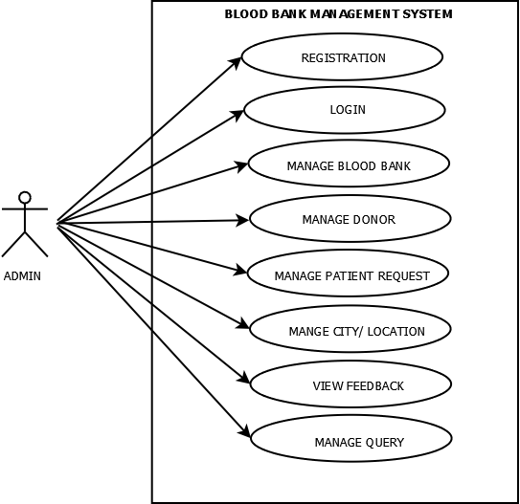 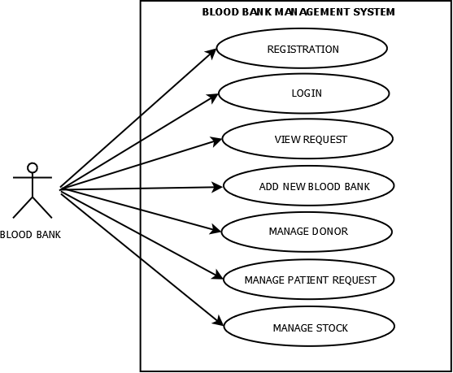

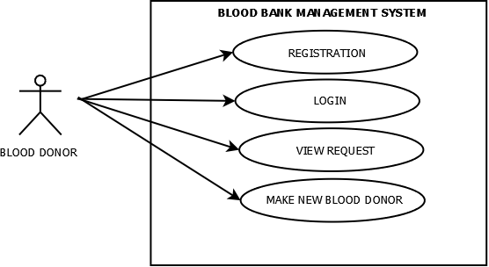 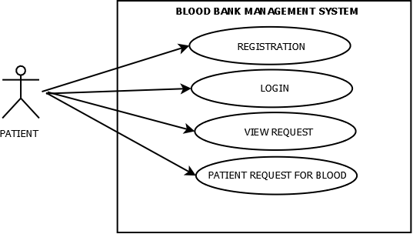

**Activity Diagram:-**

**Blood bank**

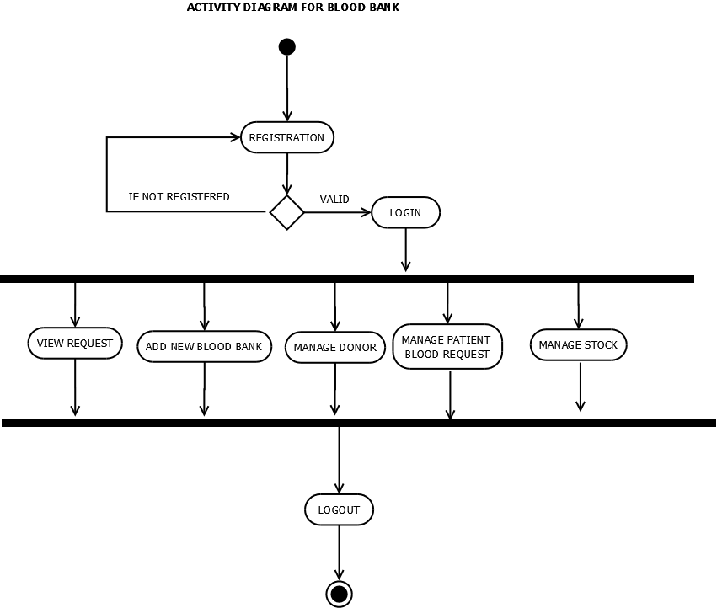

**Blood Donor**

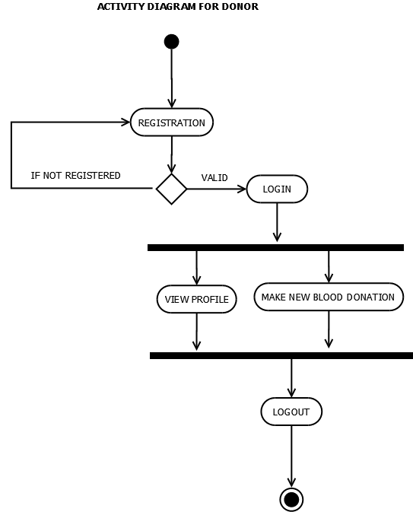

**Patient**

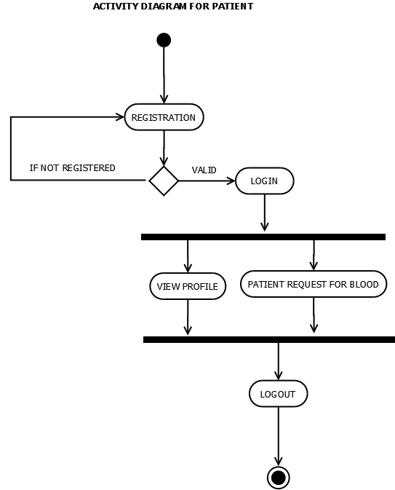

**Admin**

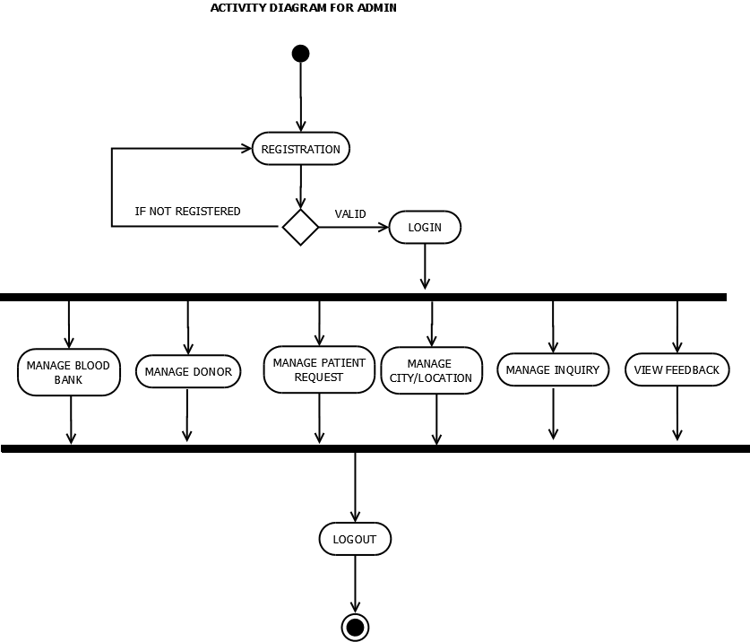

**Sequence Diagram:-**

**Admin**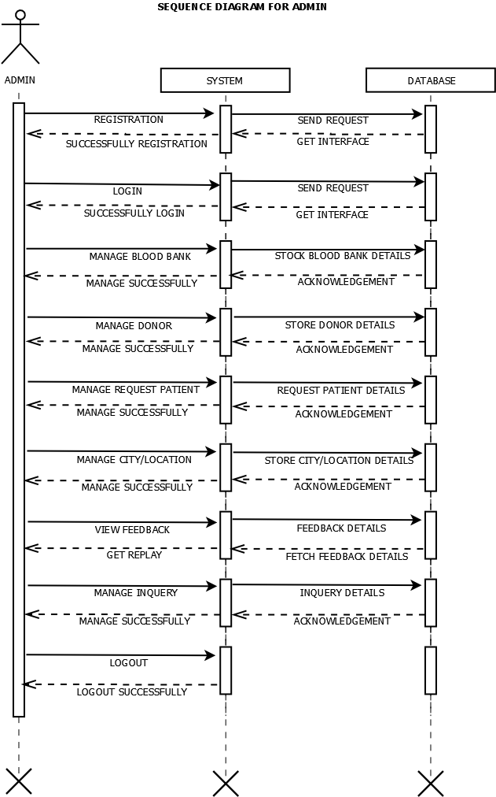

**Blood Bank**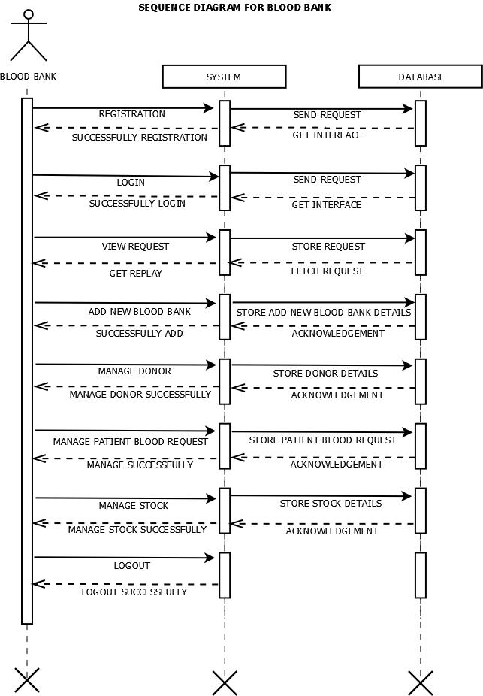

**Donor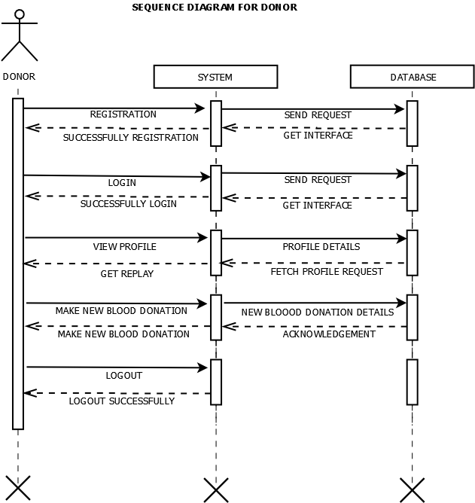Patient**