- Find total number of customers.
SELECT COUNT(*) AS total_customers FROM customers;

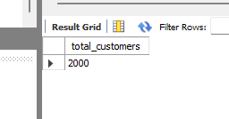

- List customers with income above 10 lakh.
SELECT customer_id, customer_name, annual_income
FROM customers
WHERE annual_income > 1000000;
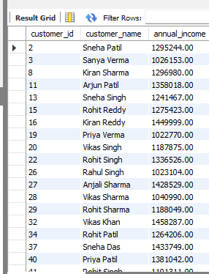

- Identify customers with more than 1 loan.
SELECT c.customer_id,
c.customer_name,
COUNT(l.loan_id) AS total_loan
FROM customers AS c
JOIN loans AS l
ON c.customer_id = l.customer_id
GROUP BY c.customer_id, c.customer_name
HAVING COUNT(l.loan_id) >1;
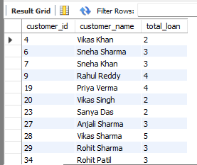

- Find top 10 highest-income customers.
SELECT customer_id, customer_name, annual_income
FROM customers
ORDER BY annual_income DESC LIMIT 10;
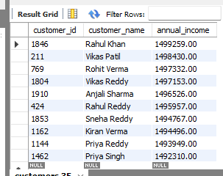

- Show customers grouped by age category.
SELECT
CASE
WHEN age BETWEEN 18 AND 25 THEN 'Young (18-25)'
WHEN age BETWEEN 26 AND 40 THEN 'Adult (26-40)'
WHEN age BETWEEN 41 AND 60 THEN 'Middile-age (41-60)'
WHEN age > 60 THEN 'Senior (60+)'
ELSE 'unknown'
END AS age_category,
COUNT(customer_id) AS total_customers
FROM customers
GROUP BY age_category
ORDER BY total_customers DESC;
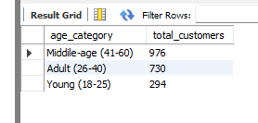

- Find city-wise customer distribution.
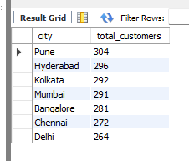

- Identify customers who joined in last 6 months.
SELECT customer_id, customer_name, join_date
FROM customers
WHERE join_date >= (
SELECT DATE_SUB(MAX(join_date), INTERVAL 6 MONTH)
FROM customers
);
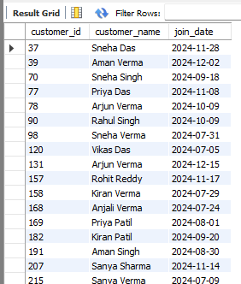

- Detect customers with income < 4 lakh.
SELECT customer_id, customer_name, annual_income
FROM customers
WHERE annual_income < 400000
ORDER BY annual_income DESC;
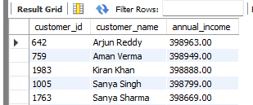

- Show gender distribution.
SELECT gender, COUNT(gender) AS total_customers
FROM customers
GROUP BY gender;
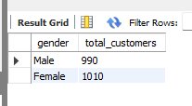

- Identify customers who have only personal loans.
SELECT c.customer_id, c.customer_name, l.loan_type
FROM customers AS c
JOIN loans AS l
ON c.customer_id = l.customer_id
WHERE loan_type = 'personal';
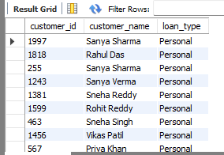

- Count total loans issued.
SELECT COUNT(*) AS total_loans
FROM loans;
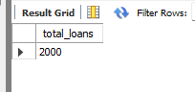

- Total loan amount disbursed.
SELECT SUM(loan_amount) AS total_disbursed_amount
FROM loans;
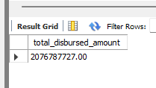

- Loan count by loan type.
SELECT loan_type, COUNT(loan_id) AS total_loans
FROM loans
GROUP BY loan_type;
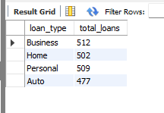

- Highest loan amount per loan type.
SELECT loan_type, MAX(loan_amount) AS highest_loan_amount
FROM loans
GROUP BY loan_type;
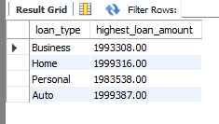

- Average interest rate by loan type.
SELECT loan_type, ROUND(AVG(interest_rate),2) AS avg_interest_rate
FROM loans
GROUP BY loan_type;
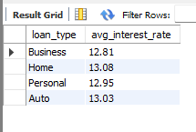

- Loans with tenure > 5 years.
SELECT loan_id, loan_type, tenure_months
FROM loans
WHERE tenure_months > 60;
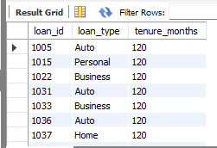
- Loans approved in last 12 months.
SELECT loan_id, loan_type, start_date
FROM loans
WHERE start_date >=(
SELECT DATE_SUB(MAX(start_date), INTERVAL 12 MONTH)
FROM loans);
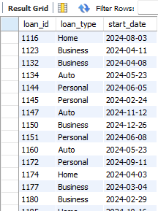

- Customer-wise loan exposure.
SELECT customer_id,
SUM(loan_amount) AS total_loan_exposure
FROM loans
GROUP BY customer_id
ORDER BY total_loan_exposure;
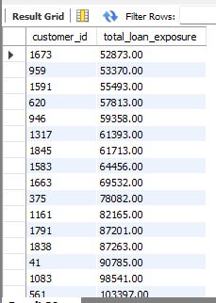

- Loans with interest rate > 15%.
SELECT loan_id, loan_type, interest_rate
FROM loans
WHERE interest_rate >15
ORDER BY interest_rate;
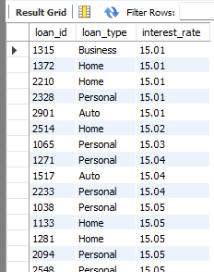

- Loan distribution by city.
SELECT c.city,
l.loan_type,
COUNT(l.loan_id) AS total_loans
FROM customers AS c
JOIN loans AS l
ON c.customer_id = l.customer_id
GROUP BY c.city, l.loan_type;
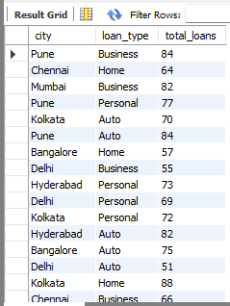

- Count total EMI payments.
SELECT COUNT(*) AS total_emi_payments
FROM payments;
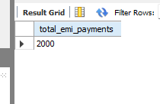

- % On-time vs Late vs Missed payments.
SELECT payment_status,
COUNT(*) AS total_payments,
ROUND(
COUNT(*) * 100.0 / ( SELECT COUNT(*) FROM payments), 2) AS percentage
FROM payments
GROUP BY payment_status;
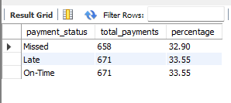

- Customers with >3 late payments.
SELECT c.customer_id,
c.customer_name,
COUNT(*) AS late_payments
FROM customers AS c
JOIN loans AS l
ON c.customer_id = l.customer_id
JOIN payments AS p
ON l.loan_id = p.loan_id
WHERE payment_status = 'Late'
GROUP BY c.customer_id, c.customer_name
HAVING COUNT(*) >3;
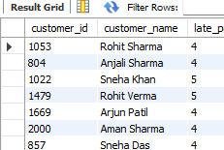

- Months with highest late payments.
SELECT
MONTHNAME(payment_date) AS month_name,
MONTH(payment_date) AS month_number,
COUNT(*) AS total_late_payments
FROM payments
WHERE payment_status = 'Late'
GROUP BY month_name, month_number
ORDER BY total_late_payments DESC;
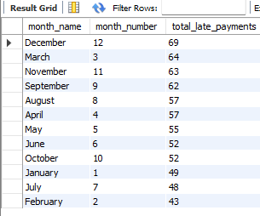

- EMI payments for last 3 months.
SELECT payment_id,
loan_id,
payment_date,
emi_amount,
payment_status
FROM payments
WHERE payment_date >= DATE_SUB(
(SELECT MAX(payment_date) FROM payments),
INTERVAL 3 MONTH)
ORDER BY payment_date DESC;
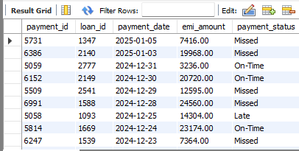

- Total EMI amount collected.
SELECT SUM(emi_amount) AS total_amount_collected
FROM payments;
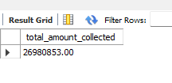
- Missing EMI payments per customer.
SELECT c.customer_id,
c.customer_name,
l.Loan_id,
COUNT(p.payment_id) AS total_missed_emi
FROM customers AS c
JOIN loans AS l
ON c.customer_id = l.customer_id
LEFT JOIN payments AS p
ON p.loan_id = l.loan_id
AND p.payment_status = 'Missed'
GROUP BY c.customer_id, c.customer_name, l.loan_id
ORDER BY total_missed_emi;
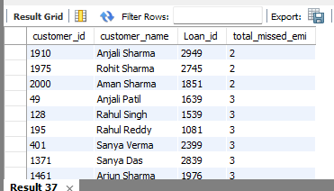
- Perfect on-time payments.
SELECT c.customer_id,
c.customer_name,
COUNT(p.payment_id) AS total_On_time_payments
FROM customers AS c
JOIN loans AS l
ON c.customer_id = l.customer_id
LEFT JOIN payments AS p
ON p.loan_id = l.loan_id
AND p.payment_status = 'On-Time'
GROUP BY c.customer_id, c.customer_name;
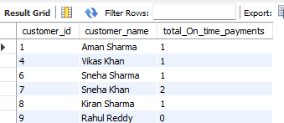

- Loans with >2 missed EMIs.
SELECT c.customer_id,
l.loan_id,
c.customer_name,
COUNT(p.payment_id) AS total_emi_missed
FROM customers AS c
JOIN loans AS l
ON c.customer_id = l.customer_id
LEFT JOIN payments AS p
On p.loan_id = l.loan_id
AND p.payment_status = 'Missed'
GROUP BY c.customer_id, l.loan_id, c.customer_name
HAVING COUNT(p.payment_id) >2;
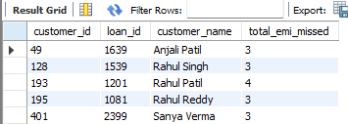

- Customers who pay 5+ days late often.
SELECT c.customer_id,
c.customer_name,
COUNT(p.payment_id) AS late_payment_count
FROM customers AS c
JOIN loans AS l
ON c.customer_id = l.customer_id
JOIN payments AS p
ON p.loan_id = l.loan_id
WHERE DATEDIFF(p.payment_date, p.due_date) >= 5
GROUP BY c.customer_id, c.customer_name
HAVING COUNT(p.payment_id) > 2
ORDER BY late_payment_count DESC;
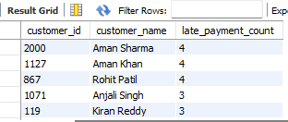

- Count total defaults.
SELECT COUNT(default_id) AS total_defaults
FROM loan_defaults;
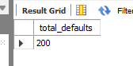

- Total default amount lost.
SELECT SUM(default_amount) AS total_amount_lost
FROM loan_defaults;
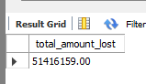

- Loan type with most defaults.
SELECT l.loan_type,
COUNT(ld.default_id) AS total_defaults
FROM loan_defaults AS ld
JOIN loans AS l
ON l.loan_id = ld.loan_id
GROUP BY l.loan_type
ORDER BY total_defaults DESC LIMIT 1;
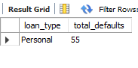
- Top 10 highest default customers.
SELECT c.customer_id,
c.customer_name,
COUNT(ld.default_id) AS total_defaults
FROM customers AS c
JOIN loans AS l
ON c.customer_id = l.customer_id
JOIN loan_defaults AS ld
ON l.loan_id = ld.loan_id
GROUP BY c.customer_id, c.customer_name
ORDER BY total_defaults DESC LIMIT 10;
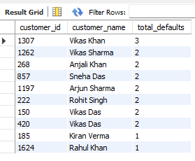

- Customers with late payment + default history.
SELECT DISTINCT
c.customer_id,
c.customer_name,
c.city,
c.annual_income
FROM customers c
JOIN loans l
ON c.customer_id = l.customer_id
JOIN loan_defaults d
ON l.loan_id = d.loan_id
JOIN payments p
ON l.loan_id = p.loan_id
WHERE (p.payment_status) IN ('Late', 'Missed');

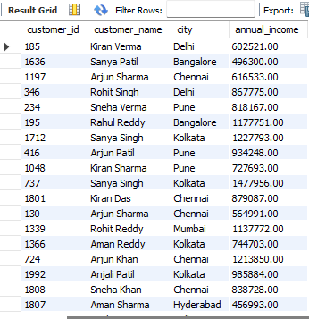

- City-wise default ratio.
SELECT
c.city,
COUNT(DISTINCT d.loan_id) AS total_defaulted_loans,
COUNT(DISTINCT l.loan_id) AS total_loans,
ROUND(
COUNT(DISTINCT d.loan_id) / COUNT(DISTINCT l.loan_id) * 100,
2
) AS default_ratio_percentage
FROM customers c
JOIN loans l
ON c.customer_id = l.customer_id
LEFT JOIN loan_defaults d
ON l.loan_id = d.loan_id
GROUP BY c.city
ORDER BY default_ratio_percentage DESC;
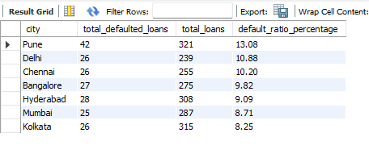
- Income vs default rate analysis.

SELECT
CASE
WHEN c.annual_income < 300000 THEN 'Low Income (<3L)'
WHEN c.annual_income BETWEEN 300000 AND 700000 THEN 'Middle Income (3L-7L)'
WHEN c.annual_income BETWEEN 700000 AND 1500000 THEN 'High Income (7L-15L)'
ELSE 'Very High Income (>15L)'
END AS income_group,

COUNT(DISTINCT l.loan_id) AS total_loans,
COUNT(DISTINCT d.loan_id) AS defaulted_loans,

ROUND(
COUNT(DISTINCT d.loan_id) / COUNT(DISTINCT l.loan_id) * 100,
2
) AS default_rate_percentage
FROM customers c
JOIN loans l
ON c.customer_id = l.customer_id
LEFT JOIN loan_defaults d
ON l.loan_id = d.loan_id
GROUP BY income_group
ORDER BY default_rate_percentage DESC;

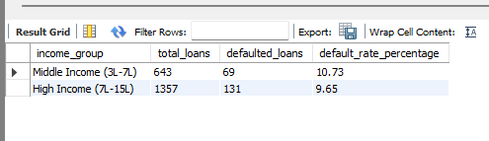

- Age group vs default rate.
SELECT
CASE
WHEN c.age < 25 THEN '18–24'
WHEN c.age BETWEEN 25 AND 34 THEN '25–34'
WHEN c.age BETWEEN 35 AND 44 THEN '35–44'
WHEN c.age BETWEEN 45 AND 54 THEN '45–54'
WHEN c.age BETWEEN 55 AND 64 THEN '55–64'
ELSE '65+'
END AS age_group,

COUNT(DISTINCT l.loan_id) AS total_loans,
COUNT(DISTINCT d.loan_id) AS defaulted_loans,

ROUND(
(COUNT(DISTINCT d.loan_id) / COUNT(DISTINCT l.loan_id)) * 100,
2
) AS default_rate_percentage
FROM customers c
JOIN loans l
ON c.customer_id = l.customer_id
LEFT JOIN loan_defaults d
ON l.loan_id = d.loan_id
GROUP BY age_group
ORDER BY default_rate_percentage DESC;

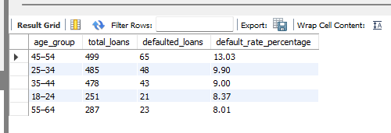

- Missed EMIs before default.
SELECT
c.customer_id,
c.customer_name,
l.loan_id,
d.default_date,
COUNT(*) AS missed_emis_before_default
FROM loan_defaults d
JOIN loans l
ON d.loan_id = l.loan_id
JOIN customers c
ON l.customer_id = c.customer_id
JOIN payments p
ON p.loan_id = l.loan_id
WHERE TRIM(p.payment_status) = 'Missed'
AND p.payment_date < d.default_date -- missed EMI occurred before default
GROUP BY
c.customer_id,
c.customer_name,
l.loan_id,
d.default_date
ORDER BY missed_emis_before_default DESC;

