Testing of Babywood

1)Sign in page

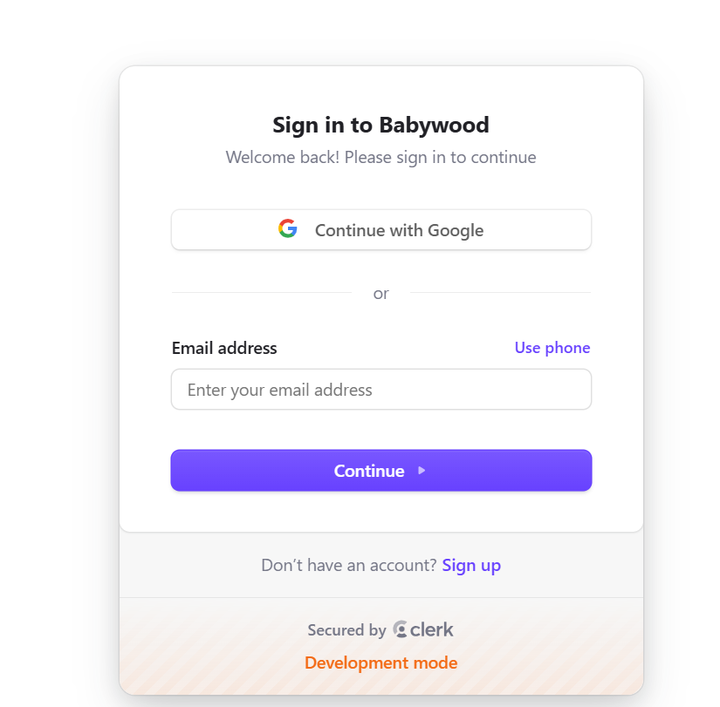

2)product fetching

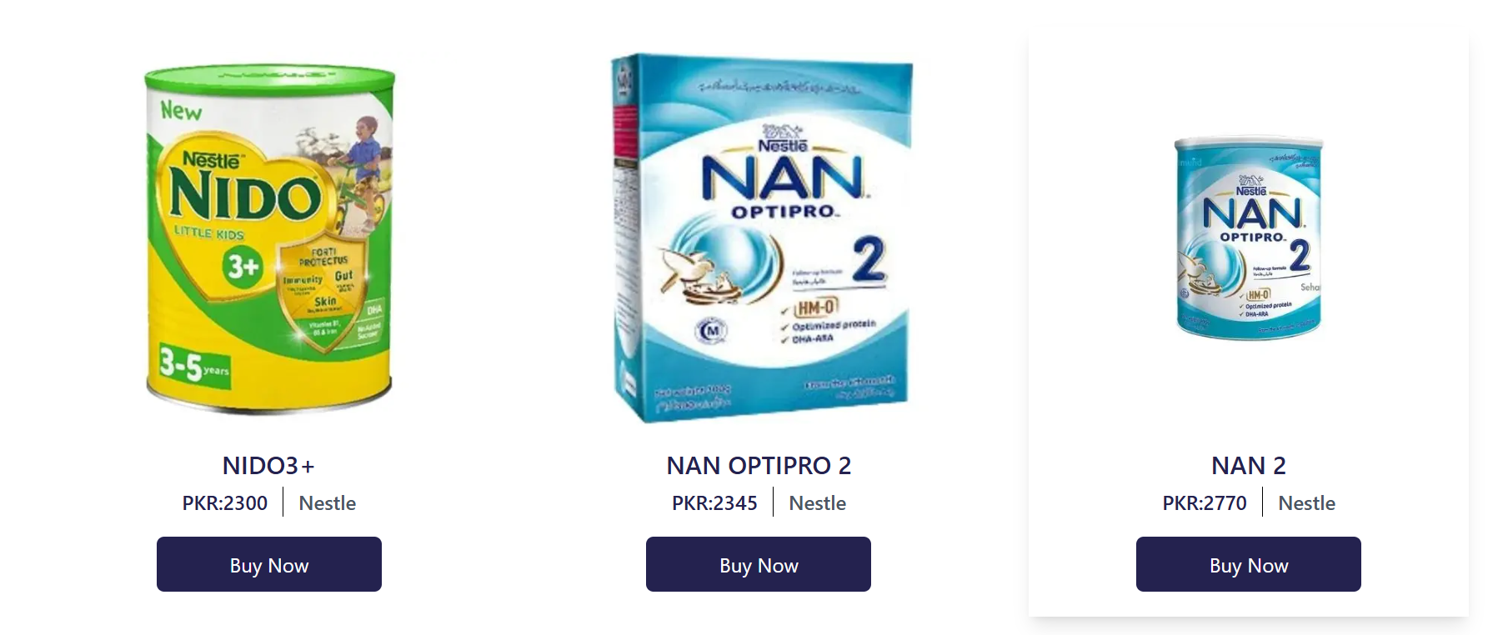

3)Searching functionality

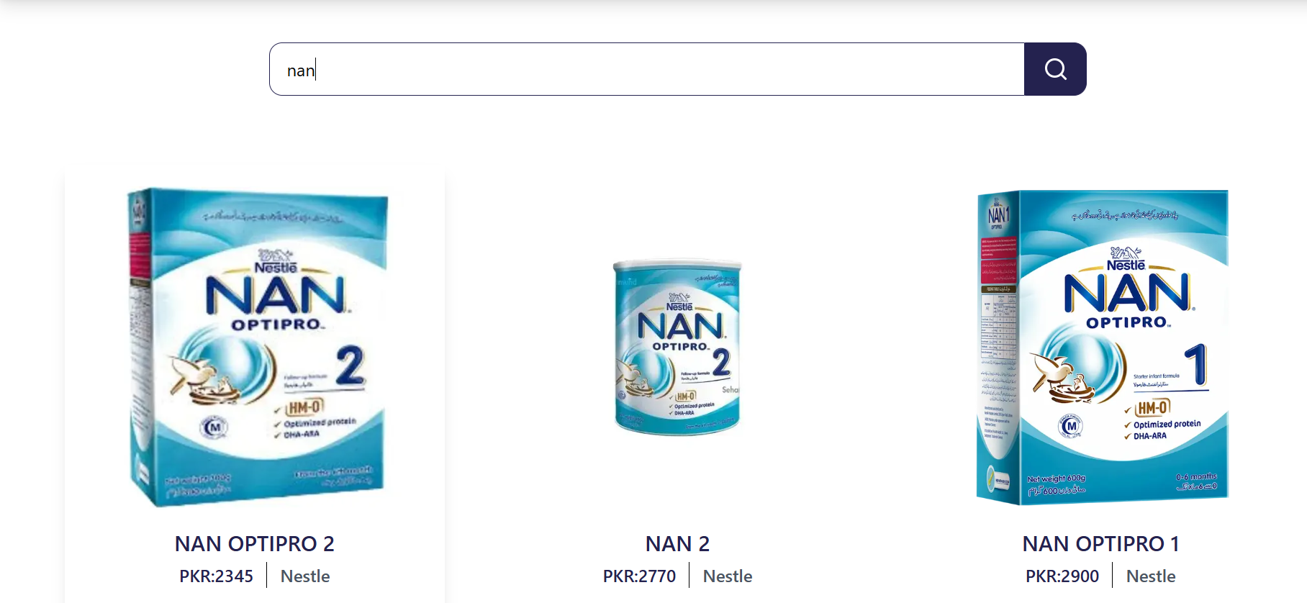

4)Responsive

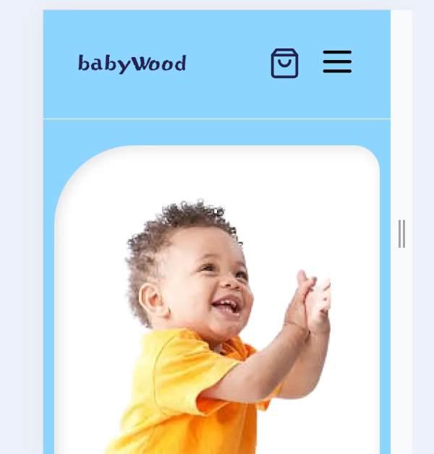

5)Dynamic data

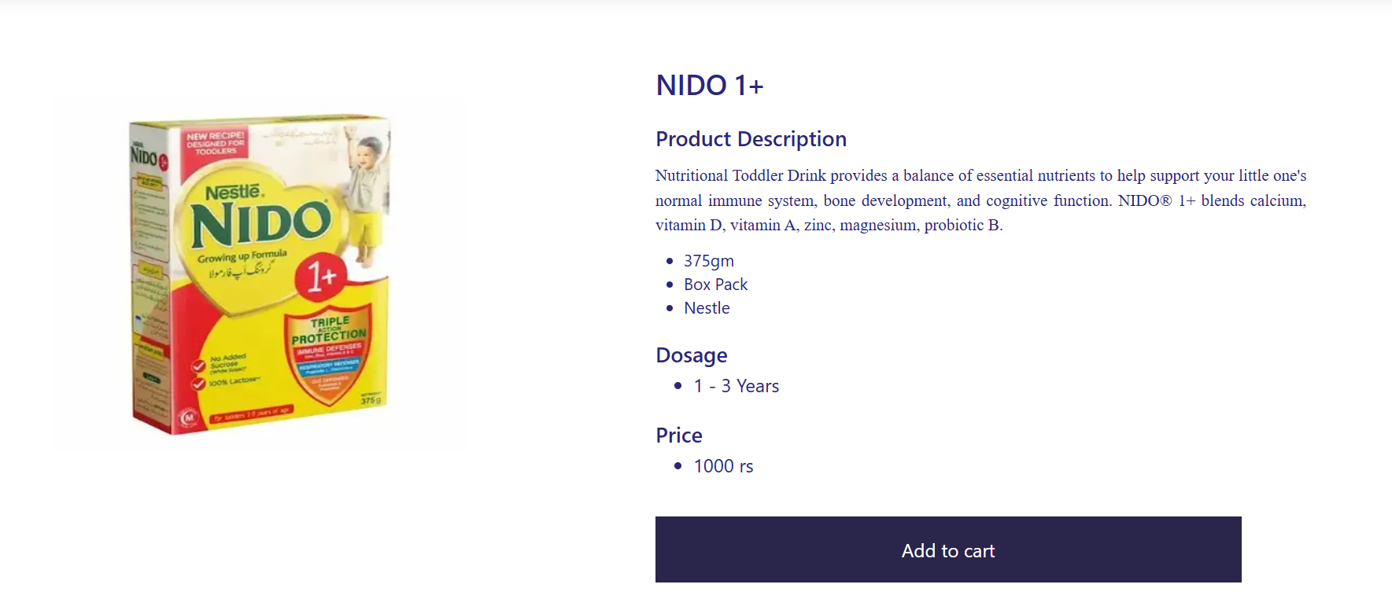

6)Add to cart

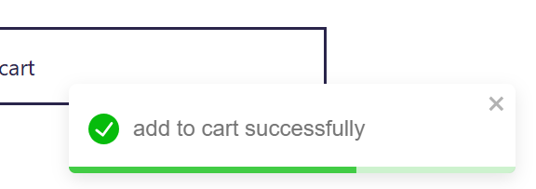

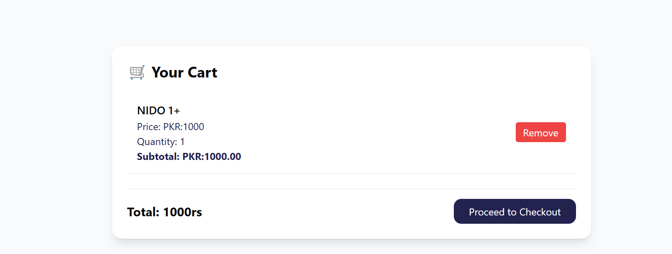

7)Perfomance optimization

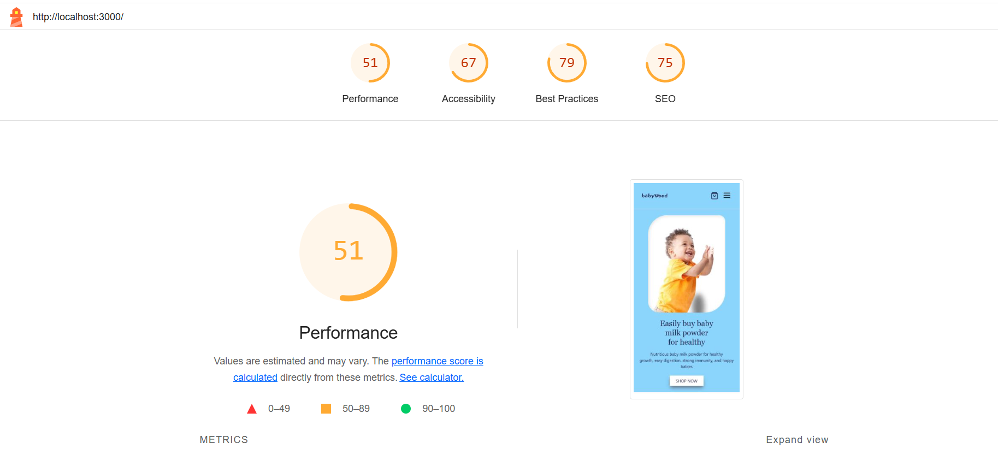

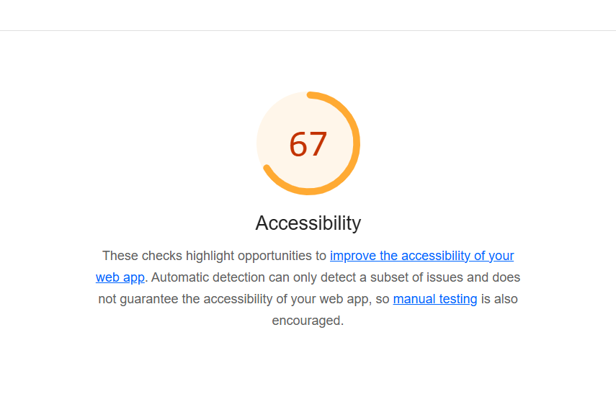

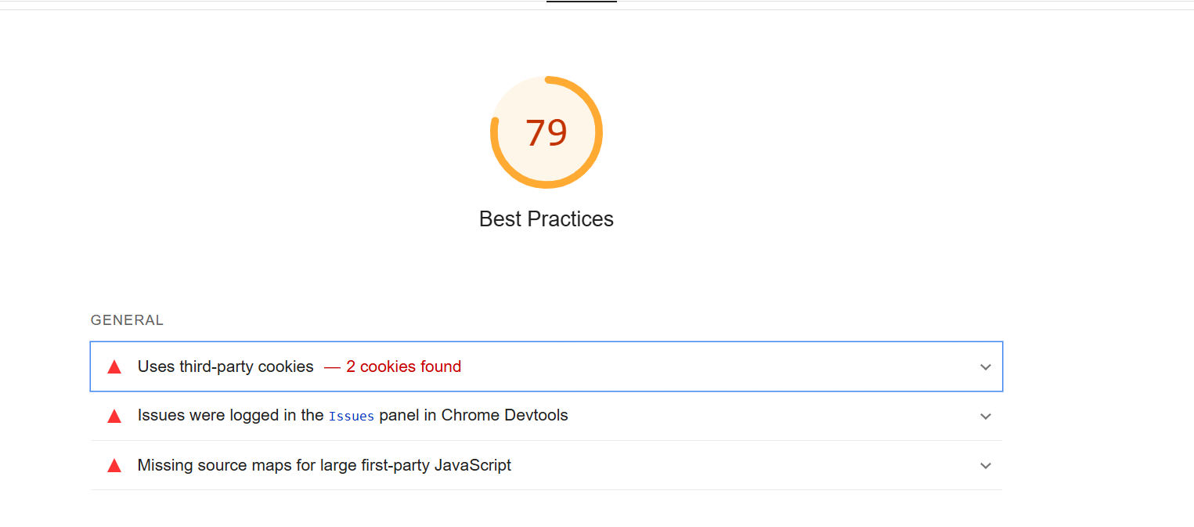

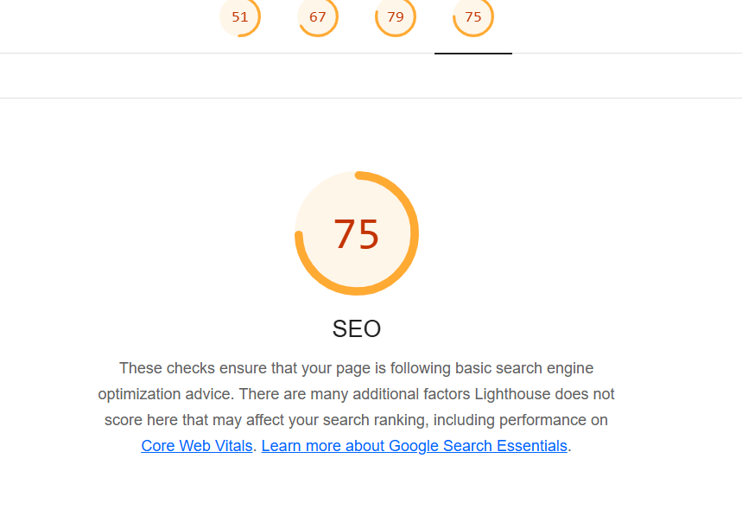

8)Developer resources

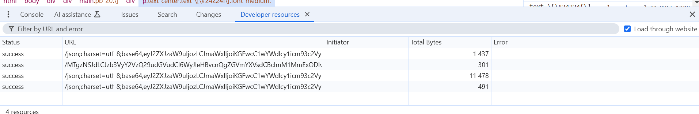

9)Performance monitor

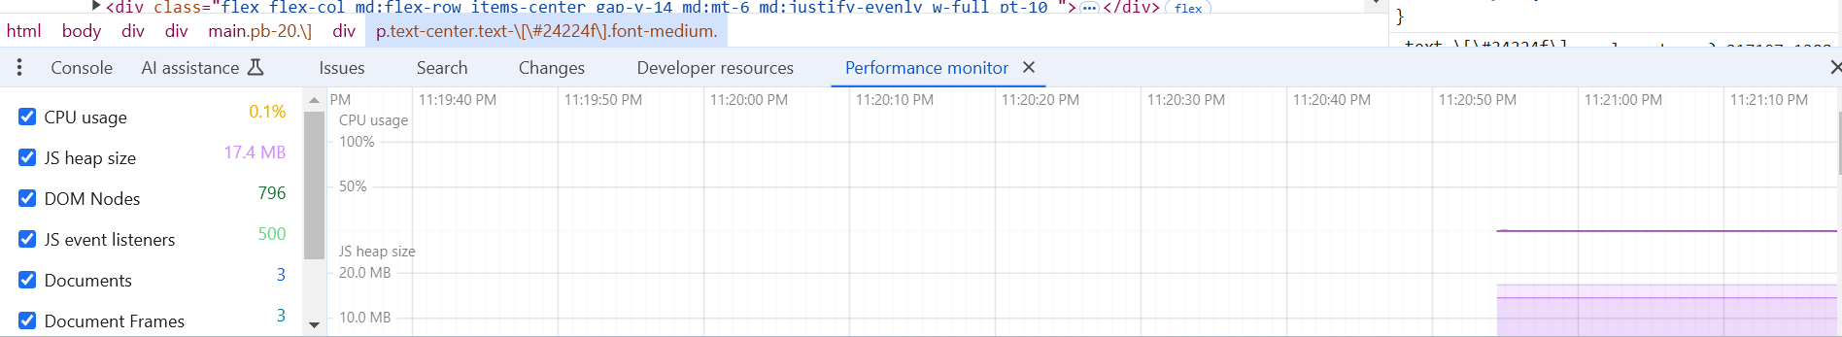

10) Team work

1)Abdul Subhan (403463)

Add to cart (functionality and ui/ux design)

Navbar (functionality and ui/ux design)

Footer (responsive : subhan) (ui/ux design:ahtesham)

Baby care page (functionality and design)

Suggestion (functionality and ui/ux design)

Feedback corner(functionality and ui/ux design)

Hero section (design: Salman)(Responsive: Subhan)

Dynamic rounding(functionality) design (Salman ) fetching & responsive(Ahtsham)

Search (functionality:ahtesham)(design:subhan)

Figma design

2)Ahtesham ahmed (286896)

Search (functionality:ahtesham)(design:subhan)

Dynamic rounting(functionality) design (salman ) fetching & responsive(ahtesham)

Footer (responsive : subhan) (ui/ux design:ahtesham)

Our product

About us

Stripe (fetch :ghufran) (design:ahtesham)

Clerkjs (ahtesham & ghufran error solve subhan)

Product (fetch : salman , design:ahtesham)

Thanks (design)

Sanity schema (logic)

3)Salman Ghafoor (485512) & Ghufran (482255)

Dynamic rounting(functionality) design (salman ) fetching & responsive(ahtesham)

Product (fetch : salman , design:ahtesham)

Images graphicdesigning

Product picture click

Hero section (design:Salman)(Responsive:Subhan)

Clerkjs (ahtesham & ghufran error solve subhan)

Stripe (fetch :ghufran) (design:ahtesham)

Sanity schema data insert

(Salman and Ghufran working in a company)