Software Design Document
< AI Study Mentor Smart Learning Planner>



Submitted by
AHTESHAM HAIDER (F22BINFT1M01032)

Submitted to
SIR FAISAL SHAB

Department of Information Technology
Faculty of Computing
The Islamia University of Bahawalpur

Table of Contents
AI Study Mentor & Smart Learning Planner
Software Design Document (SDD)
1. Introduction
1.1 Purpose of the Document
1.2 Project Overview
1.3 Scope of the System
1.4 Objectives of the Project
1.5 Intended Audience
1.6 Definitions, Acronyms, and Abbreviations
2. System Overview
2.1 Existing System Analysis
2.2 Proposed System
2.3 System Features
2.4 Benefits of the Proposed System
3.Overall System Architecture
3.1 Architectural Overview
3.2 System Architecture Diagram
3.3 Hardware Requirements
3.4 Software Requirements
3.5 Technology Stack
4.Functional Requirements
4.1 User Registration and Login
4.2 Profile Management
4.3 AI-Based Study Plan Generator
4.4 Notes Upload and Summarization
4.5 Quiz and Flashcard Generation
4.6 Smart Reminders and Notifications
4.7 Progress Tracking
5.Non-Functional Requirements
5.1 Performance Requirements
5.2 Security Requirements
5.3 Usability Requirements
5.4 Reliability Requirements
5.5 Scalability Requirements
6.Data Design
6.1 Database Design Overview
6.2 Entity Relationship Diagram (ERD)
6.3 Data Dictionary
6.4 Data Storage Strategy
7.Module Design
7.1 User Management Module
7.2 Study Planner Module
7.3 AI Recommendation Module
7.4 Quiz & Assessment Module
7.5 Analytics and Reporting Module
8.UML Diagrams
8.1 Use Case Diagram
8.2 Class Diagram
8.3 Sequence Diagram
8.4 Activity Diagram
9. User Interface Design
9.1 UI Design Principles
9.2 User Dashboard
9.3 Study Planner Screen
9.4 Quiz Interface
9.5 Progress Report Screen
10. Security Design
10.1 Authentication and Authorization
10.2 Data Privacy
10.3 Threat Handling
11. Testing Strategy
11.1 Testing Approach
11.2 Unit Testing
11.3 Integration Testing
11.4 System Testing
11.5 User Acceptance Testing
12. Deployment Plan
12.1 Deployment Environment
12.2 Installation Process
12.3 System Configuration
13. Maintenance and Future Enhancements
13.1 System Maintenance
13.2 Future Enhancements Software design

1. Introduction
1.1 Purpose of the Document
This Software Design Document (SDD) provides a detailed description of the design, architecture, and functional behavior of the AI Study Mentor & Smart Learning Planner system. It serves as a reference for developers, instructors, and stakeholders.
1.2 Project Overview
AI Study Mentor is an intelligent learning platform that assists students in planning studies, summarizing notes, generating quizzes, and tracking progress using Artificial Intelligence.
1.3 Scope of the System
The system covers:
Study planning
AI-based content summarization
Smart quizzes and flashcards
Progress monitoring
1.4 Objectives of the Project
Improve student learning efficiency
Automate study scheduling
Provide personalized recommendations
1.5 Intended Audience
University students
Teachers and instructors
Software developers
Project evaluators
1.6 Definitions, Acronyms, and Abbreviations
AI: Artificial Intelligence
SDD: Software Design Document
UI: User Interface
UML: Unified Modeling Language
2. System Overview
2.1 Existing System Analysis
Traditional learning systems rely on:
Manual study planning
No personalization
Lack of smart feedback
2.2 Proposed System
The proposed system uses AI to:
Analyze user performance
Generate adaptive study plans
Automate revision strategies
2.3 System Features
AI study planner
Notes summarization
Quiz and flashcards generation
Smart reminders
2.4 Benefits of the Proposed System
Saves time
Improves productivity
Personalized learning
3. Overall System Architecture
3.1 Architectural Overview
The system follows a Client–Server Architecture with AI services integrated at the backend.
3.2 System Architecture Diagram
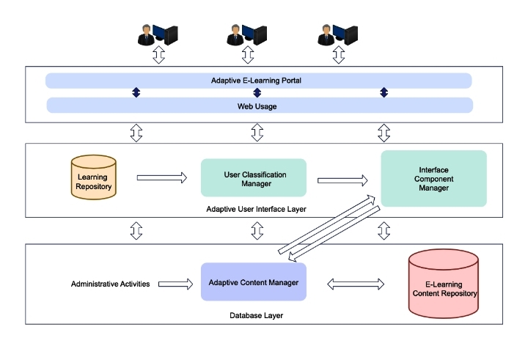
3.3 Hardware Requirements
Smartphone / Laptop
Minimum 4GB RAM
Internet connection
3.4 Software Requirements
Android / Web Browser
Cloud Server
Database (MySQL / Firebase)
3.5 Technology Stack
Frontend: React / Flutter
Backend: Python (FastAPI / Django)
AI: NLP Models
Database: Firebase / MySQL
4. Functional Requirements
4.1 User Registration and Login
Users can sign up using email and securely log in.
4.2 Profile Management
Users can update:
Subjects
Study goals
Daily availability
4.3 AI-Based Study Plan Generator
AI analyzes user input and generates a personalized study schedule.
4.4 Notes Upload and Summarization
Users upload PDFs or text; AI generates summaries.
4.5 Quiz and Flashcard Generation
The system creates MCQs and flashcards automatically.
4.6 Smart Reminders and Notifications
Reminders are sent based on study plan deadlines.
4.7 Progress Tracking
Graphical reports show learning performance.
5. Non-Functional Requirements
5.1 Performance Requirements
Fast response time
Real-time notifications
5.2 Security Requirements
Encrypted passwords
Secure authentication
5.3 Usability Requirements
Simple UI
Easy navigation
5.4 Reliability Requirements
24/7 availability
Minimal downtime
5.5 Scalability Requirements
Supports multiple users
Cloud-based scaling
6. Data Design
6.1 Database Design Overview
The database stores:
User data
Study plans
Quiz results
6.2 Entity Relationship Diagram (ERD)
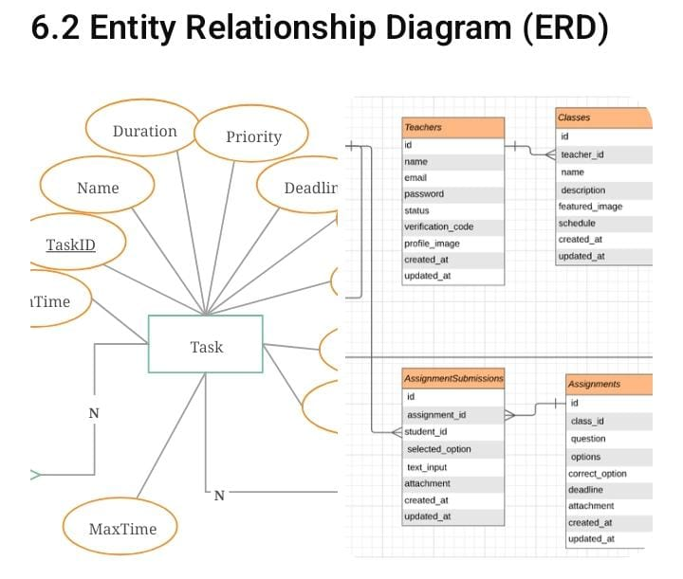
6.3 Data Dictionary
Entity
Description
User
Student profile data
StudyPlan
Generated schedules
Quiz
Questions and scores
6.4 Data Storage Strategy
Cloud-based database with backups.
7. Module Design
7.1 User Management Module
Handles authentication and profiles.
7.2 Study Planner Module
Creates and manages schedules.
7.3 AI Recommendation Module
Analyzes performance and suggests improvements.
7.4 Quiz & Assessment Module
Manages quizzes and results.
7.5 Analytics and Reporting Module
Displays charts and progress insights.

8. UML Diagrams
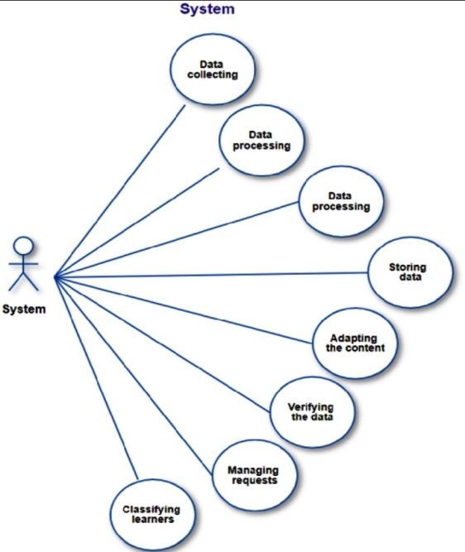
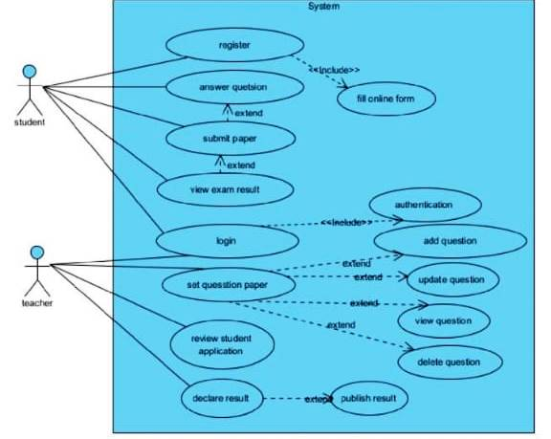
8.1 Use Case Diagram

8.2 Class Diagram
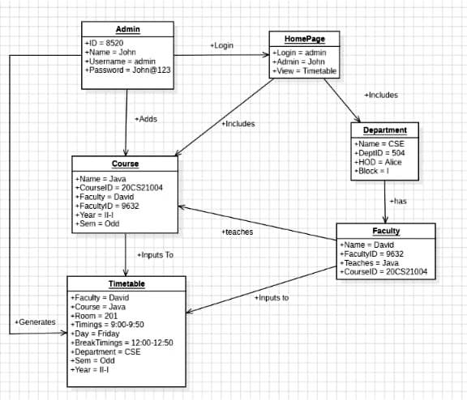
8.3 Sequence Diagram
8.4 Activity Diagram

9. User Interface Design
9.1 UI Design Principles
Minimal
Consistent
User-friendly
9.2 User Dashboard
9.3 Study Planner Screen
9.4 Quiz Interface
9.5 Progress Report Screen

10. Security Design
10.1 Authentication and Authorization
Role-based secure access.
10.2 Data Privacy
User data is encrypted.
10.3 Threat Handling
Protection against unauthorized access.
11. Testing Strategy
11.1 Testing Approach
Black-box and white-box testing.
11.2 Unit Testing
Individual modules tested separately.
11.3 Integration Testing
Modules tested together.
11.4 System Testing
End-to-end testing.
11.5 User Acceptance Testing
Feedback from students.
12. Deployment Plan
12.1 Deployment Environment
Cloud-based servers.
12.2 Installation Process
Upload backend
Configure database
12.3 System Configuration
API and environment setup.
13. Maintenance and Future Enhancements
13.1 System Maintenance
Regular updates and backups.
13.2 Future Enhancements
Voice assistant
Multilingual support

