**Attendance / Shift** – Add Record  
semicolon comes in CSS statement

class="btn btn-primary;addShow"   
  
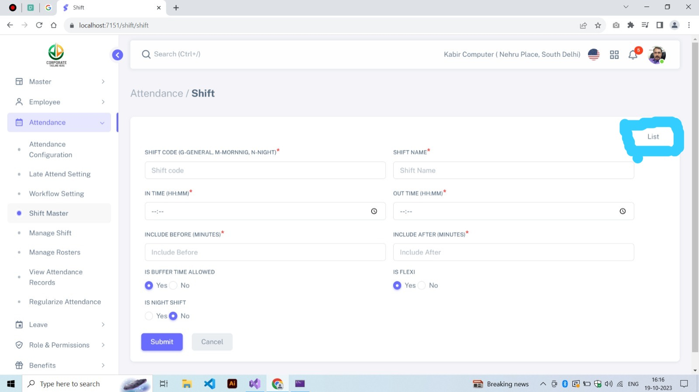  
  
__________________________________________________________________________________  
  
Change CSS

**Remove:** class=”form-check d-sm-inline-block”  
**Add:** class=”form-check form-check-inline”  
  
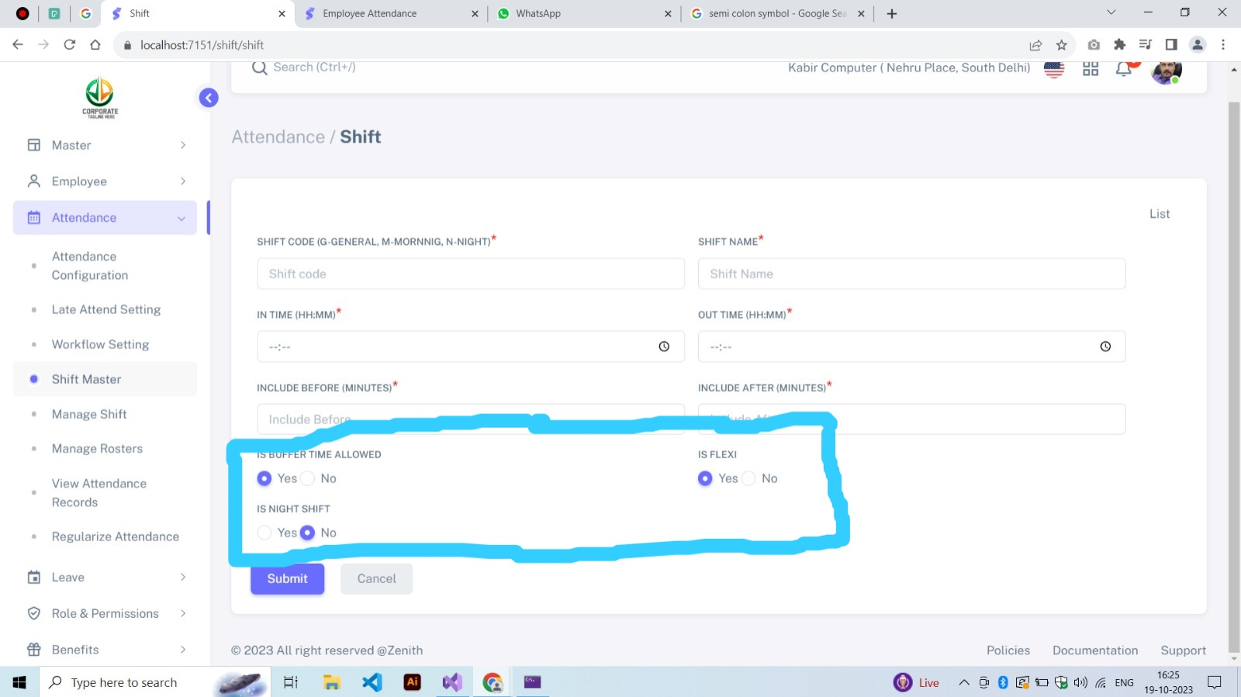

**Attendance / View Attendance**    
  
CSS Missing

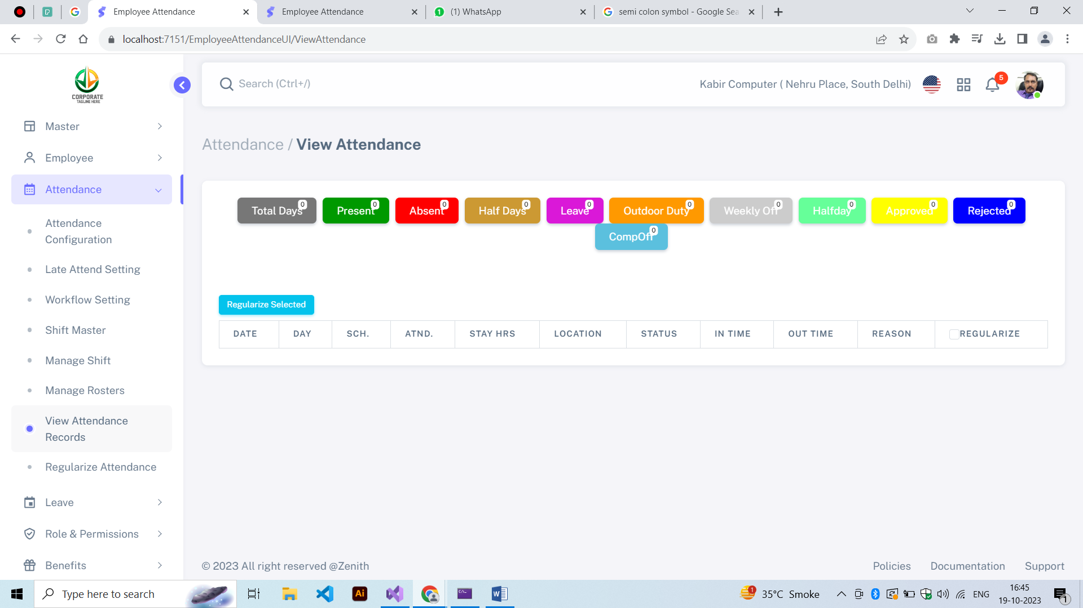  
__________________________________________________________________________________  
  
1) Please use space between Checkbox and Select 2) Please apply “mb-3” class in table  
  
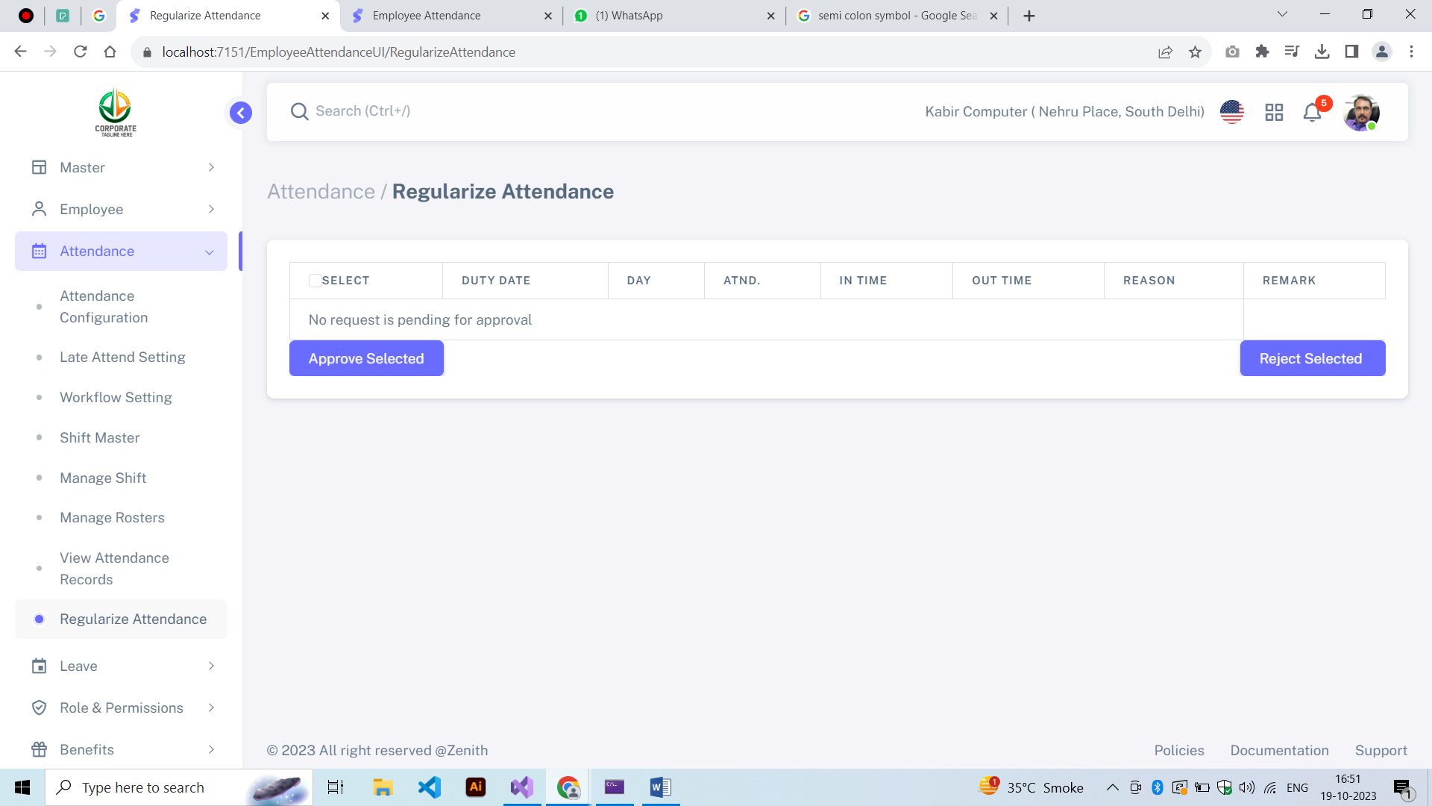  
  
  
  
  
 **Leave / Leave Type**Change CSS

**Remove:** class=”form-check d-sm-inline-block”  
**Add:** class=”form-check form-check-inline”

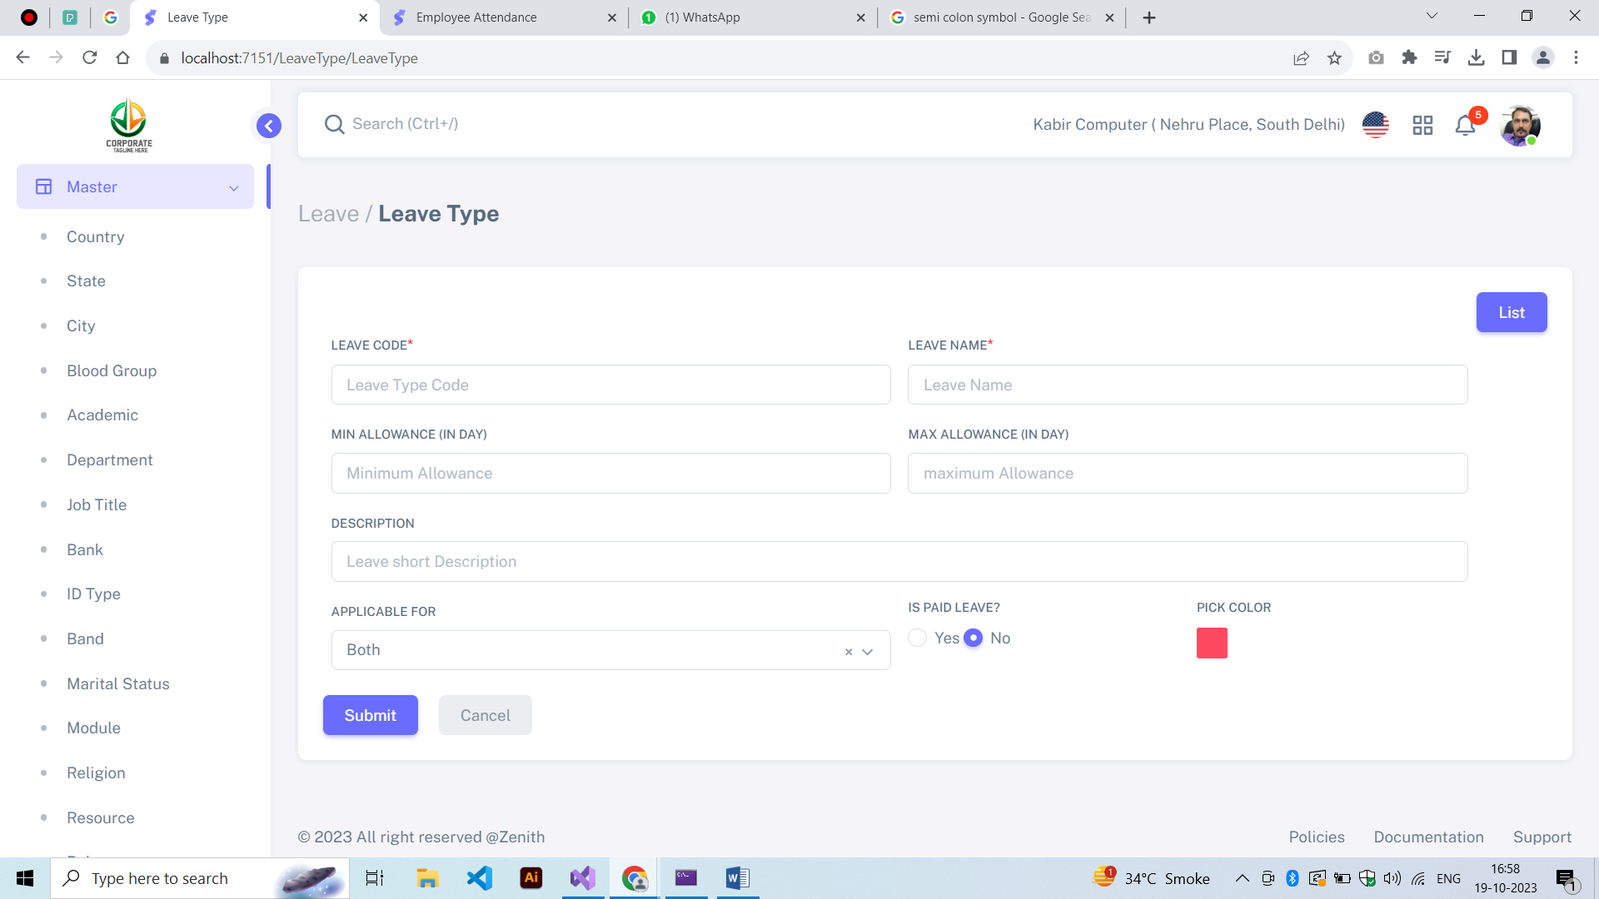  
  
  
  
  
  
**ALSO EVERY LOGIN LOGO POSITION IS DIFFERENT. PLEASE PUT IT IN THE CENTER.**