Supply Chain Disruption Predictor Documentation

7. Data Dictionary / Data Sets
The platform harnesses the following primary data schemas to store and process prediction, reporting, and news-based sentiment metrics on supply chain disruption.
Data Dictionary
1. NewsArticle:
Field Name | Data Type | Description
id | String | Unique document identifier.
source | String | Publication name fetching the news.
sentiment | Enum | Positive / Neutral / Negative.
disruption_type | Enum | Weather, Labor, Logistics, etc.

2. Prediction / Alert:
Field Name | Data Type | Description
id | String | Alert identifier.
risk_level | Enum | Risk severity ranging from Low to High.
disruption_type | Enum | Categorization of disruption anomaly.

3. RegionRisk:
Field Name | Data Type | Description
region_name | String | Target geographical location.
risk_level | Enum | Computed AI risk severity (Low, Medium, High).
alerts | List | Embedded collection of current regional warnings.

8. Screen Layouts
The software application delivers an intuitive user interface for maximum situational awareness:
Dashboard Layout
Top Panel: Executive Summary KPIs (Active Alerts, Regions Monitored, Critical Disruptions).
Center Interface: Interactive Geographic Canvas (SVG-based D3 Map) projecting active regional threats colored by intensity (Red/Amber/Green).
Right Sidebar: High-alert real-time news articles matched with semantic sentiment indicators.
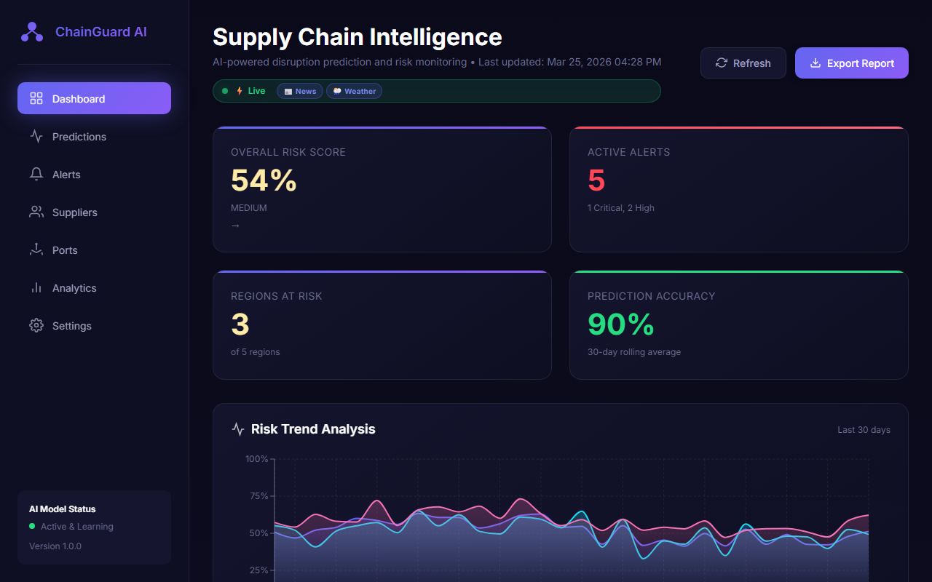
Mobile Responsive View
Stack-based representation prioritizing KPI alerts on top, followed by the map, collapsing trend analysis data at the bottom of the column structure.
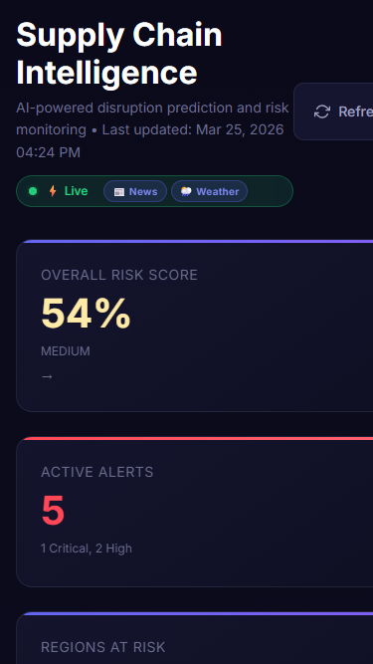
Predictions View
Interactive forecasting based on What-If Scenario and AI simulations.
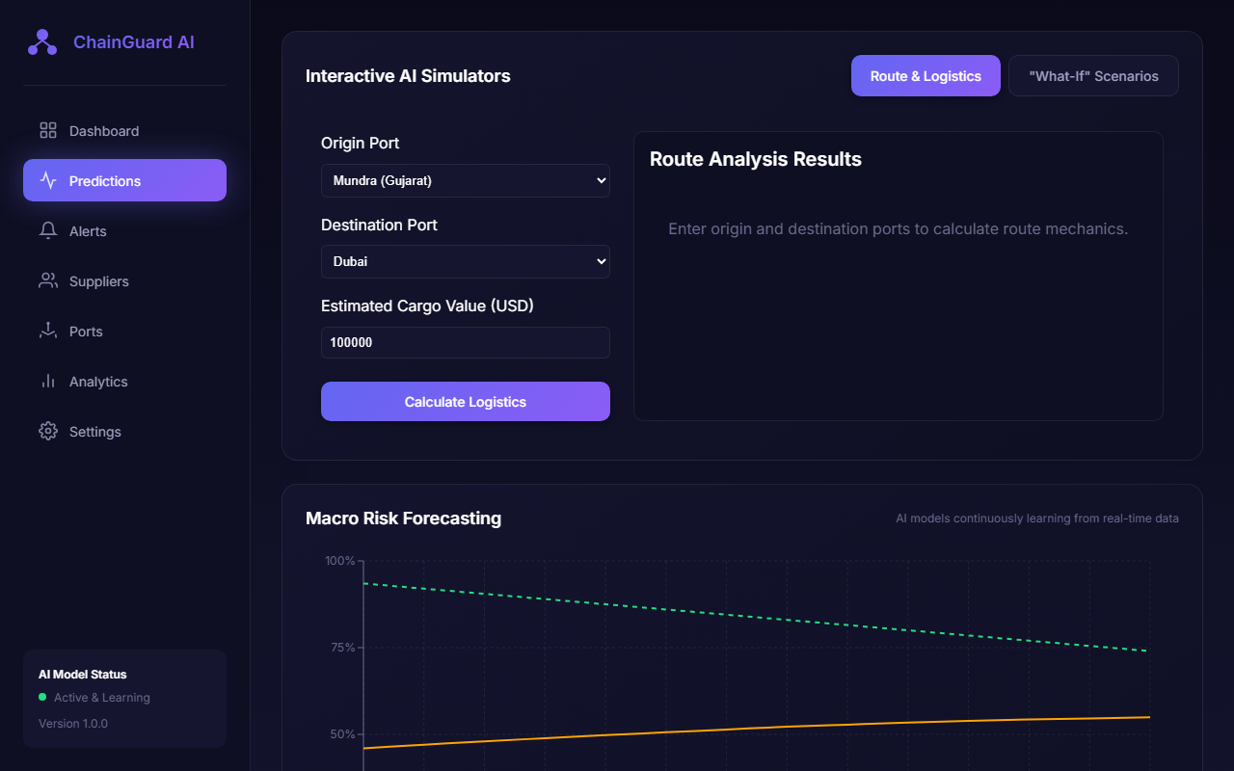
Alerts View
Comprehensive list of system-generated priority alerts.
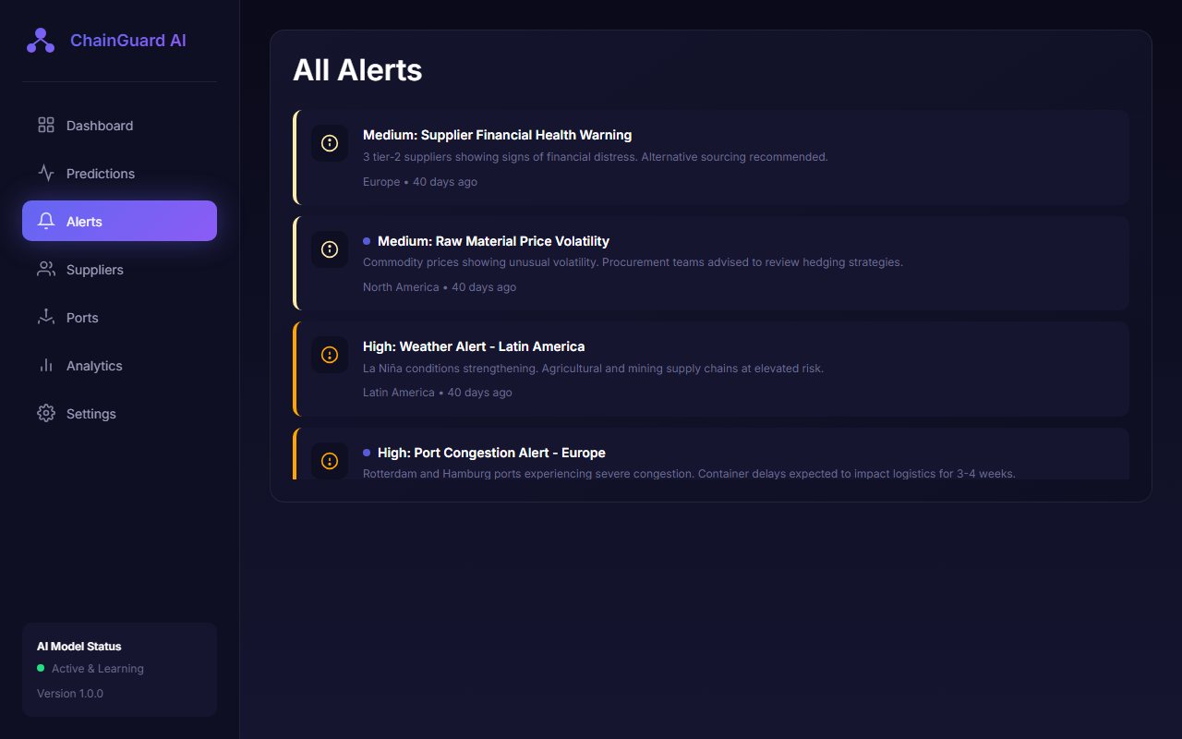
Suppliers View
Detailed overview of active suppliers and respective risk assessments.
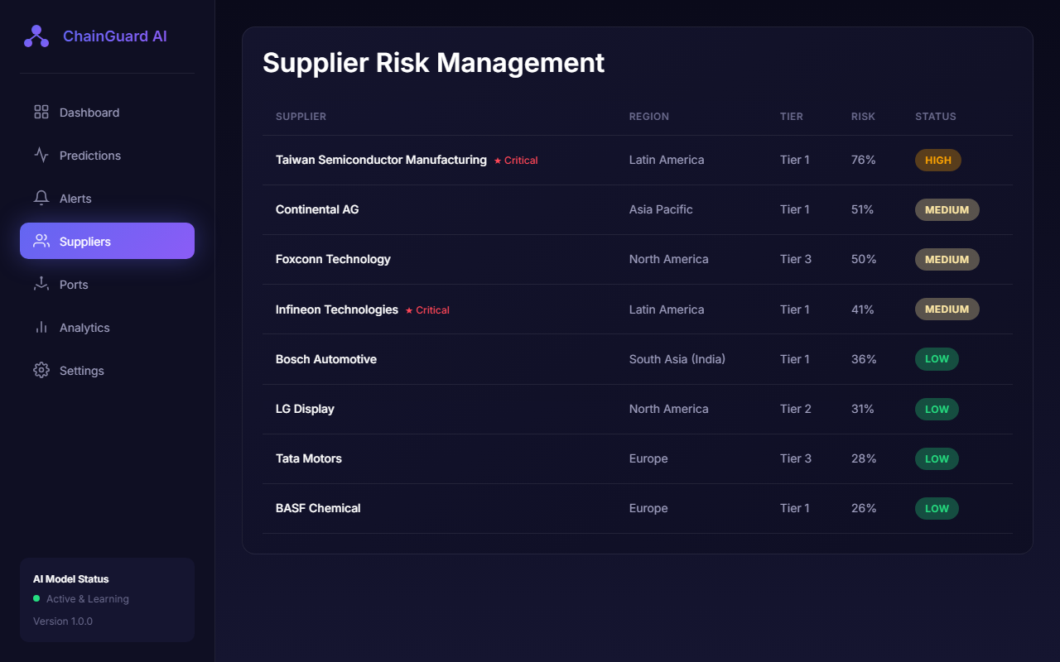
Ports View
Geospatial mapping and analytical deep dive into global port throughput.
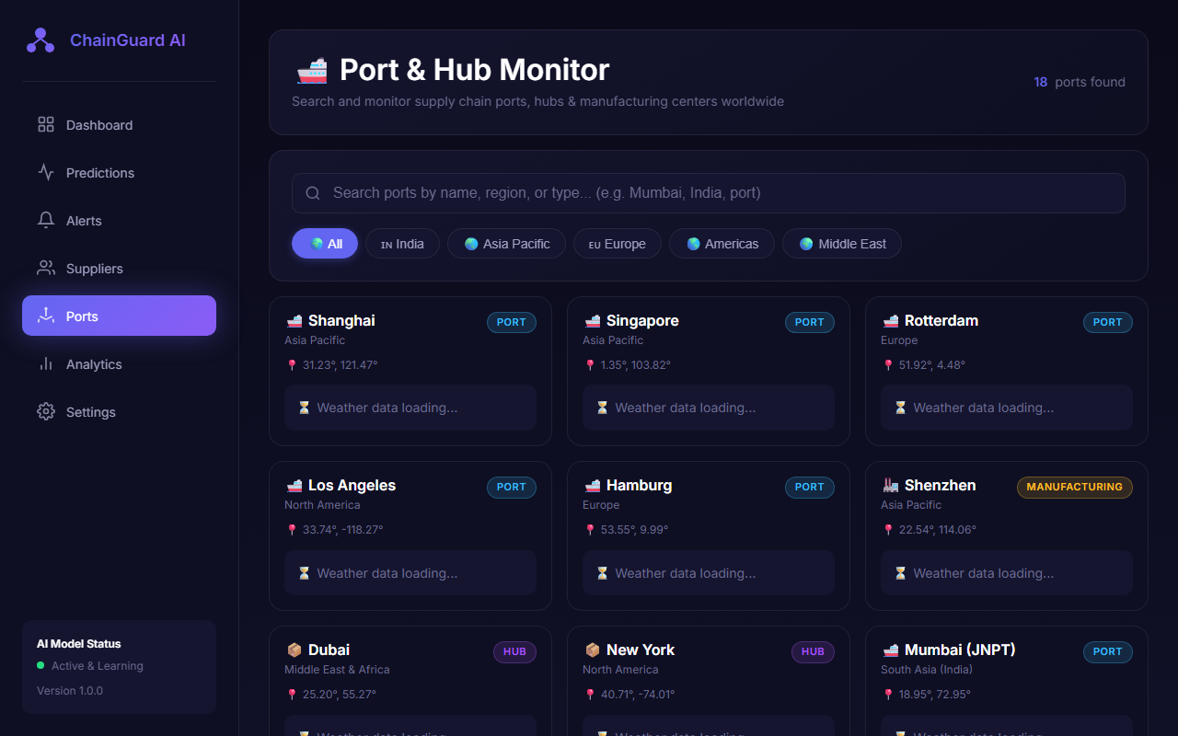
Analytics View
Advanced macroscopic indicators and temporal disruption trending analysis.
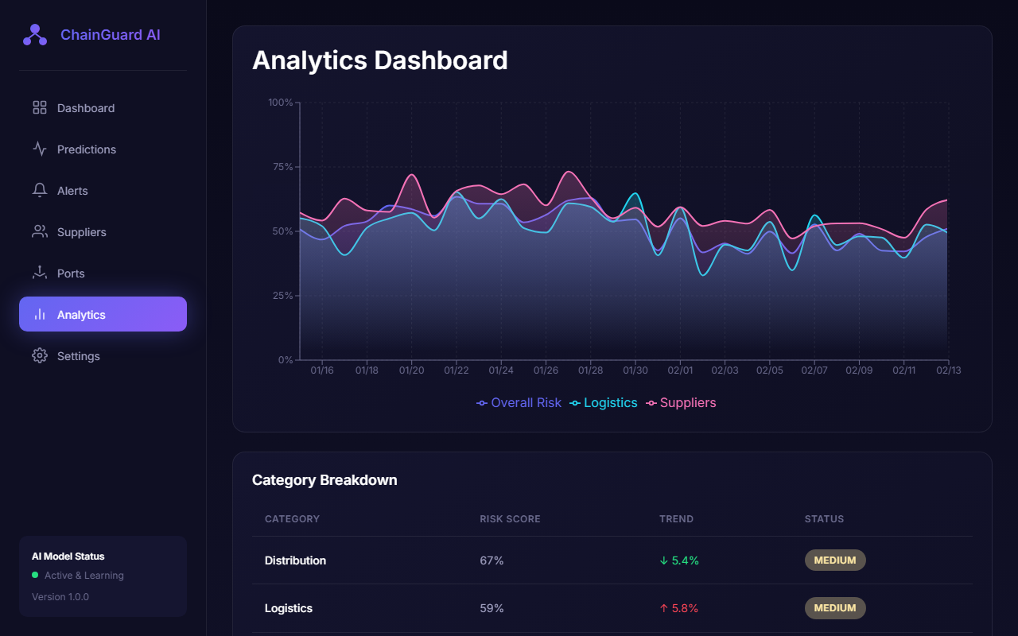
Settings View
Customizable platform configurations and API integrations.
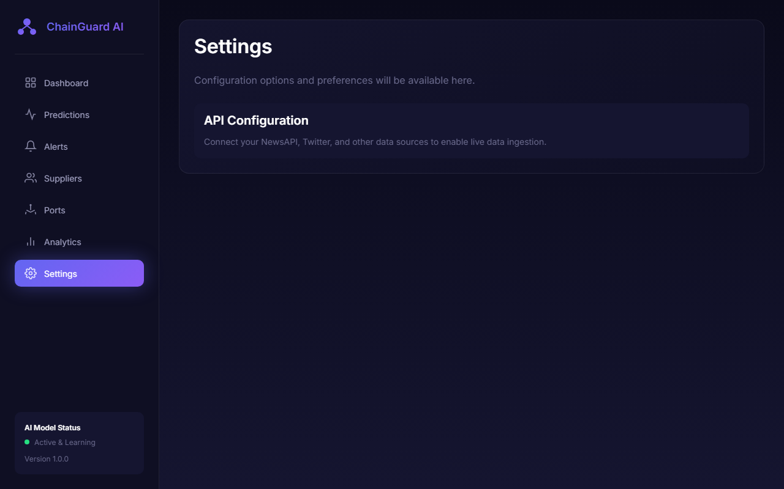

9. Report Layouts
The reporting module provides automated periodic overviews of historical delays and systemic risks.
Weekly Threat Assessment Report
- Title Header: Time period and target domain.
- Section A: Statistical abstract of top forecasted hazards.
- Section B: Tabular data representation listing specific suppliers or regions experiencing turbulence.
- Section C: Evaluative graph charting 30-day trailing disruption probability indices vs. predicted actuals.

10. Sample Coding
Below is a sample FastAPI core endpoint highlighting key implementations for fetching dashboard summaries:
from fastapi import APIRouter
from app.models import DashboardSummary

router = APIRouter()

@router.get("/api/dashboard/summary", response_model=DashboardSummary)
async def get_dashboard_summary():
"""Retrieve summarized executive insights"""
return {
"active_alerts": 12,
"high_risk_regions": 2,
"overall_status": "Moderate Risk"
}

11. Future Enhancements
To scale and mature the platform, the following advancements are planned:
1. API Integration with modern ERP platforms (SAP, Oracle) for direct tracking against active purchase orders.
2. Advanced Language Models to dynamically extract hidden relationship networks influencing logistics pathways.
3. Implementation of a mobile, natively optimized application for instant critical-threat push notifications for on-the-go managers.

12. Conclusion
The Supply Chain Disruption Predictor demonstrates how leveraging predictive models, open data, and modern web frameworks creates massive operational value. By effectively mapping and simulating geopolitical, economic, and logistical risks into one cohesive, automated risk-intelligence framework, supply professionals can respond to crises before critical bottlenecks manifest.

13. Bibliography
[1] React Documentation. Available at: https://reactjs.org/
[2] FastAPI Documentation. Available at: https://fastapi.tiangolo.com/
[3] Meta Prophet - Open Source Forecasting. Available at: https://facebook.github.io/prophet/
[4] MongoDB Python Driver API Notes. Available at: https://pymongo.readthedocs.io/

