# Initial Discussion of Software Architecture and Technology Rationale

# Technologies Used

The programming and mark-up languages that are going to be used in the project are;

* Java for the main implementation
* MySQL for persisting data
* HTML/JSP for the structure of web pages
* CSS for the style and layout of the web pages
* JavaScript/JSP for dynamic web pages

The frameworks that the project will utilise are as follows;

* OpenStreetMap to generate geological real-time maps
* Spring MVC to handle HTTP requests

The Spring MVC framework which uses the model, view and controller design pattern also comes with a lot of added functionality such as the Spring Security package; this can be utilised for user password encryption (bcrypt).

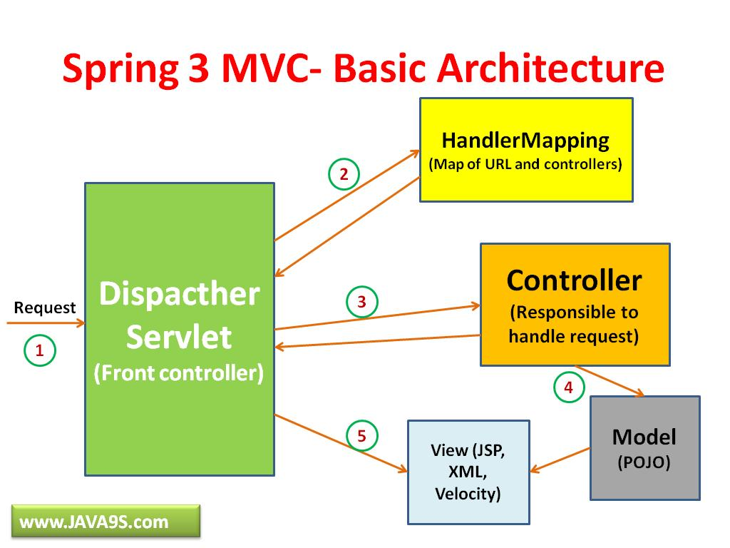

Above is a graphical representation of the design pattern which the Spring MVC framework utilises. Below is a step by step process of how the framework handles HTTP requests.

1. The **Dispatcher** object receives a HTTP request
2. Request pattern matching is delegated to the **HandlerMapping** object which returns a controller name and method to execute
3. The **Dispatcher** then invokes the controller method if it exists or throws an appropriate error message if needed.
4. On invocation the controller will gather necessary data in order to return data to **Dispatcher** this is in the form of **Models** and **Views**.
5. The dispatcher receives all required information from the controller which is needed to display the response to the user
6. The **View** is then processed along with **Model** data which forms the end user response

# Initial Prototype

The initial prototype should include most if not all of the key features of the final web application. It should incorporate the registration process for the Searchers and Landlords and the login system for all Administrators, Searchers and Landlords.

Searchers should be able to search for properties which is then represented on a geographical map along with other important information pertaining to the property. Additionally, they can express interest in a property which alerts the landlord of that property that an unspecified Searcher is interested. A Searcher should also be able to sign up for the buddy system upon registration, if they do sign up to this service then they will be recommended prospect buddies of which should be relevant to the user’s property search criteria and preferences. Searchers should also be able to message potential buddies and property landlords.

The prototype should also allow Landlords to register and login. A Landlord can create, manage and delete a property that they decide to list. The property listing can contain both written text and property images. A landlord cannot initially message potential tenants but can reply if they are directly contacted by Searchers.

Both Searchers and Landlords should be able to submit reports. Reports deal with the notifying of invalid or inappropriate use of the service by other users.

Administrators can deal with reports by removing property listings, deleting users and suspending users.

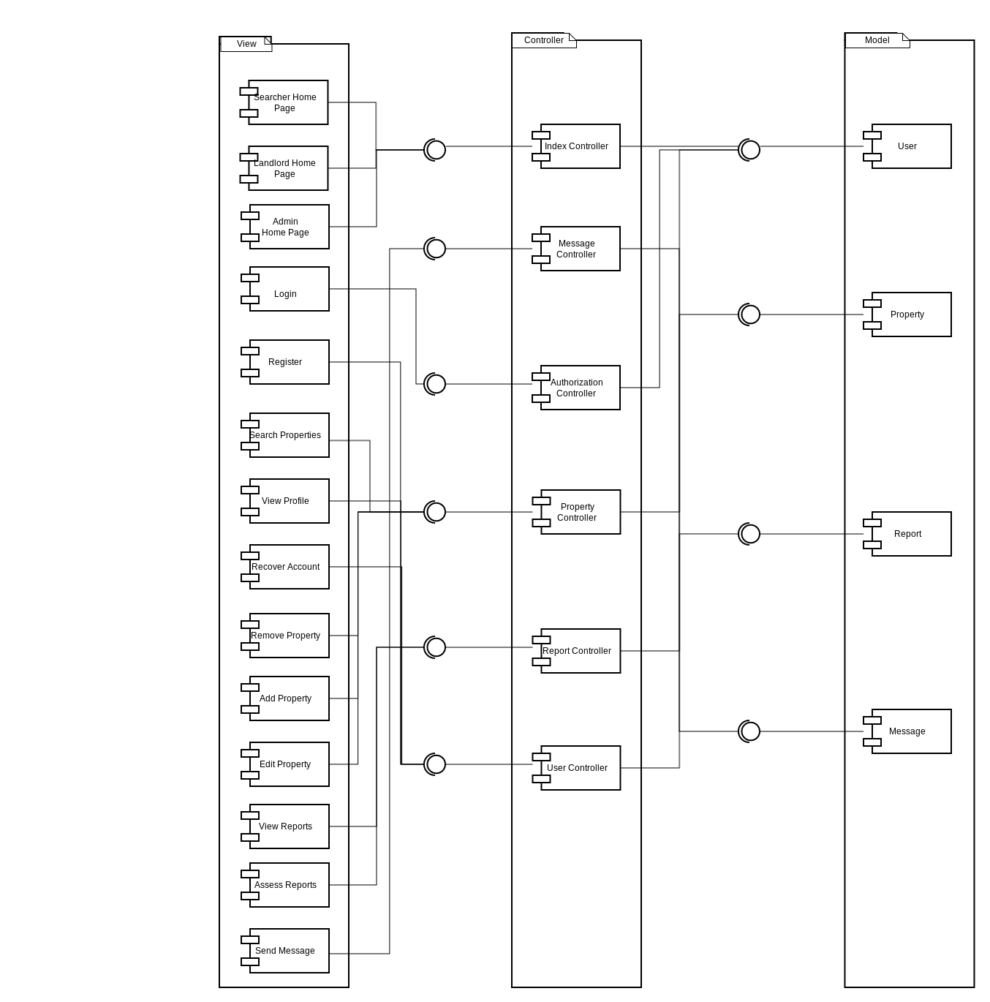Component Diagram