**NAME: Ahtisham Bin Maqsood**

**ROLL No: 055**

**SECTION: 3A**

**LAB 11**

**1. Queue using Array**

* **Enqueue** – Inserts a new element at the end (rear) of the array-based queue.
* **Dequeue** – Deletes the element at the front of the queue and shifts the remaining elements if needed.
* **Display** – Shows all elements in the queue from front to rear in the order they were added.

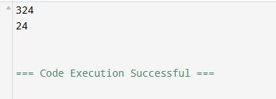

**2. Queue using Linked List**

* **Enqueue** – Allocates a new node and attaches it to the end (rear) of the linked list.
* **Dequeue** – Deletes the node at the front of the list and updates the front pointer.
* **Display** – Iterates through the list from front to rear, printing each element in sequence.

