**NAME: Ahtisham Bin Maqsood**

**ROLL No: 055**

**SECTION: 3A**

**LAB 12**

**Binary Search Tree (BST):**

A Binary Search Tree is a specialized tree structure where:

* Every node holds a specific value.
* The left subtree contains only values smaller than the current node.
* The right subtree contains only values larger than the current node.

This arrangement allows for efficient operations like search, insertion, and traversal—typically in **O(log n)** time in a balanced tree.

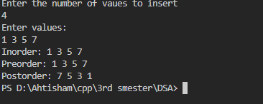

**AVL Tree:**

* An AVL Tree is a self-balancing variant of the Binary Search Tree (BST).
* For every node, the height difference (balance factor) between its left and right subtrees is at most 1.
* If the balance factor exceeds this range, the tree performs rotations (left, right, or double) to restore balance.
* This balancing keeps the tree height minimal, ensuring efficient performance.
* All major operations—**insertion**, **deletion**, and **searching**—run in **O(log n)** time.

