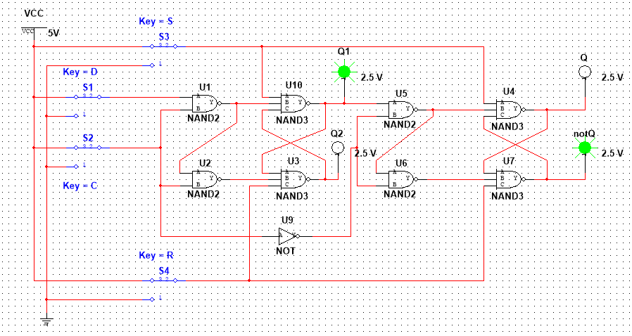

|  |  |  |  |  |  |  |  |  |
| --- | --- | --- | --- | --- | --- | --- | --- | --- |
| D | C | NOT S | NOT R |  | Qm n+1 | Not(Qm n+1) | Qs n+1 | Not(Qs n+1) |
| 1 | 1 | 1 | 1 |  | 1 | 0 | Qs n | Not(Qs m) |
| 0 | 1 | 1 | 1 |  | 0 | 1 | Qs n | Not(Qs m) |
| x | x | 0 | 0 |  | 1 | 1 | 1 | 1 |
| x | x | 0 | 1 |  | 1 | 0 | 1 | 0 |
| x | x | 1 | 0 |  | 0 | 1 | 0 | 1 |
| x | x | 1 | 1 |  | Qs m | Not(Qs m) | Qs n | Not(Qs m) |

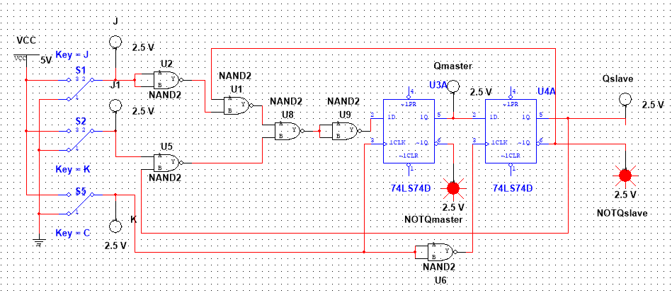

|  |  |  |  |  |  |  |  |
| --- | --- | --- | --- | --- | --- | --- | --- |
| **J** | **C** | **K** |  | **Qm n+1** | **Not(Qm n+1)** | **Qs n+1** | **Not(Qs n+1)** |
| x | 0 | x |  | Qm n | Not(Qm n) | Qs n | Not(Qs n) |
| x | 1 | x |  | Qm n | Not(Qm n) | Qs n | Not(Qs n) |
| 0 | 0->1 | 0 |  | Qm n | Not(Qm n) | Qs n | Not(Qs n) |
| 0 | 0->1 | 1 |  | 0 | 1 | Qs n | Not(Qs n) |
| 1 | 0->1 | 0 |  | 1 | 0 | Qs n | Not(Qs n) |
| 1 | 0->1 | 1 |  | Not(Qm n) | Qm n | Qs n | Not(Qs n) |
| x | 1->0 | x |  | Qm n | Not(Qm n) | Qm n | Not(Qm n) |

