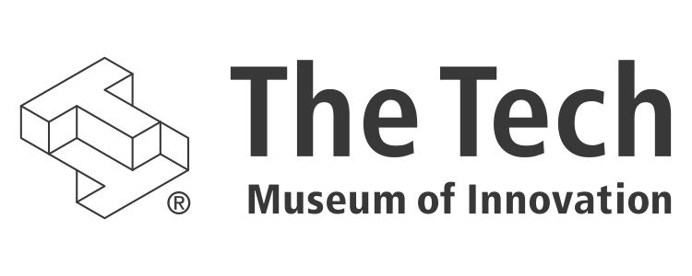

# The Design Challenge Learning Institute background

In 2012, The Tech Museum of Innovation launched The Tech 3.0 campaign, a five-year institutional transformation that is redefining the museum as a Silicon Valley resource for innovation. To achieve our mission — inspiring the innovator in everyone — we made bold but informed changes. We examined our impact over the past 25+ years and realized that The Tech does have a secret sauce. Its name is Design Challenge Learning (DCL).

DCL is a combination of project-based learning, design thinking, and the engineering design process that develops the innovator’s mindset. DCL encourages people to risk failure, to persist, to seek feedback, to work collaboratively, to improve, and to learn from all these things. It builds creative confidence and awakens potential. The Tech has honed its expertise in DCL over 28 years with The Tech Challenge, in which thousands of young people participate annually. It is only fitting that we apply this guiding principle to all of our Tech 3.0 initiatives.

DCL is visible in our newest exhibits, each of which provides deep experiences that are open-ended, social, and collaborative. The Social Robots exhibit challenges visitors to design and program a robot for human interaction in real-world settings. Body Metrics challenges visitors to use technology to assess their lifestyles’ influence on health in new ways. And the upcoming cyber security exhibit will challenge visitors to protect data and privacy by assuming the role of a new security professional.

Cementing our commitment to DCL will be the Design Challenge Learning Institute, where The Tech’s DCL experts will provide high-quality professional development for educators who serve students in low-income communities.

# the need

Silicon Valley is the epicenter of innovation, but we need more innovators. STEM occupations are growing faster than non-STEM opportunities and commanding much higher wages. But the region “is not producing enough talent with the necessary skills to fill the large volume of replacement jobs opening in community infrastructure and in high tech. It will not be able to meet these needs by importing workers from abroad and other states.” (Silicon Valley Index, 2014)

In fact, the Silicon Valley Competitiveness and Innovation Project reports that sustaining the valley’s tech strength could be tough, in part because the region struggles to educate Bay Area students in STEM subjects.

The 2014 California Department of Education publication “Innovate: A Blueprint for Science Technology, Engineering, and Mathematics in California Public Education” identified the reasons STEM education has been stymied:

* the focus on English language arts and skill-based mathematics required by No Child Left Behind
* insufficient focus on science and STEM education in the classroom
* lack of access to high-quality STEM materials and instruction
* insufficient opportunities for students to engage in hands-on, inquiry-based learning
* insufficient professional preparation by teachers at all levels

In addition, the report states that “students living in poor urban or rural areas and many students from underrepresented groups lack access to high-quality STEM education. This has resulted in lack of proficiency that disproportionately impacts students of color.” A 2013 study shows that by age 12, disadvantaged children had been exposed to about 6,000 fewer hours of learning time than their more affluent peers.

Professional development for educators is crucial to improving STEM education in California; however, funding for professional learning has been slashed by statewide budget cuts. More than half of the districts across California report that they have eliminated or significantly reduced professional learning opportunities that had been provided to teachers previously.

As a result, educators feel unprepared to teach STEM. A 2011 study of California elementary teachers found that only one-third of teachers felt prepared to teach science and more than 85 percent had not received any science-related professional development over the previous three years.

Fortunately, we are in a pivotal time. The Common Core State Standards and the Next Generation Science Standards are asking schools to meet the need for STEM-savvy professionals. But schools desperately need help because their teachers have never been asked to teach engineering and their students have never been tested for 21 st century skills (critical thinking, problem solving, and collaboration). Furthermore, it has been well over a decade since teachers have been asked to integrate all subject areas around real-life applications.

The DCLI is the right solution at the right time to meet the needs of Silicon Valley.

# about the design challenge learning institute

The mission of the Design Challenge Learning Institute, or DCLI, is to equip young people – especially those who are at risk — to succeed in the 21st century. Our strategy is to make STEM learning engaging. We will target young people in grades 4-12 and the educators who lead them.

The DCLI is the launch pad for The Tech’s key initiatives in STEM education. They are:

1. The Tech Academies of Innovation

Through The Tech Academies of Innovation program, the DCLI will work closely with educators in schools and afterschool programs that serve low-income students. This will be high-quality professional development for educators in tough situations. We will work, at first, with educators in schools with which we have long-standing relationships. Educators from those schools will apply to be in the program. They, and we, will make a three-year commitment to incorporating Design Challenge Learning into the way they teach STEM subjects. These educators will lead the charge to improve STEM teaching within their institutions and earn their distinction as a Tech Academy of Innovation. Each year we will add 8 to 10 new school/afterschool sites and ask more experienced teams to support subsequent cohorts. Over time this program will transform STEM teaching and build a large network of Tech Academy educators with common training and experiences. They will touch thousands of students’ lives.

1. Reinventing the Field Trip   
   Each year, about 135,000 students and 4,500 teachers come to The Tech for field trips. Nearly half of these students are from low-income households. These visits are untapped opportunities for deeper STEM engagement that could make a difference in the lives of low-income students. To seize these opportunities, the DCLI will develop, execute, and evaluate ways to: 1) conduct professional development for teachers in the context of a field trip, 2) ensure that each student, regardless of ability to pay, has a lab or lab-like experience during the field trip, and 3) extend the field trip to the classroom through The Tech’s Smart Museum technology. The combination of these three initiatives will make a field trip to The Tech a valuable and effective way for educators to engage students in STEM learning before, during, and after their visits.
2. Scaling Through Technology

We will expand the work of the DCLI through the creative use of technology. We are investigating virtual conferencing tools that enable interactive distance learning so we can reach the school communities that need The Tech most, but have the fewest resources to travel here. Some trainings also will be recorded and made available online. Webinars will be used for broad-based professional development. Partnerships with MOOC providers, such as Coursera and Udacity, will be explored. We also will use The Tech’s Smart Museum technology to track and scale up professional development.

1. The Tech Challenge

The DCLI will work to expand and deepen the impact of The Tech Challenge program. Winner of the Noyce Foundation’s prestigious Bright Lights Award for innovative learning programs, The Tech Challenge engages students deeply for months in engineering projects, culminating in a two-day team competition. Many of the participants are from low-income homes and nearly half are girls. The DCLI will develop and execute strategies for enrolling more teams from low-income communities, enrolling more girls, increasing the number of satellite locations, and increasing the number and quality of mentors.

1. Girls and Tech  
   At the DCLI, The Tech will expand its focus on engaging girls in STEM learning. For many years, The Tech has made it a priority to get girls involved with STEM. The Tech is the lead organization in a Girls and Tech partnership with the Maker Education Initiative, Technovation and the YWCA’s TechGYRLS program. We meet regularly and collaborate on ways to increase opportunities to engage girls in STEM, and to design well rounded experiences that will result in a larger number of girls eventually pursuing a STEM major or career. Many new initiatives, including entrepreneurship conferences with Technovation, innovator badge programs with the Girl Scouts, and Girls @ The Tech Days (with interactive workshops, STEM activities, and a talk or film targeted to girls) will be launched. We also plan to offer professional development for teachers on how to best engage girls in STEM, including providing specific tools to address gender bias. With the platform of the DCLI, these efforts will coalesce into a broader and deeper focus on girls and tech.
2. Educational Technology

The DCLI also will have an emphasis on helping educators use technology to make STEM learning more engaging, particularly for the underserved. We will bridge the gap between educators and ed-tech innovators by providing a place where ed-tech specialists can demonstrate, test, and vet ed-tech products. Educators will exchange ideas and discuss the technological support they need with peers and developers. Ed-tech innovators will benefit from access to and feedback from educators. This aspect of the DCLI’s work will be done largely through our partners, such as the Krause Center for Innovation, Benesse, CUE, Khan Academy, Ed Elements, Code.org, Code to Learn and others. The DCLI will select the most respected ed-tech partners and make its space available for seminars, trainings, and conferences.

1. Meetings   
   The DCLI will make its space available to area educators for seminars, receptions, and other events in an effort to spur innovation and deepen relationships. The DCLI will focus especially on making its space available to schools in the districts comprising San Jose’s East Side Alliance, as well as social-service organizations that serve the East Side community by addressing the social determinants of educational achievement.
2. Educators in Residence

Through our Educator-in-Residenceprogram, a rotating cadre of innovators will co-locate with us, providing a constant influx of new ideas. The summer 2014 Educator in Residence, for example, was an IISME fellow who helped develop new curricular resources for mini design challenges that prepare teachers and students for The Tech Challenge. Next summer, we anticipate having several Educators in Residence who will help us develop STEM curriculum for The Tech Academies of Innovation.

# evaluation

Success will be measured at two levels: the program level and the school/afterschool level. At the program level, the DCLI will partner with outcomes researchers to develop meaningful and verifiable metrics. We are currently in dialogue with two researchers, Cary Sneider of Portland State University, and Gil Noam of Harvard University. If all goes well, we will enter into an agreement with them. If not, we will continue to seek respected researchers to help us evaluate the DCLI’s programs. The DCLI will work with researchers to map and measure the contributions that DLCI learning makes in key school success measures such as graduation rates, attendance, and course selection.

# the physical space

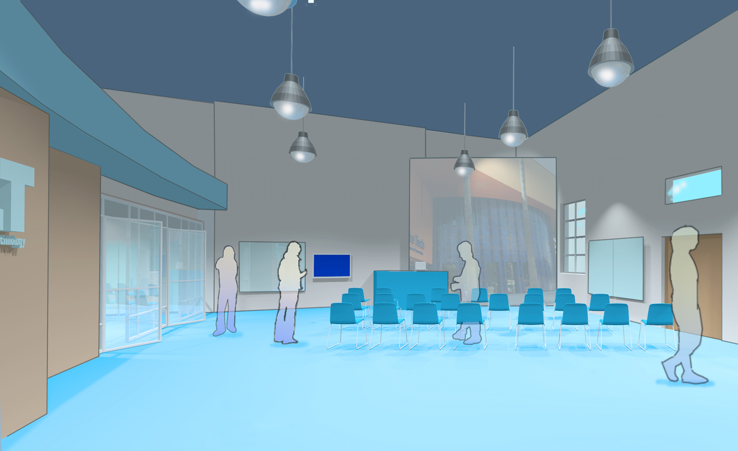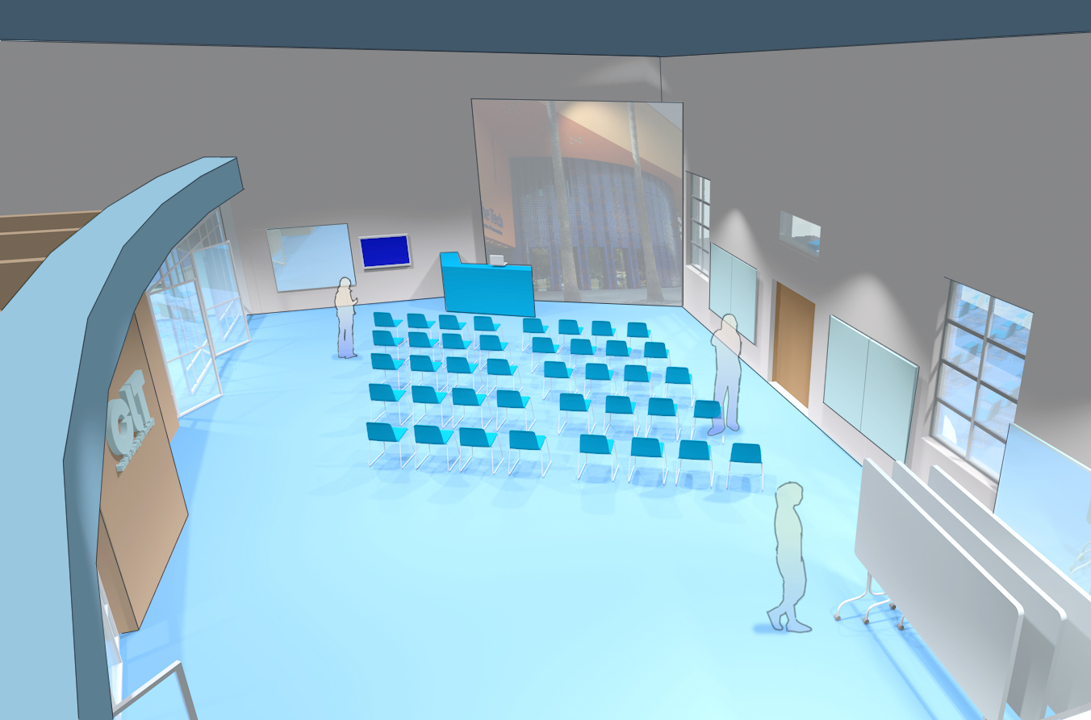

The DCLI’s base of operations will be a newly renovated 3,000-square-foot space adjoining The Tech’s business office, located next to the beautifully updated City National Civic Center and across the street from the recently transformed San Jose Convention Center. The DCLI will have its own stair-stepped entrance on West San Carlos, one of the busiest streets in downtown San Jose. (Funding for renovating this space was provided by the Packard Foundation.)

The powerfully wired, well-equipped, flexible space is thoughtfully designed to support educators, accommodate entire classrooms or small groups, house experts-in-residence, and showcase educational technologies.

The vibrant center will be abuzz with innovative activity. Our staff, educators in residence, school partners, industry partners, and ed-tech developers in residence will work alongside one another and host professional development and classroom workshops, conferences, beta jams, and other educational events. One morning, the DCLI might host an informal discussion among superintendents and principals about how to use technology to support DCL in their classrooms. That afternoon, the DCLI could present a professional development workshop for afterschool educators about how to incorporate engineering design thinking for early learners. The next day, the DCLI might host one in a series of curated TED-style talks about educational technologies, followed by a working session in which teachers and afterschool educators use the speaker’s tools. And during the weekend, dozens of education leaders from East Side Union School District might convene to determine how to transform an underperforming high school into a STEM magnet.

# the budget

1. **The Tech Academies of Innovation**

Salaries and benefits: $180,000 per year

Educator stipends, consultant: $75,000 per year

Materials, supplies, other direct costs: $18,000 per year

Indirect costs: $27,000

**Total per year:** **$300,000** **Total 10 years:** **$3 million**

1. **Reinventing the Field Trip**

Salaries and benefits: $150,000 per year

Materials, supplies, training, other direct costs: $32,000 per year

Indirect costs: $18,000

**Total per year: $200,000** **Total 10 years: $2 million**

1. **Scaling Through Technology**   
   Salaries and benefits: $31,000 per year  
   Materials, supplies, equipment, consultant, maintenance: $60,000 per year  
   Indirect costs: $9,000 per year

**Total per year: $100,000 Total 10 years: $1 million**

1. **Girls and Tech**

Salaries and benefits: $81,000  
Materials, supplies, training: $10,000  
Indirect costs: $9,000

**Total per year: $100,000 Total 10 years: $1 million**

1. **Education Technology**

Salaries and benefits: $36,000  
Materials, supplies: $10,000  
Indirect costs: $4,000

**Total per year: $50,000 Total 10 years: $500,000**

1. **Meetings**   
   Salaries and benefits: $16,000  
   Materials, supplies: $10,000

Security, facilities: $10,000   
Indirect costs: $4,000  
**Total per year: $50,000 Total 10 years: $500,000**

1. **Educators in Residence**  
   Stipends: $14,000  
   Materials, supplies: $1,000  
   **Total per year: $15,000 Total 10 years: $150,000**
2. **Evaluation**  
   Salaries and benefits: $100,000  
   **Total per year: $100,000** **Total 10 years: $1 million**
3. **The Physical Space**

Materials, supplies, furnishings: $10,000  
Overhead, utilities, maintenance: $30,000  
**Total per year: $40,000** **Total 10 years: $400,000**

**DCLI TOTAL COST**

**Total per year: $955,000 Total 10 years: $9.55 million**

# recognition for your support

The presenting funder of the DCLI will have the opportunity to rename the center as the *SPONSOR’S NAME* Design Challenge Learning Institute. The name would be visible not only at The Tech, which welcomes 400,000+ annual visitors, but also to the thousands of people who walk and drive along West San Carlos Street, as well as thousands of daily riders at the San Carlos Light Rail station.

**For information, contact:**   
**Maria Pappas, Vice President, Development  
(408) 795-6301; mpappas@thetech.org**