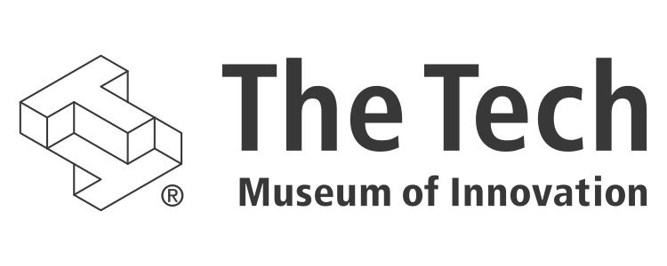

Healthcare Innovations: A New Exhibition

Opening 2016

# the tech. reinvented.

In 2012, The Tech Museum of Innovation launched a five-year institutional transformation that is redefining the museum as a Silicon Valley resource for innovation. The Tech aims to do this by creating deep experiences that are open-ended, social, and collaborative. New galleries under way include Social Robots, which challenges visitors to design and program a robot for human interactions in real-world settings, and DIY Genetics, where visitors will explore the world of genetic engineering. Multiple new “design challenge” galleries will cover the museum’s 30,000-square-foot lower level. The gallery makeovers on the upper level will also reflect this deeper engagement and highlight technology that benefits humanity.

# what is the healthcare innovations exhibition?

Thanks to medical innovations, life expectancies have been extended by a year every five years for the past three decades. New discoveries have revolutionized care for diseases such as cancer and diabetes and have reduced human suffering from countless other conditions. Many of the most revolutionary innovations are being developed right here in Silicon Valley. To shine the spotlight on health and technology, a new 3,000-square-foot Healthcare Innovations Exhibition (working title) will be constructed on the upper level of The Tech, adjacent to the DIY Genetics exhibition now in development.

The Healthcare Innovations Exhibition will examine advancements on two fronts:

* **High-tech innovations** at the cutting edge of healthcare delivery are making the unimaginable possible – and sometimes routine. Examples include interventional cardiology, minimally invasive surgery, robotic surgery, regenerative medicine, advanced prosthetics, big data, evidence-based care, and genomics.
* **High-need innovations** enable low-cost, widely distributed healthcare that impacts thousands to millions of people in some of the poorest areas of the world. These innovations are transforming health through telemedicine, clean water, refrigeration, labs, low-cost drugs, obstetrics, vaccinations, and optometry, among other ways. Possible focus areas include responses to infant mortality, birth defects, hearing loss, HIV/AIDS, tuberculosis, malaria, and influenza.

High tech and high need. These two perspectives will play off each other and intersect throughout this engaging and inspiring exhibition. Approximately 14 to 16 exhibit pieces will feature a combination of hands-on experiences, multimedia content, and interactions with complex medical devices.

In addition, information about The Tech’s renowned international program, The Tech Awards, will be integrated into parts of this exhibition. Health is one of the categories recognized at The Tech Awards, an annual event that salutes technology benefiting humanity. Elements within this exhibition will feature past laureates and their innovative solutions. Visitors will learn how they, too, can take on healthcare challenges, even amid constraints such as limited infrastructure in the affected areas and the need to develop a low-cost solution at massive scale.

The Healthcare Innovations Exhibition will be designed to be changeable so that it can remain current and relevant. It also will leverage our new Smart Museum infrastructure, which tracks visitors’ engagement and extends their experience long after they leave The Tech.

# beyond the exhibition

This exhibition will propel additional museum programming on health innovations at The Tech that includes guest lectures, hackathons, meet-ups, talks, and other high-profile events that foster conversation. The Tech will galvanize and localize discussions that would not happen without our dedication to serving as a community resource for innovation.

# timeline

2016

# budget

$3 million (a portion already secured from El Camino Hospital)

# your opportunity

A gift to the Healthcare Innovations Exhibition will align your company with the intersection of health and technology. Donors will be recognized on the exhibition and will be entitled to many other benefits, including friends and family memberships and admission tickets and discounts on museum rentals.

# in gratitude

We value your consideration of partnership to support this work at The Tech and in the Silicon Valley community and look forward to many years of mutually beneficial collaboration. If you have any questions, we would be happy to discuss them and share more details of this exciting project. Thank you for your consideration of this philanthropic opportunity.

For information, contact:   
**Maria Pappas**Vice President, Development  
(408) 795-6301, mpappas@thetech.org