# Introduction

**Problem:**

In this report we'll analyze if North York, Toronto is recommendable for opening new Cafe or coffee shop.

**Approach:**

We will run clustering on North York on various venues available in the neighborhoods.

Top 5 venues will be selected for clustering for each neighborhood.

We will synthesis features based on the data available from Foursquare.

**Data:**

Data has been taken for North York and its neighborhood. <https://en.wikipedia.org/wiki/List_of_postal_codes_of_Canada:_M> is the source of the data.

The coordinates have been taken from <https://cocl.us/Geospatial_data>.

Values where borough has not been assigned those cells are ignored.

Values where neighborhood is not assigned the value of borough will be the value of neighborhood.

The values where borough is North York those set of data has been extracted.

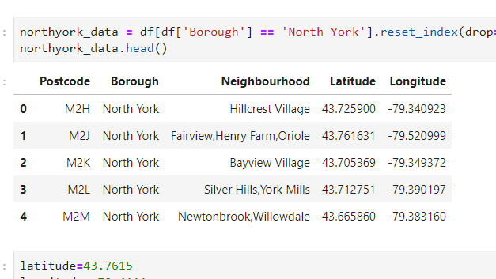

**Method:**

Through foursquare.com the data for the venues near the neighborhood has been called.

k-means clustering was performed to know what venues are more frequent to the neighborhood.

Maps are plotted using folium library to visualize the clustering.

**Exploratory Analysis:**

Most frequent venues are called and recorded in a frame respective to their neighborhood.

The neighborhoods are clustered together.

Through the clusters it is found that the most occurring venues are cafes, coffee shop and pubs.

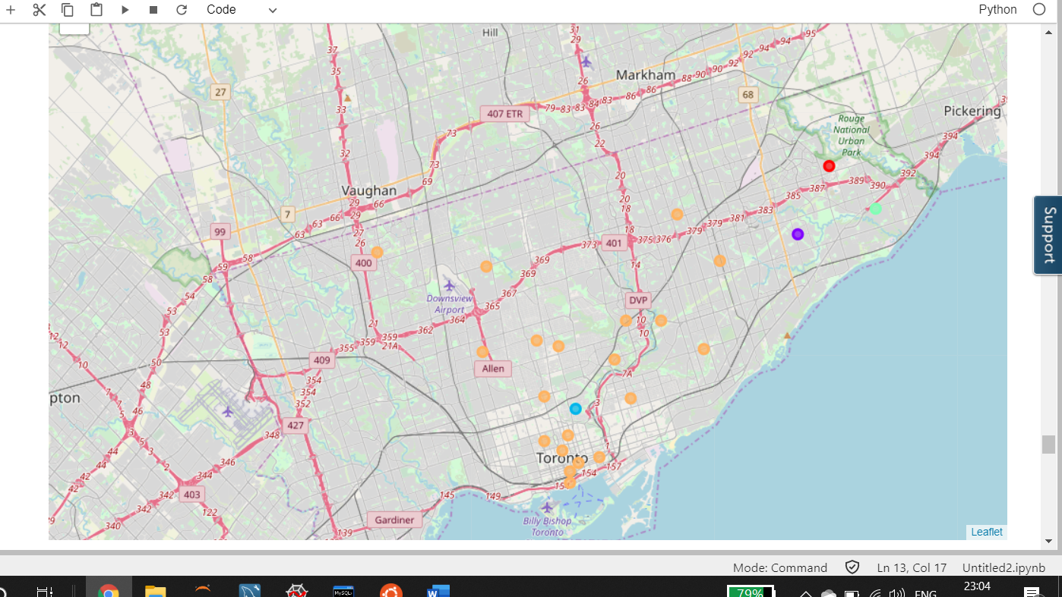

**Conclusion:**

Since it is found that the most frequent venues are bakery, cafes, coffee shops and pubs. Therefore, it is assumed that people love to visit above venues.

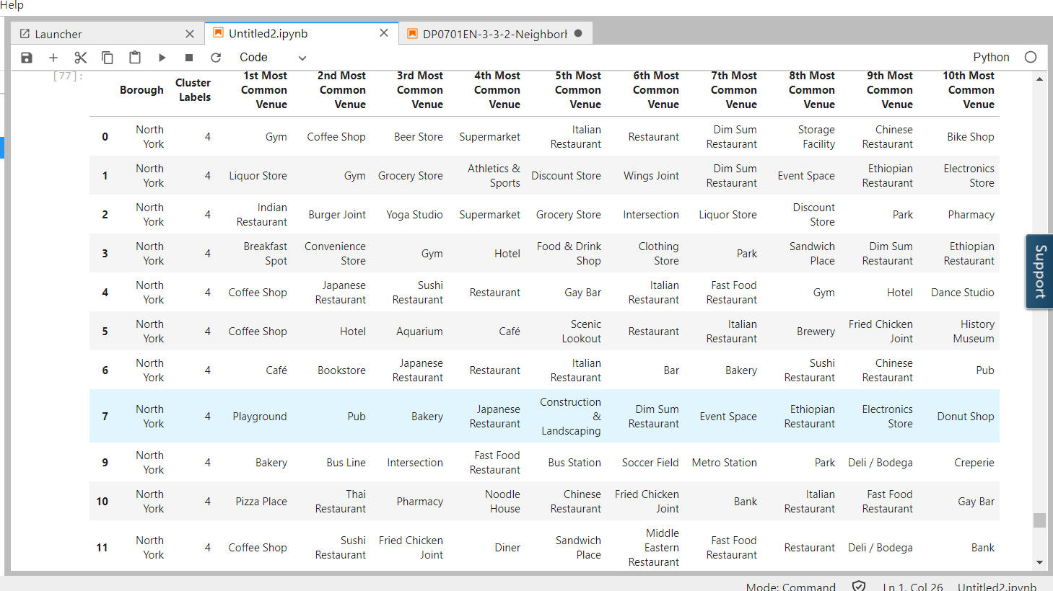

Hence, it is recommended to start a café or coffee shop in North York.