EXPERIMENT 9

Implement Recurrent Neural Network (RNN) / LSTM for Text Data

Introduction
Recurrent Neural Networks (RNN) are used for sequential data such as text, speech, and time series. LSTM (Long Short-Term Memory) is an advanced type of RNN that can capture long-term dependencies.
Applications:
- Sentiment analysis
- Language translation
- Speech recognition
- Time series prediction

About LSTM
LSTM overcomes the vanishing gradient problem of RNN using:
- Forget Gate → removes unnecessary info
- Input Gate → adds new info
- Output Gate → gives final output

Working of LSTM
- Input text is converted to sequences
- Sequences are padded
- Embedding layer converts words into vectors
- LSTM processes sequence
- Dense layer gives prediction

Dataset Source
- Dataset: IMDB Movie Reviews
- Source: TensorFlow Keras

Dataset Description
- Reviews labeled as:
  - Positive (1)
  - Negative (0)

Dataset Size:
- Training: 25,000
- Testing: 25,000

Data Preprocessing
- Limited vocabulary to 10,000 words
- Applied padding to equal length
- Converted text into sequences

Model Architecture
- Embedding Layer
- LSTM Layer (64 units)
- Dense Layer (Sigmoid)

Performance Evaluation
- Loss: Binary Crossentropy
- Optimizer: Adam
- Metric: Accuracy

Visualization
- Accuracy vs Epoch
- Loss vs Epoch
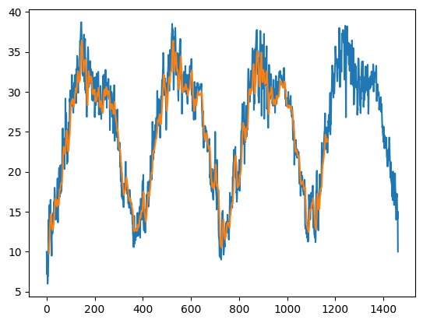

Hyperparameters
- Epochs: 5
- Batch Size: 64
- Max Length: 200
- Vocabulary Size: 10,000

Conclusion
- LSTM successfully classified text sentiment
- Captured sequential dependencies
- Better than basic RNN for long sequences
- Useful for NLP applications

