EXPERIMENT 8

Design and Train a Convolutional Neural Network (CNN) on Image Dataset

Introduction
Convolutional Neural Networks (CNN) are a class of deep learning models primarily used for image processing and computer vision tasks. CNNs automatically learn spatial features from images using convolution operations.
Applications include:
- Image classification
- Object detection
- Medical imaging
- Face recognition

About CNN
A CNN consists of:
- Convolutional Layers → Extract features
- Pooling Layers → Reduce dimensions
- Fully Connected Layers → Perform classification

Working of CNN
- Image is passed through convolution layers
- Filters extract features like edges and textures
- Pooling reduces image size
- Flatten converts data to vector
- Dense layers classify image

Dataset Source
- Dataset: Flowers Recognition Dataset
- Source: Kaggle
Reason:
This dataset contains real-world images across multiple classes, making it suitable for CNN-based classification.

Dataset Description
The dataset contains images of 5 flower categories:
- Daisy
- Rose
- Sunflower
- Tulip
- Dandelion

Characteristics
- Image dataset
- Multi-class classification
- RGB images

Data Preprocessing
- Images resized to 150×150
- Pixel values normalized (0–1)
- Dataset split into training and validation

Model Architecture
- Conv Layer (32 filters) + MaxPooling
- Conv Layer (64 filters) + MaxPooling
- Conv Layer (128 filters) + MaxPooling
- Flatten Layer
- Dense Layer (128 neurons)
- Output Layer (5 classes – Softmax)

Performance Evaluation
- Loss Function: Sparse Categorical Crossentropy
- Optimizer: Adam
- Metric: Accuracy
The model achieved good accuracy on validation data.

Visualization
- Accuracy vs Epoch graph
- Loss vs Epoch graph
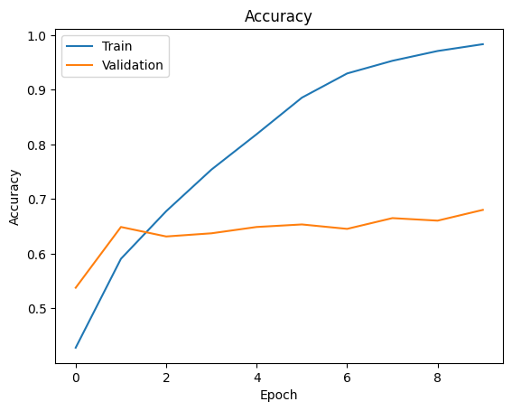
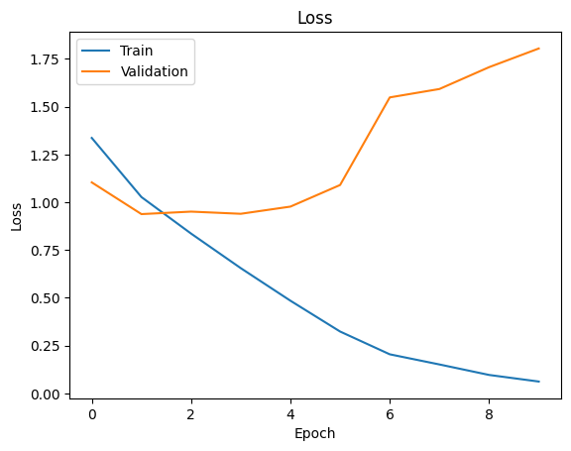
These graphs show learning progression of the model

Hyperparameter Tuning
- Epochs: 10
- Batch Size: 32
- Image Size: 150×150
- Optimizer: Adam

Conclusion
- CNN successfully classified flower images
- Model extracted meaningful features automatically
- CNN is highly effective for image-based tasks
- Performance can be improved with more epochs and data augmentation

