EXPERIMENT 10

Explore and Implement Autoencoders for Image Denoising

Introduction
Autoencoders are neural networks used for unsupervised learning. They learn to compress data and reconstruct it, making them useful for denoising images.

Dataset Source
- Dataset: MNIST Handwritten Digits
- Source: TensorFlow Keras

Dataset Description
- Grayscale images of digits (0–9)
- Image size: 28×28
- Training samples: 60,000
- Testing samples: 10,000

Data Preprocessing
- Normalized pixel values (0–1)
- Reshaped to (28,28,1)
- Added Gaussian noise

Model Architecture
- Conv2D + MaxPooling (Encoder)
- Conv2D + UpSampling (Decoder)
- Output layer with sigmoid activation

Performance Evaluation
- Loss Function: Binary Crossentropy
- Optimizer: Adam

Visualization
- Noisy image
- Denoised image
- Original image
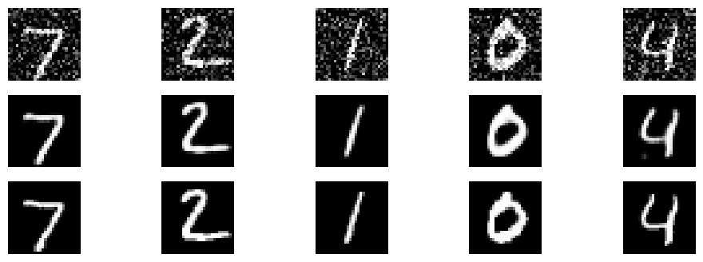

Hyperparameters
- Epochs: 5
- Batch Size: 128
- Noise Factor: 0.3

Conclusion
- Autoencoder successfully removed noise from images
- Model reconstructed clear images
- Effective for image processing tasks

