EXPERIMENT 7

Build an Artificial Neural Network (ANN) using Keras/TensorFlow

Introduction
Artificial Neural Networks (ANN) are a subset of machine learning models inspired by the human brain. They consist of interconnected neurons organized in layers and are used for solving complex problems such as classification and prediction.
ANNs are widely used in:
- Customer churn prediction
- Image recognition
- Speech processing
- Fraud detection
- Recommendation systems

About ANN
An ANN consists of:
- Input Layer → Receives input features
- Hidden Layers → Perform computations
- Output Layer → Produces final result
Each connection has weights, and activation functions help introduce non-linearity.

Working of ANN
- Input data is fed into the network
- Data passes through hidden layers
- Activation functions process outputs
- Final prediction is generated
- Error is calculated and minimized using backpropagation

Activation Functions Used
- ReLU (Rectified Linear Unit) → used in hidden layers
- Sigmoid → used in output layer for binary classification

Dataset Source
- Dataset: Telco Customer Churn Dataset
- Source: Kaggle
Reason:
This dataset helps predict whether a customer will leave a service, making it ideal for classification using ANN.

Dataset Description
The dataset contains customer details such as:
- Gender
- Senior Citizen
- Monthly Charges
- Total Charges
- Contract Type
- Internet Services
- Churn (Target Variable)

Dataset Characteristics
- Number of samples: ~7000
- Target variable: Churn (Yes/No)
- Type: Supervised Learning

Data Preprocessing
- Removed unnecessary column (customerID)
- Converted numerical columns properly
- Handled missing values
- Encoded categorical variables using Label Encoding
- Scaled features using StandardScaler

Model Architecture
- Input Layer → number of features
- Hidden Layer 1 → 16 neurons (ReLU)
- Hidden Layer 2 → 12 neurons (ReLU)
- Output Layer → 1 neuron (Sigmoid)

Performance Evaluation
- Loss Function: Binary Crossentropy
- Optimizer: Adam
- Metric: Accuracy
The model achieved high accuracy on test data, indicating good performance.

Visualization
- Accuracy vs Epoch graph plotted
- Shows improvement in learning over time
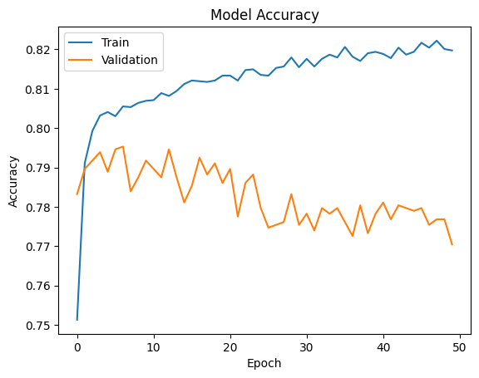

Hyperparameter Tuning
- Epochs: 50
- Batch Size: 32
- Optimizer: Adam
- Activation: ReLU + Sigmoid

Conclusion
- ANN successfully classified customer churn
- Model showed good accuracy and generalization
- ANN is effective for real-world classification problems
- Proper preprocessing and scaling improve performance

