Data Ingestion using spark in Azure Databricks

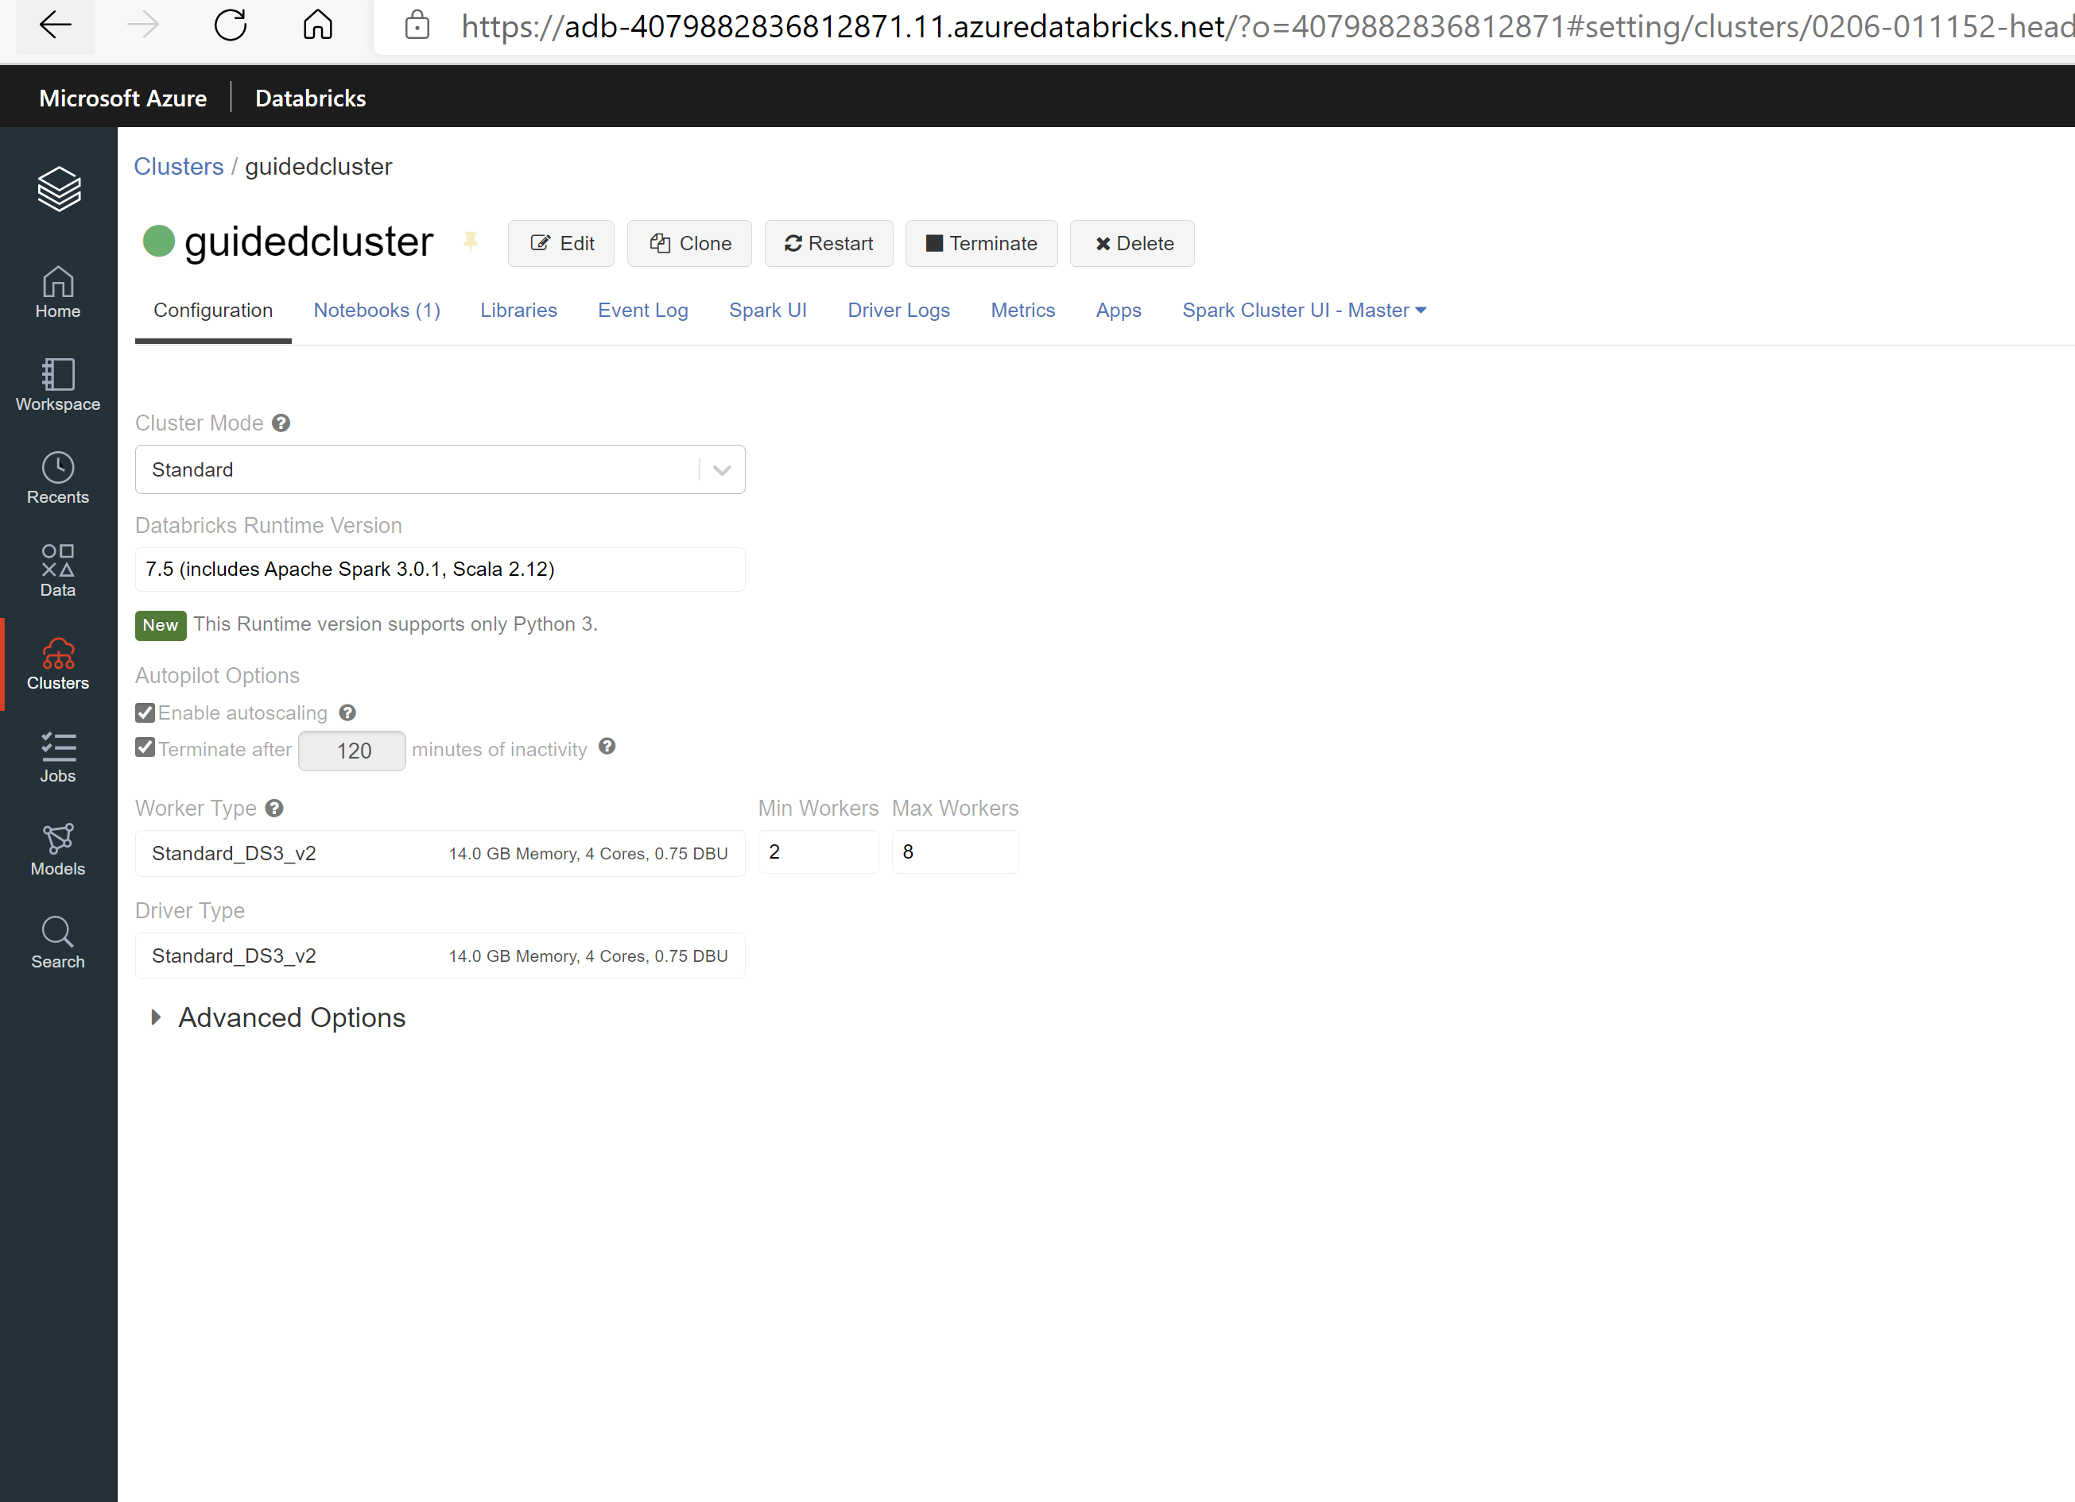

Mount the storage from Blob container to Azure Databricks

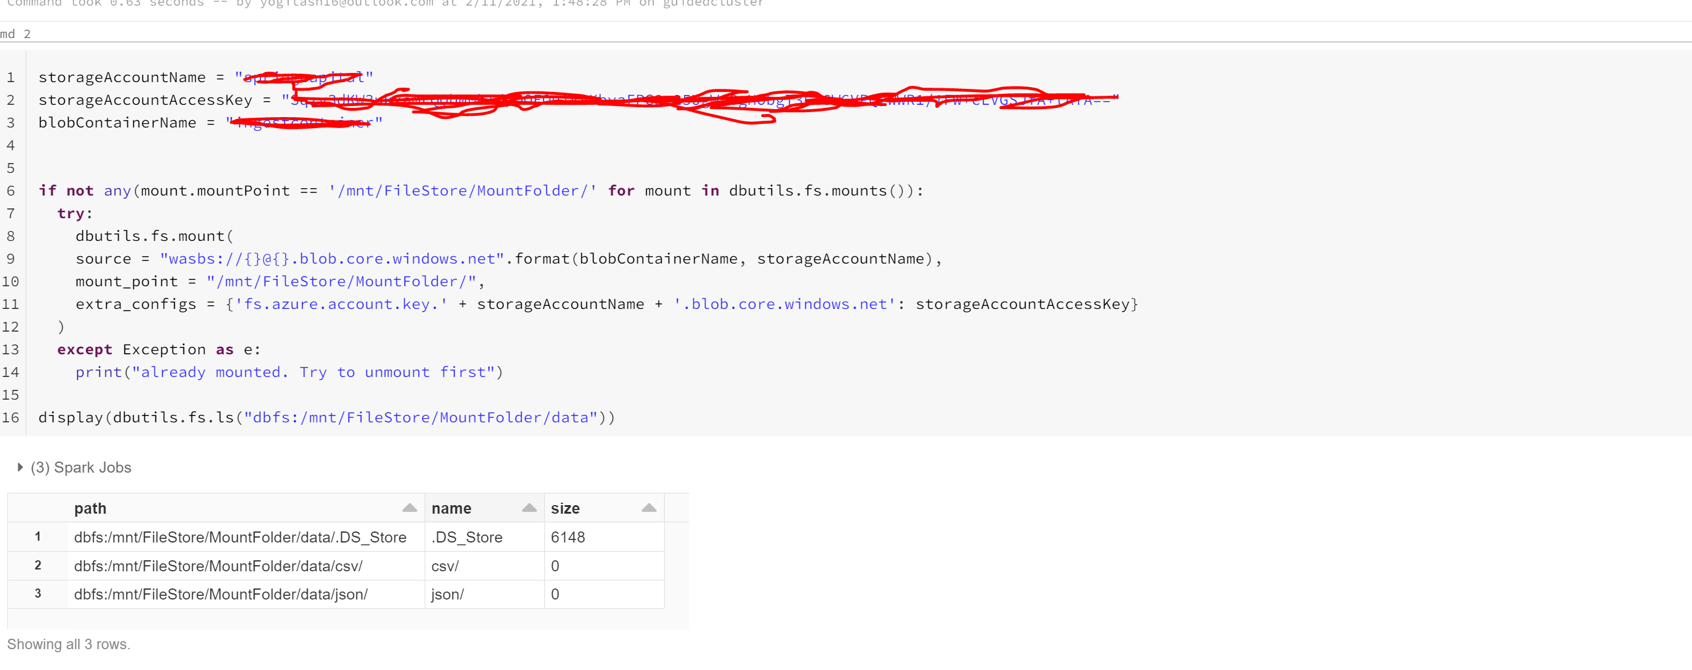

Below code is to parse the records in semi-structured format below loading into spark

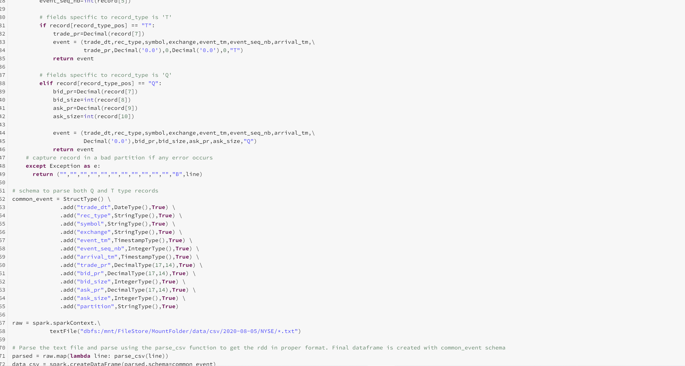

Final Dataframe table after parsing the csv records

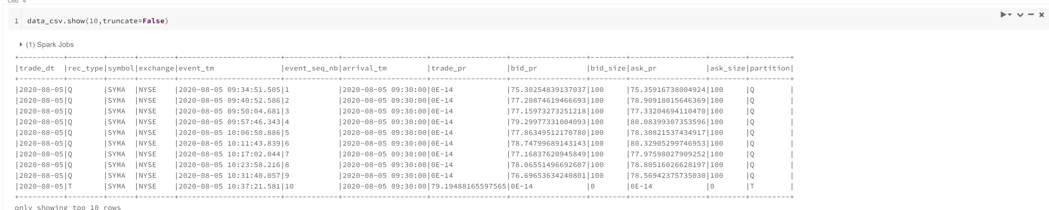

Save the csv dataframe as parquet file.

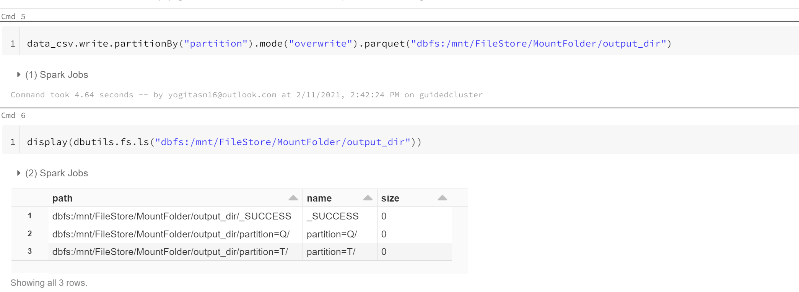

As displayed below, csv dataframe is saved as parquet files in partition ‘Q’

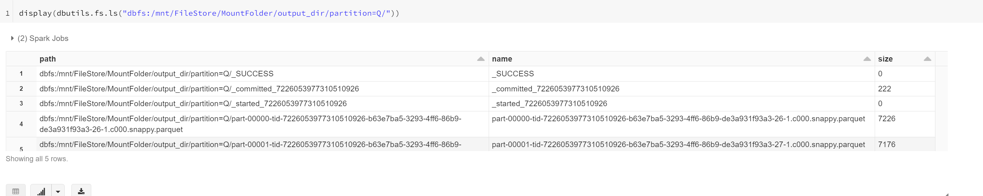

Below code is to parse the json records below loading into spark

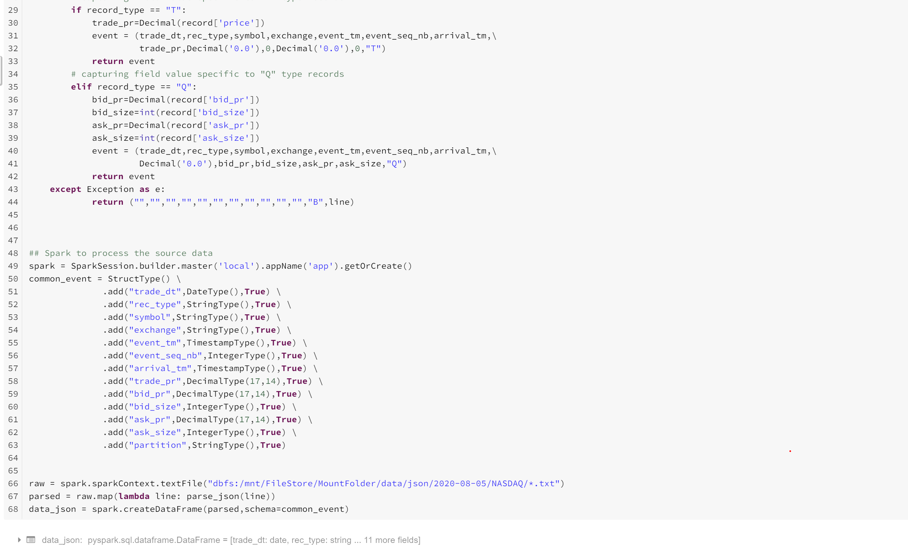

Final table

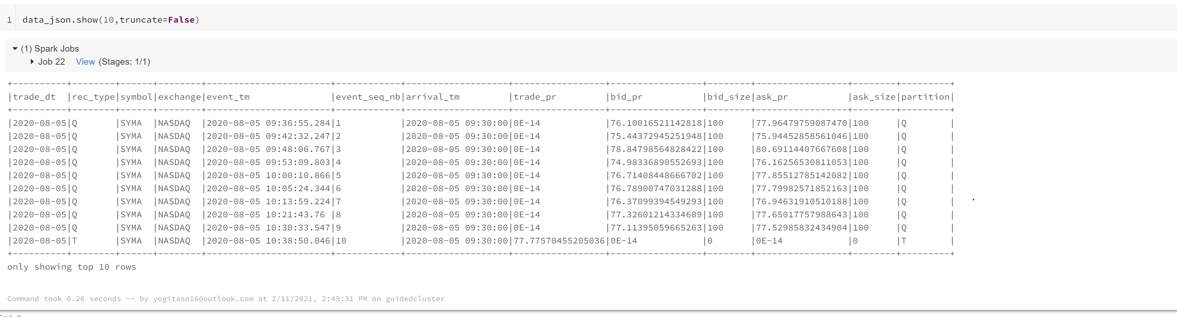

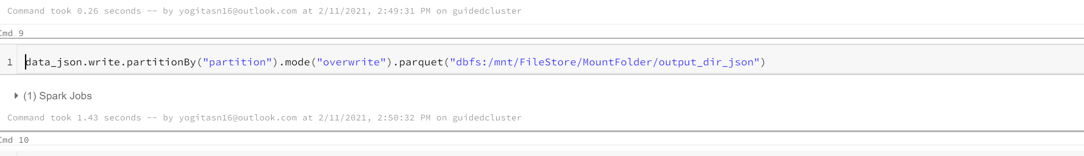

Json dataframe is saved as parquet files in partitions Q and T.

