**MongoDB**

MongoDB is a flexible and scalable NoSQL database that stores data in a document format (BSON) and doesn't require a fixed schema. It's known for its ability to handle large volumes of data and is widely used for various types of applications.

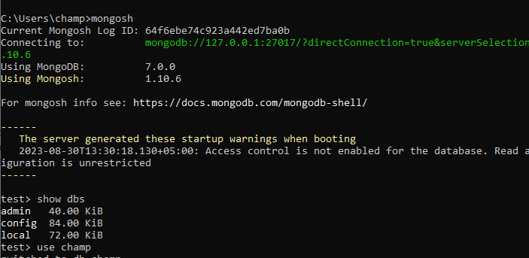

**Create:**

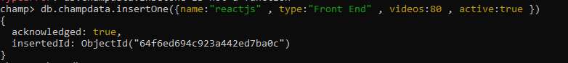

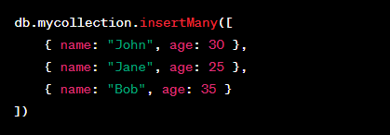

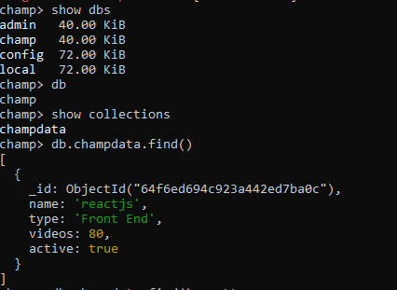

**Read:**

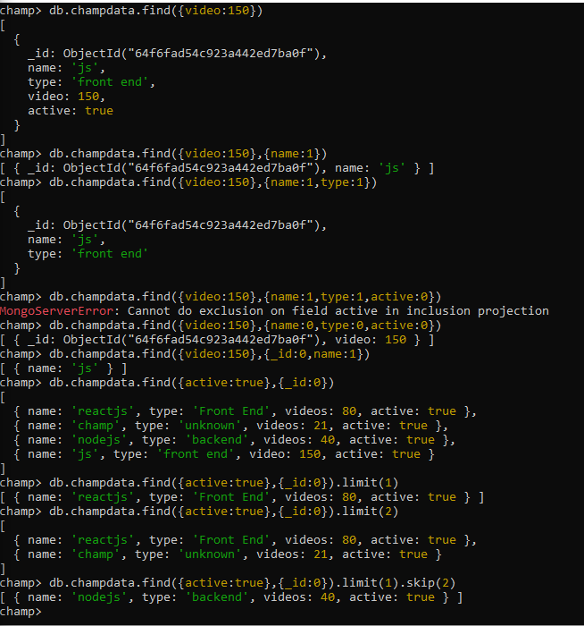

**Update:**

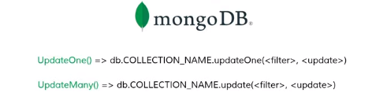

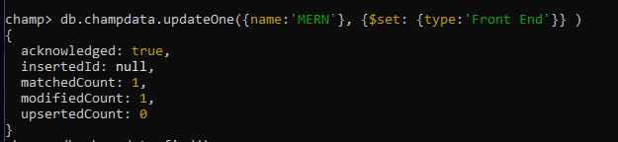

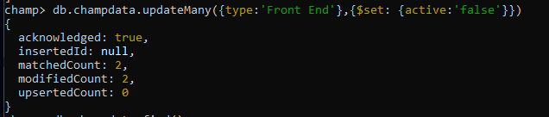

**Delete:**

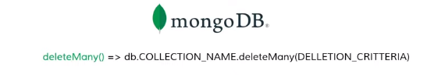



**Schemas:** In MongoDB, the schema is like a set of flexible rules for how your data can be stored. Unlike traditional databases with fixed tables, MongoDB lets you store data without a strict structure. This flexibility makes it easier to adapt to changing data needs in your applications

**Model:** In MongoDB, a "model" is like a blueprint for how you want to store and organize your data. It describes what kinds of information you expect to find in your database, such as the names and types of data fields (like name, age, email). Think of it as a template that helps you work with your data in a more organized way. This model is typically used in programming when you want to interact with MongoDB using code

**Comparison operator:**

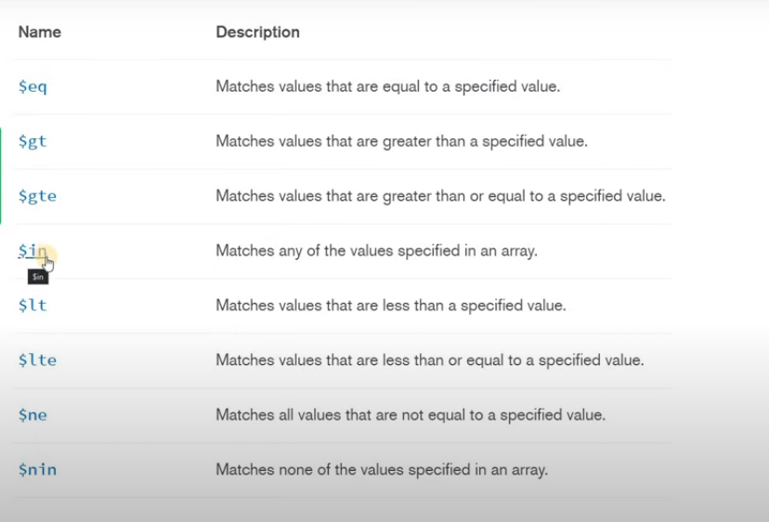

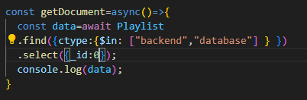

**Logical operator:**

