**Task**

* Write metadata for the data set and experiment described below. Submit your metadata file to this github repository.
* Imagine you are marking for BIOL 1001. List the necessary elements of the metadata to which you would assign marks.

**Experiment**

The large cube of potato in in beaker A has exactly the same total volume as the 8 small cubes of potato in distilled water in beaker B. The experiment is performed with 0% (Distilled Water), 0.9%, 2%, and 5% NaCl in the beaker.

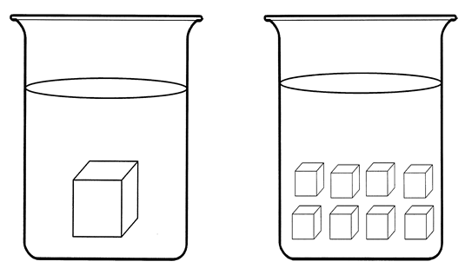

**A**

1 (2 cm x 2 cm x 2 cm)

potato cube

**B**

8 (1 cm x 1 cm x 1 cm)

potato cubes

**Data**

|  |  |  |  |
| --- | --- | --- | --- |
| Treatment | Concentration  (% NaCl) | Final Weight (g) | Initial Weight  (g) |
| A | 0 |  |  |
| B | 0 |  |  |
| A | 0.9 |  |  |
| … | … |  |  |