______________________________________________________________________________________________________________________________________________________
communications medicine
Article | Article | EcoNiche-Opt locked immune-ecology score

EcoNiche-Opt: a locked immune-ecology transcriptomic score for multicohort prediction of immune checkpoint blockade response
Pengyuan Xu1,3, Guang Yang2,3, Moyan Li3*
1 Department of Materials Science and Engineering, Monash University, Clayton, VIC 3800, Australia.
2 School of Economics and Management, China University of Mining and Technology, Xuzhou 221116, Jiangsu, China.
3 Hong Kong University of Science and Technology (Guangzhou), Guangzhou 510000, China.
*Correspondence: moyanli@hkust-gz.edu.cn
Abstract
Background Transcriptomic biomarkers of immune checkpoint blockade response remain difficult to translate because public cohorts differ in response definitions, assay platforms, sampling context, treatment setting, and tumour-immune ecological structure.
Methods We developed EcoNiche-Opt as a leakage-safe immune-ecology framework that treats cohort audit, endpoint harmonization, signed-rank ecological module construction, biologically constrained model optimization, and locked external scoring as one reproducible workflow. Expression profiles are converted into immune-ecology module scores, and the model learns both module main effects and ecological interaction edges under an objective that balances discrimination, calibration, biological consistency, complexity, and cross-cohort stability.
Results Here we show that EcoNiche-Opt reached area under the receiver operating characteristic curve (AUROC) 0.705 in the high-evidence primary melanoma stratum and AUROC 0.685 in the Response Evaluation Criteria in Solid Tumours (RECIST)-supported stratum, with family-level false-discovery-rate support over a predeclared eight-signature comparator family (two-sided q=0.002). Locked external and panel-transfer analyses showed refitting-free portability, including strict RECIST AUROC 0.610 versus a signature-family mean of 0.570 (two-sided q=0.031) and clinical-benefit AUROC 0.604 versus 0.566 (two-sided q=0.031). Single-cell localization and ecological-edge analyses linked the score to antigen presentation, T/NK effector activity, T-cell dysfunction, myeloid suppression, and stromal exclusion.
Conclusions EcoNiche-Opt provides an auditable, locked, and independently computable 62-gene immune-ecology scoring framework for multicohort biomarker development, validation, and panel-compatible external scoring.

Plain language summary
Immunotherapy can help some people with cancer, but it is difficult to predict who will respond using public gene-expression data because studies use different response labels, technologies, and patient groups. EcoNiche-Opt was designed to make these data easier to compare. It first audits each cohort and response label, then converts tumour gene expression into immune-ecology scores that describe antigen presentation, immune attack, immune dysfunction, myeloid suppression, and stromal exclusion. The final model is locked before external cohorts are scored, so new datasets cannot change the genes, weights, or thresholds. Across melanoma and external panel-transfer analyses, EcoNiche-Opt improved over a predeclared family of immune signatures and produced a 62-gene score that other researchers can compute from independent expression data.

Introduction
Most transcriptomic biomarkers for ICB response fail not because immune signals are absent, but because the same signal must survive changing labels, platforms, tumour types, treatment contexts, and sampling time points. IFN-gamma-related profiles, TIDE dysfunction and exclusion scores, CYT, IPRES, antigen-presentation signatures, and T-cell-inflamed signatures each capture part of the response signal[3-8]. Yet their performance varies across cohorts and endpoints, leaving the field with many plausible signatures but fewer reproducible frameworks for deciding when a biomarker claim is valid.
The central difficulty is therefore not the absence of candidate biomarkers, but the absence of an auditable validation framework that can handle public-cohort heterogeneity. Public ICB datasets often contain inconsistent sample identifiers, mixed baseline and on-treatment specimens, incompletely documented clinical labels, mixed CR/PR/SD/PD and DCB/NDB annotations, and variable platform-specific gene coverage. A credible biomarker study must establish which samples, labels, endpoints, and expression features are traceable before model performance can be interpreted.
A second gap is biological. ICB response is not a one-dimensional IFN-gamma or cytotoxicity signal; it reflects the balance between antigen presentation, T/NK effector activity, T-cell dysfunction, myeloid suppression, stromal exclusion, tumour dedifferentiation, and tissue-resident/TLS-like states[4,11,16,18-20]. The modelling unit should therefore be an immune-ecological state and its interaction with other states, rather than an isolated summed signature. This distinction matters because response-supporting and resistance-associated programmes can coexist in the same tumour and may be informative precisely through their coupling.
Here we develop EcoNiche-Opt, a leakage-safe immune-ecology optimization framework that integrates auditable cohort curation, endpoint harmonization, signed-rank module scoring, ecological interaction edges, biologically constrained model selection, leave-one-dataset-out testing, locked external validation, and panel-compatible open scoring. EcoNiche-Opt is evaluated under a deliberately conservative design: endpoint-stratified labels, predeclared signature-family comparison, FDR-aware claim gating, and locked external scoring without refitting. The final output is not only a classifier, but a locked 62-gene immune-ecology scoring rule that can be computed in independent cohorts while preserving the discovery/external validation boundary.

Methodological contributions of EcoNiche-Opt
- Auditable benchmark construction: cohort registration, manual response-label curation, endpoint harmonization, access-status tracking, and gene-coverage QC.
- Immune-ecology representation: signed-rank module scores for response-high and resistance-high tumour-immune states.
- Coupled ecological modelling: module main effects plus interaction edges among antigen-presentation, effector, dysfunction, myeloid, stromal, and tissue-resident/TLS-like states.
- Biologically constrained optimization: joint consideration of discrimination, calibration, biological consistency, model complexity, and cross-cohort stability.
- Leakage-safe validation: LODO testing, locked external scoring, predeclared signature-family comparison, and FDR-aware claim gating.
- Translational implementation: a locked 62-gene qPCR/NanoString-compatible panel and open scoring code for independent computation.

Results

Auditable cohort curation defines the valid search space for ICB response modelling
Because public ICB cohorts differ in response labels, sampling status, treatment context, and platform coverage, EcoNiche-Opt treats cohort audit as the first modelling step rather than as routine preprocessing (Figure 1a). Registered resources span melanoma, non-small cell lung cancer, urothelial cancer, hepatocellular carcinoma, renal cell carcinoma, glioblastoma, and esophageal/GEJ cohorts. The primary melanoma benchmark focuses on published resources including Riaz/GSE91061, Hugo/GSE78220, Gide/PRJEB23709, Liu/PHS000452-like, Jerby-Arnon/GSE145996, Auslander/GSE115821, and Du/GSE168204[6-12]. Pan-cancer and panel-transfer resources include Prat/GSE93157, a urothelial real-world cohort, IMvigor210, NSCLC DCB/NDB, HCC nCounter, RCC nivolumab, and the PERFECT esophageal cohort[13-17]. Each source is annotated for cohort role, access status, expression-matrix quality control, sample size, gene count, label evidence, and analysis boundary (Figure 1b,d; Supplementary Tables 1-5). Public, controlled, and unknown-access sources are explicitly separated; controlled or unavailable data are not replaced with simulated outputs.
Response endpoints are harmonized into three complementary definitions (Figure 1c; Supplementary Table 6). Primary RECIST defines CR/PR/MR as response and SD/PD as non-response. Strict RECIST retains CR/PR versus PD and excludes SD/MR. Clinical benefit defines CR/PR/MR/SD or DCB as benefit where supported by metadata. Across cohorts, primary RECIST and clinical benefit used 554 samples with response_raw annotations, whereas strict RECIST used 480 samples after excluding 74 intermediate-response samples (Figure 4a; Supplementary Table 6). Response-balance summaries showed marked differences in responder/nonresponder proportions across PHS000452_LIU_LIKE_PRE, GSE176307, GSE93157, GSE91061, PRJEB23709_PD1_PRE, and GSE78220 (Figure 1e), motivating explicit treatment of class imbalance and cohort heterogeneity.
Platform and gene coverage determine whether ecological modules can be computed in external and panel-transfer cohorts. Module-level coverage analysis showed complete coverage of the seven prior modules in PHS000452_LIU_LIKE_PRE and PRJEB23709_COMBO_PRE, lower coverage of antigen presentation and stromal exclusion in GSE145996, and lower stromal-exclusion coverage in the NanoString-like GSE93157/GSE140901 setting while preserving computability of IFN/T, CD8, checkpoint, antigen-presentation, and myeloid modules (Figure 1f; Supplementary Figure 2; Supplementary Table 16). These quality-control results define the input boundary for training, locked external validation, and panel-transfer analysis.

EcoNiche-Opt models ICB response through coupled immune-ecological states
A conventional signature assumes that each immune axis can be added independently. EcoNiche-Opt instead begins from seven tumour-immune ecological prior modules: IFN/T-cell inflamed, CD8 cytotoxic, checkpoint/exhaustion, antigen presentation, myeloid suppression, stromal exclusion, and TRM/TLS (Figure 2a; Supplementary Table 7). These modules represent immune-response, dysfunction/exclusion, cytolytic activity, antigen-presentation, and stromal-exclusion axes described in prior ICB biomarker studies[3-5,11,16,18]. IFN/T inflamed, CD8 cytotoxic, checkpoint/exhaustion, antigen presentation, and TRM/TLS are response-high priors; myeloid suppression and stromal exclusion are resistance-high priors. This design models ICB response as a composition of multicellular ecological states rather than as a single-gene or single-signature score.
The core feature representation is a signed-rank module score (Figure 2b). For sample i and ecological state q, EcoNiche-Opt computes a rank-normalized expression value for each available gene and averages direction-adjusted gene values within the module. This rank-based representation was designed to make ecological states comparable across RNA-seq, microarray, and targeted expression panels. The total ecological score combines module main effects and module-interaction terms: S_i = sum_q w_q M_q(i) + sum_q,r beta_qr E_qr(i), where E_qr(i) denotes ecological interaction features between states. These edges allow the model to represent immune-response and immune-resistance states as coupled processes rather than independent additive signatures. The training objective jointly rewards AUROC, AUPRC, balanced accuracy, biological-prior consistency, and cross-cohort stability while penalizing ECE, gene-set size, batch dependence, redundancy, and therapy confounding. Calibration and decision-curve analysis follow established prediction-model evaluation frameworks[25,26].
The heuristic ecology optimizer begins from a candidate gene pool and iteratively applies mutation, crossover, network-neighborhood jumps, edge search, biological-objective selection, and locked scoring (Figure 2c). Training-set optimization yields ecological edges, optimized module candidates, and an optimizer history (Supplementary Tables 8-9). Edge-class summaries showed that coexpression network edges dominate, while pathway, regulatory, checkpoint, and network edges are retained (Figure 2d). The densest source-target classes include T-cell dysfunction self-interaction, APM/MHC to T/NK effector, CAF/ECM self-interaction, T/NK effector self-interaction, and APM/MHC coupling to T-cell dysfunction, CAF/ECM, and myeloid suppression.
Component analyses show that the full ecological graph draws information from multiple sources (Figure 2e-f; Supplementary Figure 6). WordFullGraph, WordUnsignedGraph, WordNoInteraction, and WordNoBioObjective variants isolate the contributions of signed direction, interaction edges, and the biological objective. The optimized search space includes antigen presentation/MHC, CAF/ECM exclusion, T-cell dysfunction, T/NK effector, tumour dedifferentiation, and myeloid suppression, with approximately 54-63 optimized genes per expanded state. Thus, EcoNiche-Opt is not simply a renamed IFNG or CXCL9 score; it learns an ecological state structure and the coupling among states.

Coupled immune-ecology scoring improves over predeclared immune signatures in melanoma
The primary melanoma benchmark asks whether coupled immune-ecology scoring adds value beyond established immune signatures under a conservative validation design. In the melanoma core high-evidence stratum, EcoNiche-Opt reached an AUROC of 0.704903, exceeding eight predeclared signatures: IFNG, CXCL9, TIG, TIDE_dysfunction, APM, CYT, IPRES, and TIDE_exclusion (Figure 3a; Supplementary Tables 10-12). These baselines cover IFN-gamma/T-cell-inflamed signal, T-cell dysfunction/exclusion, cytolytic activity, IPRES resistance, and antigen-presentation machinery[3-8]. The strongest individual baseline was CXCL9/TIG, with AUROC approximately 0.665619; the EcoNiche-Opt point-estimate margin over this tier was approximately 0.039 (Supplementary Table 10).
The predeclared eight-signature family test provides the strongest evidence for primary melanoma superiority (Figure 3b; Supplementary Table 11). In the melanoma core high-evidence stratum, EcoNiche-Opt achieved AUROC 0.704903 versus a family mean AUROC of 0.631796, with mean delta 0.073416, 95% CI 0.031503-0.112106, and two-sided FDR q=0.002. In the RECIST-supported primary melanoma stratum, EcoNiche-Opt achieved AUROC 0.684559 versus a family mean AUROC of 0.619700, with mean delta 0.064490, 95% CI 0.024521-0.102653, and two-sided FDR q=0.002. These results support the claim that EcoNiche-Opt improves over the predeclared strong-signature family average. Paired bootstrap or DeLong-compatible comparisons were used with Benjamini-Hochberg FDR correction[23,24].
Paired delta-AUROC summaries showed positive EcoNiche-Opt deltas versus all eight individual baselines (Figure 3c). In the core high-evidence stratum, deltas versus APM, CXCL9, CYT, IFNG, IPRES, TIDE_dysfunction, TIDE_exclusion, and TIG were 0.041, 0.039, 0.075, 0.041, 0.138, 0.050, 0.161, and 0.039, respectively. In the RECIST-supported primary stratum, corresponding deltas were 0.043, 0.035, 0.060, 0.045, 0.111, 0.039, 0.145, and 0.040 (Supplementary Tables 10-12). These individual results support directionally consistent point-estimate improvement, and the formal superiority statement is anchored to the family-level FDR test.
Leave-one-dataset-out (LODO) distributions characterize cross-cohort behavior (Figure 3d; Supplementary Figure 3; Supplementary Table 12). In the core high-evidence stratum, holdout AUROCs for GSE91061, GSE78220, and PRJEB23709_PD1_PRE were 0.612821, 0.648352, and 0.875598, with mean AUROC 0.712257. In the RECIST-supported primary stratum, adding GSE145996 yielded holdout AUROCs of 0.612821, 0.648352, 0.520833, and 0.875598, with mean AUROC 0.664401. Decision-curve analysis showed positive net benefit relative to treat-all over an approximate threshold-probability range of 0.20-0.45 in the core high-evidence stratum (Figure 3e; Supplementary Table 14)[25]. The allowed-claim matrix restricts the main conclusion to FDR-supported family-level improvement in primary melanoma (Figure 3f).

Endpoint sensitivity and claim gating strengthen biomarker evidence
Endpoint sensitivity analysis showed that response definition materially changes sample inclusion and class composition (Figure 4a; Supplementary Figure 5; Supplementary Table 6). Clinical benefit and primary RECIST both used 554 samples but contained 274 and 200 responders, respectively. Strict RECIST used 480 samples after excluding 74 SD/MR or intermediate samples. This endpoint-dependent shift supports reporting strict RECIST, primary RECIST, and clinical benefit separately rather than forcing all labels into a single binary endpoint.
Word graph component ablation showed positive point-estimate contributions from interaction edges, signed direction, and the biological objective in the high-evidence melanoma stratum (Figure 4b; Supplementary Table 13). Relative to the complete WordFullGraph model, WordNoInteraction, WordUnsignedGraph, and WordNoBioObjective ablations produced delta AUROC values of 0.016656, 0.031741, and 0.052797, respectively. The biological-objective component contributed the largest point-estimate margin, indicating that biological prior constraints shape model selection.
Discrimination-calibration analysis showed complementary strengths of EcoNiche-Opt and immune signatures (Figure 4c). In the melanoma core high-evidence stratum, EcoNiche-Opt-HeuristicEcology achieved pooled AUROC 0.704903 and ECE 0.234862. Its discrimination exceeded IFNG, CXCL9, and ModuleIFNConsensus, and calibration was retained as a distinct evaluation dimension[26]. Therefore, Brier/ECE and decision-curve metrics are reported alongside AUROC (Figures 3e and 4c; Supplementary Table 14).
The claim gate translates statistical evidence into tiered statements (Figure 4d-f). Among 16 individual signature comparisons, 15 were point_estimate_only and one reached pre-directional FDR support; formal superiority wording is reserved for FDR-supported comparisons. Holdout heterogeneity showed how small cohorts such as GSE145996 shape full primary melanoma stability (Figure 4e). Together, these analyses define an auditable evidence hierarchy: EcoNiche-Opt provides FDR-supported improvement over a predeclared strong-signature family in the primary melanoma benchmark, while individual-signature advantages are reported as paired point estimates and FDR-supported results where available.

Locked external and panel-transfer analyses test portability without refitting
The portability test was intentionally locked: all genes, module directions, interaction edges, thresholds, and calibration choices were fixed before external cohorts were scored (Figure 5a; Supplementary Table 15). Strict RECIST external/panel cohorts included GSE145996, PHS000452_LIU_LIKE_PRE, GSE93157, PRJEB23709_COMBO_PRE, and GSE140901; corresponding EcoNiche-Opt AUROCs were 0.575, 0.573, 0.586, 0.762, and 0.833 (Figure 5b; Supplementary Table 15). The model performed strongly in the combination-therapy transfer and HCC NanoString-transfer cohorts and retained a refitting-free scoring path across strict PD1-like melanoma stress cohorts. Together, these results show that the locked ecological score can be transported across external RNA-seq and panel-transfer settings while preserving discovery/external separation.
The external signature-family omnibus test provides pooled external/panel statistical support (Figure 5c; Supplementary Table 15). In the strict RECIST all locked external/panel analysis, EcoNiche-Opt AUROC was 0.609671 versus a signature-family mean of 0.569882, with mean delta 0.039789 and two-sided FDR q=0.0306. In clinical benefit all locked external/panel analysis, EcoNiche-Opt AUROC was 0.604353 versus a family mean of 0.566113, with mean delta 0.038240 and two-sided FDR q=0.0306. Primary RECIST all external/panel analysis showed pre-directional support, with target AUROC 0.576664 and family mean 0.548750. These findings provide family-level external/panel evidence, with individual-model deltas reported separately.
NanoString panel transfer evaluated whether the ecological score can be computed in an assay-like input space (Figure 5d; Supplementary Table 16). GSE93157 and GSE140901 both had mean module coverage of 0.745573. IFN/T inflamed, CD8 cytotoxic, checkpoint/exhaustion, antigen presentation, and myeloid suppression retained higher coverage, whereas stromal exclusion had lower coverage, suggesting that future targeted panels should prioritize ECM/stromal genes. These results indicate that EcoNiche-Opt can be read out from panel-compatible expression data, not only from full transcriptomes.
PD1-like external stress rescue analysis was used to characterize strict melanoma PD1-like transfer settings (Figure 5e-f; Supplementary Figure 8; Supplementary Table 17). In the pooled strict RECIST PD1-like stress setting, locked panel AUROC was 0.571131, whereas the PD1LikeTransferHead reached AUROC 0.595238 and reduced ECE from 0.261296 to 0.144996. Threshold sensitivity showed balanced accuracy 0.626786 under a fixed probability 0.5 policy. This analysis suggests a reusable development path for PD1-like melanoma transfer settings while preserving the independence of the locked primary validation model.

Single-cell and edge analyses connect the score to immune response and resistance niches
EcoNiche-Opt module activities localized to biologically plausible cell compartments in single-cell data (Figure 6a; Supplementary Figure 9; Supplementary Table 18). APM/MHC was high in T.CD8, T.CD4, NK, macrophage, and endothelial compartments. T/NK effector activity was highest in NK and T.CD8 cells. T-cell dysfunction was stronger in T.CD8, T.CD4, T.cell, and NK compartments. Myeloid suppression was enriched in macrophages. These patterns are consistent with melanoma single-cell ecosystems and T-cell states associated with checkpoint immunotherapy response[19,20], linking bulk ecological scores to cellular compartments.
Optimized ecological edges further explain the model structure (Figure 6b; Supplementary Table 8). The top source-target classes included T-cell dysfunction self-interaction, APM/MHC to T/NK effector, CAF/ECM self-interaction, T/NK effector self-interaction, APM/MHC to T-cell dysfunction, APM/MHC to CAF/ECM, T-cell dysfunction to tumour dedifferentiation, myeloid suppression to tumour dedifferentiation, APM/MHC to myeloid suppression, and CAF/ECM to myeloid suppression. T-cell dysfunction self-interaction included checkpoint edges, and APM/MHC to T/NK effector included pathway edges, indicating that the model captures structural coupling between response-supporting and resistance-associated states.
Feature contribution summaries show that EcoNiche-Opt is not simply an inflammation signature under another name (Figure 6c). Tumour dedifferentiation, T/NK effector, T-cell dysfunction, CAF/ECM exclusion, myeloid suppression, and APM/MHC contributed more strongly than the original fixed prior modules. Module gene-set summaries list the gene counts and response directions for IFN/T inflamed, CD8 cytotoxic, checkpoint/exhaustion, antigen presentation, myeloid suppression, stromal exclusion, and TRM/TLS (Figure 6d; Supplementary Table 7).
Perturbation reversal converts resistance-module structure into experimentally testable hypotheses (Figure 6e; Supplementary Table 19). Dasatinib, KIN001-043, mitoxantrone, AZ-628, AZD7762, NVP-AUY922, CGP-60474, olaparib, BMS-387032, and AZD-5438 were prioritized by integrating LINCS reversal, DepMap score, and DGIdb evidence[27-29]. The perturbation layer is labelled hypothesis_only and supports mechanistic prioritization. The mechanism summary separates response-supporting axes (APM/MHC, T/NK effector, IFN/T inflamed) from resistance-associated axes (myeloid suppression and CAF/ECM exclusion) (Figure 6f).

A locked 62-gene panel makes the ecological score independently computable
After discovery, the key translational question is whether the ecological readout can be computed, interpreted, and independently checked in a more assay-like input space. Figure 7a summarizes the one-way path from RNA assay or bulk expression matrix to ecological module score, response probability, endpoint-specific classification, and external-cohort evaluation. External samples only enter scoring and evaluation; they do not alter the model. Thus, the validation chain tests a frozen ecological model rather than a score reselected on external data.
The locked qPCR/NanoString-compatible panel compresses the seven ecological modules into 63 module-gene entries and 62 unique genes (Figure 7b; Supplementary Tables 7 and 20). It preserves IFN/T inflamed, CD8 cytotoxic, checkpoint/exhaustion, antigen presentation, myeloid suppression, stromal exclusion, and TRM/TLS axes. CXCL13 belongs to both checkpoint/exhaustion and TRM/TLS, reflecting overlap between TLS-like activation and T-cell exhaustion in ICB response. Module weights are frozen after discovery: IFN/T inflamed 1.0, CD8 cytotoxic 0.5, checkpoint/exhaustion 0.25, antigen presentation 0.5, myeloid suppression -0.5, stromal exclusion -0.5, and TRM/TLS 0.25.
Endpoint-specific thresholds are also determined only from discovery cohorts GSE91061, GSE78220, and PRJEB23709_PD1_PRE (Figure 7c). The primary RECIST threshold is 0.368668 with training AUROC 0.704903. The strict RECIST threshold is 0.390778 with training AUROC 0.710197. The clinical-benefit threshold is 0.423504 with training AUROC 0.642899. All external and panel-transfer analyses use these fixed thresholds, restricting external cohorts to testing portability and endpoint stability.
External validation is independently auditable because each sample is transformed by the same rank-normalized module transformation, scored by frozen coefficients and thresholds, and only then matched to clinical response labels for AUROC, ECE, Brier score, and decision-curve evaluation (Figure 7d-e). Sample, patient, treatment, time point, and response-evidence fields are retained, allowing performance differences to be traced to cohort composition, endpoint mapping, and platform coverage. The open algorithm serves the same scientific purpose: rank normalization, signed module scoring, interaction-edge construction, thresholding, and locked scoring are fixed as a single computable rule that can be applied to independent RNA-seq, microarray, or NanoString-like matrices without changing the training/external validation boundary (Supplementary Figure 10; Supplementary Table 20).

Discussion
EcoNiche-Opt shows that ICB transcriptomic prediction can be strengthened not by replacing one immune signature with another, but by embedding immune signals into an auditable, leakage-safe, and biologically constrained ecological scoring framework. Public cohorts increase sample size but introduce heterogeneity in labels, platforms, sampling context, and treatment regimen. Single inflammatory signatures are interpretable but cannot fully represent the coexistence of effector activity, exhaustion, antigen presentation, myeloid suppression, and stromal exclusion. EcoNiche-Opt links these two problems by making cohort audit, endpoint definition, ecological representation, model selection, external validation, and open scoring part of the same evidence chain.
The methodological contribution is the coupling of data traceability with immune-ecology modelling. The data-curation layer turns public ICB cohorts from downloadable expression matrices into auditable analytical units annotated with treatment, sampling time, response evidence, endpoint mapping, and platform coverage. Signed-rank module scores then place cross-platform expression data into a shared rank space; ecological edges encode interactions among immune-response and immune-resistance states; and the biological objective constrains the search to interpretable structures instead of a purely black-box optimum. LODO testing, locked external scoring, and an FDR-aware claim gate separate model development from model assessment and reduce the risk that holdout or external cohorts influence gene selection, threshold choice, or claim wording.
The evidence supports three levels of claims. First, in primary melanoma benchmarks, EcoNiche-Opt shows FDR-supported improvement over a predeclared eight-signature family (two-sided FDR q=0.002; Figure 3b; Supplementary Table 11). Second, locked external and panel-transfer analyses support reproducible portability without refitting, including family-level support in strict RECIST and clinical-benefit pooled analyses (Figure 5c; Supplementary Table 15). Third, single-cell localization, ecological-edge structure, and perturbation reversal provide a biologically organized set of mechanistic hypotheses. This hierarchy highlights the main strengths of the framework: family-level improvement in melanoma, refitting-free external scoring, and interpretable immune-ecology structure.
Biologically, the model does not behave as a simple inflammation score. Response-associated axes include antigen presentation, IFN/T-cell inflamed activity, and T/NK effector function; resistance-associated axes include myeloid suppression, CAF/ECM exclusion, tumour dedifferentiation, and T-cell dysfunction. Ecological edges suggest that the informative signal lies partly in the balance between immune attack and immune exclusion rather than in any single module alone. These analyses support mechanistic plausibility and provide a structured map for perturbation and assay-focused follow-up work.
The translational output is a locked 62-gene immune-ecology panel and an open scoring implementation. Panel genes, module directions, interaction edges, coefficients, thresholds, and calibration choices are fixed before external scoring, making EcoNiche-Opt independently computable from RNA-seq, microarray, or targeted-expression matrices. This design turns EcoNiche-Opt into a reproducible biomarker-development and validation system with a defined route from heterogeneous public cohorts to locked, panel-compatible immune-ecology scoring.

Methods

Data registration and access-status audit
Each public data source was registered as a discovery, primary validation, locked external, panel-transfer, or secondary/confounded cohort. Source accession, cancer type, treatment regimen, platform, access status, and usable files were recorded. Public, controlled, and unknown-access data were marked separately; controlled or unavailable data were not substituted with simulated data. Cohort registration, access-status assessment, and expression QC are summarized in Supplementary Tables 1-3.

Expression-matrix processing and gene coverage
Expression matrices were parsed by registered pipelines and harmonized for sample identifiers, gene symbols, and matrix orientation. For each cohort, n_samples, n_genes, source file, and QC status were recorded. For locked panels and ecological modules, coverage_fraction was defined as the number of available module genes divided by the total number of module genes. Coverage was used to determine module computability and to evaluate NanoString panel transfer (Figure 1f and Figure 5d; Supplementary Table 16).

Response-label curation and endpoint harmonization
Subject_id, sample_id, baseline/on-treatment status, treatment, response_raw, label_source_document, and curation notes were extracted from papers, GEO supplementary files, clinical annotations, and sample metadata. Response_raw labels were mapped to strict RECIST, primary RECIST, and clinical-benefit endpoints. Strict RECIST retained CR/PR versus PD and excluded SD/MR; primary RECIST defined CR/PR/MR as response and SD/PD as non-response; clinical benefit defined CR/PR/MR/SD or DCB as benefit. Endpoint label sensitivity is reported in Supplementary Table 6.

EcoNiche-Opt module scores
EcoNiche-Opt receives a samples-by-genes expression matrix X, with samples as rows and gene symbols as columns. For sample i and gene g, expression is first transformed by sample-wise rank-gaussian normalization:

where Phi^{-1} is the standard normal quantile function and rank percentiles are clipped at extremes to avoid infinite values. For genes available in the training set T, gene direction is estimated from the sign of the correlation between z_g and the binary response label y:
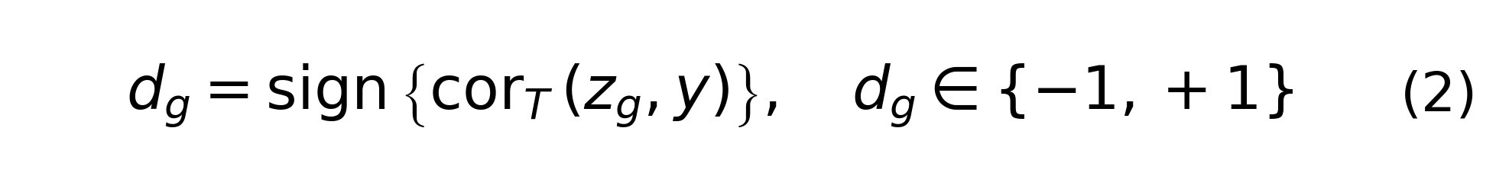
If the correlation is not estimable, direction defaults to +1. For ecological state q with gene set G_q, the signed state score of sample i is:

where A_iq is the intersection between the ecological state gene set G_q and the genes available in sample i. Square-root normalization makes module scales comparable across different coverage levels. In the WordFullGraph/heuristic model, G_q corresponds to tumour_dedifferentiation, antigen_presentation_mhc, tnk_effector, tcell_dysfunction, caf_ecm_exclusion, and myeloid_suppression. In locked panel transfer, G_q corresponds to ifn_t_cell_inflamed, cytotoxic_cd8, exhaustion_checkpoint, antigen_presentation, myeloid_suppression, stromal_exclusion, and trm_tls.
Ecological interaction edges are defined by source state q, target state r, gene pair (g,h), and edge class c. For each state, the standardized module score is passed through a sigmoid to obtain abundance term A*_iq. Edges in the same state pair are aggregated as:
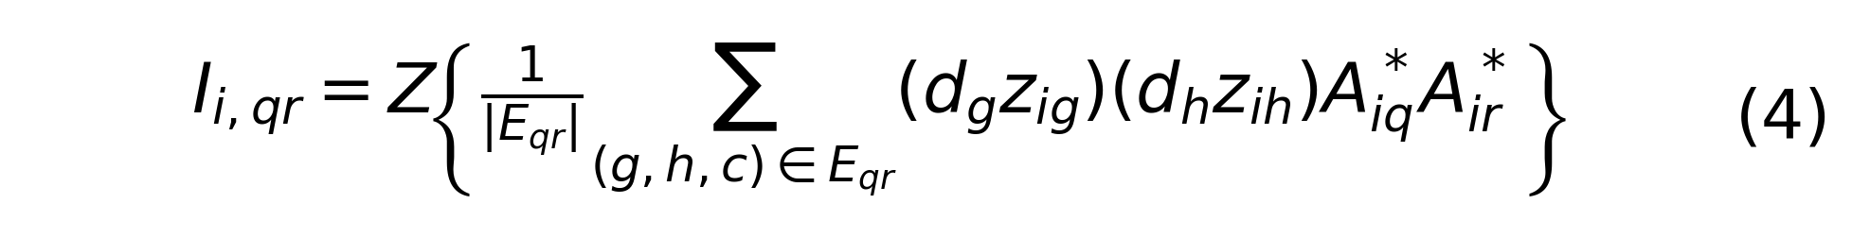
where Z[.] denotes z-score scaling of the interaction feature. The final feature vector contains module scores and interaction scores, followed by training-set standardization. The classifier is a class-balanced standardized logistic regression:

where y_i=1 denotes response/responder and y_i=0 denotes non-response/non-responder. The one-dimensional locked panel score uses the same response direction and applies the sigmoid function to the weighted sum of module scores. All gene directions, feature sets, coefficients, thresholds, and calibration objects are estimated from training data only.

Heuristic ecological optimizer
The heuristic ecological optimizer searches modules and interaction edges only within the training cohort set T. A candidate solution theta consists of state-specific candidate gene sets and an interaction set formed from seed biological edges and training-set coexpression edges. The candidate gene universe is assembled from prior module genes, seed edge genes, and genes most correlated with response in the training data. Candidate sets are updated by population initialization, mutation, crossover, and network-neighborhood jumps.
Each candidate theta is evaluated by inner leave-one-training-cohort-out evaluation. If more than one training cohort is available, one training cohort is held out as an inner validation cohort, the remaining training cohorts fit the model, and AUROC, AUPRC, balanced accuracy, and ECE are computed on the inner holdout. The candidate objective is:
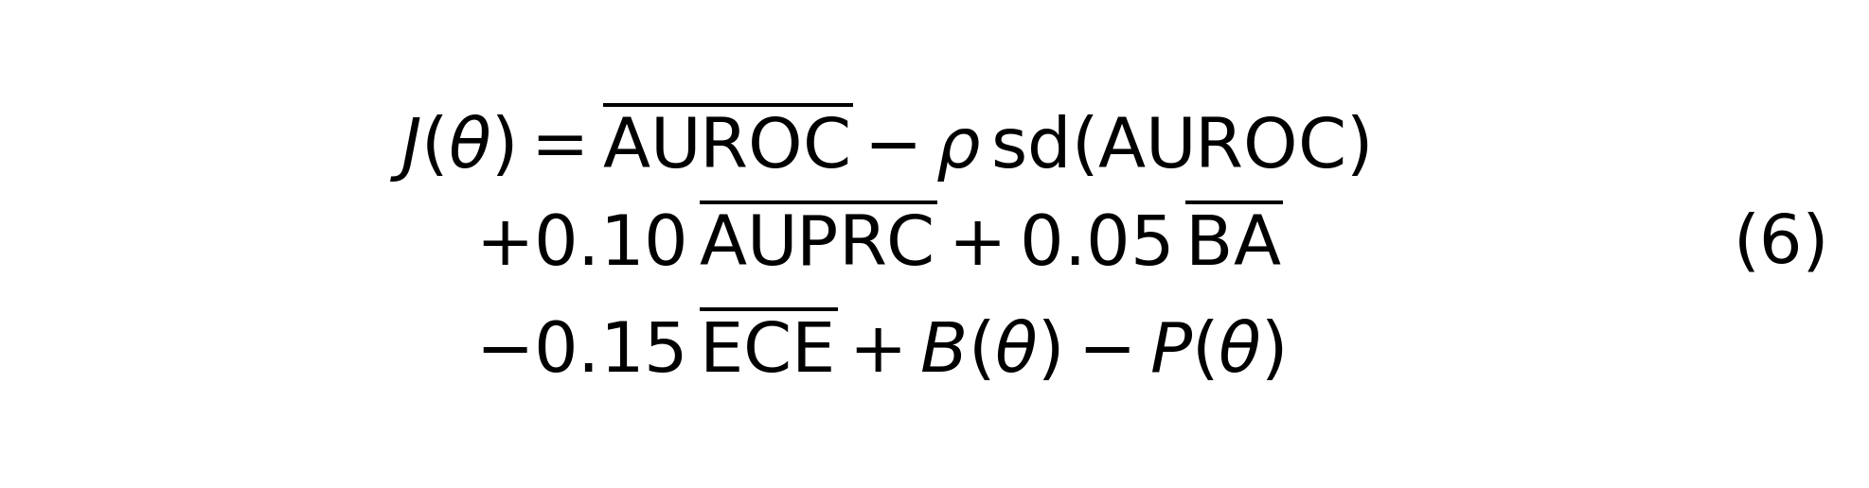
where rho=0.45 and BA denotes balanced accuracy. The biological reward term is:
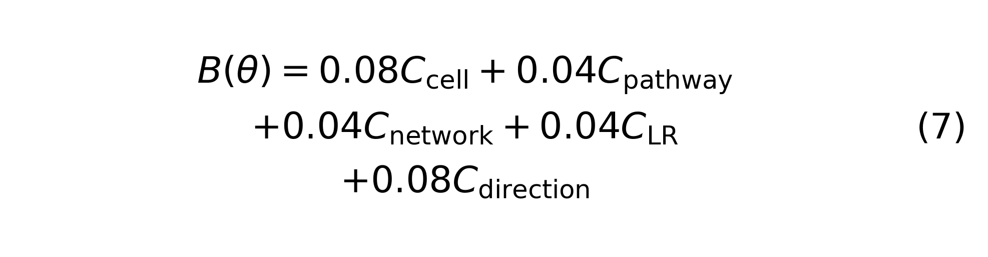
corresponding to prior cell-state consistency, pathway edges, network/regulatory/checkpoint/coexpression edges, ligand-receptor edges, and cross-cohort direction stability. The penalty term is:

which limits gene-set size, cohort/batch dependence, state redundancy, and therapy confounding. The selected model is:

When the biological objective is disabled, B(theta)-P(theta) is set to zero for the WordNoBioObjective ablation. All feature selection, direction estimation, edge selection, thresholding, and calibration are performed inside training folds. Holdout and locked external cohorts never enter Omega_T or J(theta).

Baseline signatures
EcoNiche-Opt was compared with eight predeclared strong signatures: IFNG, CXCL9, TIG, TIDE_dysfunction, APM, CYT, IPRES, and TIDE_exclusion. Signature-family comparison used the mean AUROC of this eight-signature family as the family-level baseline while retaining individual paired deltas. Melanoma benchmark summaries, signature-family FDR tests, and LODO metrics are reported in Supplementary Tables 10-12.

LODO benchmark and statistical testing
The primary melanoma benchmark used leave-one-dataset-out evaluation. For each holdout cohort h, the training set was all cohorts except h. Model selection, gene direction, module/edge selection, logistic coefficients, thresholds, and calibration were estimated only in T_h; holdout cohort h received frozen scoring. The binary threshold was selected from unique training probabilities:

When calibration was enabled, isotonic calibration was fitted only on training probabilities and training labels; holdout or external calibrated probabilities were obtained by applying the fitted calibration map to frozen predictions. Pooled AUROC, AUPRC, balanced accuracy, Brier score, ECE, calibration slope/intercept, and decision-curve metrics were generated by registered pipelines. Decision-curve analysis followed the Vickers and Elkin net-benefit framework[25]:

For stratum s, the family-level effect was:

Paired bootstrap or DeLong-compatible comparison estimated paired delta, 95% confidence interval, and P value; Benjamini-Hochberg correction controlled the FDR[23,24]. The claim gate classified results as FDR-supported family-level improvement, pre-directional support, point-estimate-only, or unsupported. Only FDR-supported family-level results were used for superiority wording.

Locked external and panel-transfer validation
Locked external validation used theta*, beta*, tau*, and optional calibration objects determined in discovery cohorts. External cohorts were not used for gene, edge, threshold, or calibration selection. External/panel cohorts included GSE145996, PHS000452_LIU_LIKE_PRE, PRJEB23709_COMBO_PRE, GSE93157, and GSE140901. GSE93157 and GSE140901 were also used for NanoString panel-transfer coverage and performance analysis. For each external sample j, the model computed only the frozen response probability and reported prespecified endpoint metrics. Locked external metrics and NanoString panel transfer are reported in Supplementary Tables 15-16.

PD1-like transfer head
PD1-like external stress rescue evaluated locked panel scoring and PD1LikeTransferHead in a pooled strict RECIST setting across GSE145996 and PHS000452_LIU_LIKE_PRE. The analysis reported AUROC, AUPRC, balanced accuracy, ECE, and threshold sensitivity to characterize model behavior in PD1-like stress cohorts (Figure 5e-f; Supplementary Figure 8; Supplementary Table 17).

Single-cell and mechanistic interpretation
Single-cell module enrichment was computed from cell_type_enrichment tables by summarizing module mean, median, and count for each cell type. Feature contribution used endpoint_module_feature_weights and computed mean absolute contribution for state-like features. Ecological interactions were aggregated from optimized_ecology_edges by source_state, target_state, and edge_class. Results are shown in Figure 6, Supplementary Figure 9, and Supplementary Table 18.

Perturbation hypothesis prioritization
Perturbation ranking integrated LINCS signature reversal, DepMap score, and DGIdb evidence[27-29]. Priority score was used to rank candidate perturbations, and status was marked as hypothesis_only. The output supports mechanism hypothesis generation and experimental prioritization. The complete candidate list is provided in Supplementary Table 19.

Locked external scoring analysis
External validation followed a freeze-then-score design. The discovery layer used pretreatment melanoma anti-PD1 RNA-seq cohorts including GSE91061, GSE78220, and PRJEB23709_PD1_PRE to define module directions, ecological states, interaction edges, model coefficients, endpoint-specific thresholds, and optional calibration functions. The external/panel layer included GSE145996, PHS000452_LIU_LIKE_PRE, PRJEB23709_COMBO_PRE, GSE93157, and GSE140901. These cohorts were used only for scoring and performance evaluation, not for gene selection, edge selection, threshold selection, or calibration. For each external sample, the expression matrix was transformed into the same rank-gaussian space, coverage-adjusted signed module scores and ecological interaction scores were computed, and the frozen linear scoring function produced response probabilities and binary predictions. Clinical response labels were read only after scoring to compute AUROC, AUPRC, balanced accuracy, ECE, Brier score, and decision-curve metrics.

Open algorithm and reproducibility boundary
The open EcoNiche-Opt implementation ensures that the statistical model has the same algorithmic definition across analysis environments. Basic inputs are a sample-by-gene expression matrix and a sample-level response table. The expression matrix uses samples as rows and gene symbols as columns. The response table must contain sample_id and a binary response label, with 1 denoting responder and 0 denoting non-responder. Optional cohort metadata support multicohort training and leave-one-dataset-out evaluation. Internally, the algorithm performs sample-wise rank-gaussian normalization, training-only gene-direction estimation, signed module scoring, ecological interaction construction, class-balanced logistic fitting, training-only threshold selection, and optional isotonic calibration. In locked scoring mode, external samples undergo only feature transformation and frozen model prediction; external labels do not enter training or selection.
Python and R interfaces call the same model implementation so that module scores, interaction features, thresholds, and probabilities remain consistent across languages. The implementation supports multicohort fitting, locked scoring, probability prediction, module/edge summaries, feature coverage audit, and model serialization. The R wrapper uses reticulate to call the same Python backend. The key design is the leakage-safety guardrail: training mode may use discovery labels for model fitting, thresholding, and calibration; locked scoring mode accepts only expression matrices and returns scores, probabilities, classifications, and gene coverage; locked external or holdout labels can be read only during evaluation.

Data availability
Public data sources, accession identifiers, access status, expression-matrix QC, response-label evidence, endpoint harmonization, and external cohort availability are reported in Supplementary Tables 1-6. Source data underlying the main figures, major supplementary figures, and supplementary tables are provided in Source Data. Publicly redistributable derived tables, benchmark metrics, figure inputs, and manuscript source files are available in the public EcoNiche-Opt repository and commit-specific source archive. Controlled or access-restricted datasets remain subject to the conditions of the original repositories and are not redistributed or replaced with simulated data.

Code availability
The EcoNiche-Opt code repository is available at https://github.com/ahvsjags/EcoNiche-Opt. The manuscript version is econiche-opt v0.3.0 at remote main commit 08ab36c4486843e7d378500ec0eaf5fe317d4a38; a commit-specific source archive is available at https://github.com/ahvsjags/EcoNiche-Opt/archive/08ab36c4486843e7d378500ec0eaf5fe317d4a38.zip. The repository provides reproducible scripts for data registration, expression processing, endpoint harmonization, model training, LODO benchmarking, locked external validation, panel-transfer analysis, mechanism interpretation, perturbation ranking, and figure/table generation, together with Python/R interfaces and shareable derived outputs.
Python installation is: git clone https://github.com/ahvsjags/EcoNiche-Opt.git, followed by python -m pip install -e . inside the repository. The main Python entry point is from econiche_opt import EcoNicheOptClassifier. R users can use the R wrapper through reticulate, which calls the same Python backend. Expression matrices should be samples-by-genes, with sample_id as row identifier and gene symbol as column name. Labels must use 1=response/responder and 0=non-response/non-responder. Command-line training and scoring use python -m econiche_opt.cli fit-package-model and python -m econiche_opt.cli score-package-model. Public API tests, demo data generation, and project validation can be run with python -m pytest -q, python -m econiche_opt.cli make-demo, and python -m econiche_opt.cli validate-project --mode demo. Controlled or access-restricted cohorts are not included in the public repository; public materials contain only shareable data, code-generated results, figures, and reproducibility documentation. The reproducibility boundary is summarized in Supplementary Figure 10 and Supplementary Table 20.

Author contributions
P.X. led the study implementation, collected and curated the datasets, designed and implemented the computational framework, performed the bioinformatic analyses and model development, generated the figures and tables, and drafted the manuscript. G.Y. assisted with manuscript formatting, presentation, and submission preparation. M.L. supervised the study, screened and reviewed the analytical outputs and manuscript content, guided interpretation, and revised the manuscript. All authors reviewed and approved the final manuscript.

Funding
The authors received no specific funding for this work.

Competing interests
The authors declare no competing interests.

References
1. Pardoll DM. The blockade of immune checkpoints in cancer immunotherapy. Nat Rev Cancer. 2012;12:252-264. doi:10.1038/nrc3239.
2. Eisenhauer EA, Therasse P, Bogaerts J, et al. New response evaluation criteria in solid tumours: revised RECIST guideline (version 1.1). Eur J Cancer. 2009;45:228-247. doi:10.1016/j.ejca.2008.10.026.
3. Ayers M, Lunceford J, Nebozhyn M, et al. IFN-gamma-related mRNA profile predicts clinical response to PD-1 blockade. J Clin Invest. 2017;127:2930-2940. doi:10.1172/JCI91190.
4. Jiang P, Gu S, Pan D, et al. Signatures of T cell dysfunction and exclusion predict cancer immunotherapy response. Nat Med. 2018;24:1550-1558. doi:10.1038/s41591-018-0136-1.
5. Rooney MS, Shukla SA, Wu CJ, Getz G, Hacohen N. Molecular and genetic properties of tumors associated with local immune cytolytic activity. Cell. 2015;160:48-61. doi:10.1016/j.cell.2014.12.033.
6. Hugo W, Zaretsky JM, Sun L, et al. Genomic and transcriptomic features of response to anti-PD-1 therapy in metastatic melanoma. Cell. 2016;165:35-44. doi:10.1016/j.cell.2016.02.065.
7. Riaz N, Havel JJ, Makarov V, et al. Tumor and microenvironment evolution during immunotherapy with nivolumab. Cell. 2017;171:934-949.e16. doi:10.1016/j.cell.2017.09.028.
8. Auslander N, Zhang G, Lee JS, et al. Robust prediction of response to immune checkpoint blockade therapy in metastatic melanoma. Nat Med. 2018;24:1545-1549. doi:10.1038/s41591-018-0157-9.
9. Gide TN, Quek C, Menzies AM, et al. Distinct immune cell populations define response to anti-PD-1 monotherapy and anti-PD-1/anti-CTLA-4 combined therapy. Cancer Cell. 2019;35:238-255.e6. doi:10.1016/j.ccell.2019.01.003.
10. Liu D, Schilling B, Liu D, et al. Integrative molecular and clinical modeling of clinical outcomes to PD1 blockade in patients with metastatic melanoma. Nat Med. 2019;25:1916-1927. doi:10.1038/s41591-019-0654-5.
11. Jerby-Arnon L, Shah P, Cuoco MS, et al. A cancer cell program promotes T cell exclusion and resistance to checkpoint blockade. Cell. 2018;175:984-997.e24. doi:10.1016/j.cell.2018.09.006.
12. Du K, Wei S, Wei Z, et al. Pathway signatures derived from on-treatment tumor specimens predict response to anti-PD1 blockade in metastatic melanoma. Nat Commun. 2021;12:6023. doi:10.1038/s41467-021-26299-4.
13. Prat A, Navarro A, Pare L, et al. Immune-related gene expression profiling after PD-1 blockade in non-small cell lung carcinoma, head and neck squamous cell carcinoma, and melanoma. Cancer Res. 2017;77:3540-3550. doi:10.1158/0008-5472.CAN-16-3556.
14. Rose TL, Weir WH, Mayhew GM, et al. Fibroblast growth factor receptor 3 alterations and response to immune checkpoint inhibition in metastatic urothelial cancer: a real world experience. Br J Cancer. 2021;125:1251-1260. doi:10.1038/s41416-021-01488-6.
15. Hwang S, Kwon AY, Jeong JY, et al. Immune gene signatures for predicting durable clinical benefit of anti-PD-1 immunotherapy in patients with non-small cell lung cancer. Sci Rep. 2020;10:643. doi:10.1038/s41598-019-57218-9.
16. Mariathasan S, Turley SJ, Nickles D, et al. TGF-beta attenuates tumour response to PD-L1 blockade by contributing to exclusion of T cells. Nature. 2018;554:544-548. doi:10.1038/nature25501.
17. van den Ende T, de Clercq NC, van Berge Henegouwen MI, et al. Neoadjuvant chemoradiotherapy combined with atezolizumab for resectable esophageal adenocarcinoma: a single-arm phase II feasibility trial (PERFECT). Clin Cancer Res. 2021;27:3351-3359. doi:10.1158/1078-0432.CCR-20-4443.
18. Thorsson V, Gibbs DL, Brown SD, et al. The immune landscape of cancer. Immunity. 2018;48:812-830.e14. doi:10.1016/j.immuni.2018.03.023.
19. Tirosh I, Izar B, Prakadan SM, et al. Dissecting the multicellular ecosystem of metastatic melanoma by single-cell RNA-seq. Science. 2016;352:189-196. doi:10.1126/science.aad0501.
20. Sade-Feldman M, Yizhak K, Bjorgaard SL, et al. Defining T cell states associated with response to checkpoint immunotherapy in melanoma. Cell. 2019;176:404. doi:10.1016/j.cell.2018.12.034.
21. Collins GS, Reitsma JB, Altman DG, Moons KGM. Transparent reporting of a multivariable prediction model for individual prognosis or diagnosis (TRIPOD): the TRIPOD statement. Ann Intern Med. 2015;162:55-63. doi:10.7326/M14-0697.
22. Collins GS, Moons KGM, Dhiman P, et al. TRIPOD+AI statement: updated guidance for reporting clinical prediction models that use regression or machine learning methods. BMJ. 2024;385:e078378. doi:10.1136/bmj-2023-078378.
23. DeLong ER, DeLong DM, Clarke-Pearson DL. Comparing the areas under two or more correlated receiver operating characteristic curves: a nonparametric approach. Biometrics. 1988;44:837-845. doi:10.2307/2531595.
24. Benjamini Y, Hochberg Y. Controlling the false discovery rate: a practical and powerful approach to multiple testing. J R Stat Soc Series B. 1995;57:289-300. doi:10.1111/j.2517-6161.1995.tb02031.x.
25. Vickers AJ, Elkin EB. Decision curve analysis: a novel method for evaluating prediction models. Med Decis Making. 2006;26:565-574. doi:10.1177/0272989X06295361.
26. Guo C, Pleiss G, Sun Y, Weinberger KQ. On calibration of modern neural networks. Proceedings of the 34th International Conference on Machine Learning. 2017;70:1321-1330. https://proceedings.mlr.press/v70/guo17a.html.
27. Subramanian A, Narayan R, Corsello SM, et al. A next generation Connectivity Map: L1000 platform and the first 1,000,000 profiles. Cell. 2017;171:1437-1452.e17. doi:10.1016/j.cell.2017.10.049.
28. Freshour SL, Kiwala S, Cotto KC, et al. Integration of the Drug-Gene Interaction Database (DGIdb 4.0) with open crowdsource efforts. Nucleic Acids Res. 2021;49:D1144-D1151. doi:10.1093/nar/gkaa1084.
29. Tsherniak A, Vazquez F, Montgomery PG, et al. Defining a cancer dependency map. Cell. 2017;170:564-576.e16. doi:10.1016/j.cell.2017.06.010.

Figure Legends

Figure 1 | Building an auditable multicohort ICB response benchmark.
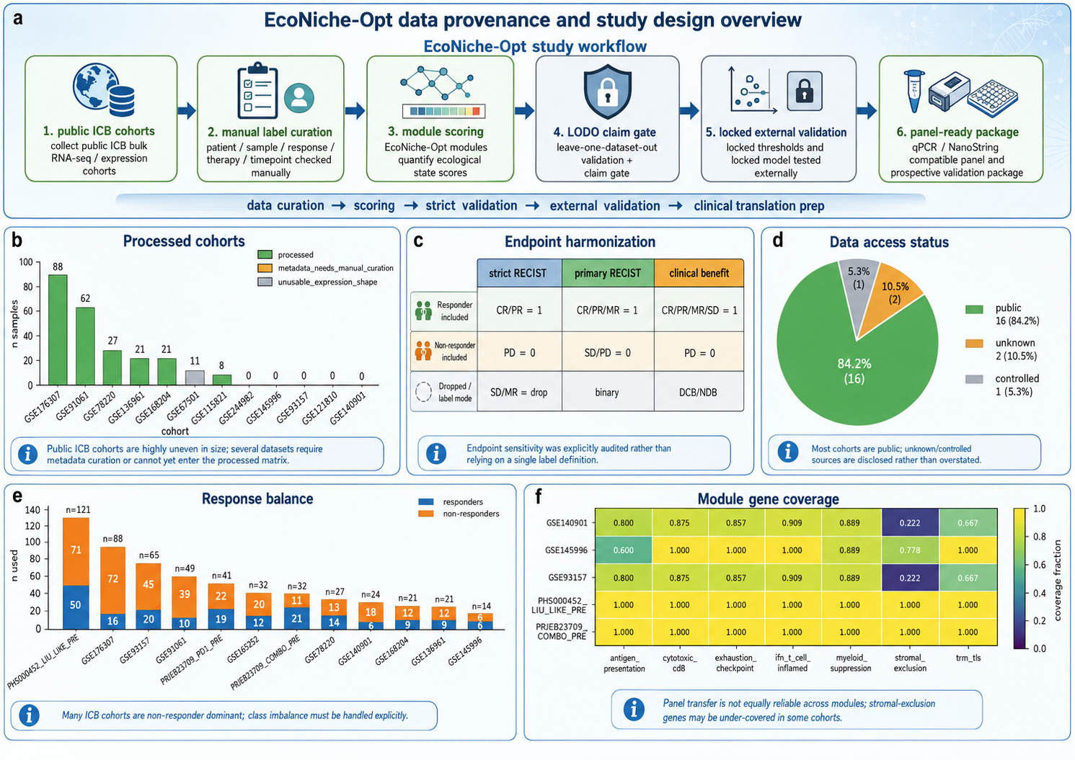
Public ICB cohorts were audited for access status, expression quality, response-label evidence, endpoint eligibility, and module coverage before model training. a, Study design. EcoNiche-Opt registers public ICB cohorts, processes expression matrices, curates response labels, harmonizes endpoints, trains models, applies a LODO claim gate, performs locked external validation, and defines panel-compatible scoring. The design prevents missing, controlled, or non-traceable data from being mixed into real-data outputs. b, Sample size and expression QC for processed cohorts, including GSE176307, GSE91061, GSE78220, GSE136961, GSE168204, GSE115821, GSE93157, and GSE140901; unavailable or manually curated resources are separately marked (Supplementary Tables 1-3). c, Endpoint harmonization rules for strict RECIST, primary RECIST, and clinical benefit (Supplementary Table 6). d, Data access status across public, unknown, and controlled datasets; controlled data are not replaced by simulated outputs. e, Responder/nonresponder balance under primary RECIST across major cohorts. f, Ecological module gene coverage in external and panel-transfer cohorts; PHS000452_LIU_LIKE_PRE and PRJEB23709_COMBO_PRE cover all seven prior modules, whereas GSE93157/GSE140901 have lower stromal-exclusion coverage but retain computability of core immune modules.

Figure 2 | EcoNiche-Opt converts immune states into a coupled ecological score.
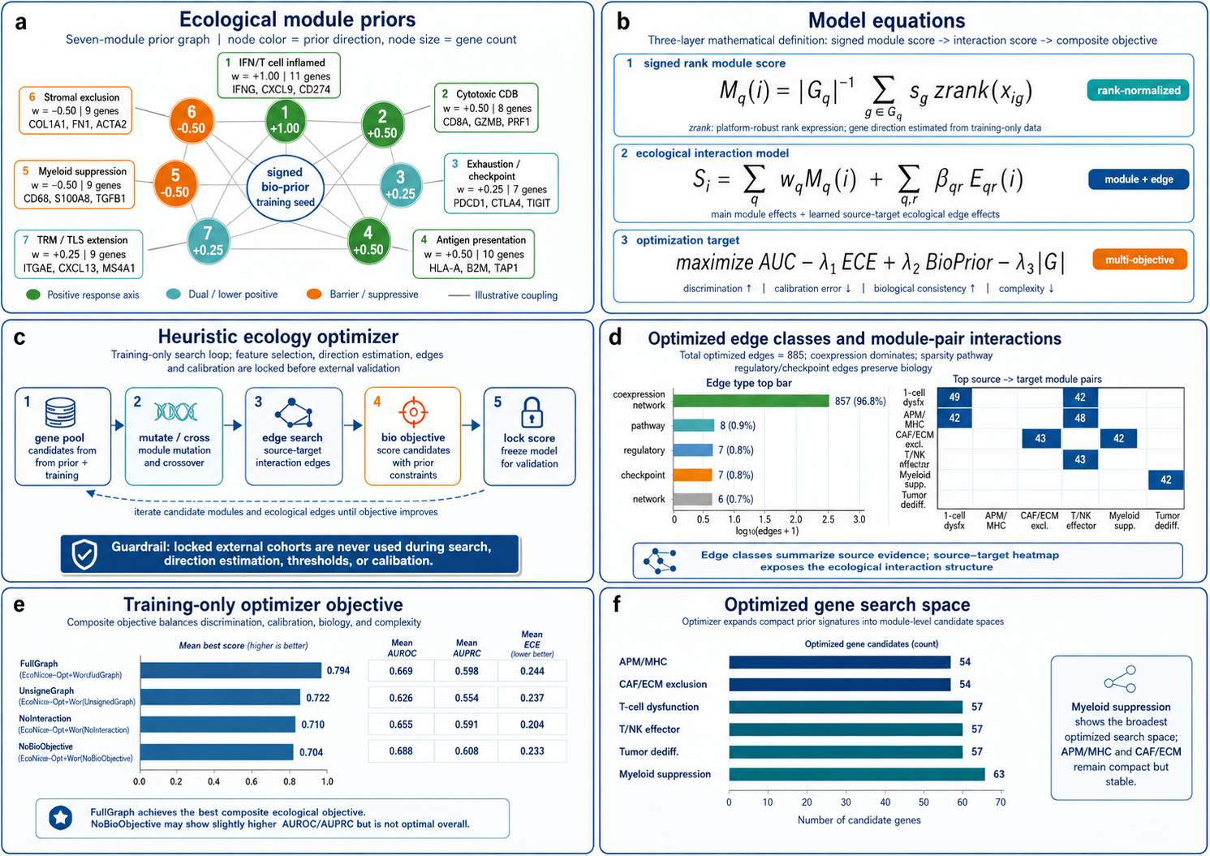
The model differs from a summed signature by combining signed-rank module scores, response-high and resistance-high state directions, and ecological interaction edges. a, Immune ecological prior modules, including IFN/T-cell inflamed, CD8 cytotoxic, checkpoint/exhaustion, antigen presentation, myeloid suppression, stromal exclusion, and TRM/TLS; module weights and directions are listed in Supplementary Table 7. b, Model formula. Sample-level module activity M_q(i) is computed from signed rank-normalized gene expression, and the total ecological score combines module main effects and ecological interaction edges. The objective considers AUROC, ECE, biological-prior consistency, and complexity penalties. c, Heuristic optimizer workflow from gene pool to mutation/crossover, edge search, biological objective selection, and locked scoring. d, Optimized edge classes dominated by coexpression-network edges with pathway, regulatory, checkpoint, and network edges retained (Supplementary Table 8). e, Optimizer objective across Word graph/ablation models (Supplementary Tables 9 and 13). f, Optimized gene search space across six expanded ecological states, each retaining approximately 54-63 unique optimized genes.

Figure 3 | Primary melanoma benchmarks support family-level improvement over immune signatures.
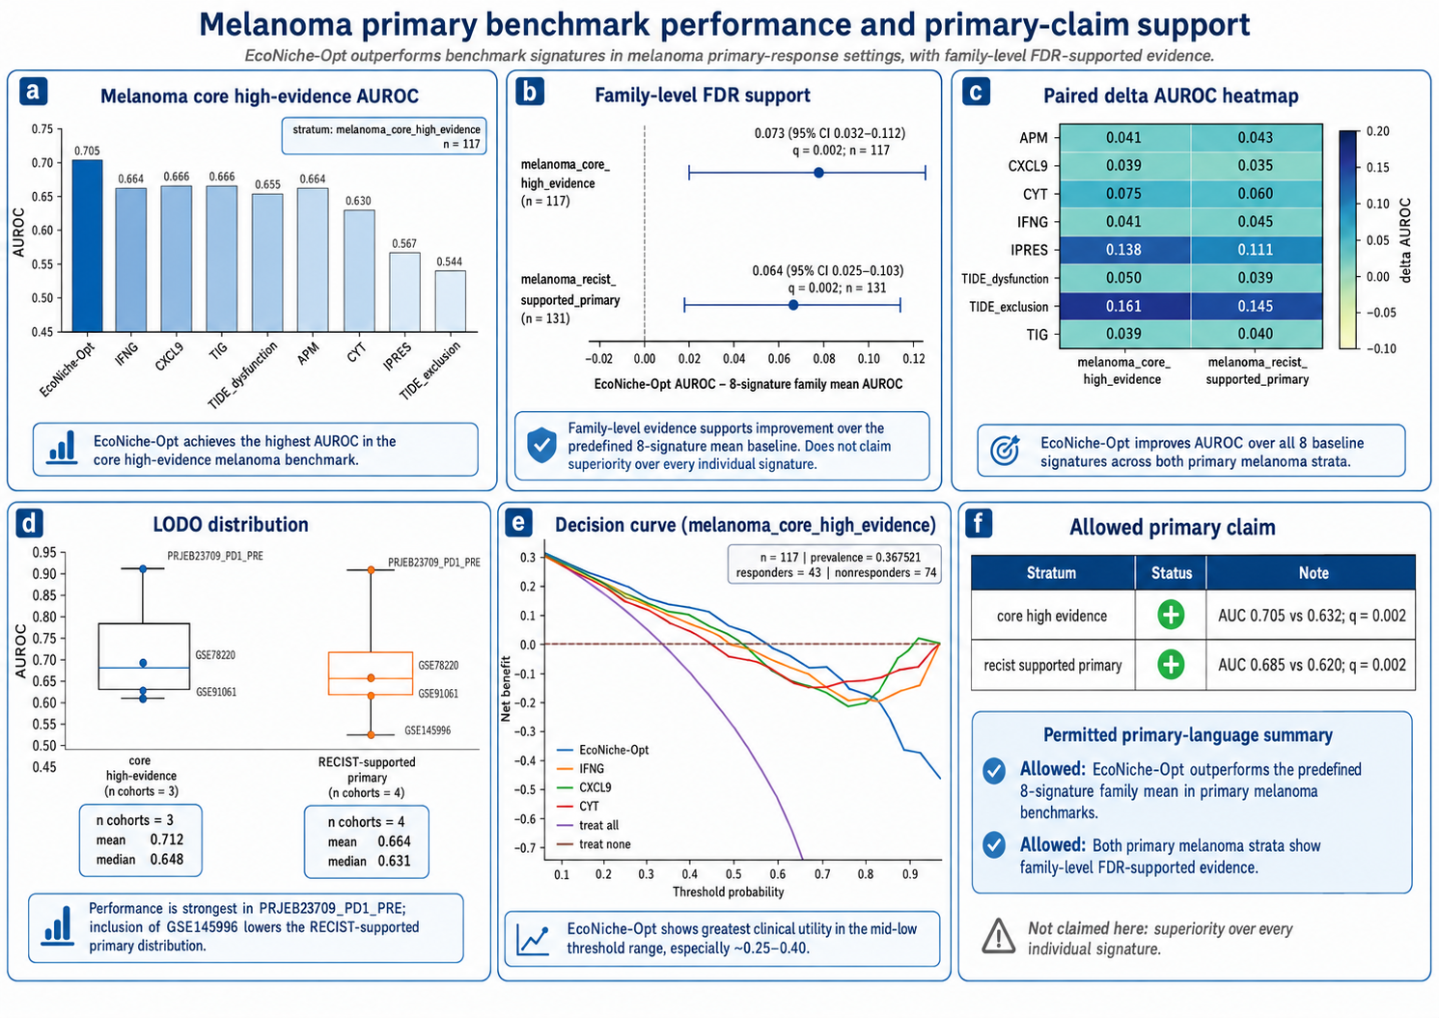
The main performance claim is tested against a predeclared eight-signature family rather than against weak machine-learning baselines. a, AUROC comparison between EcoNiche-Opt and eight strong signatures in the melanoma core high-evidence stratum. EcoNiche-Opt-HeuristicEcology reached pooled AUROC 0.704903, exceeding CXCL9/TIG (approximately 0.665619), IFNG (approximately 0.664362), APM (approximately 0.663734), TIDE_dysfunction, CYT, IPRES, and TIDE_exclusion (Supplementary Table 10). b, Predeclared eight-signature family omnibus test. Core high-evidence target AUROC was 0.704903 versus family mean 0.631796, mean delta 0.073416, 95% CI 0.031503-0.112106, two-sided FDR q=0.002. RECIST-supported primary target AUROC was 0.684559 versus family mean 0.619700, mean delta 0.064490, 95% CI 0.024521-0.102653, two-sided FDR q=0.002 (Supplementary Table 11). c, Paired delta-AUROC heatmap against APM, CXCL9, CYT, IFNG, IPRES, TIDE_dysfunction, TIDE_exclusion, and TIG; individual comparisons support point-estimate improvement, whereas the main claim is anchored to family-level FDR support. d, LODO AUROC distribution. Core high-evidence holdout AUROCs for GSE91061, GSE78220, and PRJEB23709_PD1_PRE were 0.612821, 0.648352, and 0.875598; the RECIST-supported stratum additionally includes GSE145996 with AUROC 0.520833 (Supplementary Table 12). e, Decision curve showing positive net benefit over treat-all across an approximate threshold-probability range of 0.20-0.45 (Supplementary Table 14). f, Allowed primary-claim matrix restricting superiority wording to FDR-supported strong-signature family improvement in primary melanoma.

Figure 4 | Endpoint sensitivity and ablation analyses strengthen the evidence hierarchy.
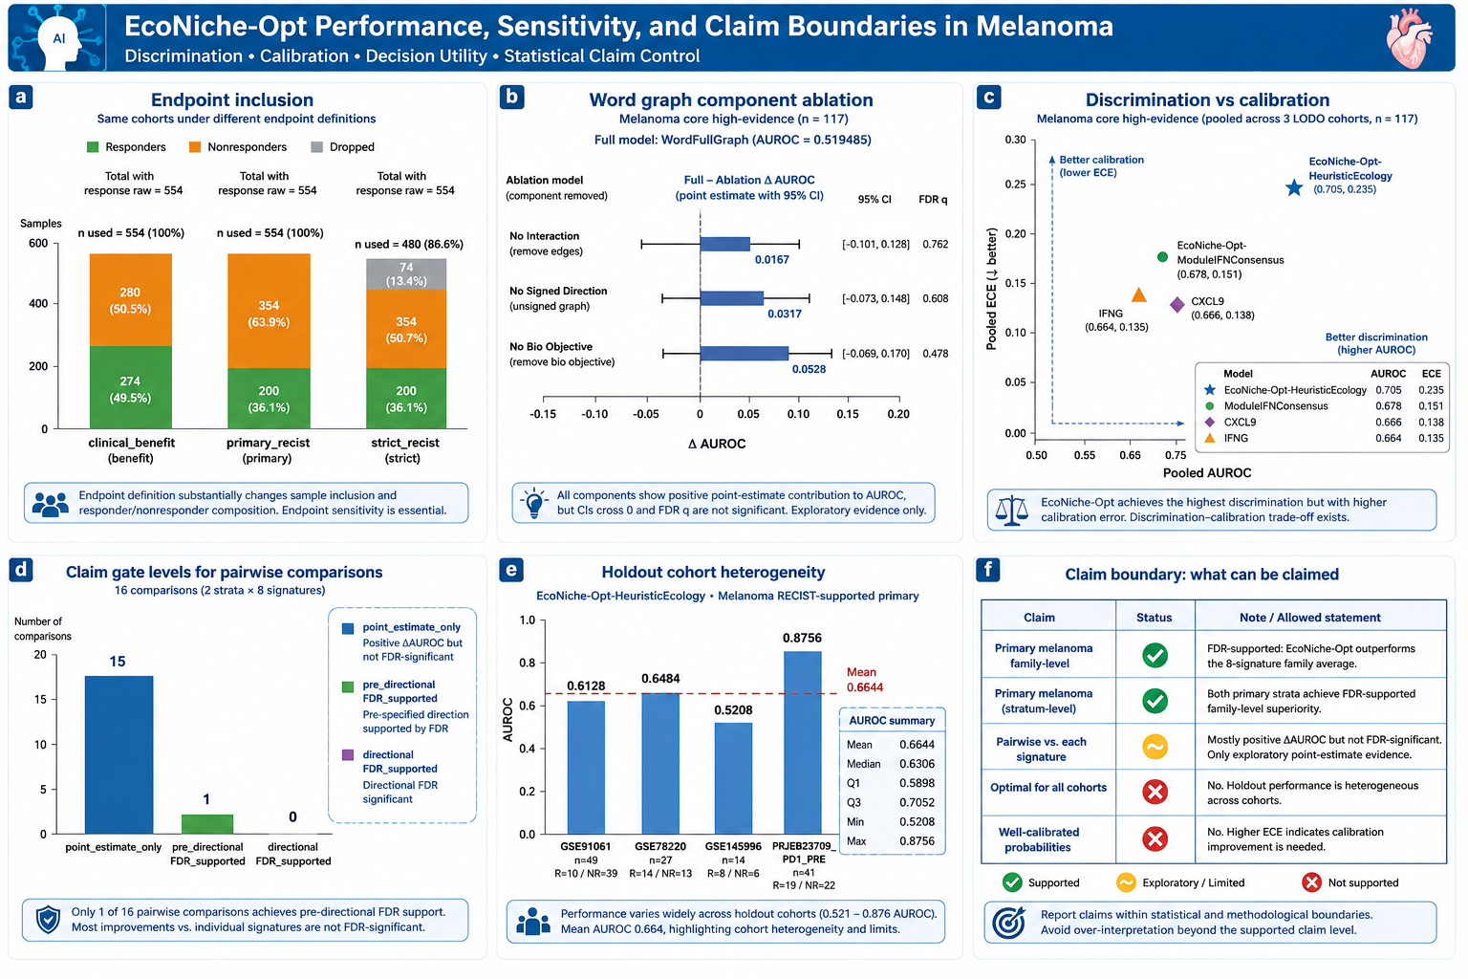
Robustness analyses connect endpoint choice, model components, calibration, and claim gating. a, Endpoint inclusion. Primary RECIST and clinical benefit used 554 samples with response_raw annotations and contained 200 and 274 responders, respectively; strict RECIST used 480 samples after excluding 74 intermediate-response samples (Supplementary Table 6). b, Word graph component ablation. Full WordFullGraph improved over WordNoInteraction, WordUnsignedGraph, and WordNoBioObjective by delta AUROC 0.016656, 0.031741, and 0.052797, respectively (Supplementary Table 13). c, Discrimination versus calibration. EcoNiche-Opt-HeuristicEcology reached pooled AUROC 0.704903 and ECE 0.234862 in the melanoma core high-evidence stratum; discrimination exceeded IFNG/CXCL9-like signatures, while calibration was reported separately (Supplementary Tables 10 and 14). d, Claim gate levels. Most individual signature comparisons were point_estimate_only; FDR-supported comparisons define formal superiority wording. e, Holdout cohort heterogeneity, including the full-primary stability pattern introduced by small cohorts such as GSE145996. f, Evidence hierarchy distinguishing supported primary melanoma family-level superiority, locked external/panel family-level support, and hypothesis-only perturbation outputs.

Figure 5 | Locked external and panel-transfer scoring evaluates portability without refitting.
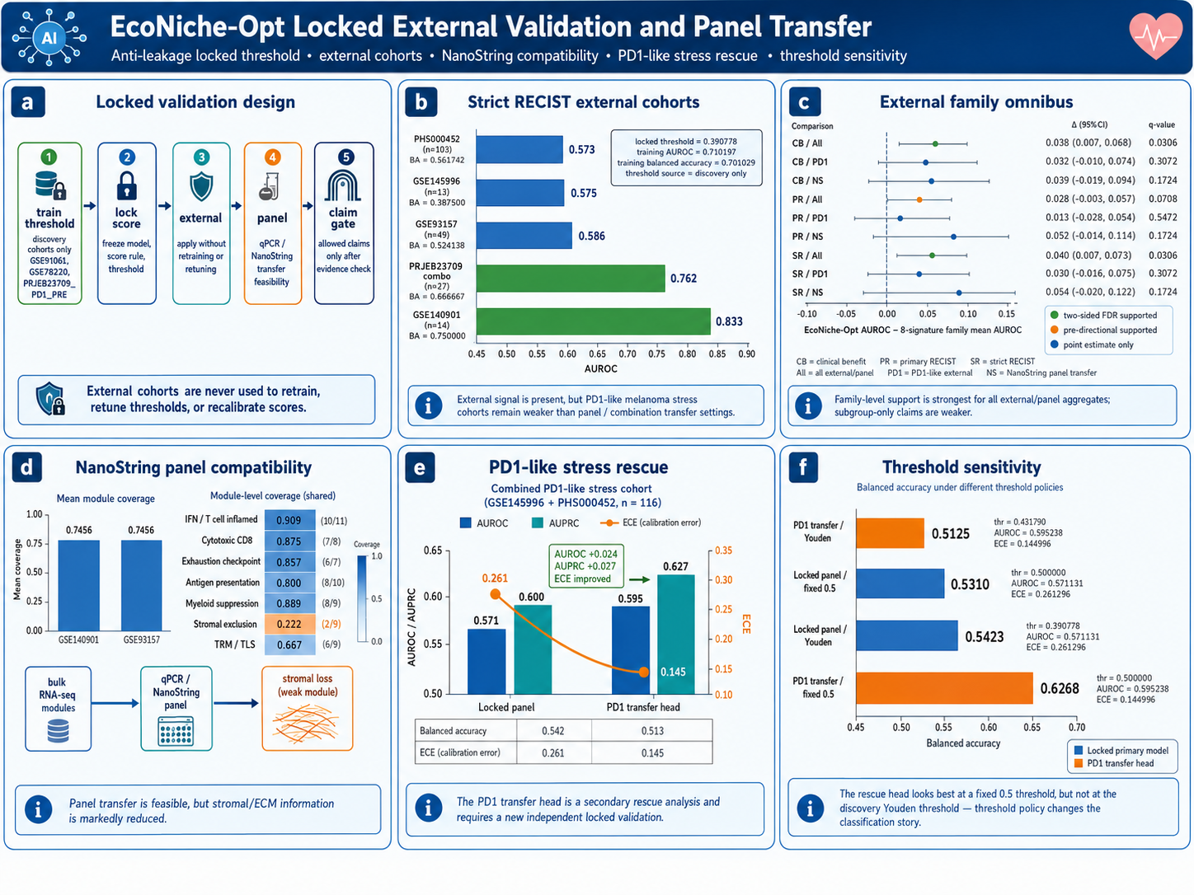
External cohorts are used for one-way scoring after discovery locking, not for gene selection, threshold tuning, or calibration. a, Locked validation design. Thresholding, score locking, and calibration are completed within discovery cohorts; external and panel-transfer cohorts are scored once and never used for model selection. b, Strict RECIST external/panel cohort AUROC: GSE145996, PHS000452_LIU_LIKE_PRE, GSE93157, PRJEB23709_COMBO_PRE, and GSE140901 reached 0.575, 0.573, 0.586, 0.762, and 0.833, respectively (Supplementary Table 15). c, External signature-family omnibus. Strict RECIST all locked external/panel AUROC was 0.609671 versus family mean 0.569882, mean delta 0.039789, two-sided FDR q=0.0306; clinical benefit target AUROC was 0.604353 versus family mean 0.566113, mean delta 0.038240, two-sided FDR q=0.0306 (Supplementary Table 15). d, NanoString panel module coverage. GSE93157 and GSE140901 had mean module coverage 0.745573, with lowest coverage in stromal exclusion (Supplementary Table 16). e, PD1-like stress rescue. In pooled strict RECIST PD1-like stress cohorts, locked panel AUROC was 0.571131 and PD1LikeTransferHead AUROC was 0.595238; ECE decreased from 0.261296 to 0.144996 (Supplementary Table 17). f, Threshold sensitivity showing PD1LikeTransferHead balanced accuracy 0.626786 under a fixed probability 0.5 policy.

Figure 6 | Single-cell and ecological-edge analyses map the score to response and resistance niches.
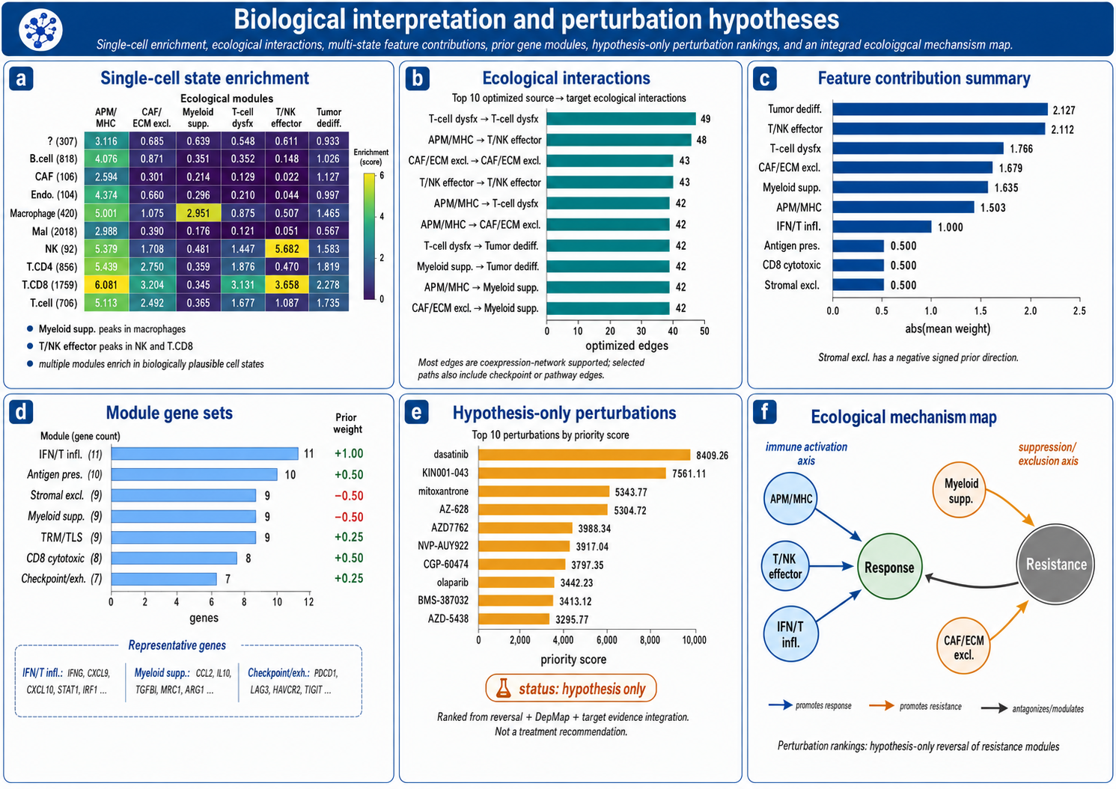
Biological interpretation asks whether the locked score reflects immune-ecological structure rather than a purely statistical ranking. a, Ecological state enrichment in single-cell compartments. APM/MHC was higher in T.CD8, T.CD4, NK, macrophage, and endothelial compartments; T/NK effector was highest in NK and T.CD8; myeloid suppression was enriched in macrophages (Supplementary Table 18). b, Top ecological source-target interactions, including T-cell dysfunction self-interaction, APM/MHC to T/NK effector, CAF/ECM self-interaction, T/NK effector self-interaction, APM/MHC to T-cell dysfunction, APM/MHC to CAF/ECM, T-cell dysfunction to tumour dedifferentiation, myeloid suppression to tumour dedifferentiation, APM/MHC to myeloid suppression, and CAF/ECM to myeloid suppression (Supplementary Table 8). c, Feature contribution summary for tumour dedifferentiation, T/NK effector, T-cell dysfunction, CAF/ECM exclusion, myeloid suppression, and APM/MHC. d, Module gene-set sizes and response directions (Supplementary Table 7). e, Hypothesis-only perturbation ranking integrating LINCS reversal, DepMap score, and DGIdb evidence; candidates include dasatinib, KIN001-043, mitoxantrone, AZ-628, AZD7762, NVP-AUY922, CGP-60474, olaparib, BMS-387032, and AZD-5438 (Supplementary Table 19). f, Mechanistic axis separating response-supporting APM/MHC, T/NK effector, and IFN/T inflamed states from resistance-associated myeloid suppression and CAF/ECM exclusion.

Figure 7 | A locked 62-gene immune-ecology panel enables independent scoring.
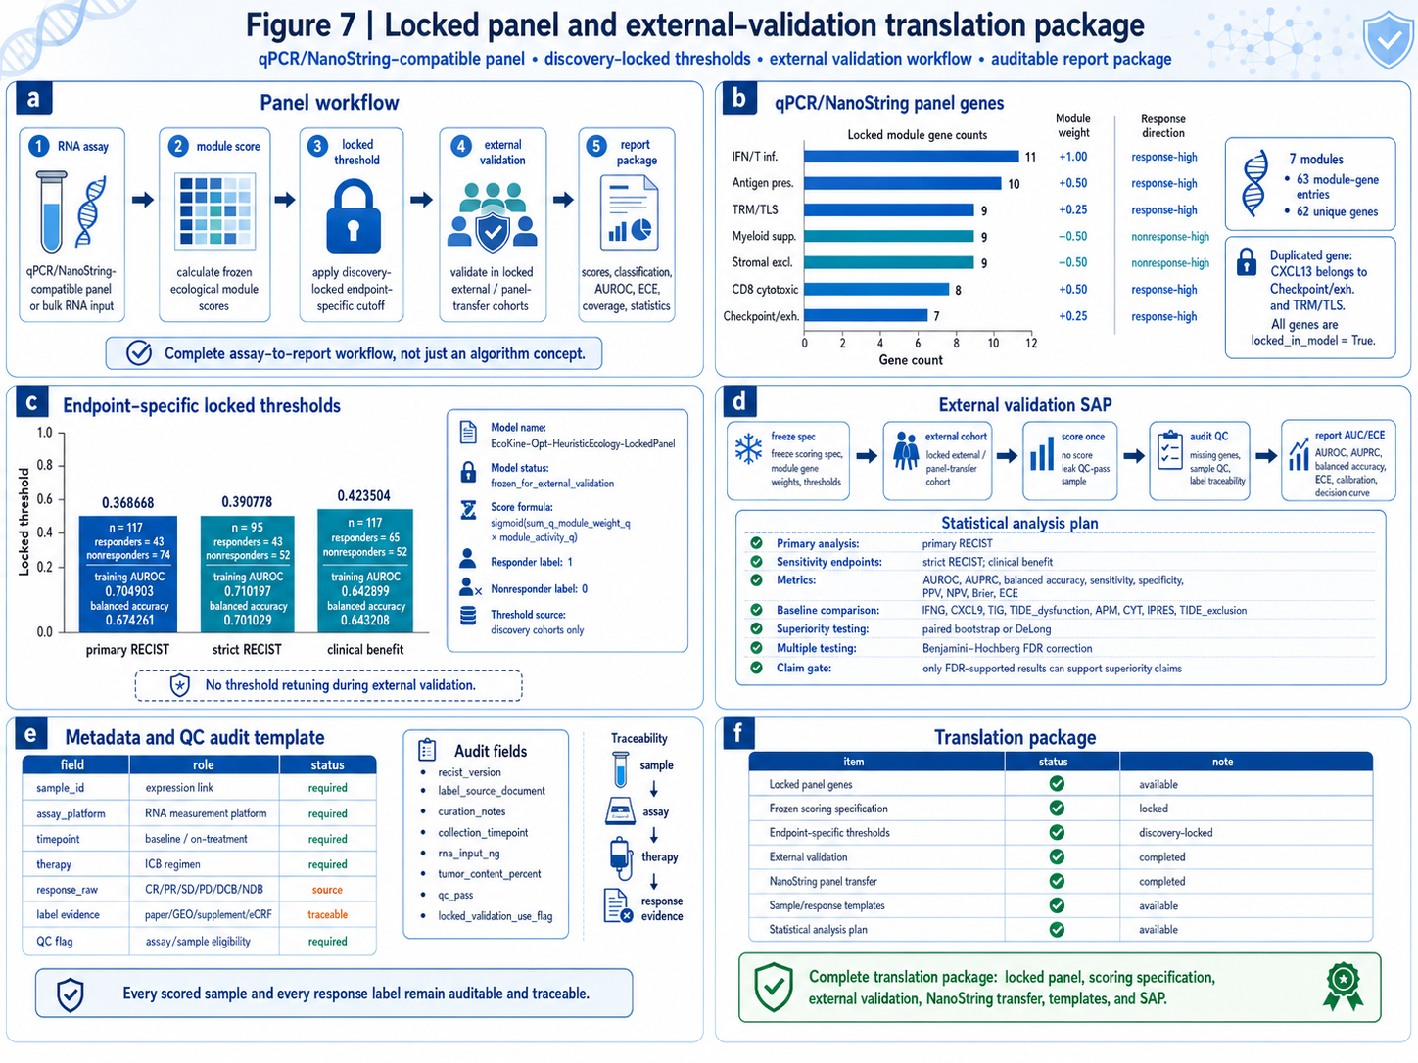
The final output is an independently computable scoring rule rather than a cohort-specific classifier. a, Assay-to-report scoring path. RNA assay or bulk expression input is transformed into rank-normalized module scores, scored by a frozen ecological model, classified by endpoint-specific thresholds, and evaluated externally; external labels are read only during evaluation. b, qPCR/NanoString-compatible locked panel genes. The locked panel covers seven modules, 63 module-gene entries, and 62 unique genes; CXCL13 belongs to both checkpoint/exhaustion and TRM/TLS modules (Supplementary Tables 7 and 20). c, Discovery-locked thresholds. Primary RECIST, strict RECIST, and clinical-benefit thresholds were 0.368668, 0.390778, and 0.423504, with corresponding training AUROCs of 0.704903, 0.710197, and 0.642899. d, External validation path. After discovery freezing, independent cohorts undergo one-way scoring, coverage QC, and prespecified AUROC/ECE reporting. e, Sample-level traceability fields link expression sample, patient, treatment, and response evidence. f, Reproducibility boundary summarizing locked model, thresholds, external outputs, panel-transfer evidence, and open scoring code (Supplementary Table 20).

