Register：

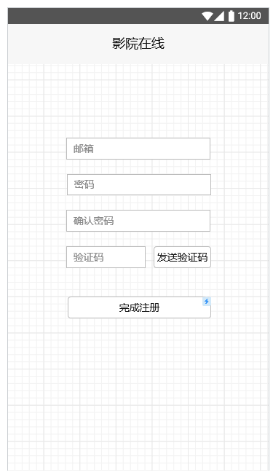

Users should register to use the app, they need to input their email and click “get verification code”, then the server will send a verification code to their email to help them finish registering.

Homepage:

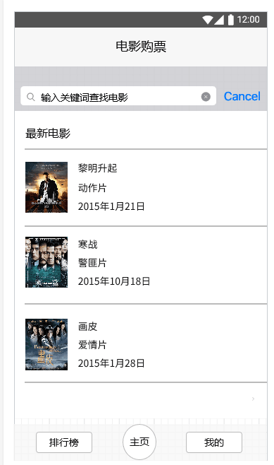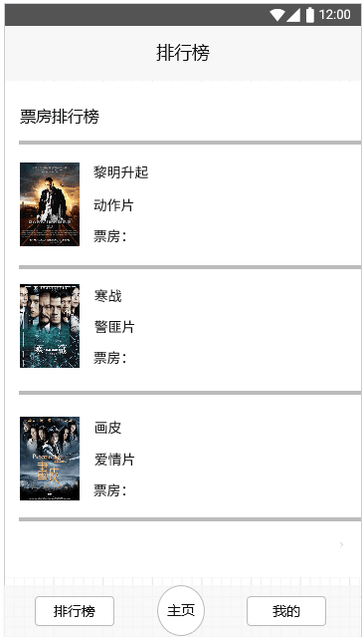

The homepage will list the latest movies, and users can sort them by rating if they click “排行榜“. If they are interested in a special movie, they can click the poster to check more information about the movie and then they can buy a ticket.

Buy ticket:

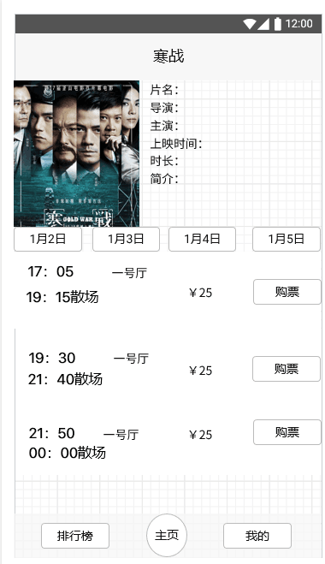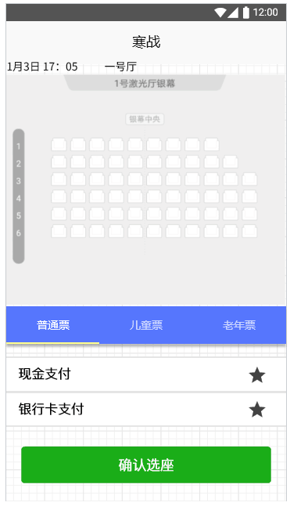

Once users click a poster in homepage, the app will jump to another activity which can show the details about the movie to help users buy the tickets. Users can find the times and location listings in this activity and they can click “购票“ button to buy the tickets. Then, they can choose the seats, the type of the tickets and the payment method.

Manage:

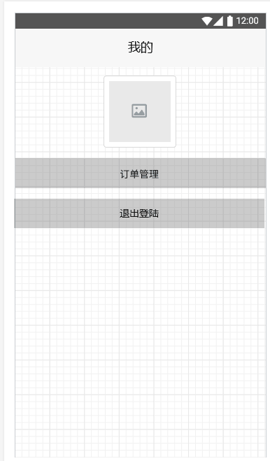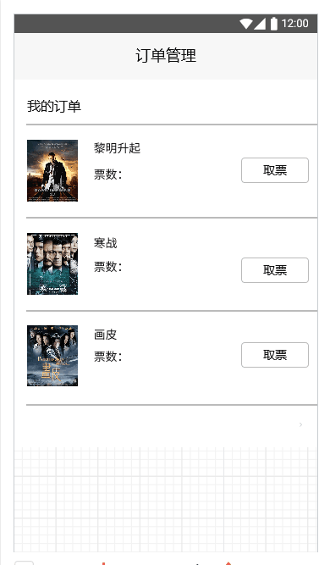

In the homepage, users can click button “我的“ to manage their order, they can know the details about their order and they can click button “取票” to get a two-dimensional code for ticket collection.