ALGORITHM RESEARCH PROJECT
Selection Sort
Logic, flowchart, and pseudocode
GROUP 4
Rothana · Dara · Deth · Lyheng · Samnang
Programming Fundamentals · Algorithm Theory
July 2026

1. The real-world problem
"If you had to sort cards by always picking the smallest one left, how would you do it?"
Imagine you are holding a hand of playing cards in random order and you want to arrange them from smallest to largest. One of the most intuitive strategies is: scan through the cards, find the smallest one, and place it at the front. Then repeat the process for the remaining cards until the whole hand is sorted.
This is exactly what the Selection Sort algorithm does. It solves the everyday problem of putting a collection of items into order — numbers, names, prices, heights, or anything else that can be compared — by repeatedly selecting the smallest remaining item and moving it to its correct position.
Sorting is one of the most important building blocks in computer science because searching, reporting, and decision-making all become faster and more reliable when data is already in order.

2. What is Selection Sort?
Selection Sort is a simple comparison-based sorting algorithm that arranges a list of items in ascending (or descending) order by repeatedly finding the smallest remaining element and placing it at the beginning of the unsorted portion of the list.

Key properties
- Works in rounds (passes). One item becomes sorted after each round.
- Each round performs one full scan of the unsorted portion to find the minimum.
- Each round performs at most one swap, not many.
- Divides the list into two parts: a sorted portion on the left and an unsorted portion on the right.

3. Step-by-step example
Let us trace how Selection Sort processes the list [64, 25, 12, 22, 11]. In each pass, we scan the unsorted portion, find the smallest value, and swap it into the correct position.
Pass | Search range (unsorted) | Minimum found | List after swap
1 | [64, 25, 12, 22, 11] | 11 | [11, 25, 12, 22, 64]
2 | [25, 12, 22, 64] | 12 | [11, 12, 25, 22, 64]
3 | [25, 22, 64] | 22 | [11, 12, 22, 25, 64]
4 | [25, 64] | 25 (no swap) | [11, 12, 22, 25, 64]
After four passes, the entire list is sorted. Notice that at most one swap occurred per pass — that is a defining feature of Selection Sort.

4. Flowchart
The flowchart below shows the complete logic of Selection Sort using standard flowchart symbols: ovals for start and end, parallelograms for input and output, rectangles for processes, and diamonds for decisions.
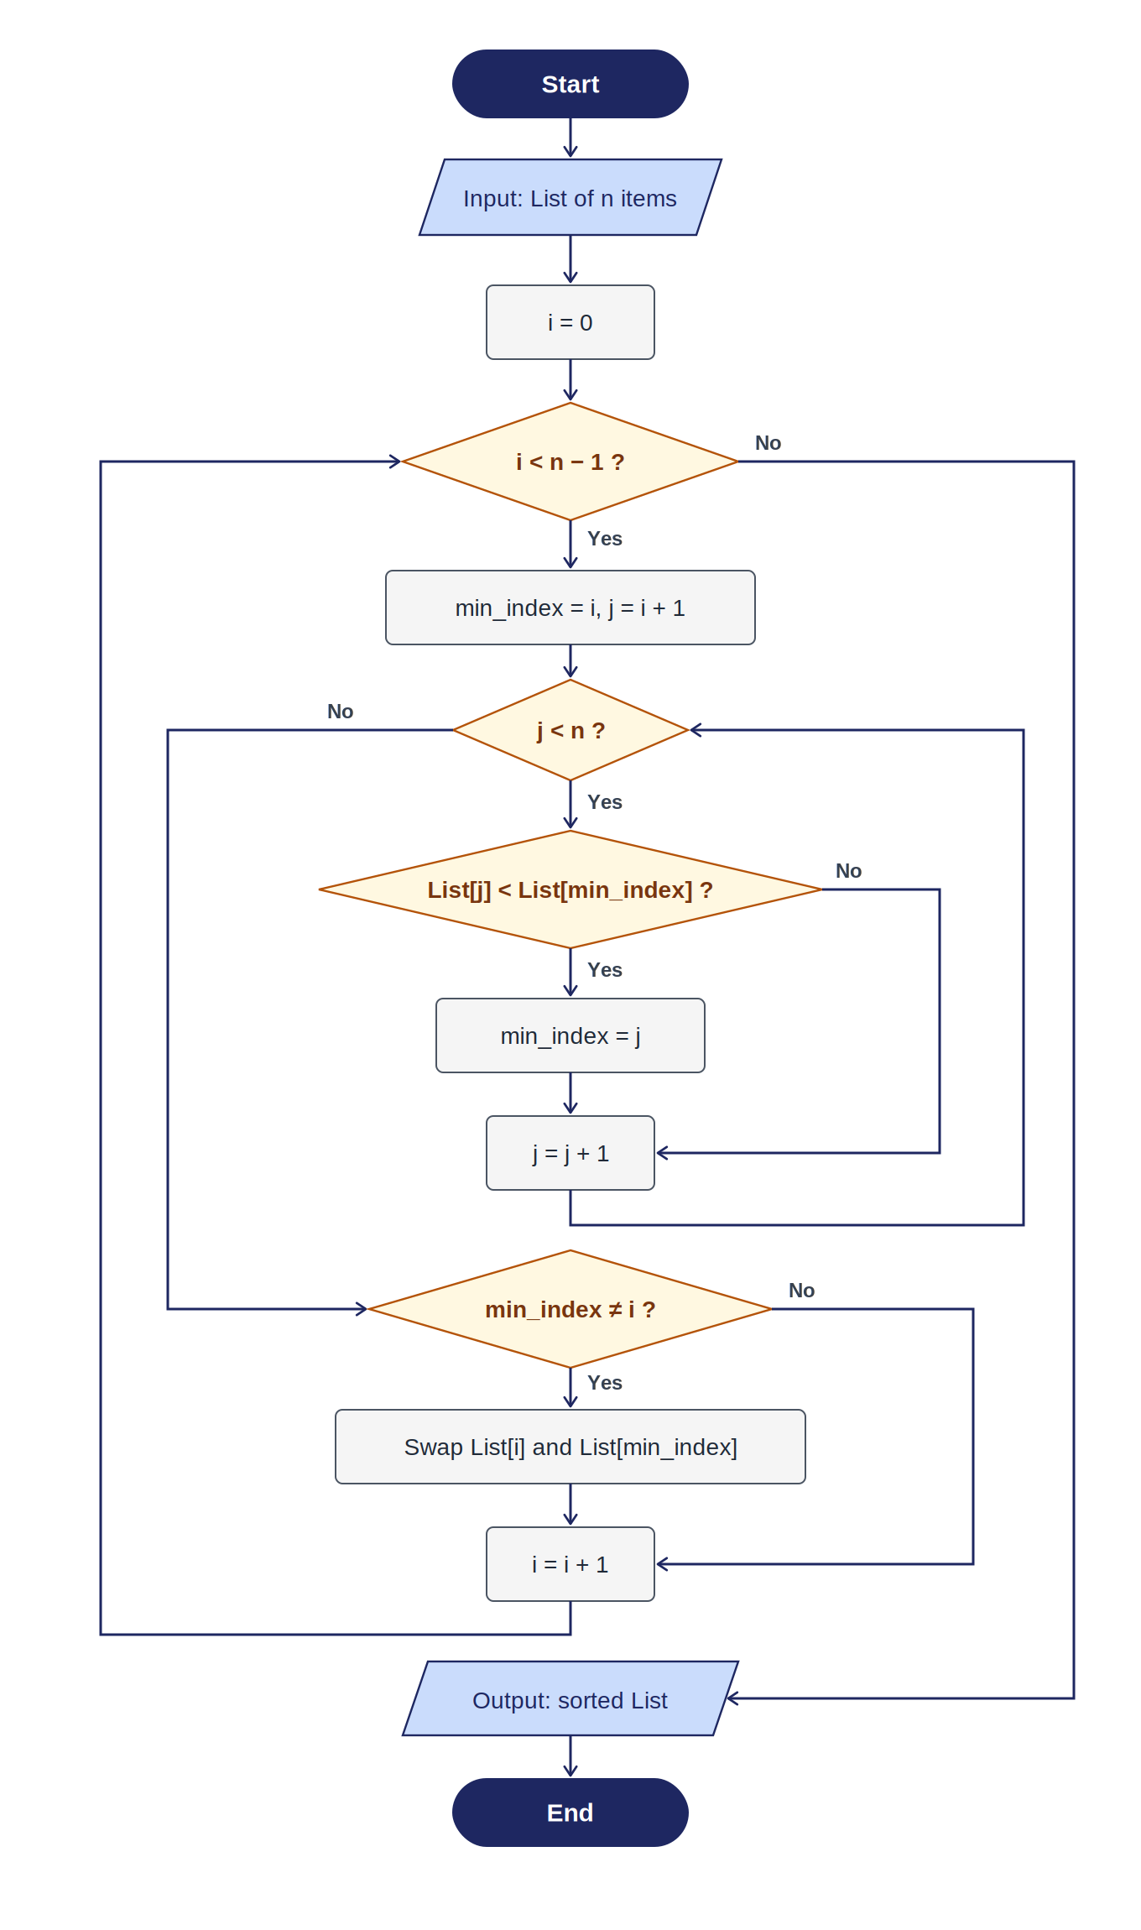
Figure 1 — Complete flowchart for Selection Sort

5. Pseudocode
The following pseudocode expresses the same logic as the flowchart in plain structured English, with no programming-language syntax.
ALGORITHM: SelectionSort

INPUT: A list called List containing n items,
indexed from 0 to n − 1

BEGIN
FOR i FROM 0 TO n − 2 DO
SET min_index = i

// Scan the unsorted portion for the smallest
FOR j FROM i + 1 TO n − 1 DO
IF List[j] < List[min_index] THEN
SET min_index = j
END IF
END FOR

// Place the smallest at position i
IF min_index ≠ i THEN
SWAP List[i] WITH List[min_index]
END IF
END FOR

OUTPUT: List, now sorted in ascending order
END

6. Selection Sort vs Bubble Sort
Both algorithms sort in rounds and both perform roughly the same number of comparisons. The key difference is what they do when they find something out of order.
- Bubble Sort swaps neighboring elements whenever they are in the wrong order, so a single pass can involve many swaps.
- Selection Sort only looks for the minimum during a pass, then performs one swap at the end of the pass.
Aspect | Selection Sort | Bubble Sort
Comparison strategy | Scans for minimum, then swaps once | Compares neighbors and swaps repeatedly
Number of swaps | At most n − 1 total | Up to n(n−1)/2 in worst case
Comparisons | Always O(n²) | Always O(n²)
Best for | Situations where writing/swapping is expensive | Teaching the idea of pairwise comparison
This is why Selection Sort is preferred when the cost of moving data is high — the algorithm reduces the number of write operations significantly.

7. Where fewer swaps matter
The main practical advantage of Selection Sort is that it minimizes the number of swap (write) operations. This matters in real systems where each move has a physical or resource cost.
- Warehouse sorting: When physical items such as boxes or pallets must be arranged by weight or size, every movement costs labor and time. Fewer swaps means less handling.
- Flash memory and SSD storage: Each write operation slowly wears out the memory cells. Algorithms that write less can extend the lifetime of the device.
- Large database records: When rows are large, swapping them involves moving significant amounts of data. Reducing swap count reduces I/O cost.
- Robotic sorting arms: Every physical pick-and-place operation takes time and mechanical wear. Selection Sort's guarantee of at most n − 1 swaps is predictable and efficient in these environments.

8. Best, worst, and average cases
Selection Sort has consistent time complexity regardless of the input. It always compares each element to find the minimum, even if the list is already sorted.
Case | Comparisons | Swaps | Notes
Best case | O(n²) | 0 | List already sorted; scanning still required
Average case | O(n²) | O(n) | Typical random data
Worst case | O(n²) | n − 1 | Never exceeds n − 1 swaps

9. Conclusion
Selection Sort is a clear, predictable algorithm that captures a very natural human sorting strategy: find the smallest, put it aside, repeat. Its logic is easy to explain, easy to draw as a flowchart, and easy to translate into pseudocode.
It is not the fastest sorting method for large datasets — algorithms like Merge Sort and Quick Sort perform far better as the list grows. However, Selection Sort remains a strong choice whenever the cost of swapping matters more than the cost of comparing, and it is one of the best algorithms for building foundational understanding of how sorting works.
Understanding Selection Sort prepares us to appreciate more advanced algorithms and to think clearly about the trade-offs between comparisons, swaps, and memory usage.

