**Name: Abdul Hasib Zahid ID: 443058333**

**Experiment # 5: Calculating Even/Odd using user defined method.**

Write a Java method that returns whether a value entered by the user is odd or even.

import java.util.Scanner;

public class EvenOdd {

    public static String evenChecker(int number){

        if(number%2==0)

        {

            return "Even";

        }

        else

        {

            return "Odd";

        }

    }

    public static void main (String[] args){

        Scanner scanner = new Scanner(System.in);

        int n = scanner.nextInt();

        String result = evenChecker(n);

        System.out.println(result);

    }

}

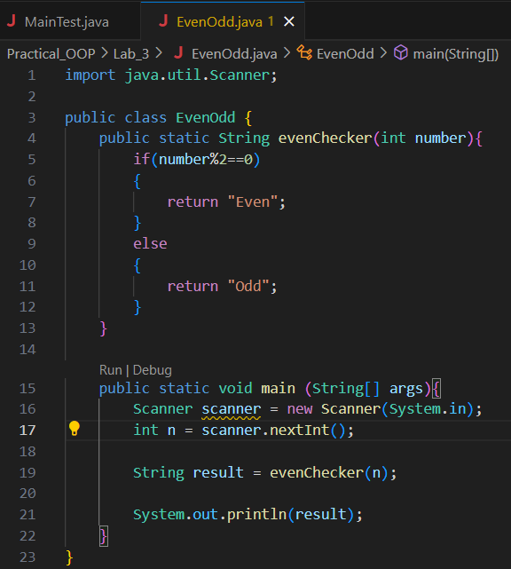





**Experiment # 6: Using static method**

Complete the following source code so that the result of execution displays the following string: “*it is an example of static method*”.



