**Name: Abdul Hasib Zahid ID: 443058333**

**Experiment # 7: Accessor and Mutator method for assigning and returning values.**

Add ***getters*** and ***setters*** to the following code and test them in a separate ***main*** method.

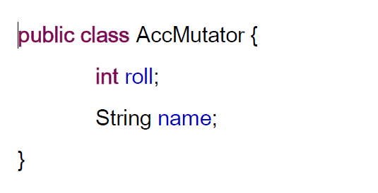

package Lab_4;

public class AccMutator {

    int roll;

    String name;

    public int getRoll()

    {

        return roll;

    }

    public void setRoll(int roll)

    {

        this.roll = roll;

    }

    public String getName()

    {

        return name;

    }

    public void setName(String name)

    {

        this.name = name;

    }

    public static void main(String[] args) {

        AccMutator student = new AccMutator();

        student.setName("Abdul Hasib Zahid");

        student.setRoll(100);

        System.out.println("Name: "+student.getName());

        System.out.println("Roll: "+student.getRoll());

        return;

    }

}



