**Name: Abdul Hasib Zahid ID: 443058333**

**Experiment # 10: Practicing Single & Multilevel Inheritance**

Write java codes that illustrate respectively single, multilevel, and hierarchical inheritance.

public class Animal {

    void eat(){

        System.out.println("This animal can eat");

    }

}

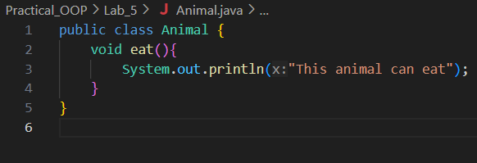

public class Dog extends Animal {

    void bark(){

        System.out.println("The dog barks.");

    }

}

public class SingleInheritance{

    public static void main(String [] args)

    {

        Dog myDog = new Dog();

        myDog.eat();

        myDog.bark();

    }

}

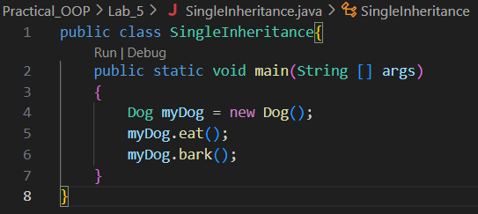



public class Puppy extends Dog {

    void weep(){

        System.out.println("The puppy is weeeping.");

    }

}

public class MultiLevelInheritance {

    public static void main(String[] args) {

        Puppy myPuppy = new Puppy();

        myPuppy.eat();

        myPuppy.bark();

        myPuppy.weep();

    }

}

public class Cat extends Animal {

    void meow(){

        System.out.println("The cat meows.");

    }

}

public class HierarchicalInheritance {

    public static void main(String[] args) {

        Dog myDog = new Dog();

        Cat myCat = new Cat();

        myDog.eat();

        myDog.bark();

        myCat.eat();

        myCat.meow();

    }

}

